Development of a Booking System for Lakeside Escapes using a Database

Software Systems Development

Unit A2 2: Implementing Solutions

Candidate Number: 7303

Centre Number: 71571

April 2024

Contents

1. Case Study Overview 1

1.1. Aims and Objectives 2

2. Project Management Techniques 3

2.1. Gantt Charts 4

2.1.1. Advantages Of Gantt Charts 4

2.1.2. Disadvantages of Gantt Charts 4

2.2. PERT Charts 4

2.2.1. Advantages of PERT Charts 5

2.2.2. Disadvantages of PERT Charts 5

2.3. Project Management Conclusion 6

3. Design Methodologies 9

3.1. Waterfall Methodology 9

3.1.1. Advantages of the Waterfall Model 9

3.1.2. Disadvantages of the Waterfall Model 9

3.1.3. Stages of the Waterfall Model 10

3.2. Rapid Application Development 10

3.2.1. Advantages of RAD 11

3.2.2. Disadvantages of RAD 11

3.3. Scrum 12

3.3.1. Advantages of Scrum 13

3.3.2. Disadvantages of Scrum 13

3.4. Design Methodology Conclusion 14

4. User Requirements 15

4.1. Functional Requirements 15

4.2. Non-Functional Requirements 16

5. Design 17

5.1. Range of Possible Solutions 17

5.1.1. Web Based Application with a Cloud Hosted Database 17

5.1.2. Mobile Application developed in Swift with a Cloud Hosted Database 18

5.1.3. Windows Desktop Application (C#) with a Locally Hosted SQL Database 19

5.1.4. Review of Possible Solutions 19

5.2. Entity Relationship Diagram 20

5.3. Normalisation 21

5.3.1. Unnormalised Form 21

5.3.2. First Normal Form 21

5.3.3. Second Normal Form 22

5.3.4. Third Normal Form 22

5.4. Data Dictionaries 23

5.5. Unified Modelling Language 26

5.5.1. Use Case Diagram 26

5.5.2. Class Diagrams 28

5.6. Storyboards 30

5.6.1. FormMenu 30

5.6.2. FormCreateGuest 32

5.6.3. FormViewGuest 35

5.6.4. FormEditGuest 38

5.6.5. FormAddBooking 41

5.6.6. FormViewBooking 44

5.6.7. FormEditBooking 47

5.6.8. FormViewPod 50

5.6.9. FormEditPod 52

5.6.10. FormReport 55

5.6.11. FormShowDetails 57

5.7. Test Plan 58

5.7.1. Data Entry Testing 59

5.7.2. Link Testing 68

5.7.3. User Acceptance Testing 73

5.8. Pseudocode 74

5.8.1. Adding a Guest 74

5.8.2. Adding a Booking 75

5.8.3. Applying Discounts 76

5.8.4. Updating a Booking 77

5.8.5. Returning a Guest Object Given the Guest ID 78

5.8.6. Selecting a Vacant Pod for A Booking 79

5.8.7. Checking if the Booking Dates Match the Course Dates 80

5.8.8. Deleting a Pod 81

5.9. Input-Process-Output 81

5.9.1. FormCreateGuest 82

5.9.2. FormViewGuest 82

5.9.3. FormEditGuest 82

5.9.4. FormAddBooking 83

5.9.5. FormViewBooking 83

5.9.6. FormEditBooking 83

5.9.7. FormViewPod 84

5.9.8. FormEditPod 84

5.9.9. FormReport 84

5.10. End-User Design Feedback 85

6. Testing 91

6.1. Data Entry Testing 91

6.1.1. FormCreateGuest 91

6.1.2. FormAddBooking 99

6.1.3. FormEditPods 102

6.1.4. FormViewGuest 102

6.1.5. FormEditGuest 105

6.1.6. FormEditBooking 107

6.1.7. FormViewBooking 108

6.1.8. FormViewPod 110

6.2. Link Testing 113

6.2.1. FormMenu 113

6.2.2. FormCreateGuest 114

6.2.3. FormAddBooking 117

6.2.4. FormViewGuest 117

6.2.5. FormViewBooking 118

6.2.6. FormEditBooking 118

6.2.7. FormEditGuest 118

6.2.8. FormViewPod 119

6.2.9. FormEditPod 119

6.2.10. FormReport 119

6.3. User Acceptance Testing 120

7. User Guide 126

8. Evaluation 149

8.1. Evaluation of Range of Approaches 149

8.2. Evaluation of User Requirements 151

8.3. Evaluation of Testing 154

8.4. Evaluation of Design Methodology 156

8.5. Evaluation of Project Management 157

8.6. Evaluation of This Solution 158

8.7. Evaluation of Developers Performance 160

Appendix A – Developer Diary 163

Appendix B – Code Repository 165

B.1. App.config 165

B.2. Classes 166

B.2.1. Guest.cs 166

B.2.2. Booking.cs 168

B.2.3. Pod.cs 170

B.2.4. PodDescription.cs 171

B.2.5. Validation.cs 172

B.2.6. tblGuestDAL.cs 174

B.2.7. tblBookingDAL.cs 176

B.2.8. tblPodDAL.cs 180

B.2.9 tblCourseGuestsDAL.cs 184

B.2.10. tblPodDescriptionDAL.cs 185

B.3. Forms 186

B.3.1. FormMenu.cs 186

B.3.2. FormCreateGuest.cs 188

B.3.3. FormViewGuest.cs 189

B.3.4. FormEditGuest.cs 191

B.3.5. FormAddBooking.cs 194

B.3.6. FormViewBookings.cs 196

B.3.7. FormEditBooking.cs 198

B.3.8. FormViewPod.cs 203

B.3.9. FormEditPod.cs 204

B.3.10. FormReport.cs 209

B.4. SQL Stored Procedures 210

B.4.1. AddBooking 210

B.4.2. AddGuest 210

B.4.3. AddPod 210

B.4.4. CheckCourseDates 211

B.4.5. DeleteBooking 211

B.4.6. DeletePod 211

B.4.7. GetBookingRecordFromBookingID 212

B.4.8. GetGuestRecordFromGuestID 212

B.4.9. GetMonthlyBookings 212

B.4.10. GetPodIDFromType 213

B.4.11. JoinCourseWithGuestDetails 213

B.4.12. PopulateDGVGivenPod 213

B.4.13. ReturnBookingIDFromGuestID 214

B.4.14. ReturnCourseIDByGuestID 214

B.4.15. ReturnGuestFrequency 214

B.4.16. ReturnGuestIDFromDetails 215

B.4.17. ReturnPodDescription 215

B.4.18. ReturnPodFrequency 215

B.4.19. ReturnVacentPods 216

B.4.20. UpdateBooking 216

B.4.21. UpdateGuest 217

B.4.22. UpdatePod 217

B.4.23. UpdatePodDescription 218

B.5 Database Tables 219

B.5.1. tblBooking 219

B.5.2. tblGuest 219

B.5.3 tblCourseDetails 220

B.5.4. tblCourseGuests 220

B.5.5. tblPod 221

B.5.6. tblPodDescription 221

Table of Figures

Figure 2‑1 – Project Management Lifecycle 3

Figure 2‑2 – Iron Triangle of Project Management 3

Figure 2‑3 – Example of a Simple Gantt Chart 4

Figure 2‑4 – Example of a PERT Chart 5

Figure 2‑5 – Gantt Chart 7

Figure 3‑1 – The Waterfall Model 10

Figure 3‑2 – RAD Model 11

Figure 3‑3 – Scrum Sprint Model 13

Figure 5‑1 – ERD of Database 20

Figure 5‑2 – Use Case Diagram 28

Figure 5‑3 – Class Diagram 29

Figure 5‑4 – FormMenu Storyboard 30

Figure 5‑5 – FormCreateGuest Storyboard 32

Figure 5‑6 – FormViewGuest Storyboard 35

Figure 5‑7 – FormViewGuest Panels Storyboard 35

Figure 5‑8 – FormEditGuest Storyboard 38

Figure 5‑9 – FormAddBooking Storyboard 41

Figure 5‑11 – FormViewBooking Panels Storyboard 44

Figure 5‑12 – FormViewBooking Storyboard 44

Figure 5‑13 – FormEditBooking Storyboard 47

Figure 5‑14 – FormEditBooking Panels Storyboard 47

Figure 5‑15 – FormViewPod Storyboard 50

Figure 5‑16 – FormEditPod Storyboard 52

Figure 5‑17 – FormReport Storyboard 55

Figure 5‑18 – FormShowDetails Storyboard 57

Figure 5‑19 – ‘V-Model’ in Testing 59

Figure 5‑20 – Pseudocode to Add a Guest 75

Figure 5‑21 – Add Booking Pseudocode 76

Figure 5‑22 – Apply Discounts Pseudocode 77

Figure 5‑23 – Update Booking Pseudocode 78

Figure 5‑24 – Return Guest Object Pseudocode 79

Figure 5‑25 – Pod Assignment Pseudocode 79

Figure 5‑26 – Check Course Guests Pseudocode 80

Figure 5‑27 – Delete Pod Pseudocode 81

Figure 5‑28 – End-User Design Form Question 1 85

Figure 5‑29 – End-User Design Form Question 2 85

Figure 5‑30 – End-User Design Form Question 3 86

Figure 5‑31 – End-User Design Form Question 4 86

Figure 5‑32 – End-User Design Form Question 5 87

Figure 5‑33 – End-User Design Form Question 6 87

Figure 5‑34 – End-User Design Form Question 7 88

Figure 5‑35 – End-User Design Form Question 8 88

Figure 5‑36 – End-User Design Form Question 9 89

Figure 5‑37 – End-User Design Form Question 10 89

Figure 5‑38 – End-User Design Form Question 11 90

Figure 5‑39 – End-User Design Form Question 12 90

Figure 6‑1 – Test 1.5.2 Failed 93

Figure 6‑2 – Test 1.5.2 Original Code (Fail) 94

Figure 6‑3 – Test 1.5.2 Revised Code (Pass) 94

Figure 6‑4 – Test 1.5.2 Passed 95

Figure 6‑5 – Test 1.12.1 Failed 96

Figure 6‑6 – Test 1.12.2 Failed 96

Figure 6‑7 – Test 1.12.3 Failed 97

Figure 6‑8 – Tests 1.12.1, 1.12.2, 1.12.3 Original Code (Fail) 97

Figure 6‑9 – Test 1.12.1, 1.12.2, 1.12.3 Revised Code (Pass) 97

Figure 6‑10 – Test 1.12.1 Passed 98

Figure 6‑11 – Test 1.12.2 Passed 98

Figure 6‑12 – Test 1.12.3 Passed 99

Figure 6‑13 – Test 2.2.4 Failed (See BookingID 16) 101

Figure 6‑14 – Test 2.2.4 Original Code (Fail) 101

Figure 6‑15 – Test 2.2.4 Revised Code (Pass) 101

Figure 6‑16 – Test 2.2.4 Passed 101

Figure 6‑17 – Test 4.1.2 Failed 103

Figure 6‑18 –Test 4.1.2 Code Original Code (Fail) 103

Figure 6‑19 – Test 4.1.2 Revised Code (Pass) 104

Figure 6‑20 – Test 4.1.2 Passed 104

Figure 6‑21 –Test 8.1.2 Original Code (Fail) 109

Figure 6‑22 – Test 8.1.2 Original Code (Fail) 109

Figure 6‑23 – Test 8.1.2 Revised Code (Pass) 110

Figure 6‑24 – Test 8.1.2 Passed 110

Figure 6‑25 – Test 8.1.2 Original Code (Fail) 111

Figure 6‑26 –Test 8.1.2 Original Code (Fail) 111

Figure 6‑27 – Test 8.1.2 Revised Code (Pass) 112

Figure 6‑28 – Test 8.1.2 Passed 112

Figure 6‑29 –Test 10.1 Failed 115

Figure 6‑30 –Test 9.1 Original Code (Fail) 115

Figure 6‑31 – Test 9.1 Revised Code (Pass) 116

Figure 6‑32 – Test 9.1 Passed 116

Figure 6‑33 – Failed Test 19.10 122

Figure 6‑34 – Test 19.10 Original Code (Fail) 122

Figure 6‑35 – tblCourseGuests Data 123

Figure 6‑36 – tblCourseDetails Data 123

Figure 6‑37 – Test 19.10 Revised Code (Pass) 124

Figure 6‑38 – Test 19.10 Passed 124

Figure 6‑39 – Test 19.9 Failed 124

Figure 6‑40 –Test 19.9 Original Code (Fail) 125

Figure 6‑41 – Test 19.9 Revised Code (Pass) 125

Figure 6‑42 – Test 19.9 Passed 125

# Case Study Overview

Lakeside Lodge is a successful luxury hotel which has been owned by the Scott family for an extended period of time. Alongside accommodation, they offer a wide range of indoor and outdoor recreational activities. However, recently they have struggled with rising costs and diminishing profits, so to increase revenue they began to offer ‘experience breaks’ that can last from a weekend to 14 days. This business is called Lakeside Escapes. Lakeside Escapes offers guests the opportunity to stay in glamping pods and participate in different courses, such as yoga, meditation, painting, and pottery. Two outbuildings have been converted to pottery and painting studios and the business utilises a hotel function room to facilitate different activities. The busiest period is Easter to Hallowe’en, although the rate of bookings for painting and pottery in December have been increasing steadily. One-day workshops have recently been introduced and due to its popularity, the business is aiming to explore this option further in the future. A programme of courses must be created at the start of each year, detailing dates and information on tutors and locations.

Lakeside Escapes is operated as a different business to the hotel and is currently managed by Ian Scott, his secretary and three assistants. Ian is passionate about this business and recognises that the current structure is inefficient and unsustainable in the long term. There is no computer system in use, which has resulted in several issues:

* Substantial amounts of data must be recorded for each individual pod booking and the data is being recorded in a diary which is untidy and disorganised. Therefore, there is a risk of recording incorrect data for a booking or double-booking pods. Also, it does not allow the employees to get an idea of pod availability at a glance.
* Customers may also be concerned about their data security when the data is kept in a diary which could be lost or stolen.
* Invoices need to be made up manually, and with different add-on activity and material costs, the invoicing can be complicated and is at risk of human error. If guests are undercharged it will cost the business money, while overcharging could frustrate customers and impact repeat business.
* Participant lists for each course are created manually which is time consuming and involves the duplication of information from the booking diary.
* Equipment required for courses is often overlooked due to the manual stock control system, leaving dissatisfied guests.
* For some courses, sessions may be located in different parts of the estate, therefore hotel, group and individual schedules must be accurate to ensure efficiency and minimal problems.
* The lack of financial management within the business will lead to complications and a financial professional has expressed the importance of recording all invoices and transactions for tax purposes.
* In single-day workshops, bookings are made over the phone and guest details are recorded in a diary, guests must pay on arrival which is inefficient and frustrating for guests if it reduces their time in the workshop. These have also been overbooked in the past.
* Ian’s lack of summary data across the range of products offer at Lakeside Escapes reduces his ability to manage the business in order to maximise profits, customer satisfaction and staff satisfaction.

When considering the overall situation, it is clear that the lack of an effective computer system has led to poor organisation within the business and continues to put the company at risk of underperformance in the future. The current systems also diminish the business’s image, as it appears unable or unwilling to remain current in a world of changing technology.

## Aims and Objectives

To develop a system which utilises a database to manage the pod bookings. This offers the largest potential gain for Lakeside Escapes as it requires the largest amount of data to be stored and accommodation is the core offering for guests. The database should store information about pod availability, guest details, pod details, booking details, discounts and payments made. The software should allow staff to create guest profiles and make pod bookings for guests, while cross referencing the booking details with the course dates to ensure the customers have booked the correct pod dates if they wish to complete a course during their stay.

# Project Management Techniques

Project management is vital in ensuring a project is completed within time and budget, while providing the functionality required by the user.

The project management lifecycle (Figure 2-1) has four phases:

1. Initialisation – Where the project and solution are defined, at this stage a feasibility study is completed to assess other possible solutions and the terms of reference are confirmed.
2. Planning – In this phase a comprehensive software development plan which will detail components such as budget, time management and resources required is produced and the scope of the project is defined.
3. Execution – During this phase the development team will develop the software under the project manager using the previously created software development plan.
4. Closure – The final phase of the project where an evaluation is completed as a reference for future projects.

The ‘Iron Triangle’ (Figure 2-2) represents the key constraints of a project; time, cost, and scope. Time and cost refer to an estimate for the time taken, and amount of money required to complete the project. Scope refers to the tasks required to implement the functionality in the project. This triangle illustrates the concept that each variable will influence the others. For example, if the customer wanted to add more components to the system, the scope would increase causing the cost and time to increase alongside it.

|  |  |
| --- | --- |
|  |  |
| Figure 2‑1 – Project Management Lifecycle | Figure 2‑2 – Iron Triangle of Project Management |

## Gantt Charts

The Gantt chart (Figure 2-3) is a tool which offers a graphical representation of activity against time. The time interval is displayed on the x-axis and the length of the bars corresponds to the duration of the task. A Gantt chart shows all tasks to be completed along with the start and end dates of each task.

### Advantages Of Gantt Charts

* Easy to understand and visually represent critical information about each task.
* Allows the team to distinguish where they are in the project at a glance and encourages them to complete each task within the given timeframe.
* Often straightforward to create and require minimal information about the project.
* Can show concurrent tasks.

### Disadvantages of Gantt Charts

* They are a rigid project management tool as they provide no flexibility for unexpected issues that may extend the duration of a task.
* They tend to oversimplify phases of the development which can be detrimental to the quality of the project.
* Unsuitable for large projects as large, complex Gantt charts can be difficult to comprehend.
* The critical path may be unclear.

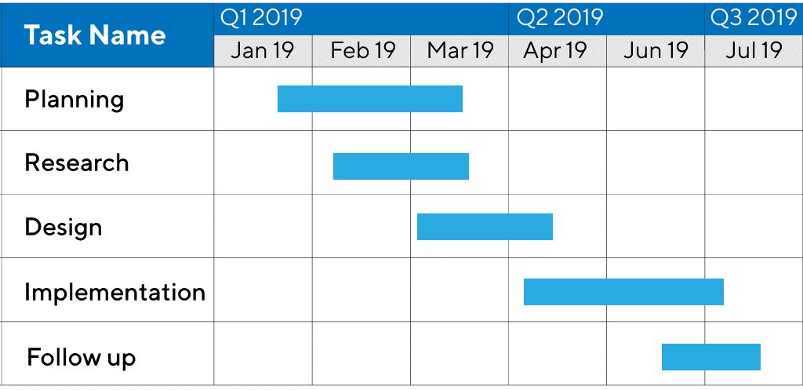Figure 2‑3 – Example of a Simple Gantt Chart

## PERT Charts

An alternative project management tool is a PERT (Program Evaluation Review Technique) chart (Figure 2-4) which unlike the Gantt chart can be used to estimate the earliest and latest time each task could start and end. This tool can be used to show the critical path, which is the sequence of tasks in which a delay in any of the tasks will extend the overall project completion time. PERT charts allows the development team to calculate float, which is the amount of time that a task can be delayed without impacting the timescale of subsequent tasks and the overall time for completion of the project. The total float can be calculated by the difference between the earliest start time and the latest start time or the earliest finish time and the latest finish time.

### Advantages of PERT Charts

* Easy to see the direction and flow of the project.
* Can be used to identify any tasks that could cause a delay.
* Can determine if resources are being used efficiently.
* PERT charts are more comprehensive than Gantt charts.
* Critical path is obvious.
* They show dependencies between tasks.

### Disadvantages of PERT Charts

* Are complex and require an understanding to utilise them.
* Only appropriate for small to medium projects.
* Despite being more intricate than Gantt charts, they can still lack detail at each task.
* Are time consuming to create.
* Require extensive information about the project.

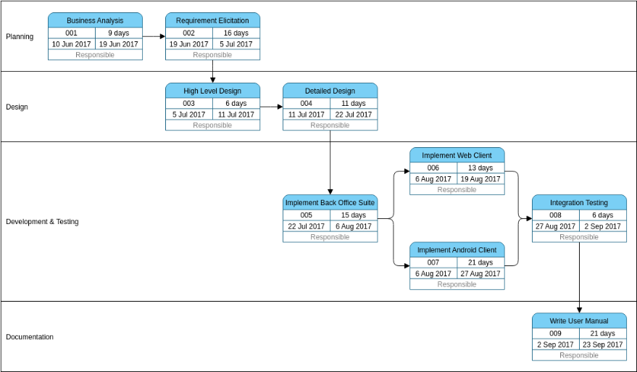Figure 2‑4 – Example of a PERT Chart

## Project Management Conclusion

The decision was made to use a Gantt chart in this project as it was well suited to the project scope and would facilitate straightforward project tracking. PERT charts require extensive amounts of information about the project and can be time-consuming to produce. They can be exceptionally comprehensive, but this project does not require such a comprehensive tool. It was concluded that the resources would be better allocated to the implementation of the solution and documentation.

The Gantt chart for this project was created using Microsoft Excel and is shown in Figure 2-5.

Figure 2‑5 – Gantt Chart

Figure 2-5 – Gantt Chart

# Design Methodologies

## Waterfall Methodology

In the waterfall model (Figure 3-1), each phase in the life cycle follows a sequence. The phases do not overlap, and no phase can begin until the previous one has been completed. The project is completed from top to bottom, like a waterfall. The phases include requirements, design, implementation, testing and maintenance.

### Advantages of the Waterfall Model

* It offers simplicity, the event sequence is easy to understand and may be a better option for an inexperienced development team as the responsibilities at each stage are clearly outlined.
* It is inflexible which means that it is much easier to suggest values for the time and cost of the project.
* It has an emphasis on documentation, which provides the developers with a clear and concise explanation of each element of the solution that can be beneficial in developer collaboration and helps to ensure compliance with industry standards and regulations.
* Allows for comprehensive project planning and the clearly defined milestones promote discipline and organisation in the development of the project.

### Disadvantages of the Waterfall Model

* It is not appropriate for projects where the user requirements are at risk of changing or are not defined in detail.
* It is not suitable for highly complex systems due to its inflexibility.
* The functional software is delivered late in the development process which could be problematic if the customer is not satisfied with the solution.
* All testing and integration are done late in the development process. Therefore, if any problems are found it is complicated and expensive to go back and resolve the problem in the solution.
* There is minimal customer interaction which means if there was a miscommunication in the requirements phase, it would most likely not be highlighted until towards the end of the development, when the system has been designed and programmed.
* The exhaustive documentation is time and resource intensive to create.

### Stages of the Waterfall Model

1. Requirements – The user defines the requirements of the system and expresses any ideas or preferences they may have for the solution. The developers use these requirements to define the scope of the project.
2. Design – The development team create a detailed document to plan the system to be created, considering elements such as the user interface and software architecture.
3. Implementation – This phase involves programming the solution based on the plan and the requirements specified by the user.
4. Verification or Testing – This phase incorporates user acceptance testing, where it is verified that the system meets the user requirements. It also tests the units of code that have been written in the implementation phase to ensure they have the correct functionality and will not be problematic.
5. Deployment and Maintenance – This phase involves delivering the product to the customer and ensuring that it is properly installed and functioning correctly. The maintenance component of this phase refers to the support provided by the development team after the system has been installed and is being used by the customer, such as fixing bugs that the users find.

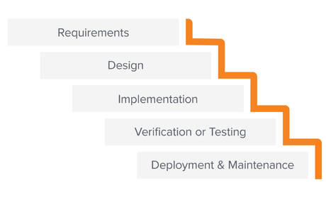Figure 3‑1 – The Waterfall Model

## Rapid Application Development

Rapid Application Development (RAD) is an agile methodology which prioritises prototyping and user feedback over excessive documentation and planning (Figure 3-2). A series of operational prototypes are presented to the user where they suggest further enhancements or modifications and the prototype is reworked. This process allows the prototypes to evolve into the finished solution. Each agile methodology has its own individual characteristics although they all use the same phases found in the waterfall model, except they are performed in an iterative and incremental manner.

Incremental refers to the division of the solution into subsections called increments, which are developed in short development lifecycles. This allows customers and developers to use certain components of the system and suggest improvements before a fully functional solution is built. Iterative means that with these prototypes will be refined in repetitive cycles until the user and developers are satisfied with that increment of the system. These increments can be developed in parallel and will eventually come together to form the solution.

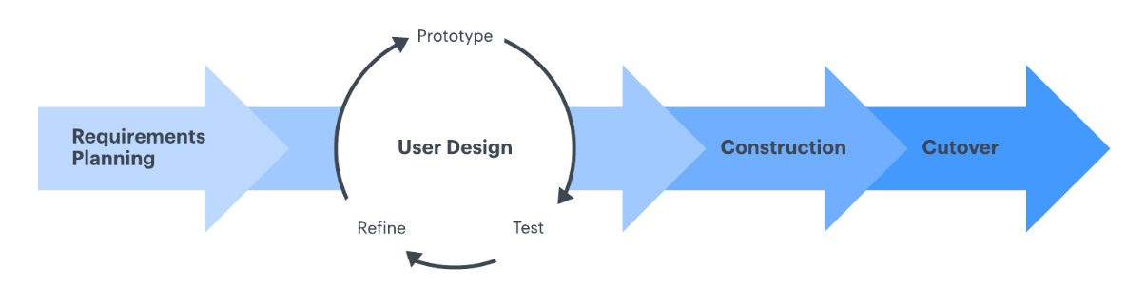Figure 3‑2 – RAD Model

### Advantages of RAD

* Has a reduced development time, the acceleration of the development process is permitted by a range of tools such as code generators and pre-built modules to reduce the time taken on manual programming along with the minimal planning required before the project.
* The cyclical nature of the development can facilitate changing user requirements, making it more adaptable and hence suitable for longer or more intricate projects.
* It is a flexible methodology and is ideal for users who are unsure about the characteristics they need the solution to have. By using prototypes, they may find it easier to express their requirements for the system.
* Its incremental development reduces the risk of project failure by breaking down the system into small manageable tasks.
* Produces a system with excellent usability due to the frequent user feedback.

### Disadvantages of RAD

* It requires more frequent engagement from the end user which is not always viable as people may not have time for that commitment.
* It demands an experienced team capable of effective collaboration for successful implementation as there is a high dependency on every member of the team.
* RAD can be resource intensive.
* It can prove difficult to estimate cost, time and manage resources due to its flexibility which could threaten the success of the project.
* The code generation used in RAD is expensive and can only be used if the budget permits.
* The minimal documentation could be problematic if there are inadequate resources for reference during the maintenance phase of the lifecycle.

## Scrum

The key characteristic of scrum are sprints, a time boxed iteration where the team complete a pre-agreed task or amount of work (Figure 3-3). Scrum takes an evidence-based empirical approach, this means it relies on actual experience and observation rather than theory or pure logic. Uncertainty and change are expected in Scrum and the team focus on accelerated development and their ability to react to new user requirements prompted by technological advancements or changing business needs of the customer. It accepts that the project is susceptible to requirement volatility which cannot be addressed by a more rigid methodology.

Sprint planning meetings happen at the start of each sprint to determine the work to be completed. Daily scrum meetings occur every day during a sprint where the team members share what they worked on the previous day to synchronise the work across the team. A sprint review is completed at the end of each sprint where the added functionality is demonstrated, and the product owner will provide feedback. A sprint retrospective is also conducted where the team reflects on the sprint and identify areas for improvement in any future sprints.

The product backlog is a scrum artifact containing functionalities that remain to be added to the system, this is ordered by priority by the end user, so the team always prioritises the most desired features. The sprint backlog is a prioritised list of tasks to be completed during the sprint. Burndown charts show the remaining amount of work to be completed in the sprint and shows briefly whether the sprint is on schedule. The main roles of the team are:

* The product owner who represents the customers and communicates their aims for the project to the development team. They are responsible for the ordering of the project backlog.
* The scrum master who removes impediments or issues to ensure the sprint can progress.
* The team which consists of 5-9 members who are responsible for the development of the project.

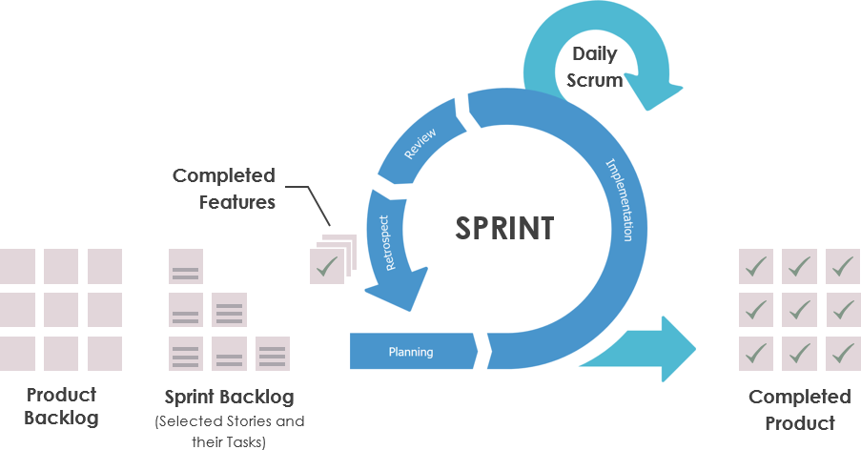Figure 3‑3 – Scrum Sprint Model

### Advantages of Scrum

* It offers similar advantages to most agile methodologies with obvious progress, suitable for vague or undefined user requirements and minimal documentation and planning.
* The regular meetings and collaborative nature of a scrum project encourages better employee morale, hence higher quality work.
* The clearly defined roles in a scrum team help ensure accountability and efficiency.
* The scrum artifacts are all ordered by priority which increases the chance that the project is delivered within budget and the given time frame.
* The range of different meetings provide structure and facilitate progress with the project.

### Disadvantages of Scrum

* Substantial resources are required for daily scrum meetings and frequent reviews.
* Like other agile methodologies, it requires significant commitment from the user and can be difficult to plan, cost and estimate the time needed to complete the project as it lacks structure at the beginning.
* It has an intense lifecycle with frequent sprints during the development which can be demanding on team members.
* It can be challenging to implement on a large scale and is vulnerable to scope creep, which could potentially cause the project to being completed over budget or late.
* Every member of the team needs to be cooperative, committed, and experienced.

## Design Methodology Conclusion

The methodology to be used in this project is the waterfall methodology. This project requires extensive documentation and planning which is facilitated by this model. The user requirements can be well defined during the planning phase and are not susceptible to change. It provides ease in project management and allows for tools such as Gantt charts to be made in a short period of time. These will help to drive the project forward and ensure the timeframe of the project has been appropriately specified. This project has a strict deadline, and this model will ensure the project has been completed to a high standard in this duration.

The agile methodology used in RAD and Scrum are not appropriate for this project as they require frequent input from the users which is unnecessary in this situation, as the user requirements and expectations have been clearly defined beforehand. Also, the experience required by the developers in agile methods is extensive and often require expensive automated code generating tools, which are not available for this project. Finally, agile methods, particularly Scrum, typically require a group of developer, and as this project is being complete by a single developer they are not suitable.

# User Requirements

## Functional Requirements

| *User Requirement* | *Description* |
| --- | --- |
| F-UR1 | Must be able to add a booking |
| F-UR2 | Must be able to view a booking |
| F-UR3 | Must be able to add a guest |
| F-UR4 | Must be able to view a guest |
| F-UR5 | Must be able to delete a booking |
| F-UR6 | Must be able to edit a guest |
| F-UR7 | Must be able to edit a booking |
| F-UR8 | Must not take bookings between the 20th of December and 20th of January |
| F-UR9 | Must check if guest has booked 6 months before their stay and record a 3% discount if true |
| F-UR10 | Must check if guest has stayed before and record a 2% discount if true |
| F-UR11 | Must check if course dates are within pod booking dates if the guest is attending a course |
| F-UR12 | Must not allow pods to be double booked |
| F-UR13 | Must store the cost per person per night for each pod type |
| F-UR14 | Must be able to view a pod’s details |
| F-UR15 | Must be able to add a pod of type “Standard” or “Luxury” |
| F-UR16 | Must delete the booking if the deposit is not made within three days |
| F-UR17 | Must not take bookings for dates closer than two months |
| F-UR18 | Must be able to edit the description of a pod type |
| F-UR19 | Must be able to delete a pod |
| F-UR20 | Must be able to search for guest by their details |
| F-UR21 | Must provide a report to show the number of bookings made per month |
| F-UR22 | Must provide a report to show the most popular pods |
| F-UR23 | Must provide a report to show the most frequent guests |
| F-UR24 | Must provide a report to show the guest details of each guest on each course |

## Non-Functional Requirements

| *User Requirement* | *Description* |
| --- | --- |
| NF-UR1 | Each employee should have an account with different privileges for different responsibilities within the business |
| NF-UR2 | The user interface should be simple and visually appealing |
| NF-UR3 | Should email customers with booking confirmation emails |
| NF-UR4 | Should provide clear error messages when problems occur |
| NF-UR5 | Should have a comprehensive user manual |
| NF-UR6 | Should be able to view course details |

# Design

## Range of Possible Solutions

### Web Based Application with a Cloud Hosted Database

In this solution, the user interface runs in a web browser while the database is stored and managed on a cloud platform. The browser accesses the application across the internet from a web server and the database is stored on a remote server which is managed by the cloud provider. The front-end of the application must be programmed in languages that can be compiled and executed by the browser such as HTML, CSS, and JavaScript. There are several options for the server-side programming language, including Python, Java, C# and PHP, and many frameworks to support server-side development. There are multiple choices available for cloud hosted databases, for example, Oracle Database and MySQL, the majority of which provide exceptional dependability and can be accessed from anywhere assuming internet access.

*Advantages*

* The greatest asset of this solution is its multi-user capabilities, it allows multiple users to access it simultaneously, with the only limit being the number of connections that the hosting web server permits.
* This has the potential to be more cost effective as it eliminates the requirement of hardware to host the database within the customer’s property.
* It offers impressive scalability.
* All established cloud providers have robust security measures and backup systems, minimising the risk of data being compromised or lost.
* Cloud providers ensure their infrastructure utilises up to date technologies.
* Websites could be considered to be a more modern approach to a solution.

*Disadvantages*

* The dependence on internet connectivity could be problematic if unforeseen circumstances lead the business to have unstable or no internet connection. The application is completely non-functional without access to the internet.
* If data transfers are high in volume, Lakeside Escapes may find themselves facing costs that exceed their initial expectations.
* As all data is transferred across the internet, it may be vulnerable to cyber-attack while in transit.
* The knowledge required of networks and different programming languages is extensive in full-stack development and the project’s development may be more time-consuming and expensive than other solutions.
* Websites are generally slower than desktop applications.
* It involves expenses for web hosting and cloud-based database services.

### Mobile Application developed in Swift with a Cloud Hosted Database

Like the web-based solution, with this option the database would be hosted on a remote server and managed by the cloud providers, but the application would be developed for and run on an iOS device such as an iPad.

*Advantages*

* Provides convenience as an iPad is mobile and not restricted to one location (providing internet access is available) which will be helpful as Lakeside Escapes is not confined to a single venue within the estate.
* It offers a straightforward way to deliver notifications.
* Is exceptionally user-friendly.
* iPads are becoming more common in businesses.

*Disadvantages*

* They can be challenging to create, and the cost of development is high.
* Swift is only suitable for devices with an iOS operating system.
* The application would require installation on mobile devices.
* Internet connectivity would be required to access the database.
* Swift is a relatively new language, and the documentation and support is not as extensive as other languages.
* Swift is not compatible with a large number of IDEs.

This solution offers the same benefits and problems as previously discussed regarding cloud-based databases.

While mobile applications can have lightweight local databases such as SQLite, they do not offer the same scalability as a cloud hosted or a database being hosted locally on a computer.

### Windows Desktop Application (C#) with a Locally Hosted SQL Database

This solution hosts the database locally and the application would be installed on a computer in Lakeside Escapes. This would be developed in C# using Microsoft Visual Studio 2022 as an IDE.

*Advantages*

* Microsoft Visual Studio offers impressive support for C# based desktop applications and boasts a range of frameworks for development of both the application and the SQL database.
* The database being stored locally eliminates many data-security concerns.
* A local database simplifies the connection process and is likely to be faster than a cloud-based database service.
* It will be more reliable as there is no dependence on internet connectivity.
* C# is an established language with impressive support and resources.
* Eliminates the cost of a cloud-based database provider and web hosting services.

*Disadvantages*

* The application is limited by the hardware available to the business and must be manually updated.
* This solution does not allow multiple users to simultaneously use the software which could be problematic for larger businesses.
* It is limited to a Windows computer.
* It relies on users maintaining backups and managing in-house security.
* Migrating data from a local database to a cloud-based database can be complex if the business decides to adjust the solution in the future.

### Review of Possible Solutions

The most suitable solution for this project is a windows desktop application with an SQL database hosted locally using C# developed using the Windows Forms framework. The developer of this project has used Windows Forms and Visual Studio previously and as a well-established language C# has comprehensive documentation and support. The small team at Lakeside Escapes means the software will not need to be used simultaneously and Windows is the standard operating system on most PCs. The security benefits of this solution are impressive as the data is never being transmitted across a network. This option was the most cost effective and will be the most financially beneficial to the business of all the possible solutions, as the database is hosted locally. There is no ongoing cost for cloud services and the development will be less expensive than web based or mobile development. The local database will offer minimal latency, fast access speeds and will be optimal during development and testing. This is the solution which will allow the most functionality to be implemented in the given time period as its ‘drag and drop’ functionality will allow for accelerated development of the graphical user interface.

## Entity Relationship Diagram

An Entity Relationship Diagram (ERD) visualises the relationships between entities in a database. An ERD will also often visualise the attributes of these entities.

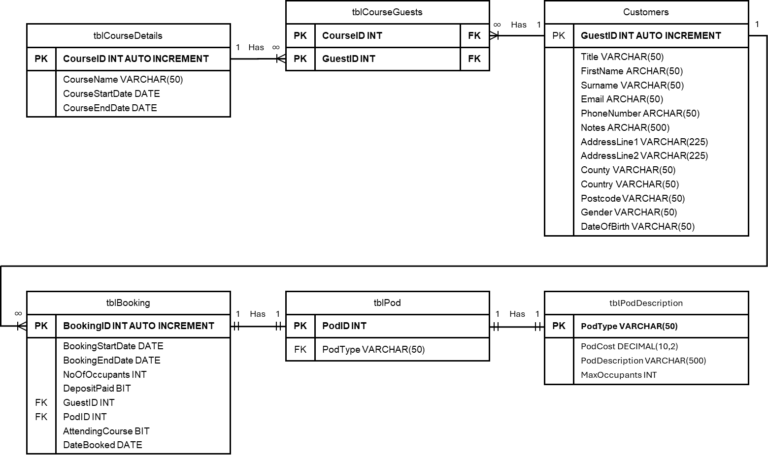Figure 5‑1 – ERD of Database

The ERD for this project (Figure 5-1) illustrates the relationships between the tables in PodBookingDB.mdf.

* Each guest has many courses
* Each course has many guests
* Each guest has many bookings
* Each booking has one pod
* Each pod has one pod description

## Normalisation

Normalisation is the process of organising data in a database. It includes creating tables and establishing relationships between those tables according to a set of rules referred to as normal forms. Database normalisation increases data integrity which means when updating, only one occurrence of data needs changing, it also increases data consistency as a column (provided it is not a foreign key) will only be present in one table so there is no risk of the same field being stored in another table in a different format. It also improves the search and access speed and allows for more complex queries as the database contains less data. It avoids data redundancy and is much more efficient as the data only must be input once.

This solutions database normalisation is completed below. The primary keys are identified with bold text and foreign keys are underlined.

### Unnormalised Form

The unnormalised form lists the fields together. It is also common practise to record all repeating fields in brackets.

GuestID, FirstName, Surname, Email, PhoneNumber, Notes, AddressLine1, AddressLine2, Country, County, Postcode, Title, Gender, Notes, DateOfBirth, (BookingID, BookingStartDate, BookingEndDate, NoOfOccupants, DepositPaid, AttendingCourse, DateBooked, PodID, PodType, PodCostPerPersonPerNight, PodDescription, MaxOccupants, Discount), (CourseID, CourseName, CourseStartDate, CourseEndDate, CourseCost)

### First Normal Form

‘A relation is in first normal form if and only if each attribute contains only atomic values, and the value of each attribute contains only a single value.’

All the data should be atomised, all repeating attributes should be moved to a different table and each record should be identified with a unique field or set of fields (the primary key).

Each guest can have many courses and each guest can have many bookings.

#### tblGuest

**GuestID**, FirstName, Surname, Email, PhoneNumber, Notes, AddressLine1, AddressLine2, Country, County, Postcode, Title, Gender, Notes, DateOfBirth

#### tblBooking

GuestID, **BookingID**, BookingStartDate, BookingEndDate, NoOfOccupants, DepositPaid, PodID, PodType, PodCostPerPersonPerNight, PodDescription, MaxOccupants, AttendingCourse, DateBooked, Discount

#### tblCourseGuests

**GuestID, CourseID**, CourseName, CourseStartDate, CourseEndDate, CourseCost

### Second Normal Form

‘A relation is in second normal form if it is in first normal form and every non-key attribute of the relation is dependent on the whole of the candidate key.’

All fields should be dependent on the entire composite key.

#### tblGuest

**GuestID**, FirstName, Surname, Email, PhoneNumber, Notes, AddressLine1, AddressLine2, Country, County, Postcode, Title, Gender, DateOfBirth

#### tblBooking

GuestID, **BookingID**, BookingStartDate, BookingEndDate, NoOfOccupants, DepositPaid, PodID, PodType, PodCostPerPersonPerNight, PodDescription, MaxOccupants, AttendingCourse, DateBooked, Discount

#### tblCourseGuests

**GuestID, CourseID**

#### tblCourseDetails

**CourseID**, CourseName, CourseStartDate, CourseEndDate, CourseCost

The CourseName, CourseCost, CourseStartDate and CourseEndDate are only dependent on the CourseID not the GuestID, so they are moved into a new table.

### Third Normal Form

‘A relation is in third normal form if a database if it is in second normal form and there are no transitive functional dependencies.’

All the fields in the tables should be completely dependent on the primary key.

#### tblGuest

**GuestID**, FirstName, Surname, Email, PhoneNumber, Notes, AddressLine1, AddressLine2, Country, County, Postcode, Title, Gender, DateOfBirth

#### tblBooking

GuestID, **BookingID**, BookingStartDate, BookingEndDate, NoOfOccupants, DepositPaid, PodID, AttendingCourse, DateBooked, Discount

#### tblCourseGuests

**GuestID, CourseID**

#### tblCourseDetails

**CourseID**, CourseName, CourseStartDate, CourseEndDate, CourseCost

#### tblPod

**PodID,** PodType

#### tblPodDescription

**PodType**, PodCostPerPersonPerNight, PodDescription, MaxOccupants

## Data Dictionaries

Database Name: PodBookingDB.mdf

|  |  |  |  |  |  |  |
| --- | --- | --- | --- | --- | --- | --- |
| **Table Name:**  tblBooking | | **Primary Key:**  BookingID | | **Foreign Key:**  GuestID, PodID | | |
| **Table Description:** Records all data related to the bookings | | | | | | |
| *Field Name* | *P-Key*  */F- Key* | *Data Type* | *Length* | *Default Value* | *Description* | *Typical Data* |
| BookingID | P-Key | INT Identity(1,1) | >0 | 1 | A number that uniquely identifies a booking | 1 |
| BookingStartDate | - | DATE | 10 | 0000/00/00 | The date the booking begins | 2024/03/10 |
| BookingEndDate | - | DATE | 10 | 0000/00/00 | The date the booking ends | 2024/03/17 |
| NoOfOccupants | - | INT | >0 | 0 | The number of people that are staying in the pod | 3 |
| DepositPaid | - | VARCHAR(50) | >0 | Null | If the deposit of the booking has been paid | True |
| GuestID | F-Key | INT | >0 | 1 | A number that uniquely identifies a customer | 1 |
| PodID | F-Key | INT | >0 | 1 | A number which uniquely identifies a pod | 1 |
| AttendingCourse | - | VARCHAR(50) | >0 | Null | If the guest is attending a course | True |
| DateBooked | - | DATE | 10 | 0000/00/00 | The date the pod booking was made | 20/10/2023 |
| Discount | - | DECIMAL(10,2) | (10,2) | 0 | The discount on the booking | 5.00 |

|  |  |  |  |  |  |  |
| --- | --- | --- | --- | --- | --- | --- |
| **Table Name**:  tblGuest | | **Primary Key:**  GuestID | | **Foreign Key:**  N/A | | |
| **Table Description:** Table containing all data related to the guests | | | | | | | |
| Field Name | P-Key  /F- Key | Data Type | Length | Default Value | Description | Typical Value |
| GuestID | P-Key | INT Identity(1,1) | 0> | 1 | A number that uniquely identifies a guest | 1 |
| Title | - | VARCHAR(50) | >0 | Null | Title of guest | Mr |
| FirstName | - | VARCHAR(50) | >0 | Null | First name of guest | Samual |
| Surname | - | VARCHAR(50) | >0 | Null | Surname of guest | Smith |
| Email | - | VARCHAR(50) | >0 | Null | Email of guest | samuelsmith@gmail.com |
| PhoneNumber | - | VARCHAR(50) | >0 | Null | Phone number of guest | 07775123456 |
| Notes | - | VARCHAR(500) | >0 | Null | Any additional notes for guest | Dairy Allergy |
| AddressLine1 | - | VARCHAR(225) | >0 | Null | First Line of guest’s address | 1 Main Road |
| AddressLine2 | - | VARCHAR(225) | >0 | Null | Second Line of guest’s address | Lisburn |
| County | - | VARCHAR(50) | >0 | Null | County of guest’s Address | Antrim |
| Country | - | VARCHAR(50) | >0 | Null | Country of guest’s address | Northern Ireland |
| Postcode | - | VARCHAR(50) | >0 | Null | Postcode of guest’s address | BT27 5TF |
| Gender | - | VARCHAR(50) | >0 | Null | Guest’s gender | Male |
| DateOfBirth | - | DATE | 10 | 0000/00/00 | Guest’s date of birth | 07/02/2000 |

|  |  |  |  |  |  |  |
| --- | --- | --- | --- | --- | --- | --- |
| **Table Name:**  tblPod | | **Primary Key:**  PodID | | **Foreign Key:**  PodType | | |
| **Table Description:** Records the type of each pod | | | | | | |
| *Field Name* | *P-Key*  */F- Key* | *Data Type* | *Length* | *Default Value* | *Description* | *Typical Value* |
| PodID | P-Key | INT Identity(1,1) | >0 | 1 | A number which uniquely identifies a pod | 1 |
| PodType | F-Key | VARCHAR(50) | >0 | Null | Describes whether pod is ‘Luxury’ or ‘Standard’ | Luxury |

|  |  |  |  |  |  |  |
| --- | --- | --- | --- | --- | --- | --- |
| **Table Name:**  tblPodDescription | | **Primary Key:**  PodType | | **Foreign Key:**  N/A | | |
| **Table Description:** Records the description of each pod type | | | | | | |
| Field Name | P-Key  /F- Key | Data Type | Length | Default Value | Description | Typical Value |
| PodType | F-Key | VARCHAR(50) | >0 | Null | Describes whether pod is ‘Luxury’ or ‘Standard’ | Luxury |
| PodCostPerPersonPerNight | - | DECIMAL(10,2) | (10,2) | 0 | Cost per person per night of that pod type | 50 |
| PodDescription | - | VARCHAR(500) | >0 | Null | Facilities provided | Oven and toaster |
| MaxOccupants | - | INT | 1 | 0 | How many guests the pod can sleep | 6 |

|  |  |  |  |  |  |  |  |
| --- | --- | --- | --- | --- | --- | --- | --- |
| **Table Name:**tblCourseDetails | | **Primary Key:**  CourseID | | | **Foreign Key:**  N/A | | |
| **Table Description:** Records all the details for each course | | | | | | | |
| Field Name | P-Key  /F- Key | Data Type | Length | Default Value | | Description | Typical Value |
| CourseID | P-Key | INT | >0 | 1 | | A number which uniquely identifies a course | 1 |
| CourseName | - | VARCHAR(50) | >0 | Null | | Name of the course | Painting |
| CourseStartDate | - | DATE | 10 | 0000/00/00 | | The date the course starts on | 2024/01/01 |
| CourseEndDate | - | DATE | 10 | 0000/00/00 | | The date the course ends on | 2024/01/03 |
| CourseCost | - | DECIMAL(10,2) | (10,2) | 0 | | The cost of the course | 45.50 |

|  |  |  |  |  |  |  |
| --- | --- | --- | --- | --- | --- | --- |
| **Table Name:**tblCourseGuests | | **Primary Key:** CourseID, CourseName | | | **Foreign Key:**  CourseID, GuestID | |
| **Table Description:** Records all the guests on each course | | | | | | |
| *Field Name* | *P-Key*  */F- Key* | *Data Type* | *Length* | *Default Value* | *Description* | *Typical Value* |
| CourseID | P-Key, F-Key | INT | >0 | 1 | A number which uniquely identifies a course | 1 |
| GuestID | P-Key, F-Key | INT | >0 | 1 | A number which uniquely identifies a guest | 1 |

## Unified Modelling Language

Unified Modelling Language (UML) is a standard language first developed in the 1990s which evolved from the object-oriented programming methods in analysis and design in use at this time. UML is used to specify, visualise, construct and document software systems. It provides a pictural method to communicate complex ideas and relationships within a system and can be understood by both software developers and business users. Object oriented concepts such as abstraction, encapsulation, polymorphism, and inheritance can all be represented using UML diagrams.

Actors is a phrase which is used to represent external entities that interact with the system, such as users or other systems.

### Use Case Diagram

A use case is a description of how a user interacts with a system and helps develop an understanding of the interactions between actors and a system. They highlight how the user performs tasks within the system. They also help the development team to recognise system demands early in the development process and their simplicity can guide decision making and help in defining the project scope.

A Use Case Diagram is a type of UML diagram that visually represents the interactions between different actors and a system. This diagram helps to understand a system’s functional requirements as it focuses on what the system’s expected behaviour is, rather than how it accomplishes these tasks. It is used to gather the system requirements and visually illustrate interactions with actors. A Use-Case diagram should identify the functionalities of the system, the actors and the relationships between use cases and actors. These diagrams cover requirement analysis and high-level design.

In this project, a Lakeside Escapes employee must be able to:

* Add a guest
* View a guest
* Edit a guest
* Add a booking
* View a booking
* Edit a booking
* Delete a booking
* View a pod
* View details of a pod type
* Add a pod of the type “Standard” or “Luxury”
* Edit details of a pod type
* Delete a pod
* Edit the type of a pod
* Generate different reports

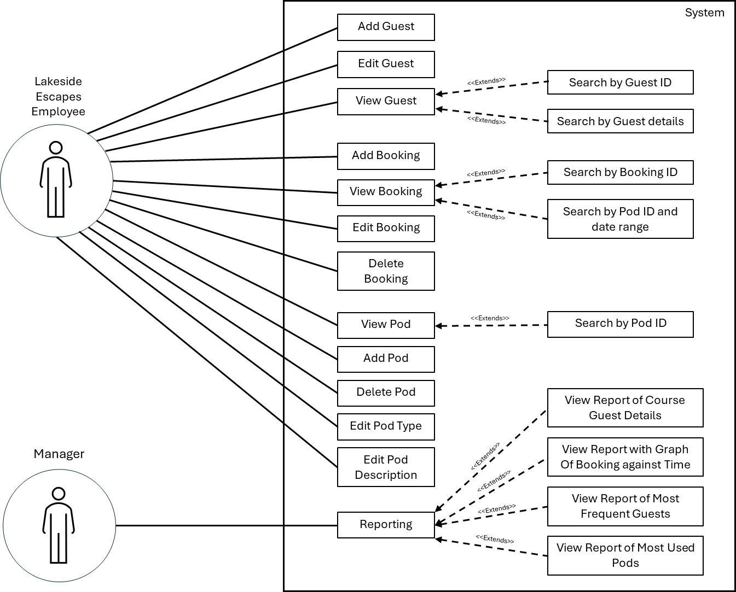Figure 5‑2 – Use Case Diagram

### Class Diagrams

Class diagrams describe the static view and structure of a system by showing the classes, attributes, methods, and relationships between objects. Each class in the diagram must have a class name, attributes, methods, and visibility symbols. This diagram are frequently used in projects that utilise object-oriented programming. Class diagrams provide an overview of the system which helps developers understand the systems architecture in a short space of time, this increases the efficiency in programming the system. Similar to the Use-Case diagrams they simplify the complexity of the system.

In this project, the Model-View-Controller framework was used to maximum modularity in the system and promote the organisation during the implementation. In this architecture the Model represents the internal data stored in the database and is completely isolated from the user interface. The View displays data from the model and presents the information to users. The controller acts as an intermediary between model and view, it receives and sends data between the view and the model. In this system the model is the database PodBookingDB.mdf. The forms are the view components which act as the user interface. The controllers are the Data Access Layer classes, which are all marked with the corresponding table name and ‘DAL’. In this project each table except tblCourseGuests and tblCourseDetails has a Data Access Layer class used to communicate with the database and a class of which objects can be created.

The visibility levels are represented by + for public and - for private.

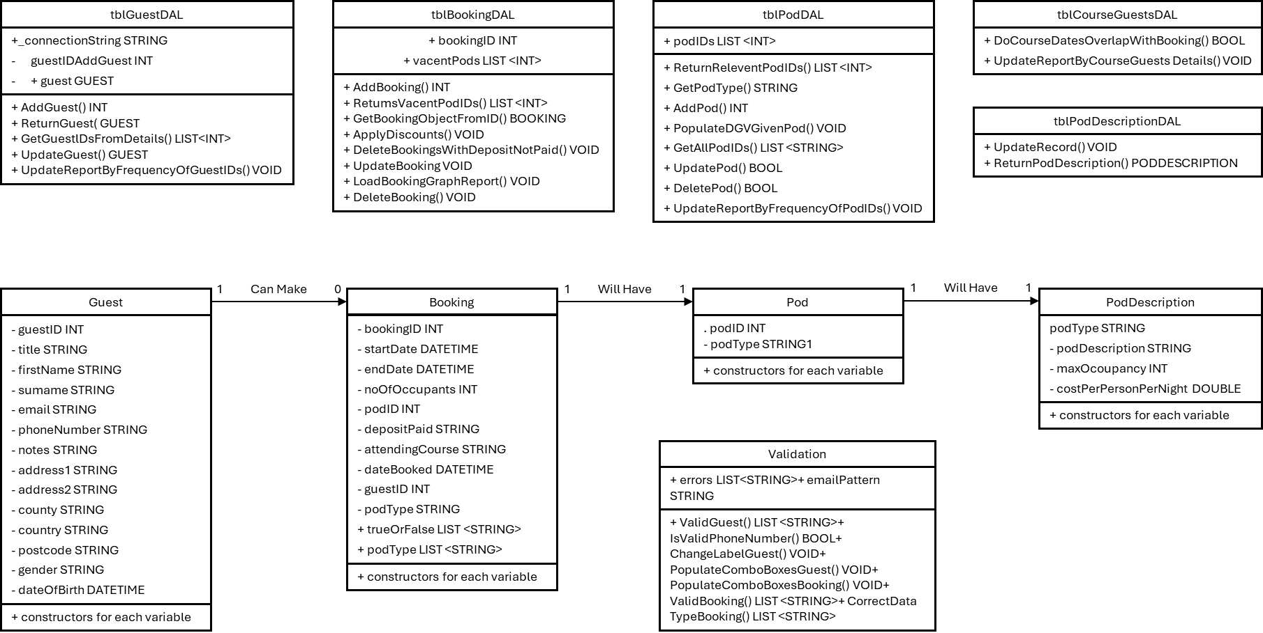Figure 5‑3 – Class Diagram

## Storyboards

Note: Any content fields marked with “-” is not static text and will be populated by the program.

### FormMenu

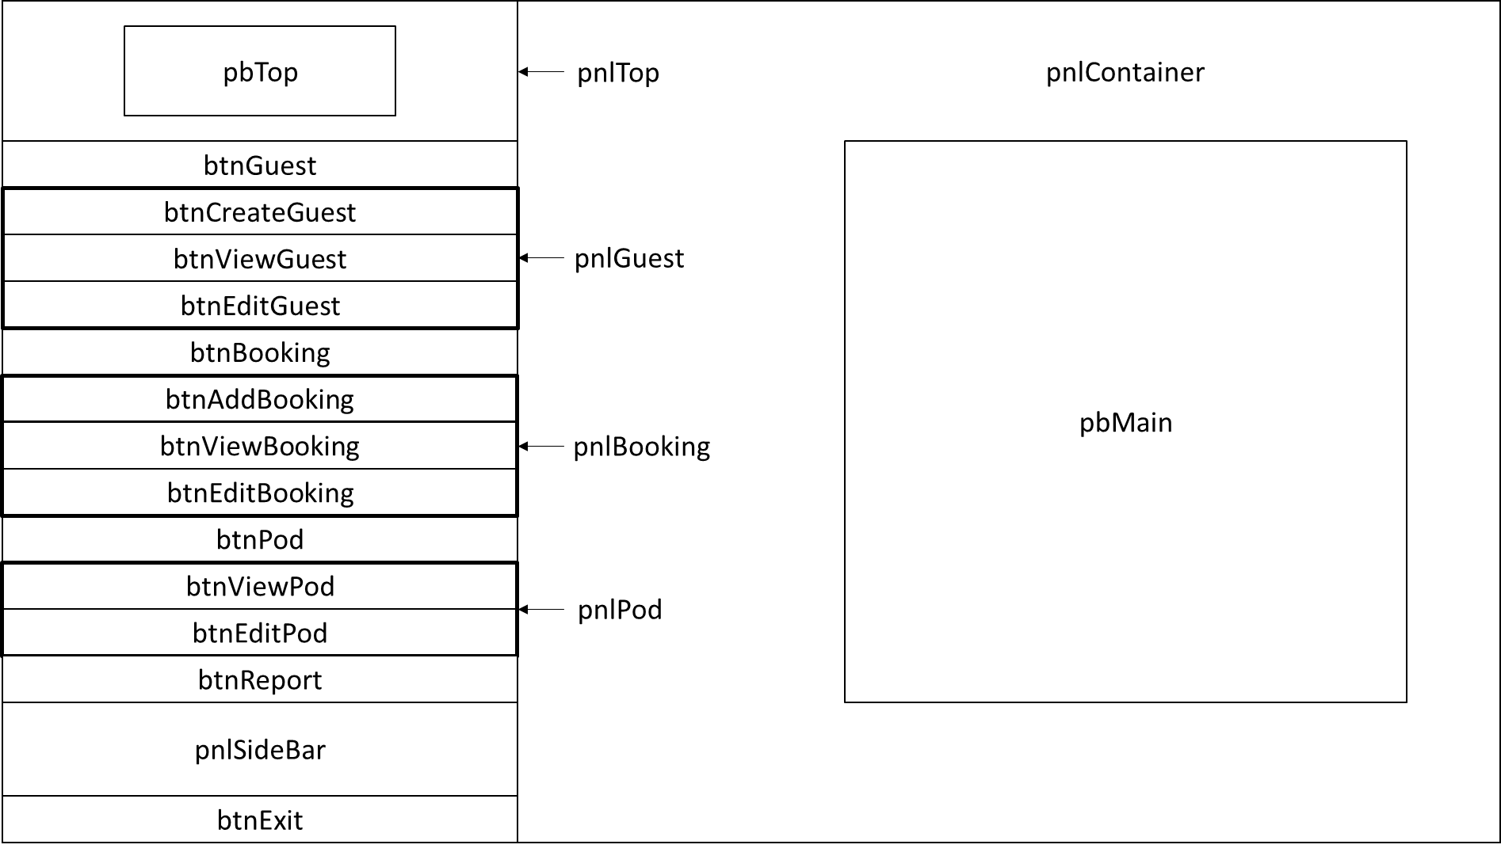Figure 5‑4 – FormMenu Storyboard

Backcolour : RGB(79, 111, 82)

|  |  |  |  |
| --- | --- | --- | --- |
| **Walkthrough** | | | |
| *Control* | *Function* | | |
| btnGuest | Sets visibility of pnlGuest to true | | |
| btnBooking | Sets visibility of pnlBooking to true | | |
| btnPod | Sets visibility of pnlPod to true | | |
| btnCreateGuest | Opens FormCreateGuest in pnlContainer | | |
| btnViewGuest | Opens FormViewGuest in pnlContainer | | |
| btnEditGuest | Opens FormEditGuest in pnlContainer | | |
| btnAddBooking | Opens FormAddBooking in pnlContainer | | |
| btnViewBooking | Opens FormViewBooking in pnlContainer | | |
| btnEditBooking | Opens FormEditBooking in pnlContainer | | |
| btnViewPod | Opens FormViewPod in pnlContainer | | |
| btnEditPod | Opens FormEditPod in pnlContainer | | |
| btnReport | Opens FormReport in pnlContainer | | |
| btnExit | Closes the application | | |
| **Buttons** | | | |
| Font | | Microsoft Tai Le 9pt | |
| Forecolour | | Black | |
| Size | | 400, 75 | |
| ***Name*** | | ***BackColour*** | ***Content*** |
| btnGuest | | LightGrey | “Guest” |
| btnCreateGuest | | WhiteSmoke | “Create Guest” |
| btnViewGuest | | WhiteSmoke | “View Guest” |
| btnEditGuest | | WhiteSmoke | “Edit Guest” |
| btnBooking | | LightGrey | “Booking” |
| btnAddBooking | | WhiteSmoke | “Add Booking” |
| btnViewBooking | | WhiteSmoke | “View Booking” |
| btnEditBooking | | WhiteSmoke | “Edit Booking” |
| btnPod | | LightGrey | “Pods” |
| btnViewPod | | WhiteSmoke | “View Pod” |
| btnEditPod | | WhiteSmoke | “Add or Edit Pod” |
| btnReport | | LightGrey | “Reports” |
| btnExit | | LightGrey | “Exit” |

|  |  |  |
| --- | --- | --- |
| **Panels** | | |
| ***Name*** | ***Size*** | ***BackColour*** |
| pnlTop | 350, 75 | RGB (115, 144, 114) |
| pnlGuest | 1200,75 | RGB (210, 227, 200) |
| pnlBooking | 1200,75 | RGB (210, 227, 200) |
| pnlPod | 800,75 | RGB (210, 227, 200) |
| pnlContainer | 1200, 1000 | RGB (115, 144, 114) |
| pnlSideBar | 400, 75 | RGB (210, 227, 200) |

|  |  |  |
| --- | --- | --- |
| **PictureBoxes** | | |
| ***Name*** | ***Size*** | ***Content*** |
| pbTop | 300, 100 | Lakeside Escapes Logo |
| pbMain | 850, 500 | Lakeside Escapes Logo |

### FormCreateGuest

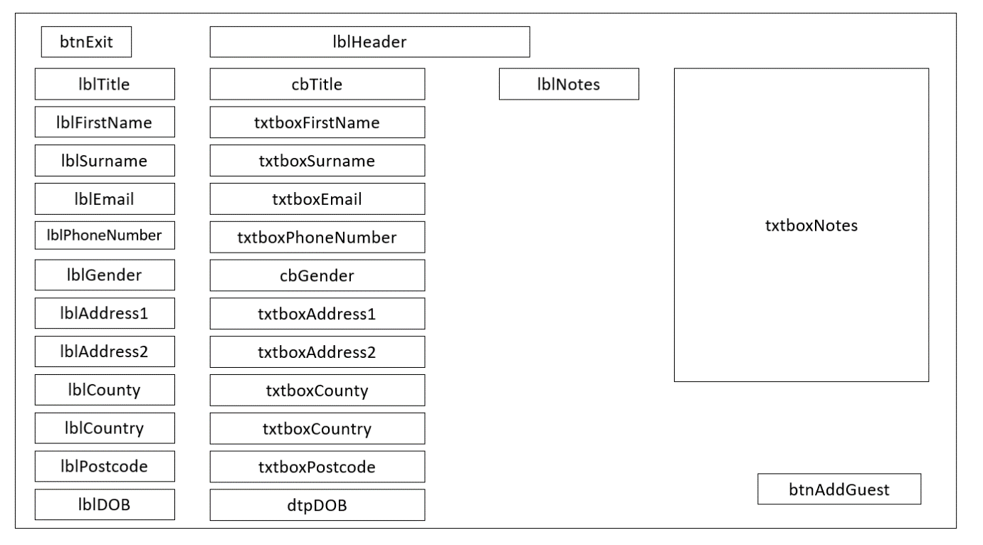Figure 5‑5 – FormCreateGuest Storyboard

Backcolour : RGB(79, 111, 82)

|  |  |
| --- | --- |
| **Walkthrough** | |
| *Control* | *Function* |
| btnAddGuest | Adds guest to database using provided input |
| cbTitle | Select a title, the value must be present in the drop-down list |
| txtboxFirstName | Enter a first name, it must be under 20 characters and contain no numeric characters |
| txtboxSurname | Enter a surname, it must be under 30 characters and contain no numeric characters |
| txtboxEmail | Enter an email, it must be in the format “name@example.com” |
| txtboxPhoneNumber | Enter a phone number, it must be between 10 and 12 digits. |
| cbGender | Select a gender, the value must be present in the drop-down list |
| txtboxAddress1 | Enter the first line of the address, it must be under 40 characters |
| txtboxAddress2 | Enter the second line of the address, it must be under 40 characters |
| txtboxCounty | Enter the county, must be under 25 characters with no digits |
| txtboxCountry | Enter the county, must be under 30 characters with no digits |
| txtboxPostcode | Enter the postcode, should be 7 or 8 characters |
| dtpDOB | Enter the date of birth, the guest must be over 18 |
| txtboxNotes | Enter any related notes, this field does not require a value and can be left empty |
| btnExit | Closes the form |

|  |  |  |
| --- | --- | --- |
| **Buttons** | | |
| Font | Microsoft Tai Le 10pt | |
| BackColour | White | |
| ForeColour | Black | |
| *Name* | *Size* | *Content* |
| btnAddGuest | 280, 75 | “Add Guest” |
| btnExit | 100, 50 | “X” |

|  |  |  |
| --- | --- | --- |
| **Labels** | | |
| BackColour | Transparent | |
| ForeColour | White | |
| ***Name*** | ***Font*** | ***Content*** |
| lblTitle | Microsoft Tai Le 11pt | “Title” |
| lblFirstName | Microsoft Tai Le 11pt | “First Name” |
| lblSurname | Microsoft Tai Le 11pt | “Surname” |
| lblEmail | Microsoft Tai Le 11pt | “Email” |
| lblPhoneNumber | Microsoft Tai Le 11pt | “Phone Number” |
| lblGender | Microsoft Tai Le 11pt | “Gender” |
| lblAddress1 | Microsoft Tai Le 11pt | “Address Line 1” |
| lblAddress2 | Microsoft Tai Le 11pt | “Address Line 2” |
| lblCounty | Microsoft Tai Le 11pt | “County” |
| lblCountry | Microsoft Tai Le 11pt | “Country” |
| lblPostcode | Microsoft Tai Le 11pt | “Postcode” |
| lblDOB | Microsoft Tai Le 11pt | “Date Of Birth” |
| lblNotes | Microsoft Tai Le 11pt | “Notes” |
| lblHeader | Microsoft Tai Le 20pt, Bold | “Create Guest” |

|  |  |
| --- | --- |
| **Textboxes** | |
| Font | Microsoft New Tai Le 11pt |
| BackColour | White |
| ForeColour | Black |
| Name | Size |
| txtboxFirstName | 292, 35 |
| txtboxSurname | 292, 35 |
| txtboxEmail | 292, 35 |
| txtboxPhoneNumber | 292, 35 |
| txtboxGender | 292, 35 |
| txtboxAddress1 | 292, 35 |
| txtboxAddress2 | 292, 35 |
| txtboxCounty | 292, 35 |
| txtboxCountry | 292, 35 |
| txtboxPostcode | 292, 35 |
| txtboxNotes | 350, 360 |

|  |  |
| --- | --- |
| **ComboBoxes** | |
| Font | Microsoft Tai Le 11pt |
| BackColour | White |
| ForeColour | Black |
| Name | Content |
| cbTitle | “Mr”, “Mrs”, “Miss”, ”Ms” |
| cbGender | “Female”, “Male” |

|  |  |  |
| --- | --- | --- |
| **DateTimePicker** | | |
| ***Name*** | ***Font*** | ***ForeColour*** |
| dtpDOB | Microsoft Tai Le 11pt | Black |

### FormViewGuest

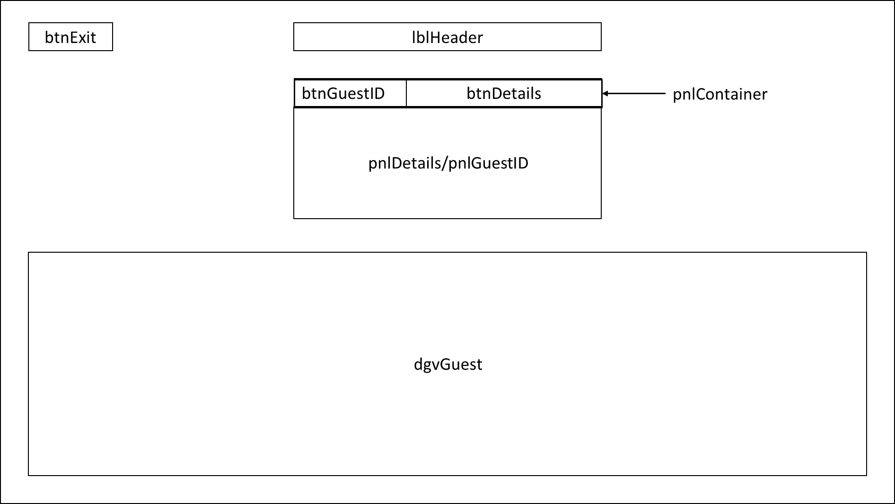Figure 5‑6 – FormViewGuest Storyboard

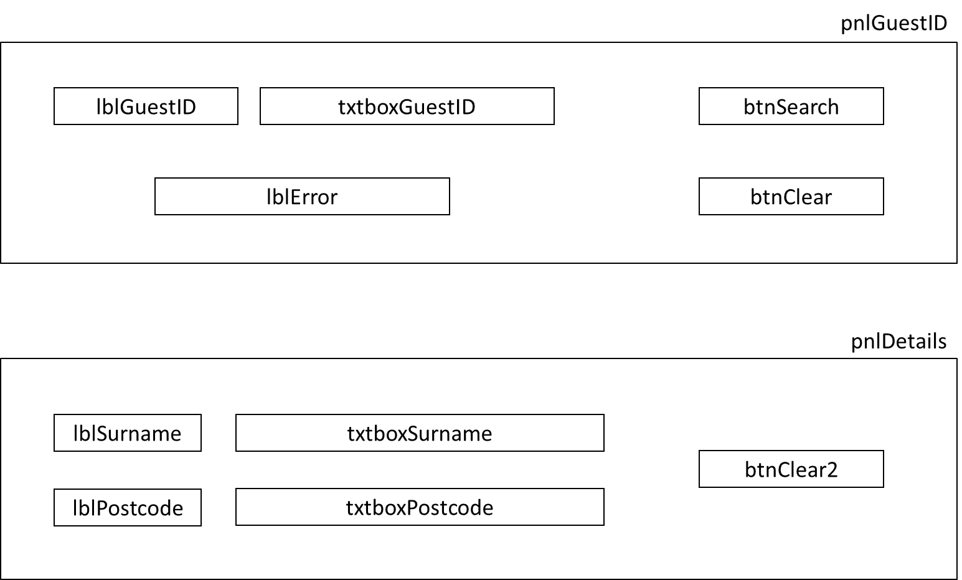Figure 5‑7 – FormViewGuest Panels Storyboard

Backcolour : RGB(79, 111, 82)

|  |  |
| --- | --- |
| **Walkthrough** | |
| *Control* | *Function* |
| btnGuestID | Sets pnlGuestID’s visibility to true and adjusts the size of btnDetails and itself |
| btnDetails | Sets pnlDetails visibility to true and adjusts the size of btnGuestID and itself |
| btnExit | Closes the form |
| txtboxGuestID | Enter a Guest ID to search for |
| btnSearch | The application searches and displays the Guest details if the Guest ID was valid |
| btnClear | Clears txtboxGuestID and any filters on the data grid view |
| txtboxSurname | Enter the surname of the required guest, the data grid view updates when the text is changed |
| txtboxPostcode | Enter the postcode of the required guest, the data grid view updates when the text is changed |
| btnClear2 | Clears txtboxSurname, txtboxPostcode and any filters on the data grid view |
| lblError | Displays the error if an invalid GuestID was input |

|  |  |  |
| --- | --- | --- |
| **Buttons** | | |
| Font | Microsoft Tai Le 10pt | |
| BackColour | White | |
| ForeColour | Black | |
| Name | Size | Contents |
| btnGuestID | 280, 75 | “Guest ID” |
| btnExit | 100, 50 | “X” |
| btnDetails | 250, 75 | “Details” |
| btnSearch | 150, 70 | “Search” |
| btnClear | 150, 70 | “Clear” |
| btnClear2 | 150, 70 | “Clear” |

|  |  |
| --- | --- |
| **Textboxes** | |
| Font | Microsoft Tai Le 10pt |
| BackColour | White |
| ForeColour | Black |
| Name | Size |
| txtboxGuestID | 250, 30 |
| txtboxSurname | 250, 30 |
| txtboxPostcode | 250, 30 |

|  |  |  |  |
| --- | --- | --- | --- |
| **Labels** | | | |
| BackColour | Transparent | | |
| ***Name*** | ***Font*** | ***Forecolour*** | ***Content*** |
| lblHeader | Microsoft Tai Le 20pt, Bold | White | “View Guest” |
| lblGuestID | Microsoft Tai Le 10pt | White | “Guest ID” |
| lblSurname | Microsoft Tai Le 10pt | White | “Surname” |
| lblPostcode | Microsoft Tai Le 10pt | White | “Postcode” |
| lblError | Microsoft Tai Le 10pt | Red | “This is an invalid Guest ID” |

|  |  |
| --- | --- |
| **DataGridView** | |
| Name | Size |
| dgvGuest | 1200, 390 |

|  |  |
| --- | --- |
| **Panels** | |
| BackColour | WhiteSmoke |
| Name | Size |
| pnlGuestID | 730, 230 |
| pnlDetails | 730, 230 |
| pnlContainer | 732, 78 |

### FormEditGuest

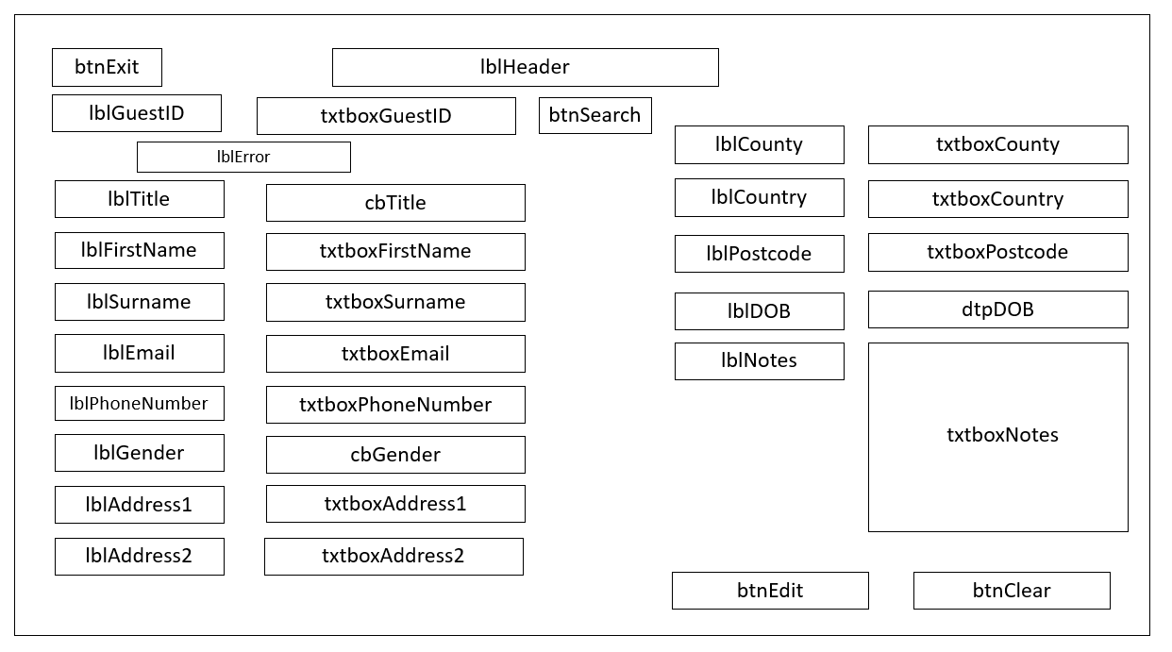Figure 5‑8 – FormEditGuest Storyboard

Backcolour : RGB(79, 111, 82)

|  |  |  |
| --- | --- | --- |
| **Walkthrough** | | |
| *Notes* | All input must meet the same criteria as when a guest is added to the database | |
| *Control* | | *Function* |
| txtboxGuestID | | Enter the required guest’s Guest ID |
| lblError | | Displays the error if input is invalid |
| btnSearch | | If the Guest ID is valid, it will populate the form with the corresponding guest details |
| btnExit | | Closes the form |
| txtboxFirstName | | Displays the guest’s first name and can be edited |
| txtboxSurname | | Displays the guest’s surname and can be edited |
| txtboxEmail | | Displays the guest’s email and can be edited |
| txtboxPhoneNumber | | Displays the guest’s phone number and can be edited |
| cbGender | | Displays the guest’s gender and can be edited |
| txtboxAddress1 | | Displays the first line of the guest’s address and can be edited |
| txtboxAddress2 | | Displays the first line of the guest’s address and can be edited |
| txtboxCounty | | Displays the guest’s county and can be edited |
| txtboxCountry | | Displays the guest’s country and can be edited |
| txtboxPostcode | | Displays the guest’s postcode and can be edited |
| dtpDOB | | Displays the guest’s date of birth and can be edited |
| txtboxNotes | | Displays any notes the guest has and can be edited |
| btnEdit | | This updates the database with the changes to the guest’s details |
| btnClear | | Clears txtboxGuestID and sets the form back to its initial state with the visibility of all the controls set to false |

|  |  |  |
| --- | --- | --- |
| **Buttons** | | |
| Font | Microsoft Tai Le, 10pt | |
| BackColour | White | |
| ForeColour | Black | |
| ***Name*** | ***Size*** | ***Content*** |
| btnExit | 100, 50 | “X” |
| btnSearch | 120, 50 | “Search” |
| btnEdit | 170, 60 | “Edit” |
| btnClear | 170, 60 | “Clear” |

|  |  |  |
| --- | --- | --- |
| **Labels** | | |
| BackColour | Transparent | |
| ForeColour | White | |
| ***Name*** | ***Font*** | ***Content*** |
| lblTitle | Microsoft Tai Le 11pt | “Title” |
| lblFirstName | Microsoft Tai Le 11pt | “First Name” |
| lblSurname | Microsoft Tai Le 11pt | “Surname” |
| lblEmail | Microsoft Tai Le 11pt | “Email” |
| lblPhoneNumber | Microsoft Tai Le 11pt | “Phone Number” |
| lblGender | Microsoft Tai Le 11pt | “Gender” |
| lblAddress1 | Microsoft Tai Le 11pt | “Address Line 1” |
| lblAddress2 | Microsoft Tai Le 11pt | “Address Line 2” |
| lblCounty | Microsoft Tai Le 11pt | “County” |
| lblCountry | Microsoft Tai Le 11pt | “Country” |
| lblPostcode | Microsoft Tai Le 11pt | “Postcode” |
| lblDOB | Microsoft Tai Le 11pt | “Date Of Birth” |
| lblNotes | Microsoft Tai Le 11pt | “Notes” |
| lblHeader | Microsoft Tai Le 20pt, Bold | “Edit Guest” |
| lblError | Microsoft Tai Le 11pt | - |
| lblGuestID | Microsoft Tai Le 11pt | “Guest ID” |

|  |  |
| --- | --- |
| **Textboxes** | |
| Font | Microsoft Tai Le 11pt |
| BackColour | White |
| ForeColour | Black |
| ***Name*** | ***Size*** |
| txtboxFirstName | 275, 35 |
| txtboxSurname | 275, 35 |
| txtboxEmail | 275, 35 |
| txtboxPhoneNumber | 275, 35 |
| txtboxGender | 275, 35 |
| txtboxAddress1 | 275, 35 |
| txtboxAddress2 | 275, 35 |
| txtboxCounty | 275, 35 |
| txtboxCountry | 275, 35 |
| txtboxPostcode | 275, 35 |
| txtboxNotes | 350, 150 |
| txtboxGuestID | 100, 35 |

|  |  |
| --- | --- |
| **ComboBoxes** | |
| Font | Microsoft Tai Le 11pt |
| BackColour | White |
| ForeColour | Black |
| Name | Content |
| cbTitle | “Mr”, “Mrs”, “Miss”, ”Ms” |
| cbGender | “Female”, “Male” |

|  |  |  |
| --- | --- | --- |
| **DateTimePicker** | | |
| ***Name*** | ***Font*** | ***ForeColour*** |
| dtpDOB | Microsoft Tai Le 11pt | Black |

### FormAddBooking

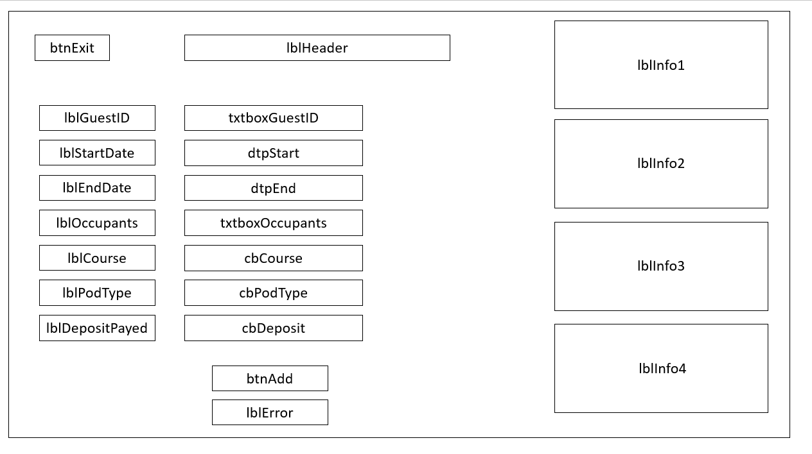Figure 5‑9 – FormAddBooking Storyboard

Backcolour : RGB(79, 111, 82)

|  |  |
| --- | --- |
| **Walkthrough** | |
| *Control* | *Function* |
| btnAdd | Adds the booking to the database |
| lblError | Displays the errors if invalid details are input |
| btnExit | Closes the form |
| txtboxGuestID | Enter the Guest ID for the booking |
| dtpStart | Enter the start date for the booking |
| dtpEnd | Enter the end date for the booking |
| txtboxOccupants | Enter the number of occupants for the booking |
| cbCourse | Enter if the guest is attending a course |
| cbPodType | Enter the required pod type for the booking |
| cbDeposit | Enter if the guest has paid the deposit |
| lblInfo1  lblInfo2  lblInfo3  lblInfo4 | Displays information on the criteria when making a booking |

|  |  |  |
| --- | --- | --- |
| **Buttons** | | |
| Font | Microsoft Tai Le 10pt | |
| BackColour | White | |
| ForeColour | Black | |
| ***Name*** | ***Size*** | ***Content*** |
| btnExit | 100, 50 | “X” |
| btnAdd | 120, 35 | “Add” |

|  |  |  |
| --- | --- | --- |
| **Labels** | | |
| BackColour | Transparent | |
| ForeColour | White | |
| ***Name*** | ***Font*** | ***Content*** |
| lblHeader | Microsoft Tai Le 20pt, Bold | “Add Booking” |
| lblGuestID | Microsoft Tai Le 11pt | “Guest ID” |
| lblStartDate | Microsoft Tai Le 11pt | “Surname” |
| lblEndDate | Microsoft Tai Le 11pt | “Email” |
| lblOccupants | Microsoft Tai Le 11pt | “Phone Number” |
| lblCourse | Microsoft Tai Le 11pt | “Attending Course” |
| lblPodType | Microsoft Tai Le 11pt | “Pod Type” |
| lblDepositPayed | Microsoft Tai Le 11pt | “Deposit Paid” |
| lblInfo1 | Microsoft Tai Le 11pt | “Bookings should be made for 3 days (2 Nights), 5 days (4 Nights), 7 days (6 Nights) or 14 days (13 Nights)” |
| lblInfo2 | Microsoft Tai Le 11pt | “Pods cannot be booked for between the 20th of December and the 20th of January” |
| lblInfo3 | Microsoft Tai Le 11pt | “Deposits must be paid within 3 days of making the booking or the dates will be released” |
| lblInfo4 | Microsoft Tai Le 11pt | “Bookings must be made two months in advance” |
| lblError | Microsoft Tai Le 11pt | - |

|  |  |
| --- | --- |
| **Textboxes** | |
| Font | Microsoft Tai Le 11pt |
| BackColour | White |
| ForeColour | Black |
| Name | Size |
| txtboxGuestID | 50, 35 |
| txtboxboxOccupants | 150, 35 |

|  |  |
| --- | --- |
| **ComboBoxes** | |
| Font | Microsoft Tai Le 11pt |
| BackColour | White |
| ForeColour | Black |
| Name | Content |
| cbCourse | “True”, “False” |
| cbPodType | “Standard”, “Luxury” |
| cbDeposit | “True”, “False” |

|  |  |  |
| --- | --- | --- |
| **DateTimePicker** | | |
| Name | Font | ForeColour |
| dtpStart | Microsoft Tai Le 11pt | Black |
| dtpEnd | Microsoft Tai Le 11pt | Black |

### FormViewBooking

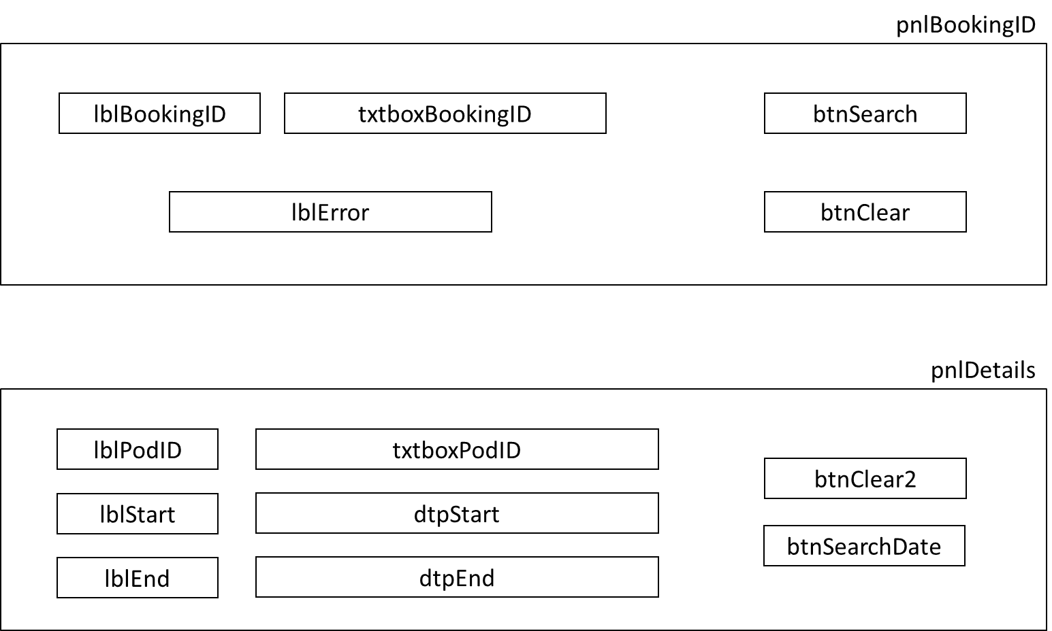Figure 5‑11 – FormViewBooking Panels Storyboard

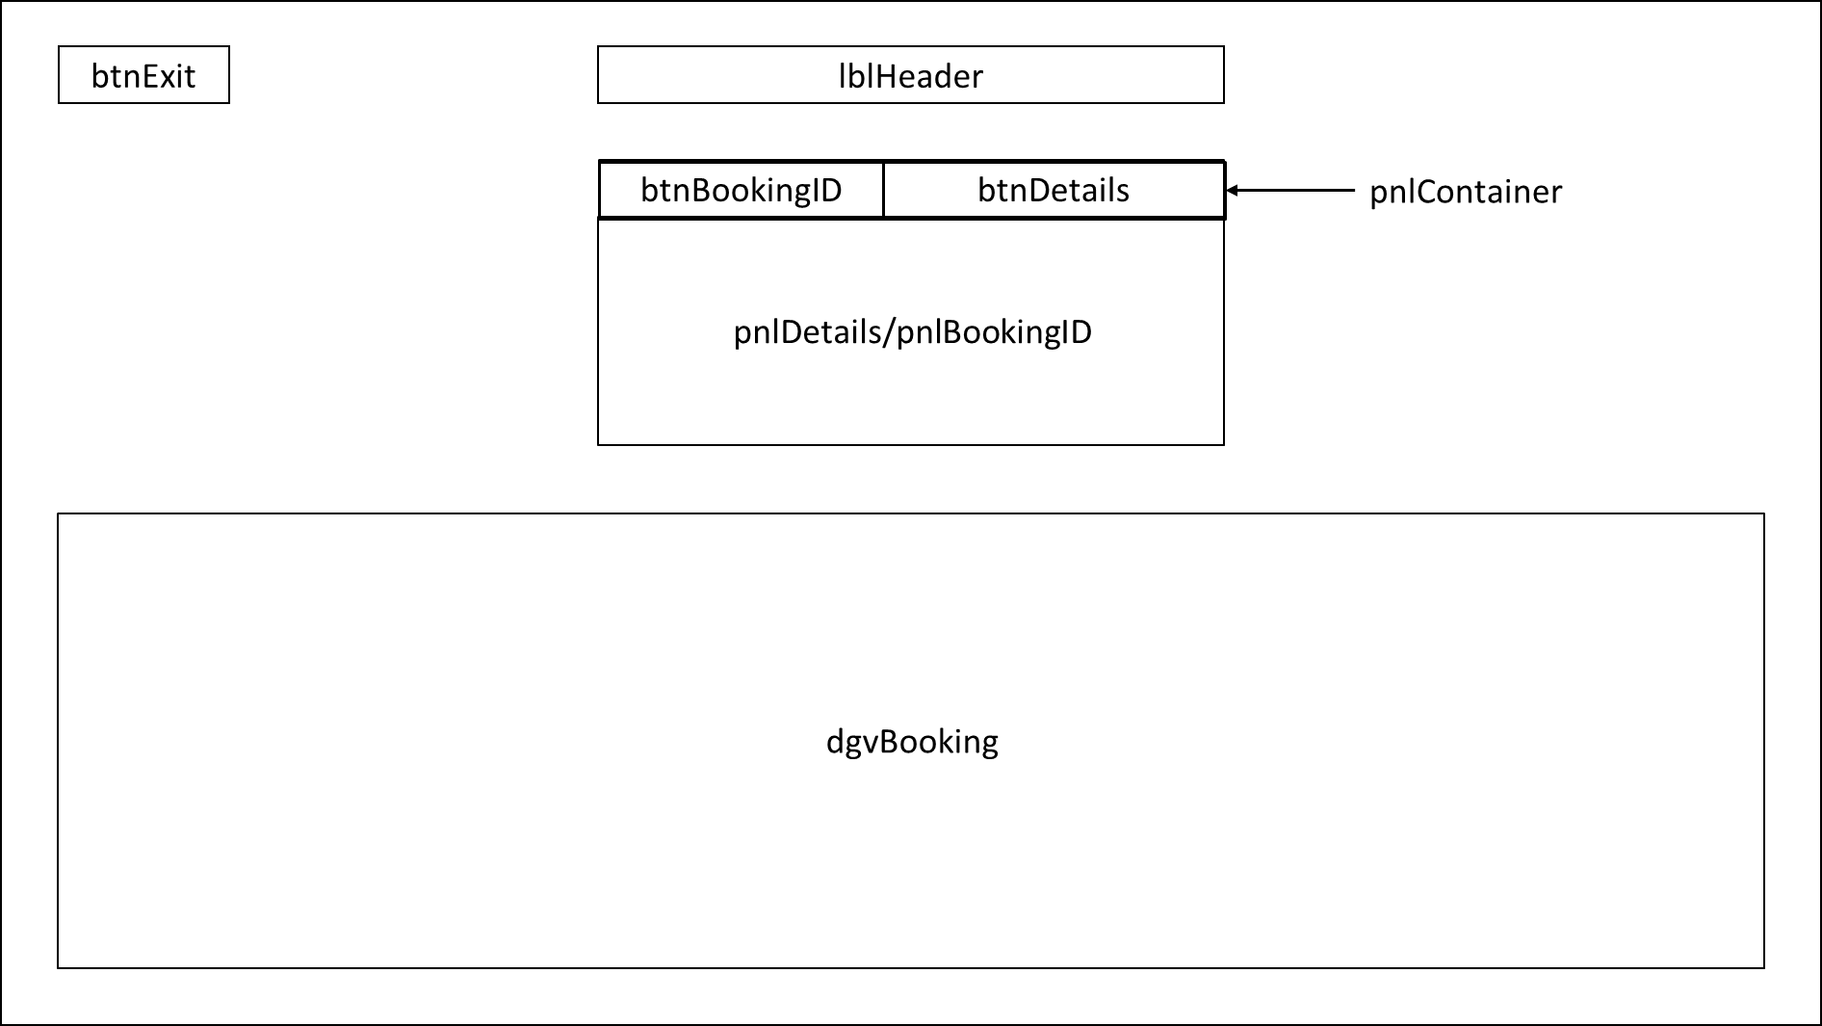Figure 5‑12 – FormViewBooking Storyboard

Backcolour : RGB(79, 111, 82)

|  |  |
| --- | --- |
| **Walkthrough** | |
| *Control* | *Function* |
| btnBookingID | Sets pnlBookingID’s visibility to true and adjusts the size of btnDetails and itself |
| btnDetails | Sets pnlDetails’s visibility to true and adjusts the size of btnBookingID and itself |
| btnExit | Closes the form |
| txtboxBookingID | Enter a Booking ID to search for |
| btnSearch | The application searches and displays the booking details if the booking ID was valid |
| btnClear | Clears txtboxBookingID and any filters on the data grid view |
| lblError | Displays the error if the input booking ID was invalid |
| txtboxPodID | Enter the required pod ID |
| dtpStart | Enter the start of the date range |
| dtpEnd | Enter the end of the date range |
| btnClear2 | Clears txtboxPodID, sets dtpStart and dtpEnd to the current date and removes any filters from the data grid view |
| btnSearchDate | The application searches and displays the bookings for that pod within the given date range |

|  |  |  |  |
| --- | --- | --- | --- |
| **Buttons** | | | |
| Font | | Microsoft Tai Le, 10pt | |
| BackColour | | White | |
| ForeColour | | Black | |
| ***Name*** | ***Size*** | | ***Content*** |
| btnExit | 100, 50 | | “X” |
| btnBookingID | 280, 80 | | “Booking ID” |
| btnDetails | 280, 80 | | “Pod Details” |
| btnClear | 140,70 | | “Clear” |
| btnClear2 | 140, 70 | | “Clear” |
| btnSearchDate | 140,70 | | “Search” |
| btnSearch | 140,70 | | “Search” |

|  |  |  |
| --- | --- | --- |
| **Labels** | | |
| BackColour | Transparent | |
| ForeColour | White | |
| ***Name*** | ***Font*** | ***Content*** |
| lblHeader | Microsoft Tai Le 20pt, Bold | “View Booking” |
| lblBookingID | Microsoft Tai Le 9pt | “Booking ID” |
| lblStart | Microsoft Tai Le 9pt | “End Date” |
| lblEnd | Microsoft Tai Le 9pt | “Start Date” |
| lblPodID | Microsoft Tai Le 9pt | “Pod ID” |
| lblError | Microsoft Tai Le 9pt | - |

|  |  |
| --- | --- |
| **Textboxes** | |
| Font | Microsoft Tai Le 9pt |
| BackColour | White |
| ForeColour | Black |
| Name | Size |
| txtboxBookingID | 200, 30 |
| txtboxPodID | 200,30 |

|  |  |  |
| --- | --- | --- |
| **DateTimePicker** | | |
| Name | Font | ForeColour |
| dtpStart | Microsoft Tai Le 9pt | Black |
| dtpEnd | Microsoft Tai Le 9pt | Black |

### FormEditBooking

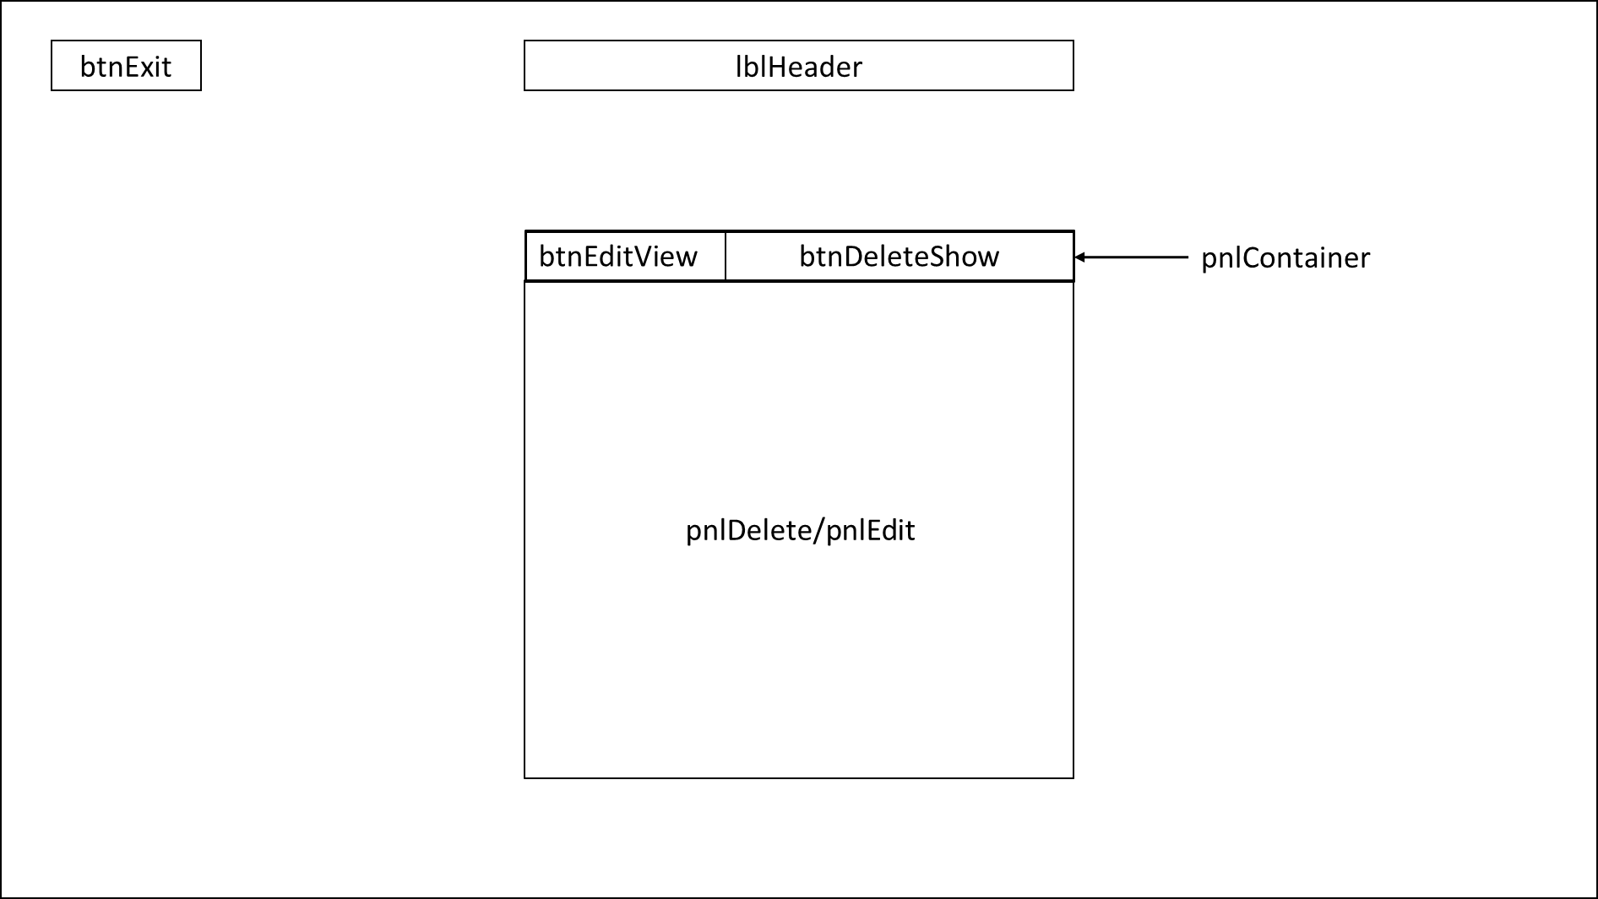Figure 5‑13 – FormEditBooking Storyboard

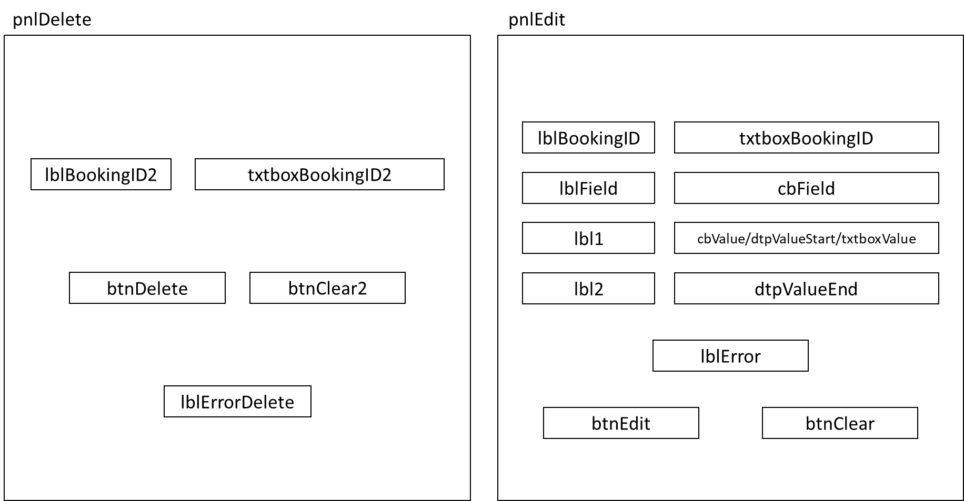Figure 5‑14 – FormEditBooking Panels Storyboard

Backcolour : RGB(79, 111, 82)

|  |  |
| --- | --- |
| **Walkthrough** | |
| *Control* | *Function* |
| btnEditView | Sets pnlEdit’s visibility to true and adjusts the size of btnDeleteShow and itself |
| btnDetails | Sets pnlDelete’s visibility to true and adjusts the size of btnEditView and itself |
| btnExit | Closes the form |
| txtboxBookingID2 | Enter a Booking ID to delete |
| btnDelete | Deletes the booking from the database |
| btnClear2 | Clears txtboxBookingID2 and any error messages |
| lblErrorDelete | Displays the error if the input booking ID was invalid |
| txtboxBookingID | Enter the booking ID |
| cbField | Select the field to be edited |
| cbValue | Select the new value |
| txtboxValue | Enter the new value |
| dtpValueStart | Enter the new start date for the booking |
| dtpValueEnd | Enter the new end date for the booking |
| btnEdit | Updates the booking in the database with the new details |
| btnClear | Clears cbField, cbValue, cbValue, txtboxBookingID, txtboxValue, lblError and sets dtpValueStart and dtpValueEnd to the current date |
| lblError | Displays any errors with the input data |

|  |  |  |
| --- | --- | --- |
| **Buttons** | | |
| Font | Microsoft Tai Le, 10pt | |
| BackColour | White | |
| ForeColour | Black | |
| ***Name*** | ***Size*** | ***Content*** |
| btnExit | 100, 50 | “X” |
| btnEditView | 185, 65 | “Edit” |
| btnDeleteShow | 185, 65 | “Delete” |
| btnDelete | 150, 65 | “Delete” |
| btnClear2 | 150, 65 | “Clear” |
| btnEdit | 150, 65 | “Edit” |
| btnClear | 150, 65 | “Clear” |

|  |  |  |
| --- | --- | --- |
| **Labels** | | |
| BackColour | Transparent | |
| ForeColour | White | |
| ***Name*** | ***Font*** | ***Content*** |
| lblHeader | Microsoft Tai Le 20pt, Bold | “View Booking” |
| lblBookingID2 | Microsoft Tai Le 10pt | “Booking ID” |
| lblErrorDelete | Microsoft Tai Le 10pt | - |
| lblBookingID | Microsoft Tai Le 10pt | “Booking ID” |
| lblField | Microsoft New Tai Le 10pt | “Field” |
| lbl1 | Microsoft Tai Le 10pt | - |
| lbl2 | Microsoft Tai Le 10pt | - |
| lblError | Microsoft Tai Le 10pt | - |

|  |  |
| --- | --- |
| **Textboxes** | |
| Font | Microsoft Tai Le 9pt |
| BackColour | White |
| ForeColour | Black |
| ***Name*** | ***Size*** |
| txtboxBookingID2 | 250, 30 |
| txtboxBookingID | 250,30 |
| txtboxValue | 115, 30 |

|  |  |
| --- | --- |
| **ComboBoxes** | |
| Font | Microsoft Tai Le 9pt |
| BackColour | White |
| ForeColour | Black |
| ***Name*** | ***Content*** |
| cbField | “Date”, “Number of Occupants”, “Attending Course”, “Pod Type” |
| cbValue | - |

|  |  |  |
| --- | --- | --- |
| **DateTimePicker** | | |
| ***Name*** | ***Font*** | ***ForeColour*** |
| dtpValueStart | Microsoft Tai Le 9pt | Black |
| dtpValueEnd | Microsoft Tai Le 9pt | Black |
| **Panels** | | |
| BackColour | WhiteSmoke | |
| ***Name*** | ***Size*** | |
| pnlDelete | 585, 545 | |
| pnlEdit | 585, 545 | |
| pnlContainer | 585, 65 | |

### FormViewPod

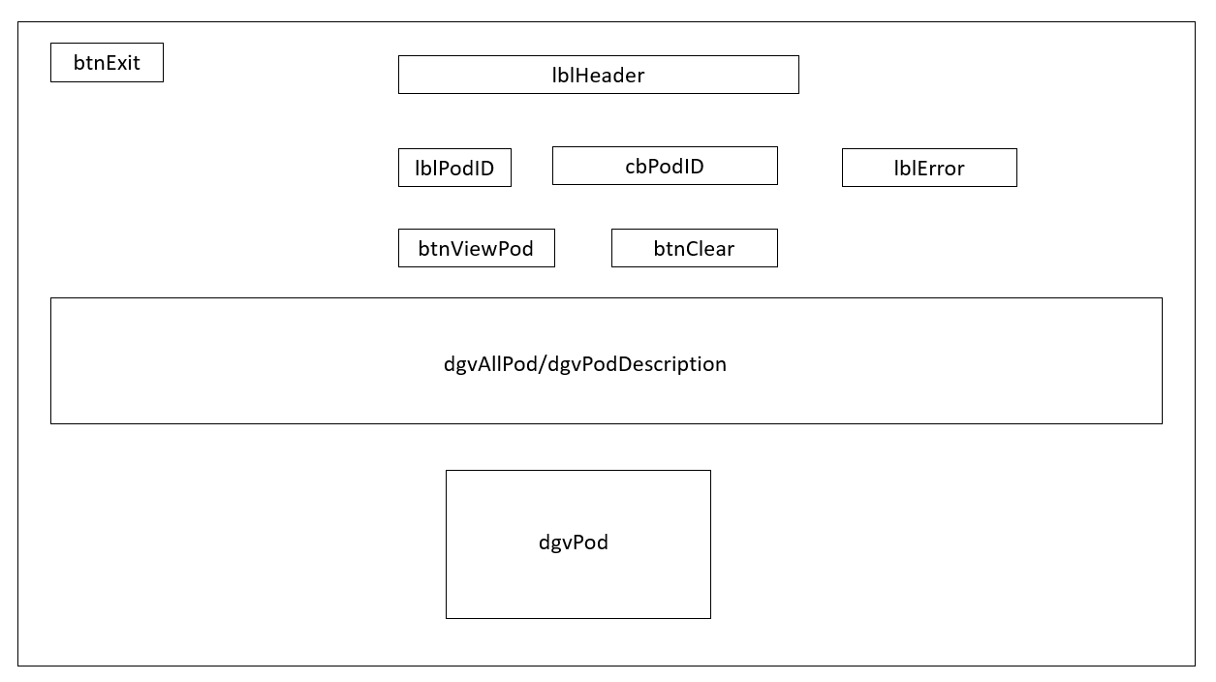Figure 5‑15 – FormViewPod Storyboard

Backcolour : RGB(79, 111, 82)

|  |  |  |  |
| --- | --- | --- | --- |
| **Walkthrough** | | | |
| *Control* | *Function* | | |
| btnViewPod | Displays the pod details in dgvAllPod of the input pod ID | | |
| btnClear | Clears cbPodID and sets the visibility of dgvAllPod to false | | |
| btnExit | Closes the form | | |
| lblError | Displays an error if an invalid pod ID is input | | |
| cbPodID | Select a pod ID from the drop-down list | | |
| dgvPod | Displays each Pod ID and its type | | |
| dgvPodDescription | Displays the details of each pod type | | |
| dgvAllPod | Displays the input pod ID, its type, and the details of that pod type | | |
| **Labels** | | | |
| BackColour | | Transparent | |
| ForeColour | | White | |
| ***Name*** | | ***Font*** | ***Content*** |
| lblHeader | | Microsoft Tai Le 20pt, Bold | “View Pod” |
| lblPodID | | Microsoft Tai Le 11pt | “Booking ID” |

|  |  |  |
| --- | --- | --- |
| **Buttons** | | |
| Font | Microsoft Tai Le, 10pt | |
| BackColour | White | |
| ForeColour | Black | |
| ***Name*** | ***Size*** | ***Content*** |
| btnExit | 100, 50 | “X” |
| btnViewPod | 140, 50 | “View” |
| btnClear | 140, 50 | “Clear” |

|  |  |
| --- | --- |
| **ComboBoxes** | |
| Font | Microsoft Tai Le 10pt |
| BackColour | White |
| ForeColour | Black |
| Name | Content |
| cbPodID | - |

|  |  |
| --- | --- |
| **DataGridView** | |
| Name | Size |
| dgvAllPod | 1220, 170 |
| dgvPodDescription | 840, 130 |
| dgvPod | 380, 250 |

### FormEditPod

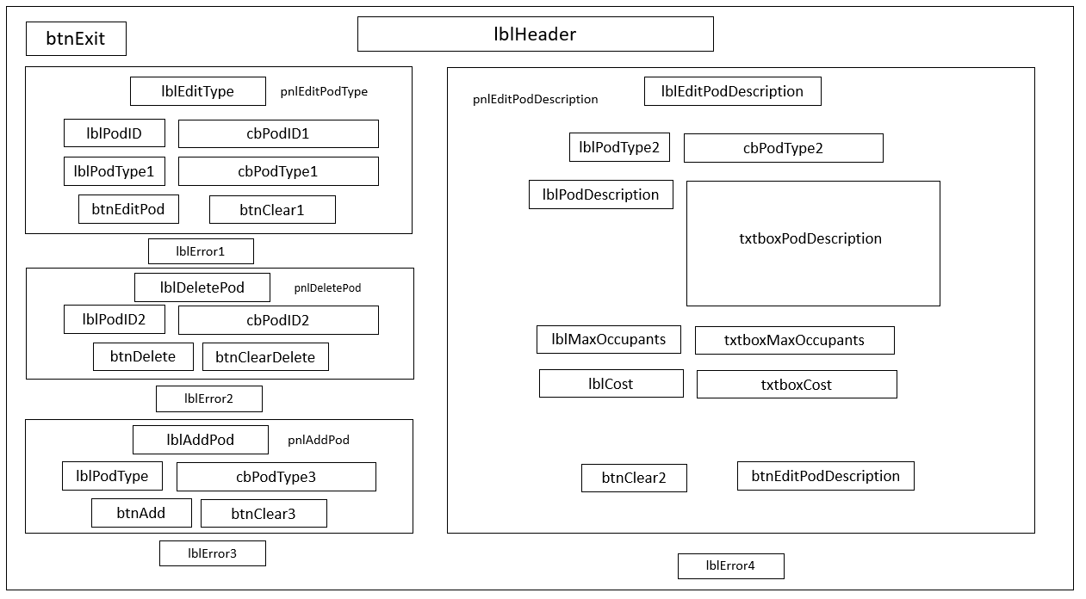Figure 5‑16 – FormEditPod Storyboard

Backcolour : RGB(79, 111, 82)

|  |  |
| --- | --- |
| **Walkthrough** | |
| *Control* | *Function* |
| btnExit | Closes the form |
| btnEditPod | Edits the selected pod’s type to the given value |
| btnDelete | Deletes the pod with the given pod ID from the database |
| btnAdd | Adds a pod to the database with the given type |
| btnEditPodDescription | Updates the description of a pod type to the input values |
| btnClear1 | Clears cbPodID1, cbPodType1 and lblError1 |
| btnClearDelete | Clears cbPodID2 and lblError2 |
| btnClear3 | Clears cbPodType3 and lblError3 |
| btnClear2 | Clears lblError4 and the controls in pnlDescription |
| cbPodID1  cbPodID2 | Select a pod ID from the drop-down list |
| cbPodType1  cbPodType2  cbPodType3 | Select a pod type from the drop-down list |
| lblError1  lblError2  lblError3  lblError4 | Displays any errors with the input data |

|  |  |  |
| --- | --- | --- |
| **Buttons** | | |
| Font | Microsoft Tai Le, 10pt | |
| BackColour | White | |
| ForeColour | Black | |
| ***Name*** | ***Size*** | ***Content*** |
| btnExit | 100, 50 | “X” |
| btnEditPod | 175, 55 | “Edit” |
| btnClear1 | 175, 55 | “Clear” |
| btnDelete | 175, 55 | “Delete” |
| btnClearDelete | 175, 55 | “Clear” |
| btnAdd | 175, 55 | “Add” |
| btnClear3 | 175, 55 | “Clear” |
| btnEditPodDescription | 175, 55 | “Edit” |
| btnClear4 | 175, 55 | “Clear” |

|  |  |  |  |
| --- | --- | --- | --- |
| **Labels** | | | |
| BackColour | Transparent | | |
| ForeColour | Black | | |
| ***Name*** | ***Font*** | | ***Content*** |
| lblEditType | Microsoft Tai Le 11pt | | “Edit Pod Type” |
| lblDeletePod | Microsoft Tai Le 11pt | | “Delete Pod” |
| lblAddPod | Microsoft Tai Le 11pt | | “Add Pod” |
| lblEditPodDescription | Microsoft Tai Le 11pt | | “Edit Pod Description” |
| lblPodID | Microsoft Tai Le, 11pt | | “Pod ID” |
| lblPodType1 | Microsoft Tai Le, 11pt | | “Pod Type” |
| lblPodID2 | Microsoft Tai Le, 11pt | | “Pod ID” |
| lblPodType | Microsoft Tai Le, 11pt | | “Pod Type” |
| lblPodType2 | Microsoft Tai Le, 11pt | | “Pod Type” |
| lblPodDescription | Microsoft Tai Le, 11pt | | “Pod Description” |
| lblMaxOccupants | Microsoft Tai Le, 11pt | | “Maximum Number of Occupants” |
| lblCost | Microsoft Tai Le, 11pt | | “Cost Per Person Per Night” |
| lblError1 | Microsoft Tai Le, 11pt | | - |
| lblError2 | Microsoft Tai Le, 11pt | | - |
| lblError3 | Microsoft Tai Le, 11pt | | - |
| lblError4 | Microsoft Tai Le, 11pt | | - |
| ForeColour | | White | |
| lblHeader | Microsoft New Tai Le 20pt, Bold | | “View Pod” |

|  |  |
| --- | --- |
| **ComboBoxes** | |
| Font | Microsoft New Tai Le 10pt |
| BackColour | White |
| ForeColour | Black |
| ***Name*** | ***Content*** |
| cbPodID1 | - |
| cbPodType1 | “Standard”, “Luxury” |
| cbPodID2 | - |
| cbPodType3 | “Standard”, “Luxury” |
| cbPodType2 | “Standard”, “Luxury” |

|  |  |
| --- | --- |
| **Textboxes** | |
| Font | Microsoft Tai Le 9pt |
| BackColour | White |
| ForeColour | Black |
| ***Name*** | ***Size*** |
| txtboxPodDescription | 345, 165 |
| txtboxMaxOccupants | 215, 32 |
| txtboxCost | 215, 32 |

|  |  |
| --- | --- |
| **Panels** | |
| BackColour | WhiteSmoke |
| ***Name*** | ***Size*** |
| pnlAddPod | 390, 210 |
| pnlEditPodType | 390, 242 |
| pnlDeletePod | 390, 203 |
| pnlEditPodDescription | 605, 695 |

### FormReport

Figure 5‑17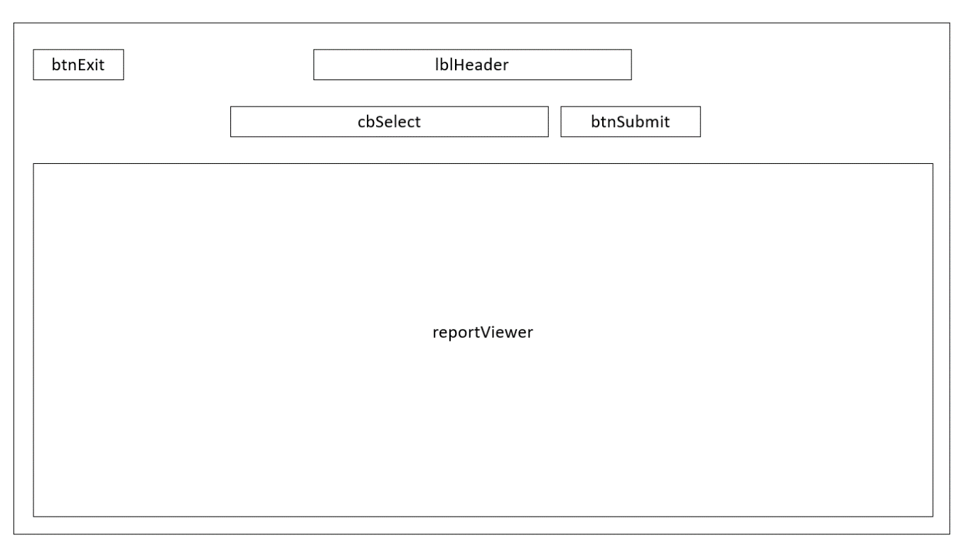 – FormReport Storyboard

Backcolour : RGB(79, 111, 82)

|  |  |
| --- | --- |
| **Walkthrough** | |
| *Control* | *Function* |
| btnSubmit | Generates and displays the selected report in the reportViewer |
| cbSelect | Select a report from the drop-down list :   * Most frequent guests * Most popular pods * Guest details of guests on each course * Rate of bookings |
| reportViewer | Visibility is false until a report is selected and btnSubmit is clicked, it then displays the report |

|  |  |  |
| --- | --- | --- |
| **Labels** | | |
| BackColour | Transparent | |
| ForeColour | White | |
| Name | Font | Content |
| lblHeader | Microsoft Tai Le 20pt, Bold | “Reports” |

|  |  |  |  |
| --- | --- | --- | --- |
| **Buttons** | | | |
| Font | | Microsoft Tai Le, 12pt | |
| BackColour | | White | |
| ForeColour | | Black | |
| Name | Size | | Content |
| btnSubmit | 90, 30 | | “Submit” |
| btnExit | 100, 50 | | “X” |

|  |  |
| --- | --- |
| **ComboBoxes** | |
| Font | Microsoft Tai Le 9pt |
| BackColour | White |
| ForeColour | Black |
| ***Name*** | ***Content*** |
| cbSelect | “Organise Report by Most Popular Pods”, “Organise Report by Most Frequent Guests”, “Organise Report by Rate of Bookings”, “Organise Reports by Course Guests” |

|  |  |
| --- | --- |
| **ReportViewer** | |
| Font | Microsoft Tai Le 9pt |
| BackColour | White |
| ForeColour | Black |
| ***Name*** | ***Size*** |
| reportViewer | 780, 255 |

### FormShowDetails

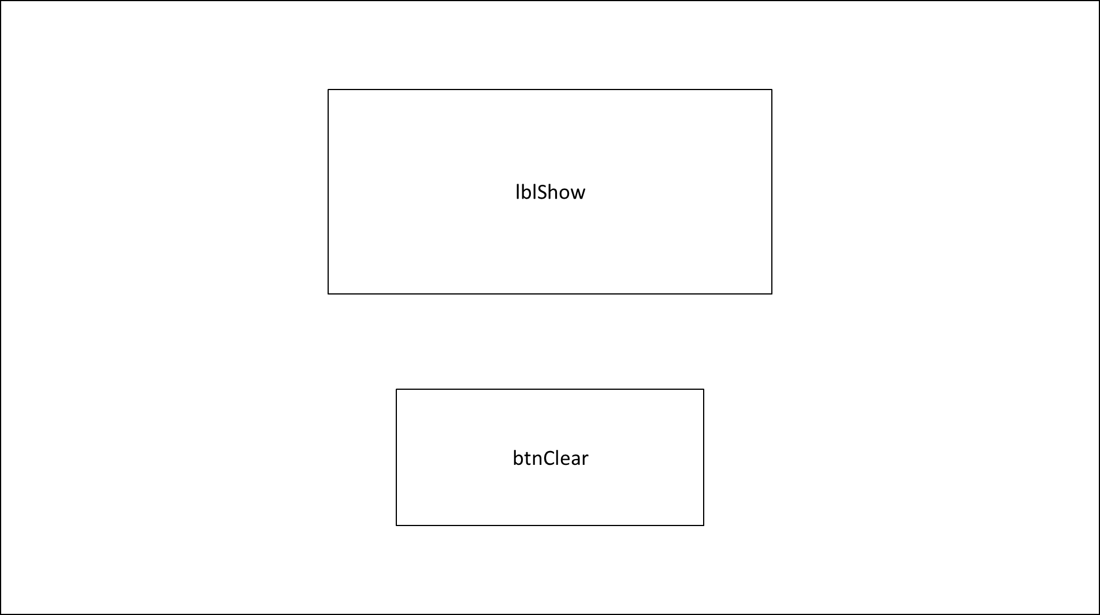Figure 5‑18 – FormShowDetails Storyboard

Backcolour : RGB(79, 111, 82)

|  |  |
| --- | --- |
| **Walkthrough** | |
| *Control* | *Function* |
| lblShow | Displays the relevant information |
| btnClear | Closes the form |

|  |  |  |
| --- | --- | --- |
| **Labels** | | |
| BackColour | Transparent | |
| ForeColour | White | |
| Name | Font | Content |
| lblShow | Microsoft New Tai Le 14pt | - |

|  |  |  |  |
| --- | --- | --- | --- |
| **Buttons** | | | |
| Font | | Microsoft Tai Le, 12pt | |
| BackColour | | White | |
| ForeColour | | Black | |
| Name | Size | | Content |
| btnClear | 185, 85 | | “OK” |

## Test Plan

Testing is the process of executing a software system and examining the behaviour to validate its functionality and highlight any errors or bugs. It determines whether the user requirements have been met and whether the system is ready to be deployed. Testing is vital in producing a high-quality system and maximising user satisfaction. It will expose and prompt correction of any bugs in the system and minimise problems once it has been deployed.

Functional testing is testing that validates the software system against the functional requirements, as defined in the design phase of the development. Unit testing and link testing are both functional testing, where unit testing involves verifying the behaviour of individual code units, and link testing refers to the application’s ability to link different user interfaces together when given the required input. Non-functional testing refers to testing non-functional requirements such as scalability and performance.

Black box testing is where the tester has no knowledge of the code beneath the user interface and the testing is done without any regard for the internal logical structure of the software. White box testing is done by developers and requires a knowledge of the internal logical structure of the system. It is conducted to ensure that all internal operations are performed according to the specifications.

Modern software testing emphasises preventative testing, which means testing early in the software development process. Discovering errors early in the development process will be less problematic than finding them at the end. While this early testing is a common practice in agile design methodologies, it is notably absent in the traditional waterfall approach. It was recognised that testing could be done after each stage of the development to optimise the system and from this concept the ‘V-Model’ was derived. This project will utilise this model.

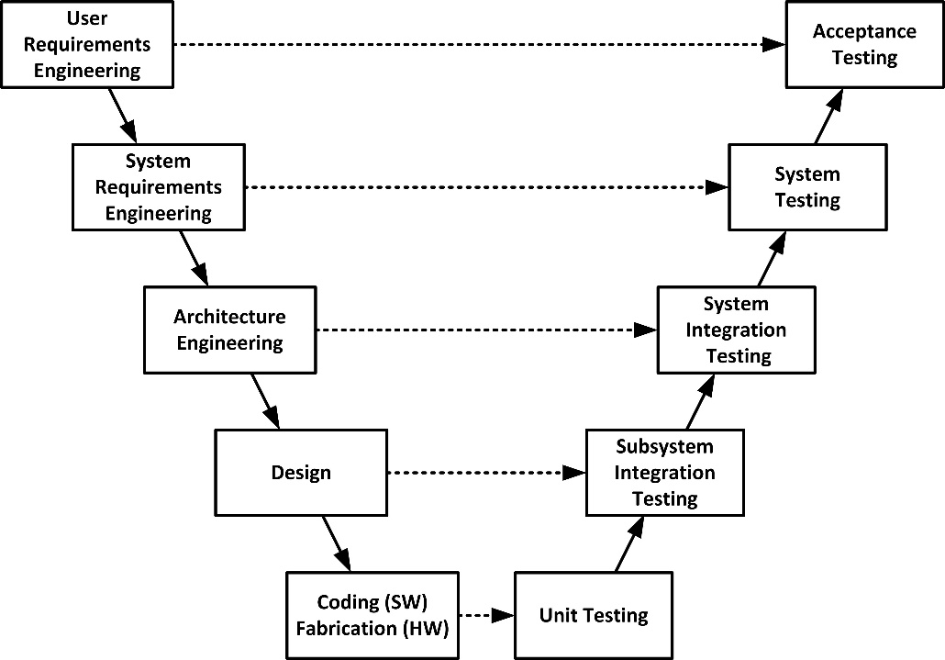In the V-Model (Figure 5-18), suitable units of testing are done after each stage of the development then the entire system is tested against all of these units again after the implementation phase is complete. This model is simple to understand and produces higher quality software systems. This is mainly because the systematic approach prevents problems from being identified late in the development process which can be expensive and time consuming to fix.

Figure 5‑19 – ‘V-Model’ in Testing

### Data Entry Testing

This project will utilise a range of validation for data being added to the database, these preventive measures will vastly reduce the problems associated with data integrity issues. It will also ensure all bookings made adhere to the restrictions defined in the user requirements. This testing should include a range of tests to examine the system’s ability to perform this validation and will also cover all instances where data is input to the system. This falls under unit testing as individual units of code will be tested to measure and record their validity which allows the tester to readily identify the location of any bugs. This testing will be white box, as it requires an understanding of the software in order to identify and fix problems in a timely manner. The test data will fall into three categories: ‘Valid’ which is data which fits the criteria and should be accepted by the system, ‘Extreme’ which are values that are at the extremes of the acceptable range. ‘Erroneous’ test data does not fit the criteria and should be rejected. Testing to be carried out is presented below.

|  |  |
| --- | --- |
| Test Plan | Data Entry Testing |
| Time | 12:00pm |
| Date | 07/03/2024 |
| Environment | Windows 11 PC (Intel(R) Core(TM) i5-10210U CPU, 8 GB RAM) |
| Notes | Any values to be selected from a combo box will not be tested against extreme data as it can only be a value in or not in the drop-down list.  The DateTimePicker used to select dates can never be null and these values do not require testing for null.  Erogenous will refer to an incorrect data type or null and any more complex validation will be specified in the test data type. |

|  |  |  |  |  |  |  |
| --- | --- | --- | --- | --- | --- | --- |
| **FormCreateGuest** | | | | | | |
| *Test*  *Number* | *Description* | *Test Data Type* | *Test Data* | *Expected Outcome* | *Pass/*  *Fail* | *Actual Outcome* |
| 1.1.1 | Title | Valid | “Mr” | Accepted |  |  |
| 1.1.2 | Erroneous | “5tFh_vh” | Rejected |  |  |
| 1.2.1 | First Name | Valid | “Test” | Accepted |  |  |
| 1.2.2 | Extreme | “TeSTttt” | Accepted |  |  |
| 1.2.3 | Erroneous | “5tFh_vh” | Rejected |  |  |
| 1.2.4 | Null | Rejected |  |  |
| 1.2.5 | Length | “TestTestTestTestTestTestTestTestTestTestTest” | Rejected |  |  |
| 1.3.1 | Surname | Valid | “Subject” | Accepted |  |  |
| 1.3.2 | Extreme | “SubJECCt” | Accepted |  |  |
| 1.3.3 | Erroneous | “5t64_vh” | Rejected |  |  |
| 1.3.4 | Null | Rejected |  |  |
| 1.3.5 | Length | “TestTestTestTestTestTestTestTestTestTestTest” | Rejected |  |  |
| 1.4.1 | Email | Valid | “testsubject@gmail.com” | Accepted |  |  |
| 1.4.2 | Extreme | “Test.SUBJECT@outlook.co.uk” | Accepted |  |  |
| 1.4.3 | Erroneous | “test.com” | Rejected |  |  |
| 1.4.4 | Null | Rejected |  |  |
| 1.5.1 | Phone Number | Valid | “07775123456” | Accepted |  |  |
| 1.5.2 | Extreme | “07775 123456” | Accepted |  |  |
| 1.5.3 | Erroneous | “TesT_Data67” | Rejected |  |  |
| 1.5.4 | Null | Rejected |  |  |
| 1.5.5 | Length | “012345” | Rejected |  |  |
| 1.5.6 | “0123456789101112” | Rejected |  |  |
| 1.6.1 | Gender | Valid | “Male” | Accepted |  |  |
| 1.6.2 | Erroneous | “65_Gender” | Rejected |  |  |
| 1.7.1 | Address Line 1 | Valid | “1 Main Street” | Accepted |  |  |
| 1.7.2 | Erroneous | Null | Rejected |  |  |
| 1.7.3 | Length | “TestTestTestTestTestTestTestTestTestTestTest” | Rejected |  |  |
| 1.8.1 | Address Line 2 | Valid | “Lisburn” | Accepted |  |  |
| 1.8.2 | Erroneous | Null | Rejected |  |  |
| 1.8.3 | Length | “TestTestTestTestTestTestTestTestTestTestTest” | Rejected |  |  |
| 1.9.1 | County | Valid | “Armagh” | Accepted |  |  |
| 1.9.2 | Extreme | “ARMAGH” | Accepted |  |  |
| 1.9.3 | Erroneous | “Armagh_234” | Rejected |  |  |
| 1.9.4 | Null | Rejected |  |  |
| 1.9.5 | Length | “TestTestTestTestTestTestTestTest” | Rejected |  |  |
| 1.10.1 | Country | Valid | “Northern Ireland” | Accepted |  |  |
| 1.10.2 | Extreme | “NORTHERN-ireland” | Accepted |  |  |
| 1.10.3 | Erroneous | “7823” | Rejected |  |  |
| 1.10.4 | Null | Rejected |  |  |
| 1.10.5 | Length | “TestTestTestTestTestTestTestTest” | Rejected |  |  |
| 1.11.1 | Postcode | Valid | “BT20 3FG” | Accepted |  |  |
| 1.11.2 | Extreme | “bt203fg” | Accepted |  |  |
| 1.11.3 | Erroneous | Null | Rejected |  |  |
| 1.11.4 | Length | “BT 76-FG56” | Rejected |  |  |
| 1.11.5 | “BT50” | Rejected |  |  |
| 1.12.1 | Date Of Birth | Valid | 01/01/1990 | Accepted |  |  |
| 1.12.2 | Extreme | 07/03/2005 | Accepted |  |  |
| 1.12.3 | Erroneous | 07/03/2024 | Rejected |  |  |

|  |  |  |  |  |  |  |
| --- | --- | --- | --- | --- | --- | --- |
| **FormAddBooking** | | | | | | |
| *Test*  *Number* | *Description* | *Test Data Type* | *Test Data* | *Expected Outcome* | *Pass/Fail* | *Actual Outcome* |
| 2.1.1 | GuestID | Valid | “2” | Accepted |  |  |
| 2.1.2 | Erroneous | “test-DATA” | Rejected |  |  |
| 2.1.3 | Invalid Guest ID | “456678” | Rejected |  |  |
| 2.2.1 | BookingDates | Valid | Start: 25/01/2025  End:  27/01/2025 | Accepted |  |  |
| 2.2.2 | Not Two Months in Advance | Start: 27/04/2024  End:  29/04/2024 | Rejected |  |  |
| 2.2.3 | Invalid duration | Start: 25/01/2025  End:  28/01/2025 | Rejected |  |  |
| 2.2.4 | Made between 20th of December and 20th January | Start: 01/01/2025  End:  03/01/2025 | Rejected |  |  |
| 2.3.1 | Number Of Occupants | Valid | 2 | Accepted |  |  |
| 2.3.2 | Maximum 4 for Standard | 6 | Rejected |  |  |
| 2.3.3 | Maximum 6 for Luxury | 8 | Rejected |  |  |
| 2.3.4 | Erroneous | “Test---56” | Rejected |  |  |
| 2.3.5 | Null | Rejected |  |  |
| 2.4.1 | Attending Course | Valid | “True” | Accepted |  |  |
| 2.4.2 | Erroneous | “Test” | Rejected |  |  |
| 2.5.1 | Pod Type | Valid | “Standard” | Accepted |  |  |
| 2.5.2 | Erroneous | “Test” | Rejected |  |  |
| 2.6.1 | Deposit Paid | Valid | “True” | Accepted |  |  |
| 2.6.2 | Erroneous | “Test” | Rejected |  |  |

|  |  |  |  |  |  |  |
| --- | --- | --- | --- | --- | --- | --- |
| **FormEditPods** | | | | | | |
| *Test*  *Number* | *Description* | *Test Data Type* | *Test Data* | *Expected Outcome* | *Pass/Fail* | *Actual Outcome* |
| 3.1.1 | Input Pod Type (Combo-Box) | Valid | “Standard” | Accepted |  |  |
| 3.1.2 | Erroneous | “Test” | Rejected |  |  |
| 3.2.1 | Input Pod ID  (Combo-Box) | Valid | “1” | Accepted |  |  |
| 3.2.2 | Erroneous | “Test” | Rejected |  |  |
| 3.3.1 | Input Pod Cost | Valid | 23 | Accepted |  |  |
| 3.3.2 | Erroneous | Null | Rejected |  |  |
| 3.3.3 | “Test” | Rejected |  |  |

|  |  |  |  |  |  |  |
| --- | --- | --- | --- | --- | --- | --- |
| **FormViewGuest** | | | | | | |
| *Test*  *Number* | *Description* | *Test Data Type* | *Test Data* | *Expected Outcome* | *Pass/Fail* | *Actual Outcome* |
| 4.1.1 | Input Guest ID | Valid | “2” | Accepted |  |  |
| 4.1.2 | Erroneous | “test-DATA” | Rejected |  |  |
| 4.1.3 | Invalid Guest ID | “456678” | Rejected |  |  |

|  |  |  |  |  |  |  |
| --- | --- | --- | --- | --- | --- | --- |
| **FormEditGuest** | | | | | | |
| *Test*  *Number* | *Description* | *Test Data Type* | *Test Data* | *Expected Outcome* | *Pass/*  *Fail* | *Actual Outcome* |
| 5.1.1 | Input Guest ID | Valid | “2” | Accepted |  |  |
| 5.1.2 | Erroneous | “test-DATA” | Rejected |  |  |
| 5.1.3 | Invalid Guest ID | “456678” | Rejected |  |  |
| 5.2.1 | Title | Valid | “Mr” | Accepted |  |  |
| 5.2.2 | Erroneous | “5tFh_vh” | Rejected |  |  |
| 5.3.1 | First Name | Valid | “Test” | Accepted |  |  |
| 5.3.2 | Extreme | “TeSTttt” | Accepted |  |  |
| 5.3.3 | Erroneous | “5tFh_vh” | Rejected |  |  |
| 5.3.4 | Null | Rejected |  |  |
| 5.3.5 | Length | “TestTestTestTestTestTestTestTestTestTestTest” | Rejected |  |  |
| 5.4.1 | Surname | Valid | “Subject” | Accepted |  |  |
| 5.4.2 | Extreme | “SubJECCt” | Accepted |  |  |
| 5.4.3 | Erroneous | “5t64_vh” | Rejected |  |  |
| 5.4.4 | Null | Rejected |  |  |
| 5.4.5 | Length | “TestTestTestTestTestTestTestTestTestTestTest” | Rejected |  |  |
| 5.5.1 | Email | Valid | “testsubject@gmail.com” | Accepted |  |  |
| 5.5.2 | Extreme | “Test.SUBJECT@outlook.co.uk” | Accepted |  |  |
| 5.5.3 | Erroneous | “test.com” | Rejected |  |  |
| 5.5.4 | Null | Rejected |  |  |
| 5.6.1 | Phone Number | Valid | “07775123456” | Accepted |  |  |
| 5.6.2 | Extreme | “07775 123456” | Accepted |  |  |
| 5.6.3 | Erroneous | “TesT_Data67” | Rejected |  |  |
| 5.6.4 | Null | Rejected |  |  |
| 5.6.5 | Length | “012345” | Rejected |  |  |
| 5.6.6 | “0123456789101112” | Rejected |  |  |
| 5.7.1 | Gender | Valid | “Male” | Accepted |  |  |
| 5.7.2 | Erroneous | “65_Gender” | Rejected |  |  |
| 5.8.1 | Address Line 1 | Valid | “1 Main Street” | Accepted |  |  |
| 5.8.2 | Erroneous | Null | Rejected |  |  |
| 5.8.3 | Length | “TestTestTestTestTestTestTestTestTestTestTest” | Rejected |  |  |
| 5.9.1 | Address Line 2 | Valid | “Lisburn” | Accepted |  |  |
| 5.9.2 | Erroneous | Null | Rejected |  |  |
| 5.9.3 | Length | “TestTestTestTestTestTestTestTestTestTestTest” | Rejected |  |  |
| 5.10.1 | County | Valid | “Armagh” | Accepted |  |  |
| 5.10.2 | Extreme | “ARMAGH” | Accepted |  |  |
| 5.10.3 | Erroneous | “Armagh_234” | Rejected |  |  |
| 5.10.4 | Null | Rejected |  |  |
| 5.10.5 | Length | “TestTestTestTestTestTestTestTest” | Rejected |  |  |
| 5.11.1 | Country | Valid | “Northern Ireland” | Accepted |  |  |
| 5.11.2 | Extreme | “NORTHERN-ireland” | Accepted |  |  |
| 5.11.3 | Erroneous | “7823” | Rejected |  |  |
| 5.11.4 | Null | Rejected |  |  |
| 5.11.5 | Length | “TestTestTestTestTestTestTestTest” | Rejected |  |  |
| 5.12.1 | Postcode | Valid | “BT20 3FG” | Accepted |  |  |
| 5.12.2 | Extreme | “bt203fg” | Accepted |  |  |
| 5.12.3 | Erroneous | Null | Rejected |  |  |
| 5.12.4 | Length | “bt 76-FG56” | Rejected |  |  |
| 5.13.1 | Date Of Birth | Valid | 01/01/1990 | Accepted |  |  |
| 5.13.2 | Extreme | 07/03/2005 | Accepted |  |  |
| 5.13.3 | Erroneous | 07/01/2010 | Rejected |  |  |

|  |  |  |  |  |  |  |
| --- | --- | --- | --- | --- | --- | --- |
| **FormEditBooking** | | | | | | |
| *Test*  *Number* | *Description* | *Test Data Type* | *Test Data* | *Expected Outcome* | *Pass/Fail* | *Actual Outcome* |
| 6.1.1 | Input Booking ID | Valid | “2” | Accepted |  |  |
| 6.1.2 | Erroneous | “test-DATA” | Rejected |  |  |
| 6.1.3 | Invalid Booking ID | “456678” | Rejected |  |  |
| 6.2.1 | GuestID | Valid | “2” | Accepted |  |  |
| 6.2.2 | Erroneous | “test-DATA” | Rejected |  |  |
| 6.2.3 | Invalid Guest ID | “456678” | Rejected |  |  |
| 6.3.1 | BookingDates | Valid | Start: 25/01/2025  End:  27/01/2025 | Accepted |  |  |
| 6.3.2 | Not Two Months in Advance | Start: 27/04/2024  End:  29/04/2024 | Rejected |  |  |
| 6.3.3 | Invalid duration | Start: 25/01/2025  End:  28/01/2025 | Rejected |  |  |
| 6.3.4 | Made between 20th of December and 20th January | Start: 01/01/2025  End:  03/01/2025 | Rejected |  |  |
| 6.4.1 | Number Of Occupants | Valid | 2 | Accepted |  |  |
| 6.4.2 | Maximum 4 for Standard | 6 | Rejected |  |  |
| 6.4.3 | Maximum 6 for Luxury | 8 | Rejected |  |  |
| 6.4.4 | Erroneous | “Test---56” | Rejected |  |  |
| 6.4.5 | Null | Rejected |  |  |
| 6.5.1 | Attending Course | Valid | “True” | Accepted |  |  |
| 6.5.2 | Erroneous | “Test” | Rejected |  |  |
| 6.5.3 | Course Dates Do Not Match Pod Dates | “True” | Rejected |  |  |
| 6.6.1 | Pod Type | Valid | “Standard” | Accepted |  |  |
| 6.6.2 | Erroneous | “Test” | Rejected |  |  |
| 6.7.1 | Deposit Paid | Valid | “True” | Accepted |  |  |
| 6.7.2 | Erroneous | “Test” | Rejected |  |  |

|  |  |  |  |  |  |  |
| --- | --- | --- | --- | --- | --- | --- |
| **FormViewBooking** | | | | | | |
| *Test*  *Number* | *Description* | *Test Data Type* | *Test Data* | *Expected Outcome* | *Pass/Fail* | *Actual Outcome* |
| 7.1.1 | Input Booking ID | Valid | “2” | Accepted |  |  |
| 7.1.2 | Erroneous | “test-DATA” | Rejected |  |  |
| 7.1.3 | Invalid Booking ID | “456678” | Rejected |  |  |
| 7.2.1 | Input Pod ID | Valid | “2” | Accepted |  |  |
| 7.2.2 | Erroneous | “test__;” | Rejected |  |  |
| 7.2.3 | Invalid Pod ID | “456678” | Rejected |  |  |

|  |  |  |  |  |  |  |
| --- | --- | --- | --- | --- | --- | --- |
| **FormViewPod** | | | | | | |
| *Test*  *Number* | *Description* | *Test Data Type* | *Test Data* | *Expected Outcome* | *Pass/Fail* | *Actual Outcome* |
| 8.1.1 | Select Pod ID (Combo-Box) | Valid | 2 | Accepted |  |  |
| 8.1.2 | Erroneous | “Test__;” | Rejected |  |  |

### Link Testing

Link testing is vital as it confirms that interconnected components work seamlessly together, reducing the risk of unexpected failures. This testing ensures the system can provide the correct user interface to perform the required functionality without any problems. Link testing is important in order to reduce issues with the user experience and maximise user satisfaction. This testing is white box and the testing to be carried out is described below.

|  |  |
| --- | --- |
| Test Plan | Link Testing |
| Time | 09:00 am |
| Date | 08/03/2024 |
| Environment | Windows 11 PC (Intel(R) Core(TM) i5-10210U CPU, 8 GB RAM) |

|  |  |  |  |  |
| --- | --- | --- | --- | --- |
| **FormMenu** | | | | |
| *Test*  *Number* | *Description* | *Expected Outcome* | *Pass/Fail* | *Actual Outcome* |
| 9.1 | btnCreateGuest is clicked | FormCreateGuest will be opened in the menu form, btnCreateGuest’s BackColour will become #E0E0E0 |  |  |
| 9.2 | btnViewGuest is clicked | FormViewGuest will be opened in the menu form, btnViewGuest’s BackColour will become #E0E0E0 |  |  |
| 9.3 | btnEditGuest is clicked | FormEditGuest will be opened in the menu form, btnEditGuest’s BackColour will become #E0E0E0 |  |  |
| 9.4 | btnAddBooking is clicked | FormAddBooking will be opened in the menu form, btnAddBooking’s BackColour will become #E0E0E0 |  |  |
| 9.5 | btnViewBooking is clicked | FormViewBooking will be opened in the menu form, btnViewBooking’s BackColour will become #E0E0E0 |  |  |
| 9.6 | btnEditBooking is clicked | FormEditBooking will be opened in the menu form, btnEditBooking’s BackColour will become #E0E0E0 |  |  |
| 9.7 | btnViewPod is clicked | FormViewPod will be opened in the menu form, btnViewPod’s BackColour will become #E0E0E0 |  |  |
| 9.8 | btnEditPod is clicked | FormEditPod will be opened in the menu form, btnEditPod’s BackColour will become #E0E0E0 |  |  |
| 9.9 | btnReport | FormReport will be opened in the menu form |  |  |
| 9.10 | btnExit is clicked | The program will close |  |  |

|  |  |  |  |  |
| --- | --- | --- | --- | --- |
| **FormCreateGuest** | | | | |
| *Test*  *Number* | *Description* | *Expected Outcome* | *Pass/Fail* | *Actual Outcome* |
| 10.1 | btnAddGuest is clicked with valid data input in the controls | FormShowDetails will open, display the Guest ID and FormCreateGuest will close, btnCreateGuest’s backcolour will return to WhiteSmoke |  |  |
| 10.2 | btnExit is clicked | FormCreateGuest will close, btnCreateGuest’s backcolour will return to WhiteSmoke |  |  |

|  |  |  |  |  |
| --- | --- | --- | --- | --- |
| **FormAddBooking** | | | | |
| *Test*  *Number* | *Description* | *Expected Outcome* | *Pass/Fail* | *Actual Outcome* |
| 11.1 | btnAdd is clicked with valid data input in the controls | FormShowDetails will open, display the Booking ID and Pod ID FormAddBooking will close, btnAddBooking’s backcolour will return to WhiteSmoke |  |  |
| 11.2 | btnExit is clicked | FormAddBooking will close, btnAddBooking’s backcolour will return to WhiteSmoke |  |  |

|  |  |  |  |  |
| --- | --- | --- | --- | --- |
| **FormViewGuest** | | | | |
| *Test*  *Number* | *Description* | *Expected Outcome* | *Pass/Fail* | *Actual Outcome* |
| 12.1 | btnGuestID is clicked | pnlGuestID will become visible |  |  |
| 12.2 | btnDetails is clicked | pnlDetails will become visible |  |  |
| 12.3 | btnExit is clicked | FormViewGuest will close, btnViewGuest’s backcolour will return to WhiteSmoke |  |  |

|  |  |  |  |  |
| --- | --- | --- | --- | --- |
| **FormViewBooking** | | | | |
| *Test*  *Number* | *Description* | *Expected Outcome* | *Pass/Fail* | *Actual Outcome* |
| 13.1 | btnBookingID is clicked | pnlBookingID will become visible |  |  |
| 13.2 | btnDetails is clicked | pnlDetails will become visible |  |  |
| 13.3 | btnExit is clicked | FormViewBooking will close, btnViewBooking’s backcolour will return to WhiteSmoke |  |  |

|  |  |  |  |  |
| --- | --- | --- | --- | --- |
| **FormEditBooking** | | | | |
| *Test*  *Number* | *Description* | *Expected Outcome* | *Pass/Fail* | *Actual Outcome* |
| 14.1 | btnDeleteShow is clicked | pnlDelete will become visible |  |  |
| 14.2 | btnEditView is clicked | pnlEdit will become visible |  |  |
| 14.3 | btnExit is clicked | FormEditBooking will close, btnEditBooking’s backcolour will become WhiteSmoke |  |  |

|  |  |  |  |  |
| --- | --- | --- | --- | --- |
| **FormEditGuest** | | | | |
| *Test*  *Number* | *Description* | *Expected Outcome* | *Pass/Fail* | *Actual Outcome* |
| 15.1 | btnExit is clicked | FormEditGuest will close, btnEditGuest’s backcolour will become WhiteSmoke |  |  |

|  |  |  |  |  |
| --- | --- | --- | --- | --- |
| **FormViewPod** | | | | |
| *Test*  *Number* | *Description* | *Expected Outcome* | *Pass/Fail* | *Actual Outcome* |
| 16.1 | btnExit is clicked | FormViewPod will close, btnViewPod’s backcolour will become WhiteSmoke |  |  |

|  |  |  |  |  |
| --- | --- | --- | --- | --- |
| **FormEditPod** | | | | |
| *Test*  *Number* | *Description* | *Expected Outcome* | *Pass/Fail* | *Actual Outcome* |
| 17.1 | btnExit is clicked | FormEditPod will close, btnEditPod’s backcolour will become WhiteSmoke |  |  |
| 17.2 | btnDelete is clicked | If input Pod ID is valid, a confirmation MessageBox should open |  |  |

|  |  |  |  |  |
| --- | --- | --- | --- | --- |
| **FormReport** | | | | |
| *Test*  *Number* | *Description* | *Expected Outcome* | *Pass/Fail* | *Actual Outcome* |
| 18.1 | btnExit is clicked | FormReport will close |  |  |

### User Acceptance Testing

This process uses the predefined user requirements as a check list to test the system’s ability to complete these tasks and hence a measure of how effective it is. This testing is done at the end of the testing phase. This testing is alpha testing which is done by developers in a controlled environment where any bugs can be identified and fixed quickly. It is done to validate that the system behaves as expected from a user’s perspective, which aligns more with alpha testing than white box testing. The focus of alpha testing is on the functionality and user experience while white box relates to the internal processes of the system.

|  |  |
| --- | --- |
| Test Plan | Link Testing |
| Time | 09:00 am |
| Date | 08/03/2024 |
| Environment | Windows 11 PC (Intel(R) Core(TM) i5-10210U CPU, 8 GB RAM) |
| Notes | This will test the user requirements that have not been previously detailed in the Data Entry Testing plan (Booking Restrictions). |

|  |  |  |  |  |
| --- | --- | --- | --- | --- |
| *Test*  *Number* | *Description* | *Reference* | *Pass/Fail* | *Actual Outcome* |
| 19.1 | Add a booking | F-UR1 |  |  |
| 19.2 | View a booking | F-UR2 |  |  |
| 19.3 | Add a guest | F-UR3 |  |  |
| 19.4 | View a guest | F-UR4 |  |  |
| 19.5 | Delete a booking | F-UR5 |  |  |
| 19.6 | Edit a guest | F-UR6 |  |  |
| 19.7 | Edit a booking | F-UR7 |  |  |
| 19.8 | Check if guest has booked 6 months before their stay and record a 3% discount | F-UR9 |  |  |
| 19.9 | Check if guest has stayed before and record a 2% discount if true | F-UR10 |  |  |
| 19.10 | Check if course dates are within pod booking dates if the guest is attending a course | F-UR11 |  |  |
| 19.11 | Not allow pods to be double booked | F-UR12 |  |  |
| 19.12 | Store the cost per person per night for each pod type | F-UR13 |  |  |
| 19.13 | Edit the description of a pod type | F-UR18 |  |  |
| 19.14 | View a pod’s details | F-UR14 |  |  |
| 19.15 | Add a pod of type “Standard” or “Luxury” | F-UR15 |  |  |
| 19.16 | The system deletes the booking if the deposit is not made within three days | F-UR16 |  |  |
| 19.17 | Search for guest by their details | F-UR20 |  |  |
| 19.18 | Delete a pod | F-UR19 |  |  |
| 19.19 | Provide a report to show the number of bookings made per month | F-UR21 |  |  |
| 19.20 | Provide a report to show the most popular pods | F-UR22 |  |  |
| 19.21 | Provide a report to show the most frequent guests | F-UR23 |  |  |
| 19.22 | Provide a report to show the guest details of each guest on each course | F-UR24 |  |  |

Pseudocode

The following sections present the more complex components of code to be implemented in the solution. Pseudocode is provided for these functions and supported with an explanation.

### Adding a Guest

* A guest object is created with the input data.
* The ValidGuest method from the validation class is called and the object is passed through as a parameter.
* The returned error list is stored in a list of strings.
* This error list and the controls in the form are passed to a method in the validation class which changes the forecolour of any labels that correspond to invalid data to red.
* If the error list is empty, the object is passed to the AddGuest method in the tblGuestDAL which adds the guest to the database.

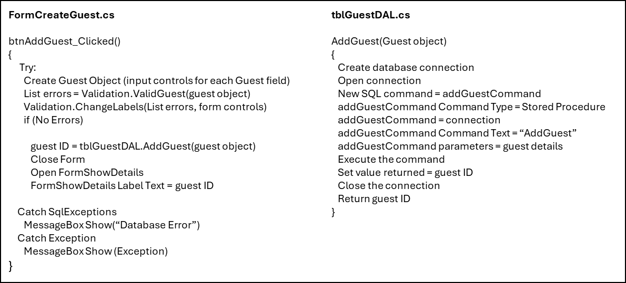Figure 5‑20 – Pseudocode to Add a Guest

### Adding a Booking

* The form passes through the input data to a method in the validation class which completes basic validation to check for any incorrect data types in the input so it can be identified before the object is created and the system can highlight the problem field to the user. This will prevent an exception being thrown when the program attempts to create an object with invalid data.
* If there is no invalid data the system makes a Booking object.
* It passes through the pod type to the method ReturnRelevantPodIDs from the tblPodDAL class which returns a list of the pod IDs with the required pod type.
* This list is then passed to the method ReturnVacentPods in the tblBookingDAL class which returns a list of all vacant pods of that type within the given date range.
* It assigns a boolean value to the method DoCourseDatesOverlapWithBooking from tblCourseGuests and passes through the booking object as a parameter which returns true if the guest is on a course and the course dates are within the pod booking dates. If the booking has AttendingCourse set to false, the Boolean is set to true regardless.
* If there are available pods, the booking objects pod ID is set to the first pod in the list of vacant pods.
* The booking object is passed to the ValidBooking method which validates the complex booking requirements specified in the user requirements.
* If the valid course Boolean is true, there are no logic errors and the guest exists the booking is added to the database and the discounts are applied, the booking ID and pod ID is displayed to the user and the form closes.
* If this is not true, the list of errors is displayed to the user.

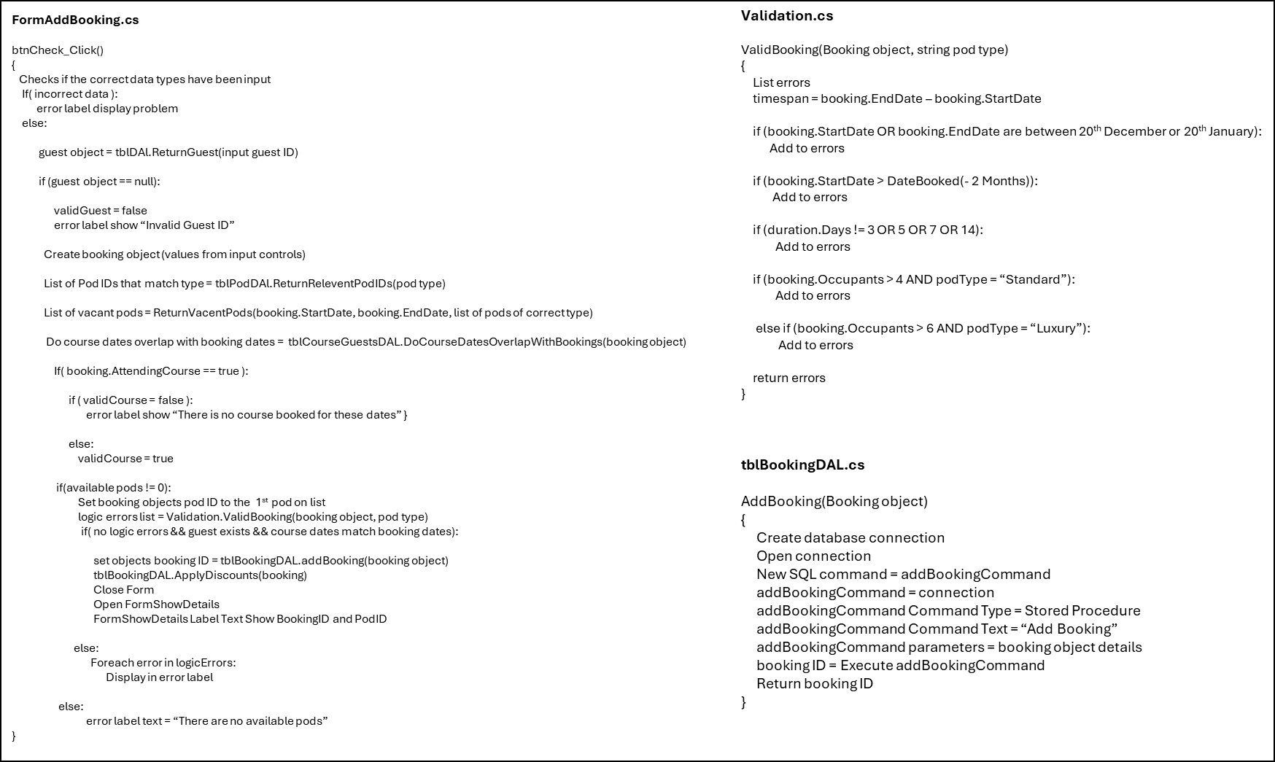Figure 5‑21 – Add Booking Pseudocode

### Applying Discounts

* Establishes a connection to the database
* Executes the SQL query which selects all records from tblBooking where the guest ID matches the guest ID of the booking object.
* An SQL reader object is used to count the rows returned, this method is called after the booking is added to the database, therefore there should be more than one booking with the given guest ID if they have made previous bookings.
* If there is more than one row returned, the discount variable is increased by two.
* If the booking objects start date is more than six months after the date they made the booking, the discount variable is increased by three.
* A connection is made to the database and an SQL query which updates the corresponding records ‘Discount’ field to the new discount is executed.

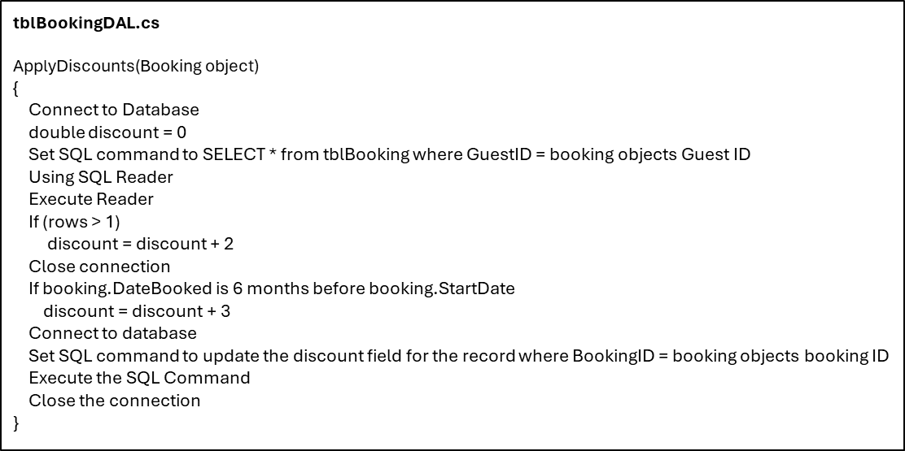Figure 5‑22 – Apply Discounts Pseudocode

### Updating a Booking

* This method will be called in the btnEdit_Click event method
* Similar to the Add Booking function, it first validates the input data to ensure it is of the correct type and will not throw an exception when the object is updated.
* If it is invalid, an error message will be displayed and the method will return.
* The booking object is created by passing through the input booking ID to a method which returns a booking object given the booking ID.
* If the returned booking object is null which means it does not exist in the database, the method displays an error message and returns.
* The booking object’s details are updated to the data input by the user.
* If the pod type or the date range has been changed, the program must use the same methods as used in Add Booking to assign new pods to the bookings, if there are no available pods with the specified type or date range the method will display the error and return.
* If the Attending Course value has been set to true, the program checks if the booking dates match the course dates, if they do validCourse is set to true, validCourse is always set to true when the Attending Course field is set to false.
* If there are no logic errors and the validCourse is true, the method will call the UpdateBooking method from tblBookingDAL and pass through the booking object, this will update the booking in the database with the new object.
* If there are errors they will be displayed.

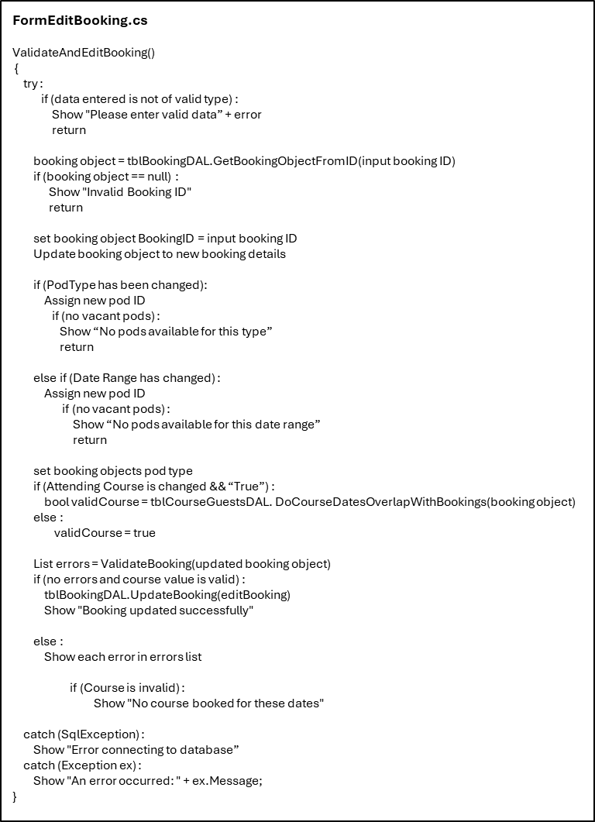Figure 5‑23 – Update Booking Pseudocode

### Returning a Guest Object Given the Guest ID

* This method returns a guest object when given the guest ID, this will be helpful throughout the system as it can be used to check if a guest ID is valid. If the method returns null, the guest ID is not present in the database.
* It uses an SQL data reader object which reads the data returned by the SQL query into the preexisting guest object then returns it.

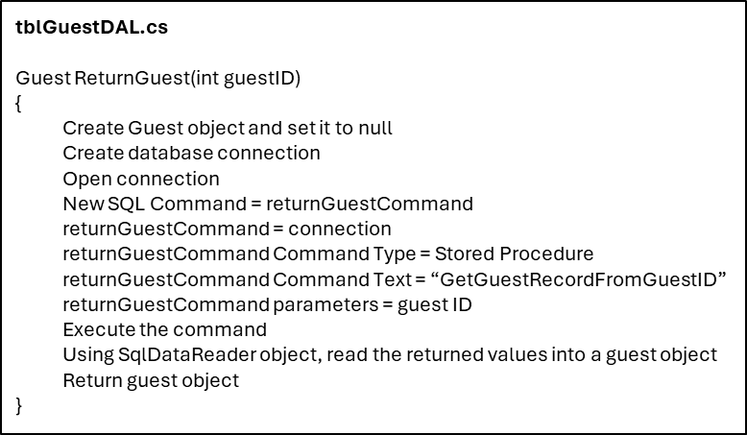Figure 5‑24 – Return Guest Object Pseudocode

### Selecting a Vacant Pod for A Booking

* The list returned by the ReturnRelevantPodIDs method is used as a parameter in the ReturnsVacentPodIDs method. ReturnRelevantPodIDs returns a list of all pod IDs with the pod type passed through to it as a parameter.
* The ReturnsVacentPods method iterates over this list in a foreach loop. It passes through the current pod ID and a set of dates as parameters to the stored procedure which will check if that pod is vacant in the given date range. If it is vacant it will add the pod ID to the list. This process occurs for each pod ID in the list.
* It returns the list of vacant pods within the date range.

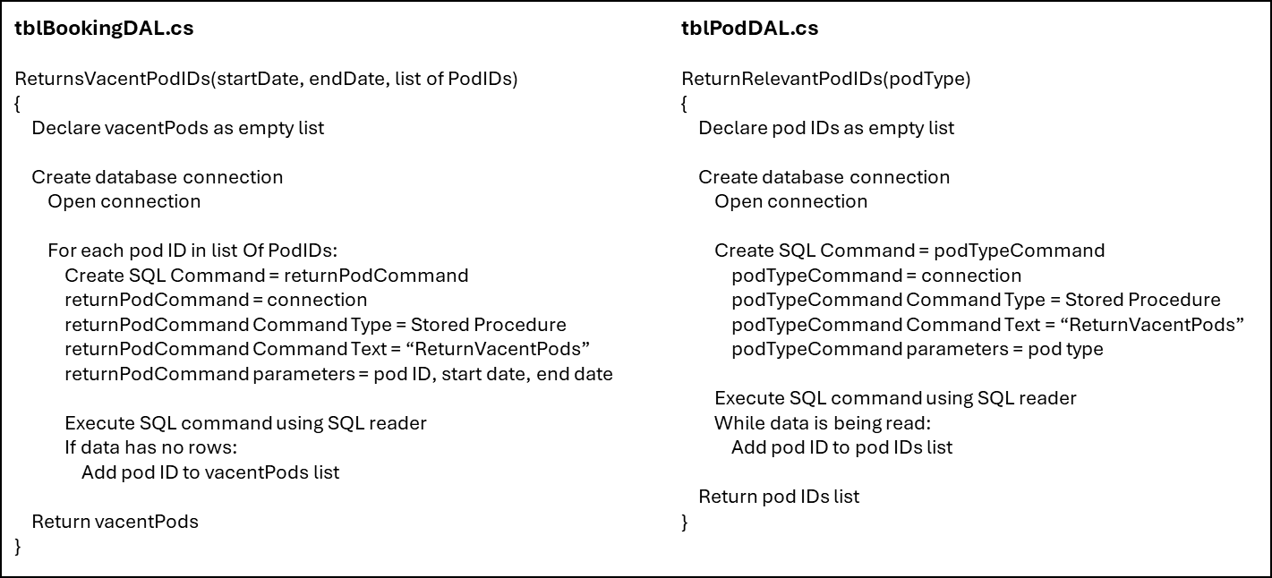Figure 5‑25 – Pod Assignment Pseudocode

### Checking if the Booking Dates Match the Course Dates

* Opens a connection to the database
* Passes through the guest ID as a parameter to a stored procedure
* Uses an SQL Reader object to read in all the course IDs of the courses that the given guest was enrolled in.
* For each course ID in the list, a stored procedure is called, and the booking objects start date, end date and the current course ID are passed through as parameters.
* The stored procedure checks if the given course’s dates are within the booking dates. If they are the command will return a record when executed. If it returns a record, the course ID is added to a list of courses which the guest is enrolled in, and dates fall within the given booking dates.
* If this list is not empty, the method will return true, if not it will return false.

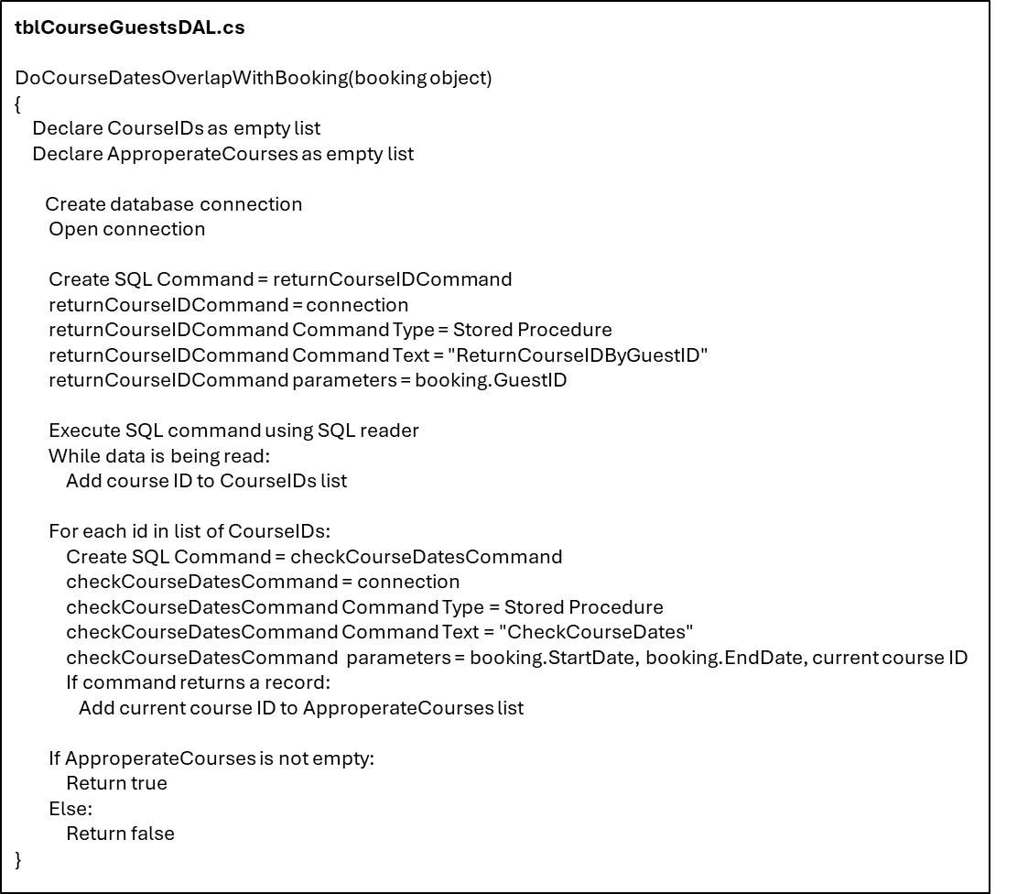Figure 5‑26 – Check Course Guests Pseudocode

### Deleting a Pod

* The system confirms the user would like to delete the pod as all bookings with the given pod ID will also be deleted.
* If they continue the program calls the DeletePod method which executes the stored procedure to delete a pod, if no pod is found with the given pod ID, no record is deleted so the method will return false.
* If the method returns true, a success message is displayed
* If the method returns false an error message is displayed.
* If the user inputs a value that is not an integer, the SystemException catch block will be executed and display an appropriate error message when the system throws an exception.

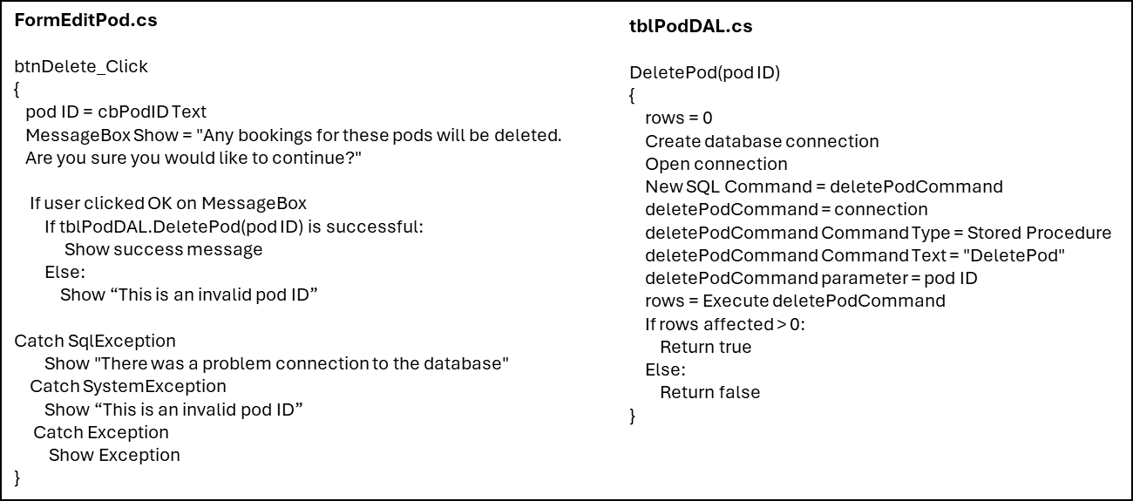Figure 5‑27 – Delete Pod Pseudocode

## Input-Process-Output

The Input-Process-Output Model is used widely in programming to describe an operation. The input is a requirement from the environment, for example a button being clicked or the text in a textbox being changed. This input prompts a process; a computation determined by the input which then elicits an output from the system. This model is helpful in visualising functionalities of the system; they form many small building blocks which when put together create software systems. The simplicity of this model aids in the design and implementation of the solution and the modularity concept promotes organisation in the development. The efficiency of the system can also be enhanced using this model to decrease the number of unnecessary computations.

What follows is a general overview of the forms. A more comprehensive understanding of the functionality is presented in the walkthroughs in Section 5.6.

### FormCreateGuest

|  |
| --- |
| **Input** |
| Guest details |
| **Process** |
| Validation of guest details |
| Guest is added to database |
| **Output** |
| Guest ID is displayed |
| Forecolour of the label that corresponds to incorrect input data turns red |
| Form is closed |

### FormViewGuest

|  |
| --- |
| **Input** |
| Guest ID |
| Guest surname and postcode |
| **Process** |
| Data Grid View is filtered by Guest ID |
| Data Grid View is filtered by surname and postcode |
| **Output** |
| Data Grid View shows required guest |
| Error message is shown |

### FormEditGuest

|  |
| --- |
| **Input** |
| Guest ID |
| Edited Guest details |
| **Process** |
| Retrieves guest details by guest ID |
| Updates guest details in database |
| Populates controls in the form with the corresponding guest details |
| **Output** |
| Displays an error message |
| Displays a success message |
| Shows all controls in form |

### FormAddBooking

|  |
| --- |
| **Input** |
| Booking details |
| **Process** |
| Validates booking |
| Adds booking to database |
| **Output** |
| Displays an error message |
| Displays the booking ID and pod ID |
| Closes the form |

### FormViewBooking

|  |
| --- |
| **Input** |
| Booking ID |
| Pod ID, start date and end date |
| **Process** |
| Filters the data grid view by booking ID |
| Filters the data grid view to show all bookings of the given pod ID within the date range |
| **Output** |
| Displays the required bookings in the data grid view |
| Shows an error message |

### FormEditBooking

|  |
| --- |
| **Input** |
| Booking ID |
| Field to be edited |
| New value for field |
| **Process** |
| Deletes the booking |
| Validates the booking |
| Edits the booking in the database |
| **Output** |
| Shows a confirmation message |
| Shows an error message |

### FormViewPod

|  |
| --- |
| **Input** |
| Pod ID |
| **Process** |
| Searches for the pod in the database and does a join to combine tblPod and tblPodDescription |
| **Output** |
| Shows a data grid view which contains the requested pod ID, pod type, pod description, maximum occupancy, and cost per person per night |
| Shows an error message |

### FormEditPod

|  |
| --- |
| **Input** |
| Pod ID |
| Pod Type |
| Description of a pod type |
| **Process** |
| Deletes a pod |
| Adds a pod of the given type |
| Edits an existing pods type |
| Edits the description of a pod type |
| **Output** |
| Shows a confirmation message |
| Shows an error message |

### FormReport

|  |
| --- |
| **Input** |
| Required report |
| **Process** |
| Generate requested report |
| **Output** |
| Shows the requested Report |

## End-User Design Feedback

Collecting feedback at the end of the design phase is an integral part of the V-model. This feedback will indicate any design changes that are necessary before implementing the solution. An online survey was used to collect feedback from 10 end-users on the design and usability of the system. The end-users included Ian Scott, employees of Lakeside Escapes, and employees of the hotel who are familiar with the business. This comprehensive user audit will increase the reliability of the results.

Figure 5‑28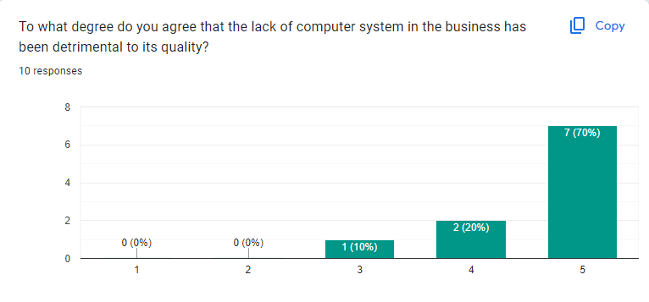 – End-User Design Form Question 1

This reinforces the original hypothesis that a computer system would benefit Lakeside Escapes and has shown that the employees are eager to embrace a new system.

Figure 5‑29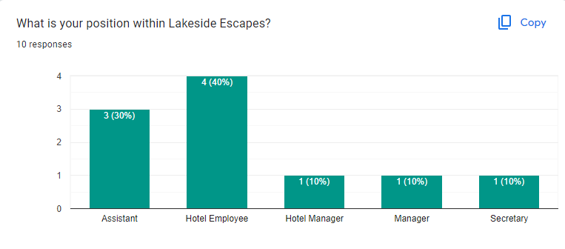 – End-User Design Form Question 2

Question 2 is helpful in analysing the source of feedback and if particular feedback should be given more or less weight.

Figure 5‑30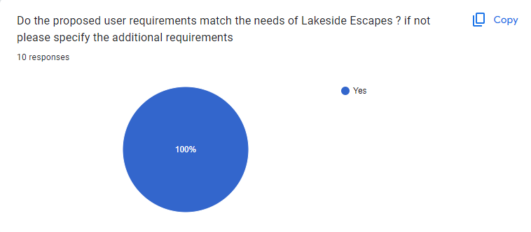 – End-User Design Form Question 3

This is excellent as it confirms that the initial user requirements are appropriate.

Figure 5‑31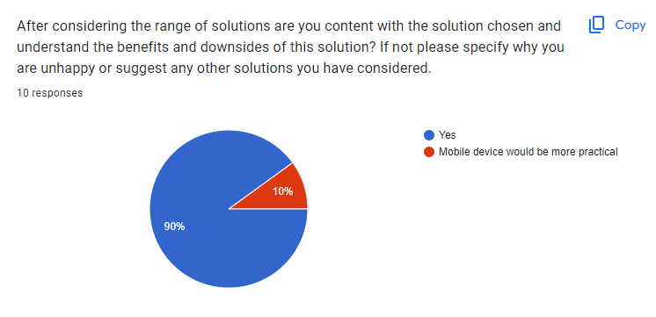 – End-User Design Form Question 4

The majority of feedback was content with the chosen solution hence it will remain as a Windows forms application despite the practicality of a mobile device.

Figure 5‑32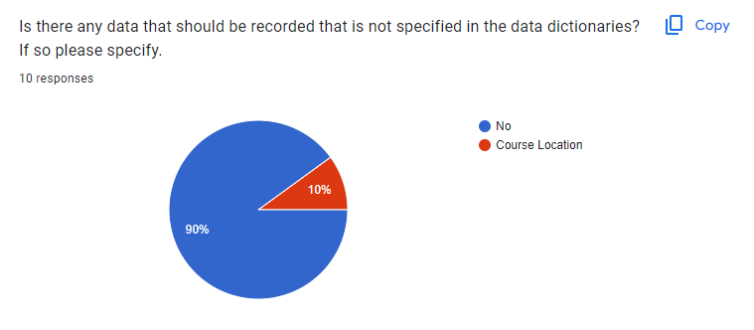 – End-User Design Form Question 5

The course location is not covered by this system as the data is not required to make a pod booking.

Figure 5‑33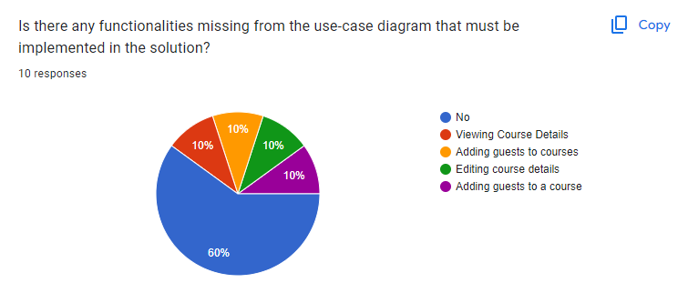 – End-User Design Form Question 6

All the functionalities relating to courses are not covered by this microsystem and would instead be implemented in an application for course booking.

Figure 5‑34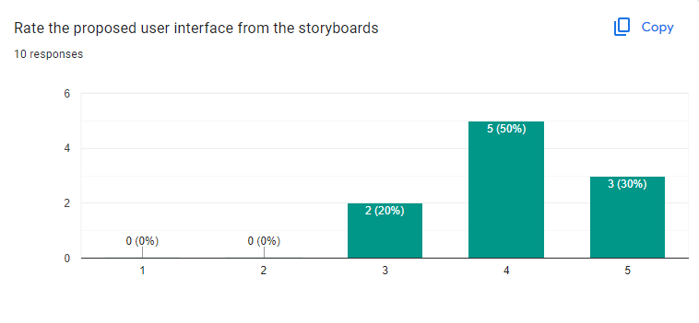 – End-User Design Form Question 7

This shows generally positive feedback regarding the graphical user interface.

Figure 5‑35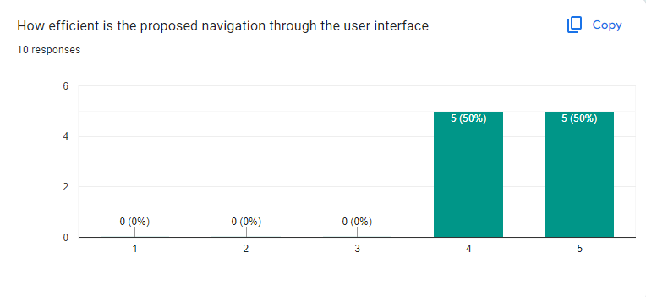 – End-User Design Form Question 8

Again, this showed positive feedback regarding the navigation component of the application.

Figure 5‑36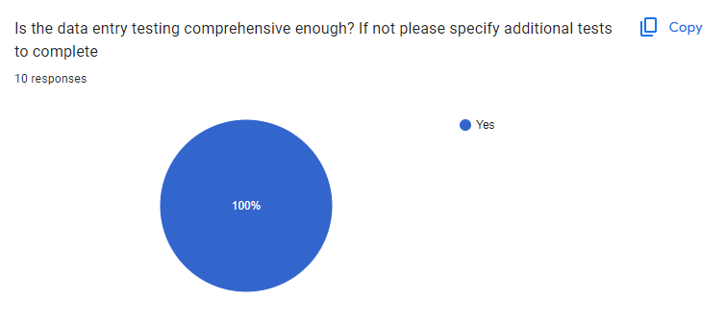 – End-User Design Form Question 9

Figure 5‑37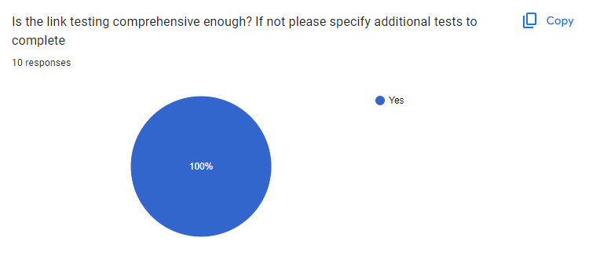 – End-User Design Form Question 10

Figure 5‑38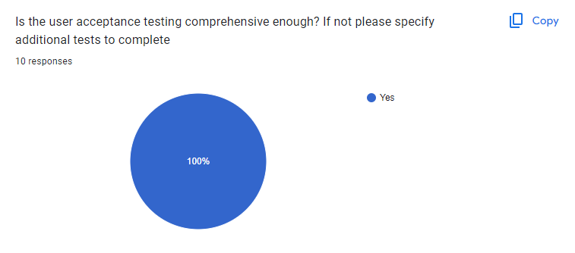 – End-User Design Form Question 11

This set of responses is positive and confirms that the test plan is exhaustive and should catch all potential errors with the solution.

Figure 5‑39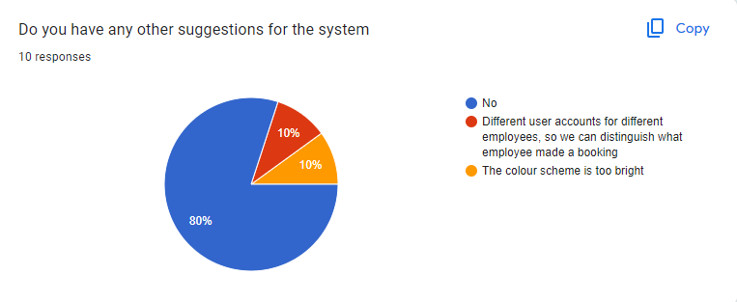 – End-User Design Form Question 12

User accounts were identified in the non-functional user requirements and unfortunately will not be within the scope, cost, or timescale of this project.

The majority of feedback received on the graphical user interface was positive and unfortunately this single response cannot warrant a change to the colour scheme.

# Testing

## Data Entry Testing

This testing was complete by the developer and all failed tests have been identified and amended.

### FormCreateGuest

|  |  |  |  |  |  |  |
| --- | --- | --- | --- | --- | --- | --- |
| *Test*  *Number* | *Description* | *Test Data Type* | *Test Data* | *Expected Outcome* | *Pass/*  *Fail* | *Actual Outcome* |
| 1.1.1 | Title | Valid | “Mr” | Accepted | Pass | Accepted |
| 1.1.2 | Erroneous | “5tFh_vh” | Rejected | Pass | Rejected |
| 1.2.1 | First Name | Valid | “Test” | Accepted | Pass | Accepted |
| 1.2.2 | Extreme | “TeSTttt” | Accepted | Pass | Accepted |
| 1.2.3 | Erroneous | “5tFh_vh” | Rejected | Pass | Rejected |
| 1.2.4 | Null | Rejected | Pass | Rejected |
| 1.2.5 | Length | “TestTestTestTestTestTestTestTestTestTestTest” | Rejected | Pass | Rejected |
| 1.3.1 | Surname | Valid | “Subject” | Accepted | Pass | Accepted |
| 1.3.2 | Extreme | “SubJECCt” | Accepted | Pass | Accepted |
| 1.3.3 | Erroneous | “5t64_vh” | Rejected | Pass | Rejected |
| 1.3.4 | Null | Rejected | Pass | Rejected |
| 1.3.5 | Length | “TestTestTestTestTestTestTestTestTestTestTest” | Rejected | Pass | Rejected |
| 1.4.1 | Email | Valid | “testsubject@gmail.com” | Accepted | Pass | Accepted |
| 1.4.2 | Extreme | “Test.SUBJECT@outlook.co.uk” | Accepted | Pass | Accepted |
| 1.4.3 | Erroneous | “test.com” | Rejected | Pass | Rejected |
| 1.4.4 | Null | Rejected | Pass | Rejected |
| 1.5.1 | Phone Number | Valid | “07775123456” | Accepted | Pass | Accepted |
| 1.5.2 | Extreme | “07775 123456” | Accepted | **Fail** | Rejected |
| 1.5.3 | Erroneous | “TesT_Data67” | Rejected | Pass | Rejected |
| 1.5.4 | Null | Rejected | Pass | Rejected |
| 1.5.5 | Length | “012345” | Rejected | Pass | Rejected |
| 1.5.6 | “0123456789101112” | Rejected | Pass | Rejected |
| 1.6.1 | Gender | Valid | “Male” | Accepted | Pass | Accepted |
| 1.6.2 | Erroneous | “65_Gender” | Rejected | Pass | Rejected |
| 1.7.1 | Address Line 1 | Valid | “1 Main Street” | Accepted | Pass | Accepted |
| 1.7.2 | Erroneous | Null | Rejected | Pass | Rejected |
| 1.7.3 | Length | “TestTestTestTestTestTestTestTestTestTestTest” | Rejected | Pass | Rejected |
| 1.8.1 | Address Line 2 | Valid | “Lisburn” | Accepted | Pass | Accepted |
| 1.8.2 | Erroneous | Null | Rejected | Pass | Rejected |
| 1.8.3 | Length | “TestTestTestTestTestTestTestTestTestTestTest” | Rejected | Pass | Rejected |
| 1.9.1 | County | Valid | “Armagh” | Accepted | Pass | Accepted |
| 1.9.2 | Extreme | “ARMAGH” | Accepted | Pass | Accepted |
| 1.9.3 | Erroneous | “Armagh_234” | Rejected | Pass | Rejected |
| 1.9.4 | Null | Rejected | Pass | Rejected |
| 1.9.5 | Length | “TestTestTestTestTestTestTestTest” | Rejected | Pass | Rejected |
| 1.10.1 | Country | Valid | “Northern Ireland” | Accepted | Pass | Accepted |
| 1.10.2 | Extreme | “NORTHERN-ireland” | Accepted | Pass | Accepted |
| 1.10.3 | Erroneous | “7823” | Rejected | Pass | Rejected |
| 1.10.4 | Null | Rejected | Pass | Rejected |
| 1.10.5 | Length | “TestTestTestTestTestTestTestTest” | Rejected | Pass | Rejected |
| 1.11.1 | Postcode | Valid | “BT20 3FG” | Accepted | Pass | Accepted |
| 1.11.2 | Extreme | “bt203fg” | Accepted | Pass | Accepted |
| 1.11.3 | Erroneous | Null | Rejected | Pass | Rejected |
| 1.11.4 | Length | “bt 76-FG56” | Rejected | Pass | Rejected |
| 1.11.5 | “BT50” | Rejected | Pass | Rejected |
| 1.12.1 | Date Of Birth | Valid | 01/01/1990 | Accepted | **Fail** | Rejected |
| 1.12.2 | Extreme | 07/03/2005 | Accepted | **Fail** | Rejected |
| 1.12.3 | Erroneous | 07/03/2024 | Rejected | **Fail** | Accepted |

|  |  |  |
| --- | --- | --- |
| Test Number | Description of Problem | Fixed |
| 1.5.2 | While being the same phone number except with a space and within the character count, the validation rejected the test data with the space as the ValidPhoneNumber method returns false when any character in the string is not a digit. The space is not a digit and was triggering the method to return false. | To fix this I created a new string in the method which removed any spaces from the original phone number string before it was validated. |

Figure 6‑1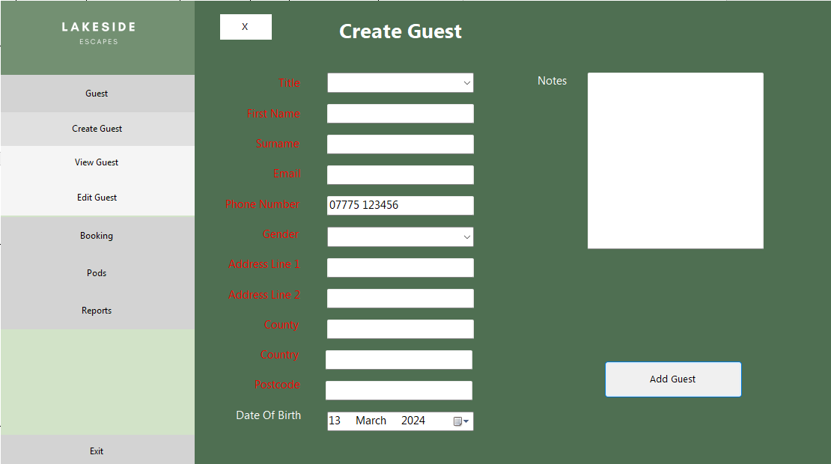 – Test 1.5.2 Failed

Figure 6‑2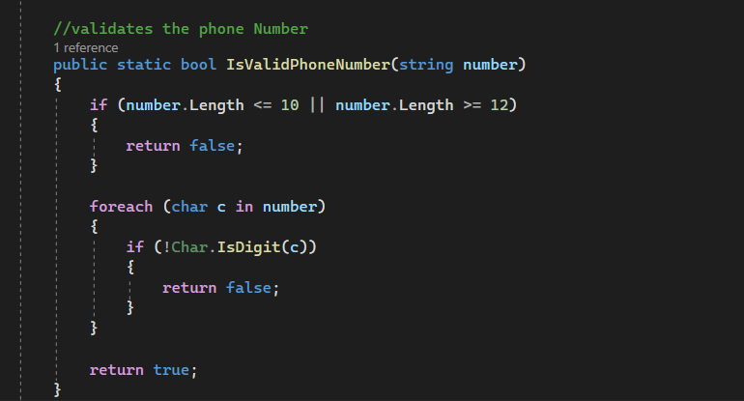 – Test 1.5.2 Original Code (Fail)

Figure 6‑3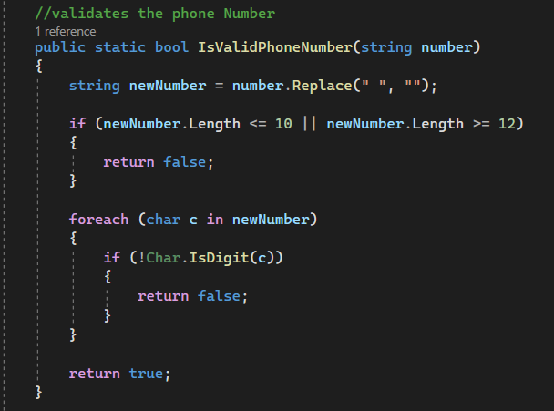 – Test 1.5.2 Revised Code (Pass)

Figure 6‑4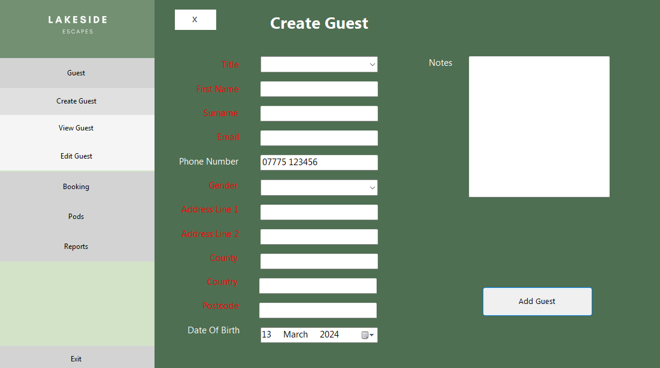 – Test 1.5.2 Passed

|  |  |  |
| --- | --- | --- |
| Test Number | Description of Problem | Fixed |
| 1.12.1 | The date 01/01/1990 means the guest is over 18 and the system should accept this as a valid date of birth. | The validation method added date of birth to the list of errors if the guest was over 18 instead of under 18. It used the incorrect operator. |
| 1.12.2 | The date 07/03/2005 means the guest is just 18 and the system should accept this as a valid date of birth. | The validation method used greater than operator(>) instead of greater than or equal to operator (>=) |
| 1.12.3 | The date 07/03/2024 means the guest is under 18 and the system should reject this as a valid date of birth. | This error was a result of the incorrect operator stated above in 1.12.1. |

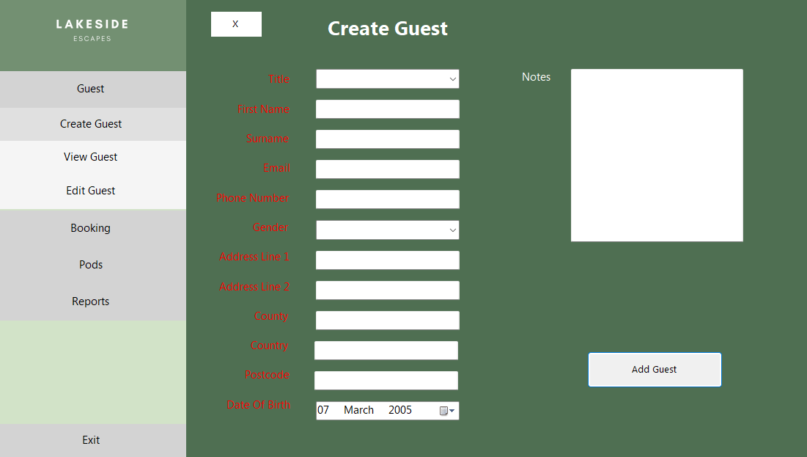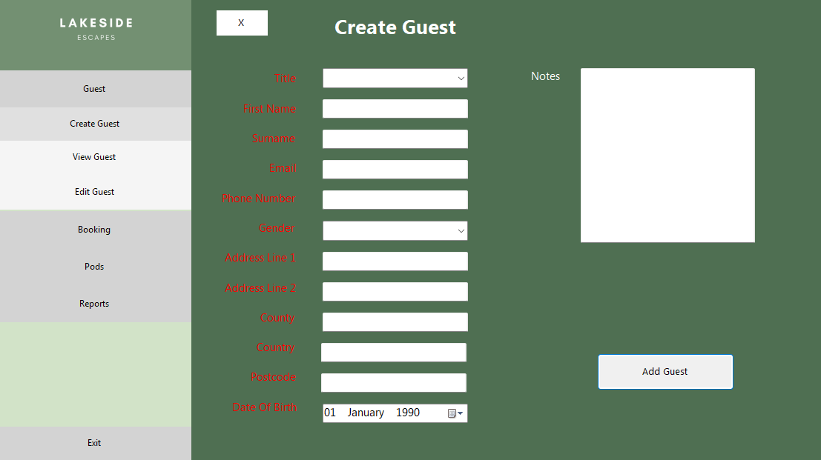Figure 6‑5 – Test 1.12.1 Failed

Figure 6‑6 – Test 1.12.2 Failed

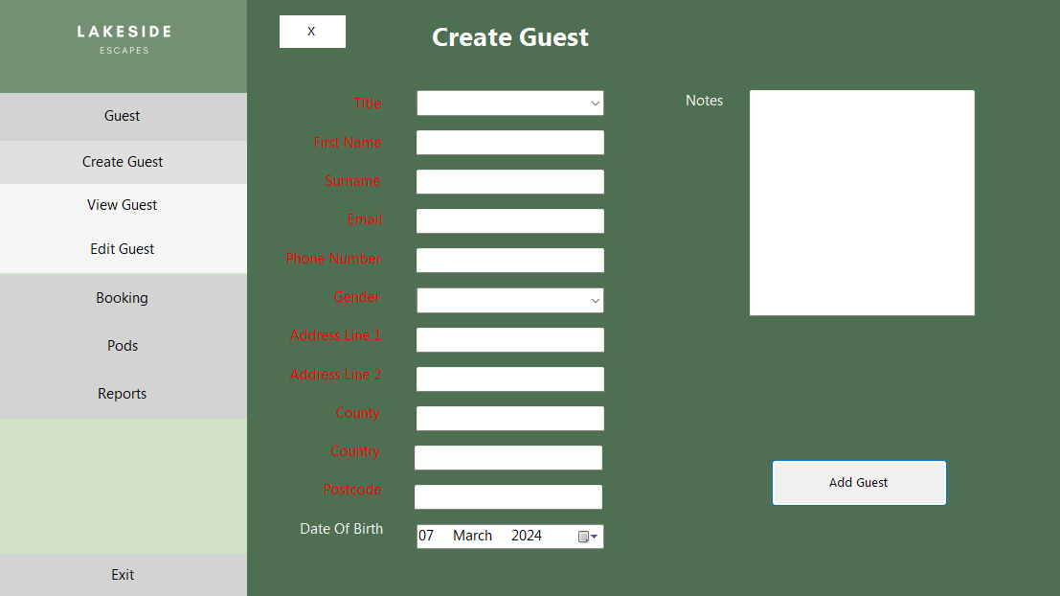

Figure 6‑7 – Test 1.12.3 Failed

Figure 6‑8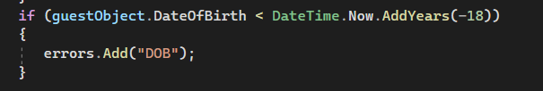 – Tests 1.12.1, 1.12.2, 1.12.3 Original Code (Fail)

Figure 6‑9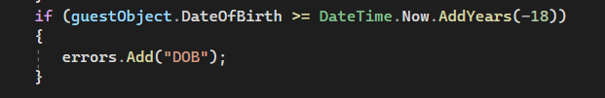 – Test 1.12.1, 1.12.2, 1.12.3 Revised Code (Pass)

Figure 6‑10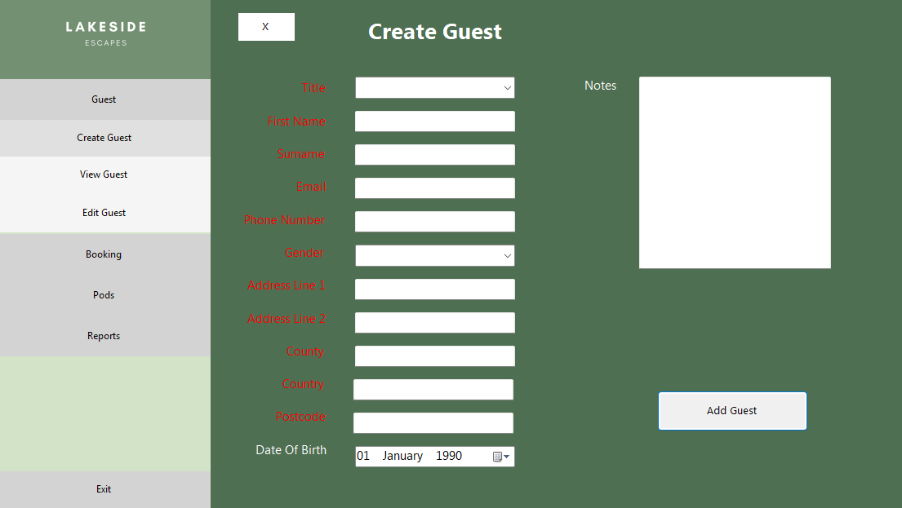 – Test 1.12.1 Passed

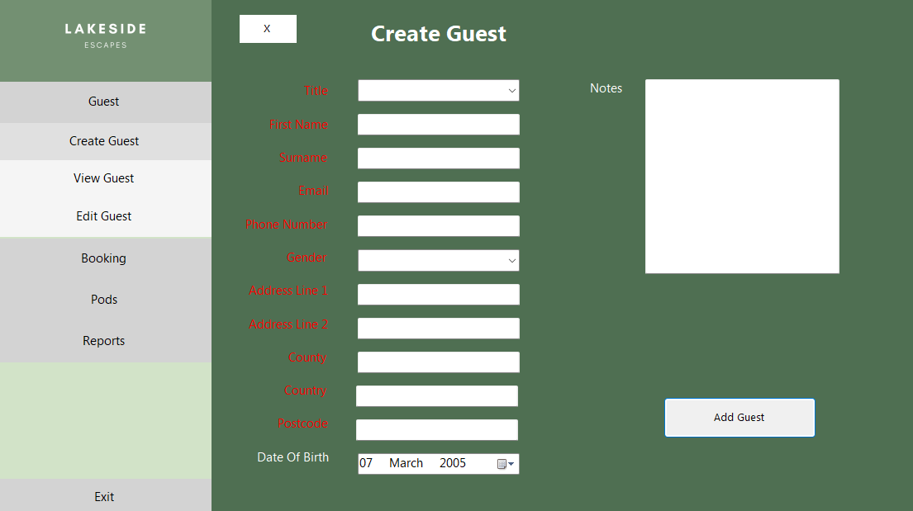Figure 6‑11 – Test 1.12.2 Passed

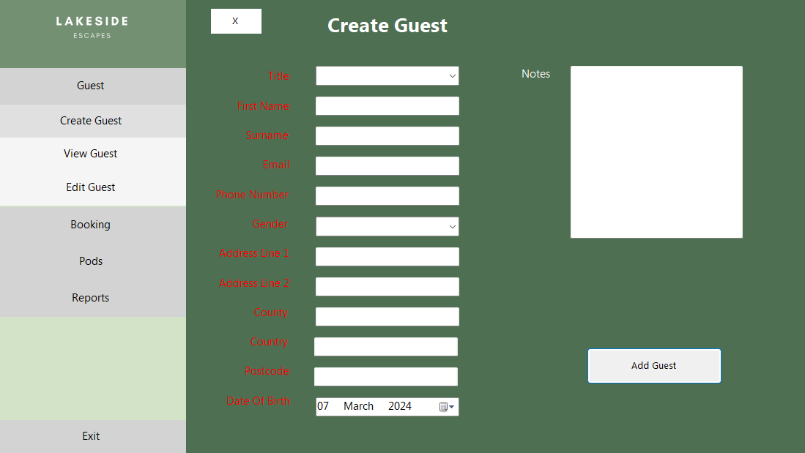Figure 6‑12 – Test 1.12.3 Passed

### FormAddBooking

|  |  |  |  |  |  |  |
| --- | --- | --- | --- | --- | --- | --- |
| *Test*  *Number* | *Description* | *Test Data Type* | *Test Data* | *Expected Outcome* | *Pass/Fail* | *Actual Outcome* |
| 2.1.1 | GuestID | Valid | “2” | Accepted | Pass | Accepted |
| 2.1.2 | Erroneous | “test-DATA” | Rejected | Pass | Rejected |
| 2.1.3 | Invalid Guest ID | “456678” | Rejected | Pass | Rejected |
| 2.2.1 | BookingDates | Valid | Start: 25/01/2025  End:  27/01/2025 | Accepted | Pass | Accepted |
| 2.2.2 | Not Two Months in Advance | Start: 27/04/2024  End:  29/04/2024 | Rejected | Pass | Rejected |
| 2.2.3 | Invalid duration | Start: 25/01/2025  End:  28/01/2025 | Rejected | Pass | Rejected |
| 2.2.4 | Made between 20th of December and 20th January | Start: 01/01/2025  End:  03/01/2025 | Rejected | **Fail** | Accepted |
| 2.3.1 | Number Of Occupants | Valid | 2 | Accepted | Pass | Accepted |
| 2.3.2 | Maximum 4 for Standard | 6 | Rejected | Pass | Rejected |
| 2.3.3 | Maximum 6 for Luxury | 8 | Rejected | Pass | Rejected |
| 2.3.4 | Erroneous | “Test---56” | Rejected | Pass | Rejected |
| 2.3.5 | Null | Rejected | Pass | Rejected |
| 2.4.1 | Attending Course | Valid | “True” | Accepted | Pass | Accepted |
| 2.4.2 | Erroneous | “Test” | Rejected | Pass | Rejected |
| 2.4.3 | Course Dates Do Not Match Pod Dates | “True” | Rejected | Pass | Rejected |
| 2.5.1 | Pod Type | Valid | “Standard” | Accepted | Pass | Accepted |
| 2.5.2 | Erroneous | “Test” | Rejected | Pass | Rejected |
| 2.6.1 | Deposit Paid | Valid | “True” | Accepted | Pass | Accepted |
| 2.6.2 | Erroneous | “Test” | Rejected | Pass | Rejected |

|  |  |  |
| --- | --- | --- |
| Test Number | Description of Problem | Fixed |
| 2.2.4 | The set of dates 01/01/25 and 03/01/25 are within the 20th of December and 20th of January and bookings should not be taken for these dates. | The logic behind the code was incorrect. A new, simpler approach checked if it the months of the start and end date were January or December, if they were, it checked if the day was between the 20th of December and 20th of January. |

Figure 6‑13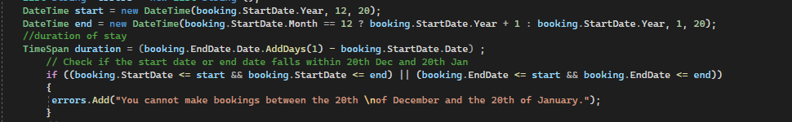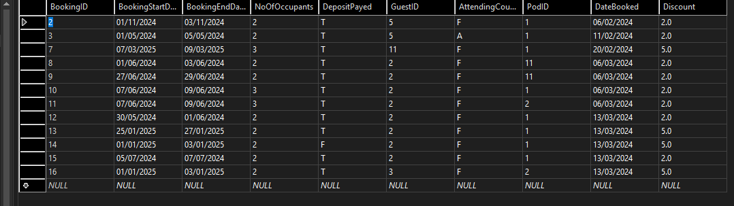 – Test 2.2.4 Failed (See BookingID 16)

Figure 6‑14 – Test 2.2.4 Original Code (Fail)

Figure 6‑15 – Test 2.2.4 Revised Code (Pass)

Figure 6‑16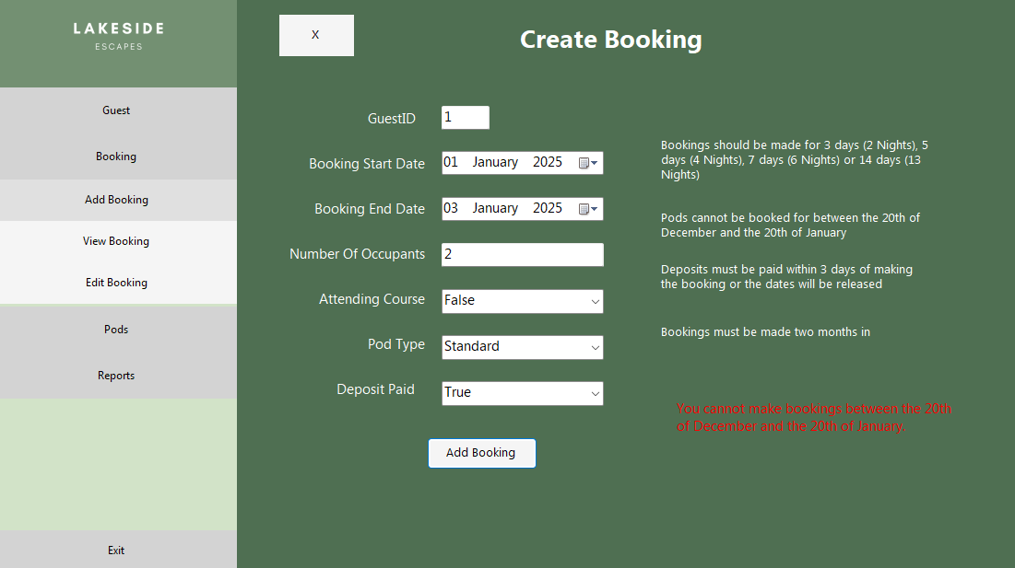 – Test 2.2.4 Passed

### FormEditPods

|  |  |  |  |  |  |  |
| --- | --- | --- | --- | --- | --- | --- |
| *Test*  *Number* | *Description* | *Test Data Type* | *Test Data* | *Expected Outcome* | *Pass/Fail* | *Actual Outcome* |
| 3.1.1 | Input Pod Type (Combo-Box) | Valid | “Standard” | Accepted | Pass | Accepted |
| 3.1.2 | Erroneous | “Test” | Rejected | Pass | Rejected |
| 3.2.1 | Input Pod ID  (Combo-Box) | Valid | “1” | Accepted | Pass | Accepted |
| 3.2.2 | Erroneous | “Test” | Rejected | Pass | Rejected |
| 3.3.1 | Input Pod Cost | Valid | 23 | Accepted | Pass | Accepted |
| 3.3.2 | Erroneous | Null | Rejected | Pass | Rejected |
| 3.3.3 |  | “Test” | Rejected | Pass | Rejected |

### FormViewGuest

|  |  |  |  |  |  |  |
| --- | --- | --- | --- | --- | --- | --- |
| *Test*  *Number* | *Description* | *Test Data Type* | *Test Data* | *Expected Outcome* | *Pass/Fail* | *Actual Outcome* |
| 4.1.1 | Input Guest ID | Valid | “2” | Accepted | Pass | Accepted |
| 4.1.2 | Erroneous | “test-DATA” | Rejected | **Fail** | Rejected but no error message |
| 4.1.3 | Invalid Guest ID | “456678” | Rejected | Pass | Rejected |

|  |  |  |
| --- | --- | --- |
| Test Number | Description of Problem | Fixed |
| 4.1.2 | The system rejected the invalid guest ID data but did not inform the user | The code for the error label to display the error was placed in the else statement |

Figure 6‑17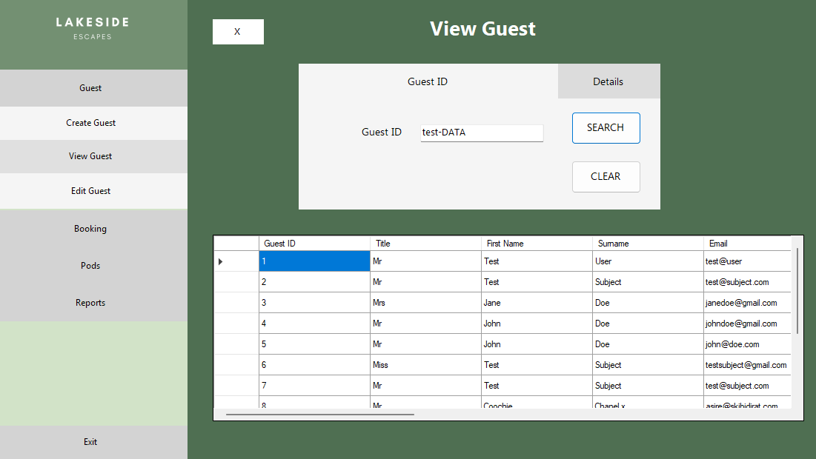 – Test 4.1.2 Failed

Figure 6‑18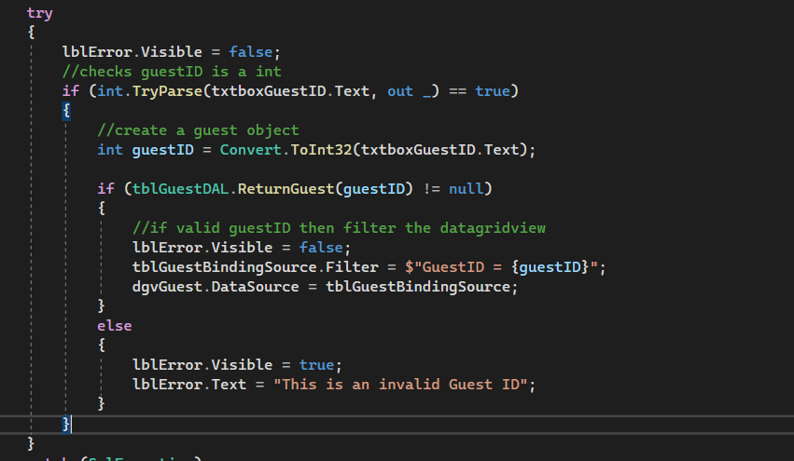 –Test 4.1.2 Code Original Code (Fail)

Figure 6‑19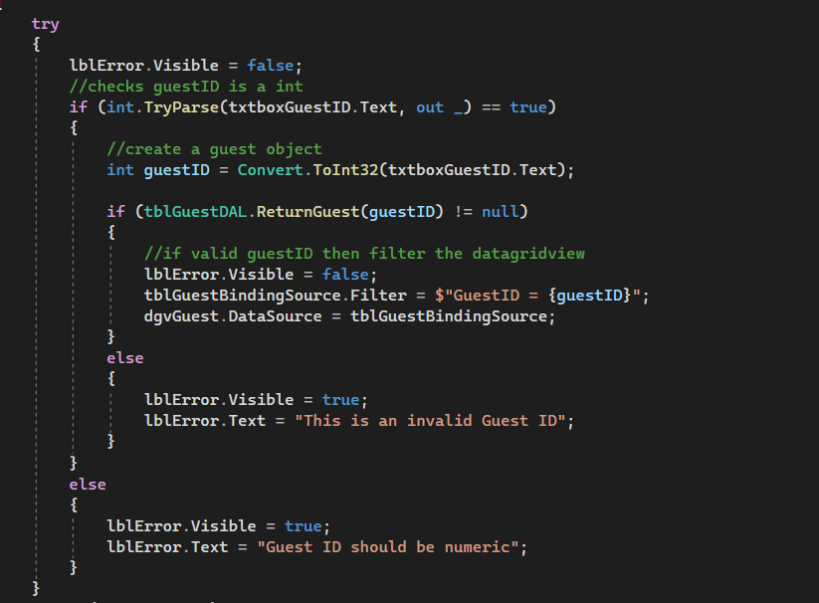 – Test 4.1.2 Revised Code (Pass)

Figure 6‑20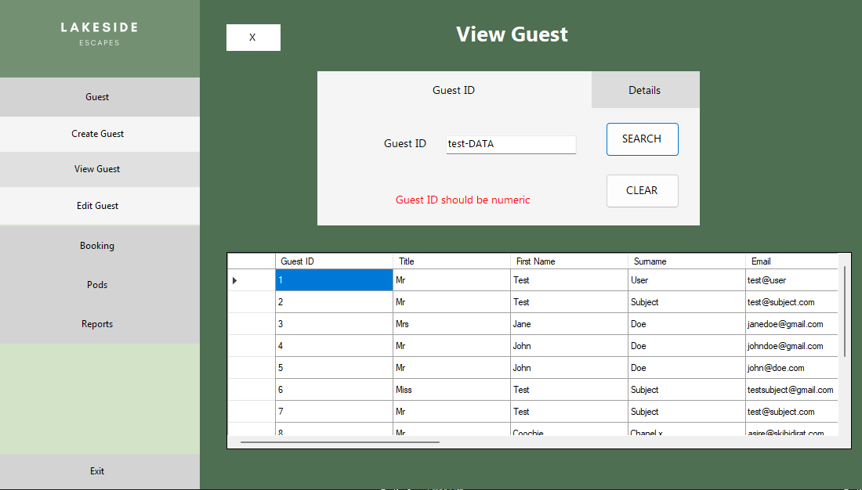 – Test 4.1.2 Passed

### FormEditGuest

|  |  |  |  |  |  |  |
| --- | --- | --- | --- | --- | --- | --- |
| *Test*  *Number* | *Description* | *Test Data Type* | *Test Data* | *Expected Outcome* | *Pass/*  *Fail* | *Actual Outcome* |
| 5.1.1 | Input Guest ID | Valid | “2” | Accepted | Pass | Accepted |
| 5.1.2 | Erroneous | “test-DATA” | Rejected | Pass | Rejected |
| 5.1.3 | Invalid Guest ID | “456678” | Rejected | Pass | Rejected |
| 5.2.1 | Title | Valid | “Mr” | Accepted | Pass | Accepted |
| 5.2.2 | Erroneous | “5tFh_vh” | Rejected | Pass | Rejected |
| 5.3.1 | First Name | Valid | “Test” | Accepted | Pass | Accepted |
| 5.3.2 | Extreme | “TeSTttt” | Accepted | Pass | Accepted |
| 5.3.3 | Erroneous | “5tFh_vh” | Rejected | Pass | Rejected |
| 5.3.4 | Null | Rejected | Pass | Rejected |
| 5.3.5 | Length | “TestTestTestTestTestTestTestTestTestTestTest” | Rejected | Pass | Rejected |
| 5.4.1 | Surname | Valid | “Subject” | Accepted | Pass | Accepted |
| 5.4.2 | Extreme | “SubJECCt” | Accepted | Pass | Accepted |
| 5.4.3 | Erroneous | “5t64_vh” | Rejected | Pass | Rejected |
| 5.4.4 | Null | Rejected | Pass | Rejected |
| 5.4.5 | Length | “TestTestTestTestTestTestTestTestTestTestTest” | Rejected | Pass | Rejected |
| 5.5.1 | Email | Valid | “testsubject@gmail.com” | Accepted | Pass | Accepted |
| 5.5.2 | Extreme | “Test.SUBJECT@outlook.co.uk” | Accepted | Pass | Accepted |
| 5.5.3 | Erroneous | “test.com” | Rejected | Pass | Rejected |
| 5.5.4 | Null | Rejected | Pass | Rejected |
| 5.6.1 | Phone Number | Valid | “07775123456” | Accepted | Pass | Accepted |
| 5.6.2 | Extreme | “07775 123456” | Accepted | Pass | Accepted |
| 5.6.3 | Erroneous | “TesT_Data67” | Rejected | Pass | Rejected |
| 5.6.4 | Null | Rejected | Pass | Rejected |
| 5.6.5 | Length | “012345” | Rejected | Pass | Rejected |
| 5.6.6 | “0123456789101112” | Rejected | Pass | Rejected |
| 5.7.1 | Gender | Valid | “Male” | Accepted | Pass | Accepted |
| 5.7.2 | Erroneous | “65_Gender” | Rejected | Pass | Rejected |
| 5.8.1 | Address Line 1 | Valid | “1 Main Street” | Accepted | Pass | Accepted |
| 5.8.2 | Erroneous | Null | Rejected | Pass | Rejected |
| 5.8.3 | Length | “TestTestTestTestTestTestTestTestTestTestTest” | Rejected | Pass | Rejected |
| 5.9.1 | Address Line 2 | Valid | “Lisburn” | Accepted | Pass | Accepted |
| 5.9.2 | Erroneous | Null | Rejected | Pass | Rejected |
| 5.9.3 | Length | “TestTestTestTestTestTestTestTestTestTestTest” | Rejected | Pass | Rejected |
| 5.10.1 | County | Valid | “Armagh” | Accepted | Pass | Accepted |
| 5.10.2 | Extreme | “ARMAGH” | Accepted | Pass | Accepted |
| 5.10.3 | Erroneous | “Armagh_234” | Rejected | Pass | Rejected |
| 5.10.4 | Null | Rejected | Pass | Rejected |
| 5.10.5 | Length | “TestTestTestTestTestTestTestTest” | Rejected | Pass | Rejected |
| 5.11.1 | Country | Valid | “Northern Ireland” | Accepted | Pass | Accepted |
| 5.11.2 | Extreme | “NORTHERN-ireland” | Accepted | Pass | Accepted |
| 5.11.3 | Erroneous | “7823” | Rejected | Pass | Rejected |
| 5.11.4 | Null | Rejected | Pass | Rejected |
| 5.11.5 | Length | “TestTestTestTestTestTestTestTest” | Rejected | Pass | Rejected |
| 5.12.1 | Postcode | Valid | “BT20 3FG” | Accepted | Pass | Accepted |
| 5.12.2 | Extreme | “bt203fg” | Accepted | Pass | Accepted |
| 5.12.3 | Erroneous | Null | Rejected | Pass | Rejected |
| 5.12.4 | Length | “bt 76-FG56” | Rejected | Pass | Rejected |
| 5.13.1 | Date Of Birth | Valid | 01/01/1990 | Accepted | Pass | Accepted |
| 5.13.2 | Extreme | 07/03/2005 | Accepted | Pass | Accepted |
| 5.13.3 | Erroneous | 07/01/2010 | Rejected | Pass | Rejected |

Note: FormEditGuest uses the same validation methods as the FormCreateGuest from the Validation class and hence was not expected to present any errors.

### FormEditBooking

|  |  |  |  |  |  |  |
| --- | --- | --- | --- | --- | --- | --- |
| *Test*  *Number* | *Description* | *Test Data Type* | *Test Data* | *Expected Outcome* | *Pass/Fail* | *Actual Outcome* |
| 6.1.1 | Input Booking ID | Valid | “2” | Accepted | Pass | Accepted |
| 6.1.2 | Erroneous | “test-DATA” | Rejected | Pass | Rejected |
| 6.1.3 | Invalid Booking ID | “456678” | Rejected | Pass | Rejected |
| 6.2.1 | GuestID | GuestID | Valid | “2” | Accepted | Pass |
| 6.2.2 | Erroneous | Erroneous | “test-DATA” | Rejected | Pass |
| 6.2.3 | Invalid Guest ID | Invalid Guest ID | “456678” | Rejected | Pass |
| 6.3.1 | BookingDates | Valid | Start: 25/01/2025  End:  27/01/2025 | Accepted | Pass | Accepted |
| 6.3.2 | Not Two Months in Advance | Start: 27/04/2024  End:  29/04/2024 | Rejected | Pass | Rejected |
| 6.3.3 | Invalid duration | Start: 25/01/2025  End:  28/01/2025 | Rejected | Pass | Rejected |
| 6.3.4 | Made between 20th of December and 20th January | Start: 01/01/2025  End:  03/01/2025 | Rejected | Pass | Rejected |
| 6.4.1 | Number Of Occupants | Valid | 2 | Accepted | Pass | Accepted |
| 6.4.2 | Maximum 4 for Standard | 6 | Rejected | Pass | Rejected |
| 6.4.3 | Maximum 6 for Luxury | 8 | Rejected | Pass | Rejected |
| 6.4.4 | Erroneous | “Test---56” | Rejected | Pass | Rejected |
| 6.4.5 | Null | Rejected | Pass | Rejected |
| 6.5.1 | Attending Course | Valid | “True” | Accepted | Pass | Accepted |
| 6.5.2 | Erroneous | “Test” | Rejected | Pass | Rejected |
| 6.5.3 | Course Dates Do Not Match Pod Dates | “True” | Rejected | Pass | Rejected |
| 6.6.1 | Pod Type | Valid | “Standard” | Accepted | Pass | Accepted |
| 6.6.2 | Erroneous | “Test” | Denied | Pass | Rejected |
| 6.7.1 | Deposit Paid | Valid | “True” | Accepted | Pass | Accepted |
| 6.7.2 | Erroneous | “Test” | Denied | Pass | Accepted |

Note: FormEditBooking uses the same validation methods as the FormAddBooking from the Validation class and hence was not expected to present any errors.

### FormViewBooking

|  |  |  |  |  |  |  |
| --- | --- | --- | --- | --- | --- | --- |
| *Test*  *Number* | *Description* | *Test Data Type* | *Test Data* | *Expected Outcome* | *Pass/Fail* | *Actual Outcome* |
| 7.1.1 | Input Booking ID | Valid | “2” | Accepted | Pass | Accepted |
| 7.1.2 | Erroneous | “test-DATA” | Rejected | Pass | Rejected |
| 7.1.3 | Invalid Booking ID | “456678” | Rejected | Pass | Rejected |
| 7.2.1 | Input Pod ID | Valid | “2” | Accepted | Pass | Accepted |
| 7.2.2 | Erroneous | “test__;” | Rejected | **Fail** | Rejected |
| 7.2.3 | Invalid Pod ID | “456678” | Rejected | Pass | Rejected |

|  |  |  |
| --- | --- | --- |
| *Test Number* | *Description of Problem* | *Fixed* |
| 7.2.2 | The system threw an exception when the user input the incorrect data type. Incorrect error handling had been used in the search button’s clicked event method. InvalidCastException instead of FormatException was used and no Exception block was implemented below to catch remaining errors. | The method now has a FormatException catch block to catch any errors due to incorrect data types and an Exception catch block has been implemented to catch any unforeseen errors and prevent the system crashing |

Figure 6‑21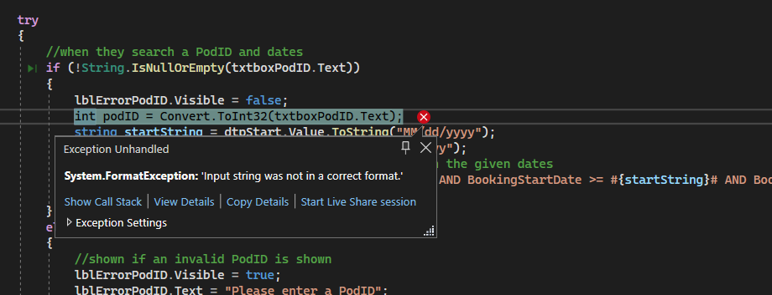 –Test 8.1.2 Original Code (Fail)

Figure 6‑22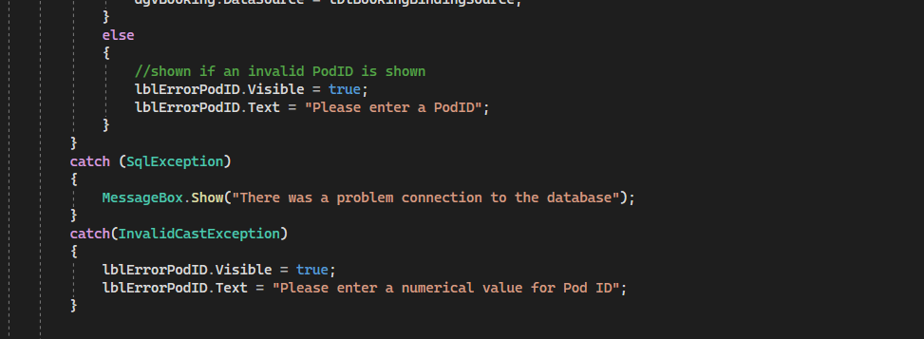 – Test 8.1.2 Original Code (Fail)

Figure 6‑23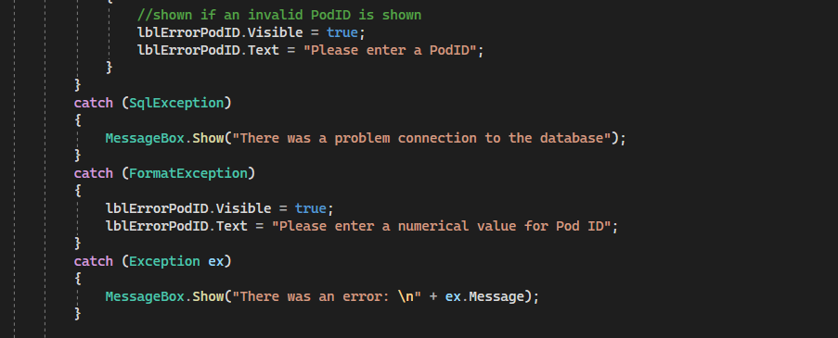 – Test 8.1.2 Revised Code (Pass)

Figure 6‑24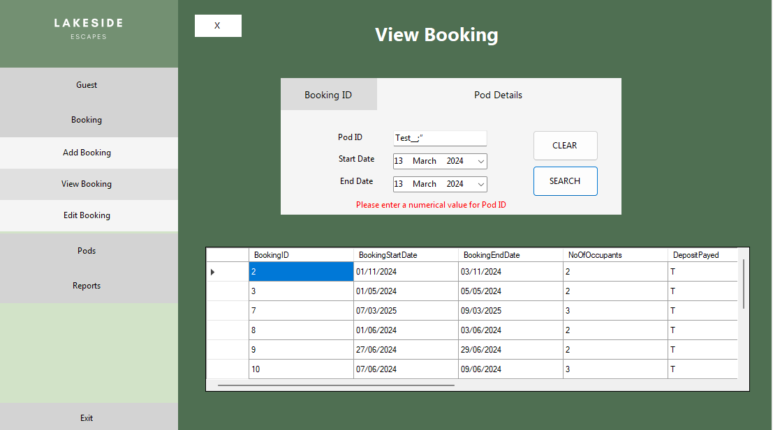 – Test 8.1.2 Passed

### FormViewPod

|  |  |  |  |  |  |  |  |  |  |
| --- | --- | --- | --- | --- | --- | --- | --- | --- | --- |
| *Test*  *Number* | | *Description* | *Test Data Type* | *Test Data* | *Expected Outcome* | | *Pass/Fail* | *Actual Outcome* | |
| 8.1.1 | | Select Pod ID (Combo-Box) | Valid | 2 | Accepted | | Pass | Accepted | |
| 8.1.2 | | Erroneous | “Test__;” | Rejected | | **Fail** | System threw an exception | |
| *Test Number* | *Description of Problem* | | | | | *Fixed* | | |
| 8.1.2 | The system threw an exception when the user input the incorrect data type. The developer had failed to implement error handling in this form. | | | | | Error handling has been implemented and the system displays an error message when an invalid pod ID is input. | | |

Figure 6‑25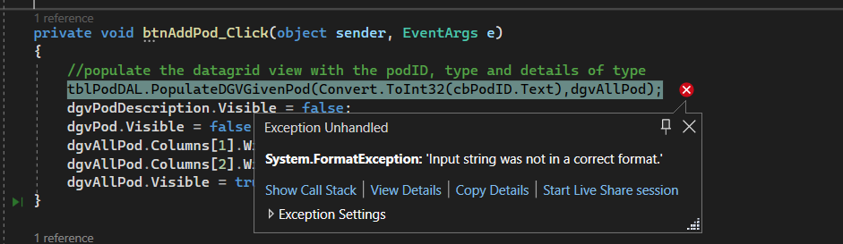 – Test 8.1.2 Original Code (Fail)

Figure 6‑26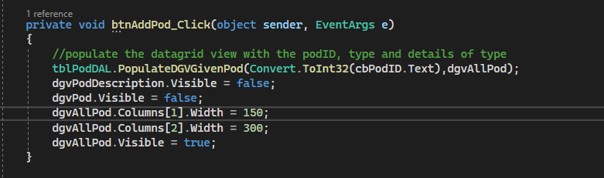 –Test 8.1.2 Original Code (Fail)

Figure 6‑27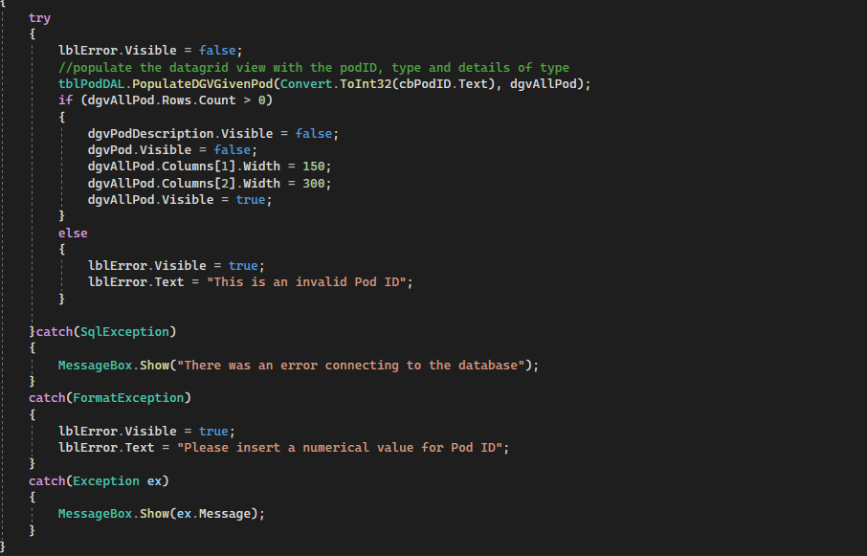 – Test 8.1.2 Revised Code (Pass)

Figure 6‑28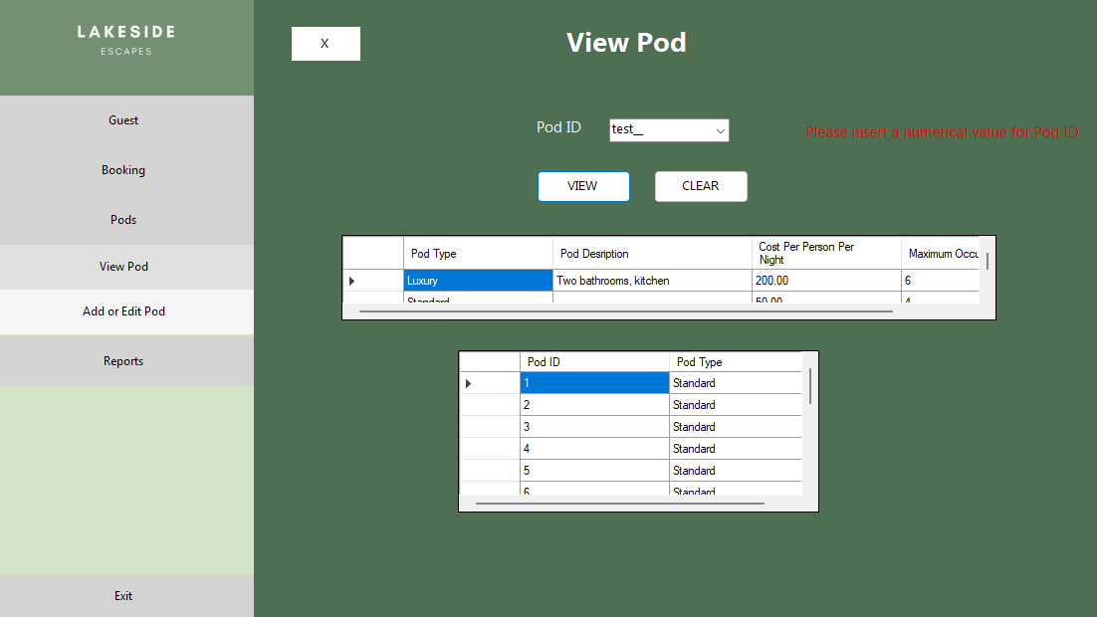 – Test 8.1.2 Passed

Link Testing

### FormMenu

|  |  |  |  |  |
| --- | --- | --- | --- | --- |
| *Test*  *Number* | *Description* | *Expected Outcome* | *Pass/Fail* | *Actual Outcome* |
| 9.1 | btnCreateGuest is clicked | FormCreateGuest will be opened in the menu form, btnCreateGuest’s BackColour will become #E0E0E0 | Pass | FormCreateGuest was opened in the menu form, btnCreateGuest’s BackColour became #E0E0E0 |
| 9.2 | btnViewGuest is clicked | FormViewGuest will be opened in the menu form, btnViewGuest’s BackColour will become #E0E0E0 | Pass | FormViewGuest was opened in the menu form, btnViewGuest’s BackColour became #E0E0E0 |
| 9.3 | btnEditGuest is clicked | FormEditGuest will be opened in the menu form, btnEditGuest’s BackColour will become #E0E0E0 | Pass | FormEditGuest was opened in the menu form, btnEditGuest’s BackColour became #E0E0E0 |
| 9.4 | btnAddBooking is clicked | FormAddBooking will be opened in the menu form, btnAddBooking’s BackColour will become #E0E0E0 | Pass | FormAddBooking was opened in the menu form, btnAddBooking’s BackColour became #E0E0E0 |
| 9.5 | btnViewBooking is clicked | FormViewBooking will be opened in the menu form, btnViewBooking’s BackColour will become #E0E0E0 | Pass | FormViewBooking was opened in the menu form, btnViewBooking’s BackColour became #E0E0E0 |
| 9.6 | btnEditBooking is clicked | FormEditBooking will be opened in the menu form, btnEditBooking’s BackColour will become #E0E0E0 | Pass | FormEditBooking was opened in the menu form, btnEditBooking’s BackColour became #E0E0E0 |
| 9.7 | btnViewPod is clicked | FormViewPod will be opened in the menu form, btnViewPod’s BackColour will become #E0E0E0 | Pass | FormViewPod was opened in the menu form, btnViewPod’s BackColour became #E0E0E0 |
| 9.8 | btnEditPod is clicked | FormEditPod will be opened in the menu form, btnEditPod’s BackColour will become #E0E0E0 | Pass | FormEditPod was opened in the menu form, btnEditPod’s BackColour became #E0E0E0 |
| 9.9 | btnReport | FormReport will be opened in the menu form | Pass | FormReport was opened in the menu form |
| 9.10 | btnExit is clicked | The program will close | Pass | The program closed |

### FormCreateGuest

|  |  |  |  |  |
| --- | --- | --- | --- | --- |
| *Test*  *Number* | *Description* | *Expected Outcome* | *Pass/Fail* | *Actual Outcome* |
| 10.1 | btnAddGuest is clicked with valid data input in the controls | FormShowDetails will open, display the Guest ID and FormCreateGuest will close, btnCreateGuest’s backcolour will return to WhiteSmoke | **Fail** | FormShowDetails opened and displayed the Guest ID, FormCreateGuest was closed but btnCreateGuest’s BackColour remained #E0E0E0 |
| 10.2 | btnExit is clicked | FormCreateGuest will close, btnCreateGuest’s backcolour will return to WhiteSmoke | Pass | FormCreateGuest was closed |

|  |  |  |
| --- | --- | --- |
| *Test Number* | *Description of Problem* | *Fixed* |
| 10.1 | btnCreateGuest failed to return to the initial backcolour when the form was closed after the user added a guest. | The developer had failed to implement the code in the btnAddGuest clicked event method, it had only been implemented in the btnExit Click event method. |

Figure 6‑29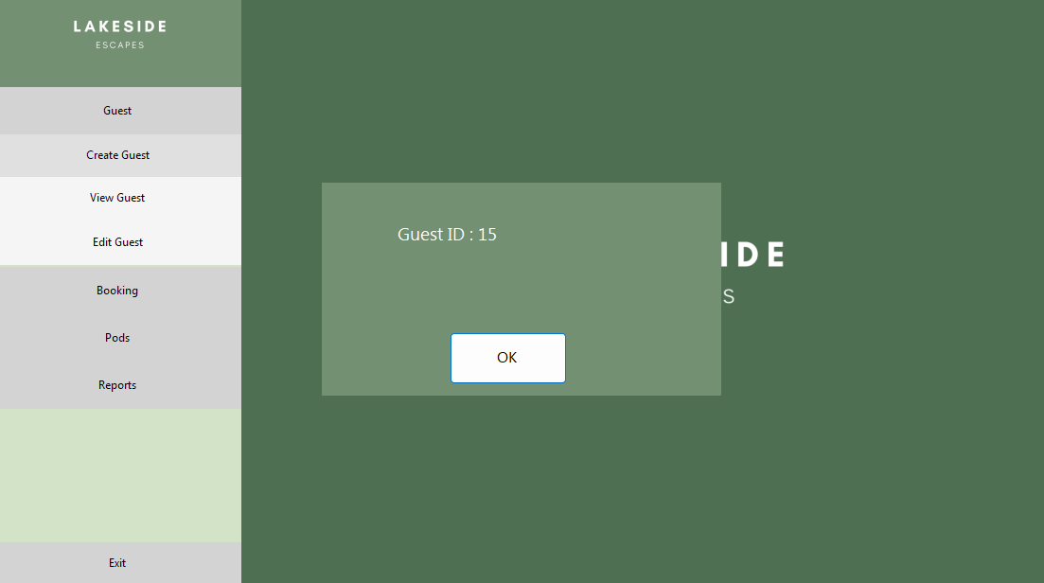 –Test 10.1 Failed

Figure 6‑30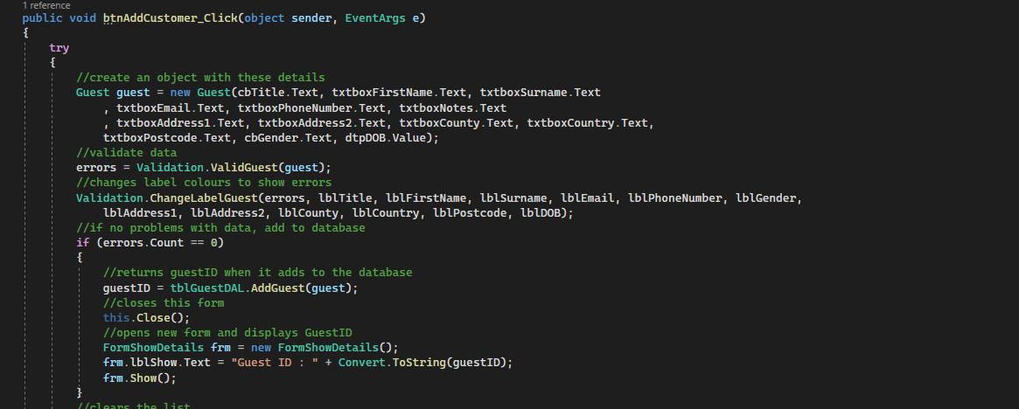 –Test 9.1 Original Code (Fail)

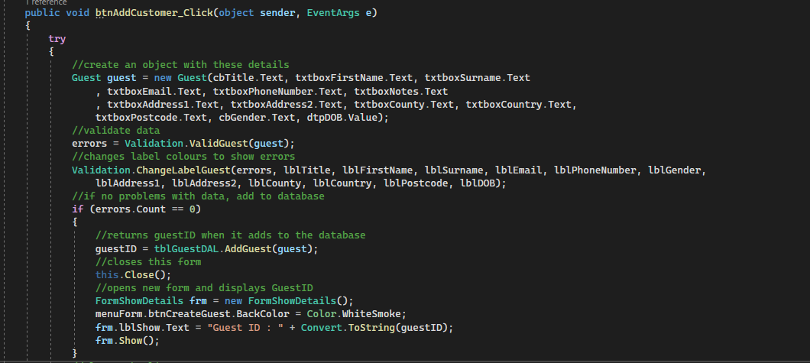Figure 6‑31 – Test 9.1 Revised Code (Pass)

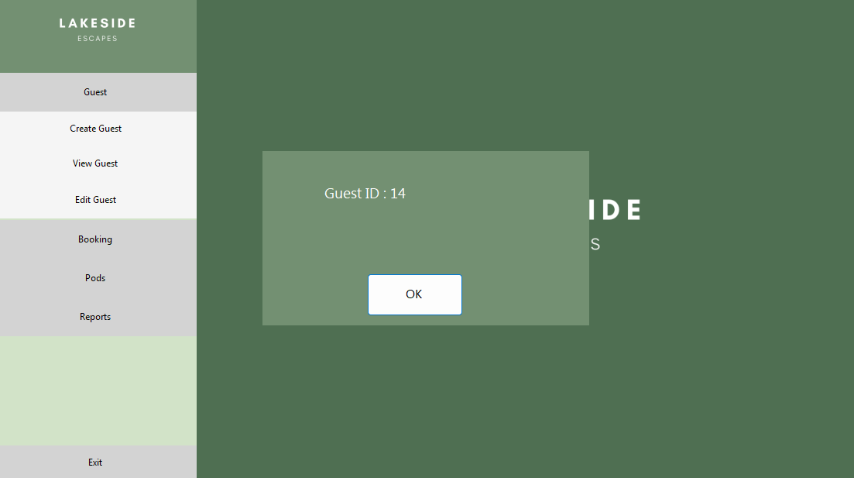Figure 6‑32 – Test 9.1 Passed

### FormAddBooking

|  |  |  |  |  |
| --- | --- | --- | --- | --- |
| *Test*  *Number* | *Description* | *Expected Outcome* | *Pass/Fail* | *Actual Outcome* |
| 11.1 | btnAdd is clicked with valid data input in the controls | FormShowDetails will open, display the Booking ID and Pod ID FormAddBooking will close, btnAddBooking’s backcolour will return to WhiteSmoke | Pass | FormShowDetails opened, displayed the Booking ID and Pod ID FormAddBooking closed, btnAddBooking’s backcolour returned to WhiteSmoke |
| 11.2 | btnExit is clicked | FormAddBooking will close, btnAddBooking’s backcolour will return to WhiteSmoke | Pass | FormAddBooking closed, btnAddBooking’s backcolour returned to WhiteSmoke |

### FormViewGuest

|  |  |  |  |  |
| --- | --- | --- | --- | --- |
| *Test*  *Number* | *Description* | *Expected Outcome* | *Pass/Fail* | *Actual Outcome* |
| 12.1 | btnGuestID is clicked | pnlGuestID will become visible | Pass | pnlGuestID became visible |
| 12.2 | btnDetails is clicked | pnlDetails will become visible | Pass | pnlDetails became visible |
| 12.3 | btnExit is clicked | FormViewGuest will close, btnViewGuest’s backcolour will return to WhiteSmoke | Pass | FormViewGuest closed, btnViewGuest’s backcolour returned to WhiteSmoke |

### FormViewBooking

|  |  |  |  |  |
| --- | --- | --- | --- | --- |
| *Test*  *Number* | *Description* | *Expected Outcome* | *Pass/Fail* | *Actual Outcome* |
| 13.1 | btnBookingID is clicked | pnlBookingID will become visible | Pass | pnlBookingID became visible |
| 13.2 | btnDetails is clicked | pnlDetails will become visible | Pass | pnlDetails became visible |
| 13.3 | btnExit is clicked | FormViewBooking will close, btnViewBooking’s backcolour will return to WhiteSmoke | Pass | FormViewBooking closes and btnViewBooking’s backcolour returns to WhiteSmoke |

### FormEditBooking

|  |  |  |  |  |
| --- | --- | --- | --- | --- |
| *Test*  *Number* | *Description* | *Expected Outcome* | *Pass/Fail* | *Actual Outcome* |
| 14.1 | btnDeleteShow is clicked | pnlDelete will become visible | Pass | pnlDelete became visible |
| 14.2 | btnEditView is clicked | pnlEdit will become visible | Pass | pnlEdit became visible |
| 14.3 | btnExit is clicked | FormEditBooking will close, btnEditBooking’s backcolour becomes WhiteSmoke | Pass | FormEditBooking closed and btnEditBooking’s backcolour became WhiteSmoke |

### FormEditGuest

|  |  |  |  |  |
| --- | --- | --- | --- | --- |
| *Test*  *Number* | *Description* | *Expected Outcome* | *Pass/Fail* | *Actual Outcome* |
| 15.1 | btnExit is clicked | FormEditGuest will close, btnEditGuest’s backcolour will become WhiteSmoke | Pass | FormEditGuest closed and btnEditGuest’s backcolour returned to WhiteSmoke |

### FormViewPod

|  |  |  |  |  |
| --- | --- | --- | --- | --- |
| *Test*  *Number* | *Description* | *Expected Outcome* | *Pass/Fail* | *Actual Outcome* |
| 16.1 | btnExit is clicked | FormViewPod will close, btnViewPod’s backcolour will become WhiteSmoke | Pass | FormViewPod closed and btnViewPod’s backcolour became WhiteSmoke |

### FormEditPod

|  |  |  |  |  |
| --- | --- | --- | --- | --- |
| *Test*  *Number* | *Description* | *Expected Outcome* | *Pass/Fail* | *Actual Outcome* |
| 17.1 | btnExit is clicked | FormEditPod will close, btnEditPod’s backcolour will become WhiteSmoke | Pass | FormEditPod closed and btnEditPod’s backcolour became WhiteSmoke |
| 17.2 | btnDelete is clicked | If input Pod ID is valid, a confirmation MessageBox should open. | Pass | Confirmation MessageBox appeared. |

### FormReport

|  |  |  |  |  |
| --- | --- | --- | --- | --- |
| *Test*  *Number* | *Description* | *Expected Outcome* | *Pass/Fail* | *Actual Outcome* |
| 18.1 | btnExit is clicked | FormReport will close | Pass | FormReport closed |

User Acceptance Testing

|  |  |  |  |  |
| --- | --- | --- | --- | --- |
| *Test*  *Number* | *Description* | *Reference* | *Pass/Fail* | *Actual Outcome* |
| 19.1 | Add a booking | F-UR1 | Pass | Added a booking to the database |
| 19.2 | View a booking | F-UR2 | Pass | Booking details were presented to user |
| 19.3 | Add a guest | F-UR3 | Pass | Guest was added to database |
| 19.4 | View a guest | F-UR4 | Pass | Guest details were presented to the user |
| 19.5 | Delete a booking | F-UR5 | Pass | Booking was deleted from database |
| 19.6 | Edit a guest | F-UR6 | Pass | Guest was updated in database |
| 19.7 | Edit a booking | F-UR7 | Pass | Booking was updated in database |
| 19.8 | Check if guest has booked 6 months before their stay and record a 3% discount | F-UR9 | Pass | A 3% discount was recorded when the criteria was met |
| 19.9 | Check if guest has stayed before and record a 2% discount if true | F-UR10 | **Fail** | A 2% discount was recorded despite the guest having no previous bookings. |
| 19.10 | Check if course dates are within pod booking dates if the guest is attending a course | F-UR11 | **Fail** | The system rejected the booking although the dates matched a set of course dates for a course the guest was enrolled in. |
| 19.11 | Not allow pods to be double booked | F-UR12 | Pass | No bookings were accepted for fully booked dates. |
| 19.12 | Stores the cost per person per night for each pod type | F-UR13 | Pass | Data is present in database |
| 19.13 | Edit the description of a pod type | F-UR18 | Pass | Data is updated in the database |
| 19.14 | View a pod’s details | F-UR14 | Pass | Pod details are viewed |
| 19.15 | Add a pod of type “Standard” or “Luxury” | F-UR15 | Pass | Pod is added to database |
| 19.16 | The system deletes the booking if the deposit is not made within three days | F-UR16 | Pass | Booking is deleted |
| 19.17 | Search for guest by their details | F-UR20 | Pass | Correct guest record is presented to the user |
| 19.18 | Delete a pod | F-UR19 | Pass | The pod is deleted from the database |
| 19.19 | Provide a report to show the number of bookings made per month | F-UR21 | Pass | The appropriate report is presented to the user |
| 19.20 | Provide a report to show the most popular pods | F-UR22 | Pass | The appropriate report is presented to the user |
| 19.21 | Provide a report to show the most frequent guests | F-UR23 | Pass | The appropriate report is presented to the user |
| 19.22 | Provide a report to show the guest details of each guest on each course | F-UR24 | Pass | The appropriate report is presented to the user |

|  |  |  |
| --- | --- | --- |
| *Test Number* | *Description of Problem* | *Fixed* |
| 19.10 | The system would reject all bookings when Attending Course was set to true, this was due to inconsistencies in the SQL stored procedure which meant it could not identify when the course dates fell within the booking dates. | The SQL query was rewritten to catch any invalid date sets. |

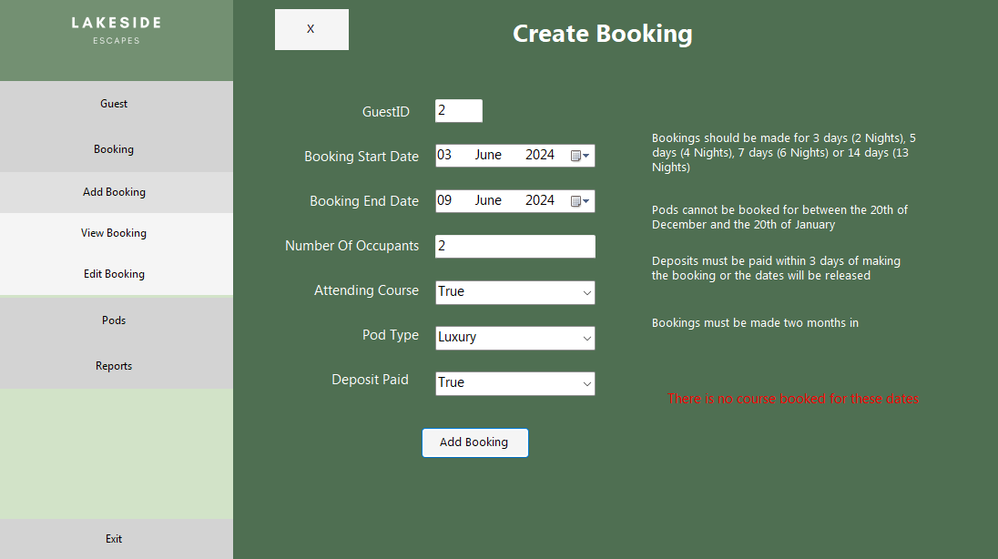 Figure 6‑33 – Failed Test 19.10

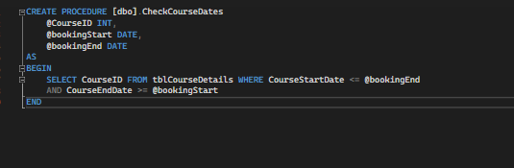Figure 6‑34 – Test 19.10 Original Code (Fail)

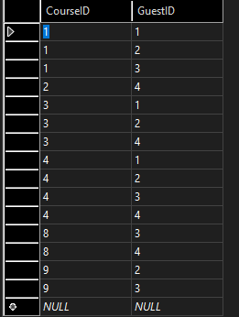Figure 6‑35 – tblCourseGuests Data

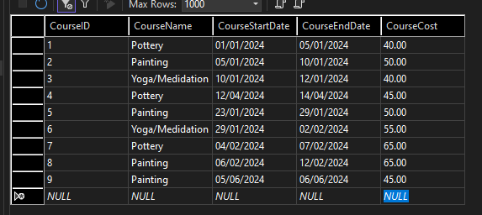Figure 6‑36 – tblCourseDetails Data

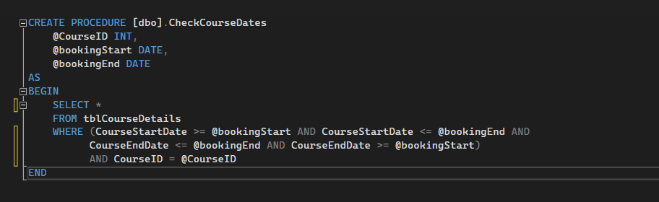Figure 6‑37 – Test 19.10 Revised Code (Pass)

Attending Course

Figure 6‑38 – Test 19.10 Passed

Figure 6.34 shows two bookings that has been made while the course dates are within the booking dates of a guest who is enrolled in the given course.

|  |  |  |
| --- | --- | --- |
| *Test Number* | *Description of Problem* | *Fixed* |
| 19.9 | The system would always apply the 2% discount regardless of if this was the guest’s first booking. This was because the booking was added to the database before the discount was applied, hence when the ApplyDiscounts method checked if the guest had any bookings, it would return true as the current booking was present in the database. | The ApplyDiscounts method only applied the 2% discount if there was more than one booking with the given guest ID. |

Figure 6‑39 – Test 19.9 Failed

*Discount*

Note: All bookings shown belong to guests who have not made previous bookings

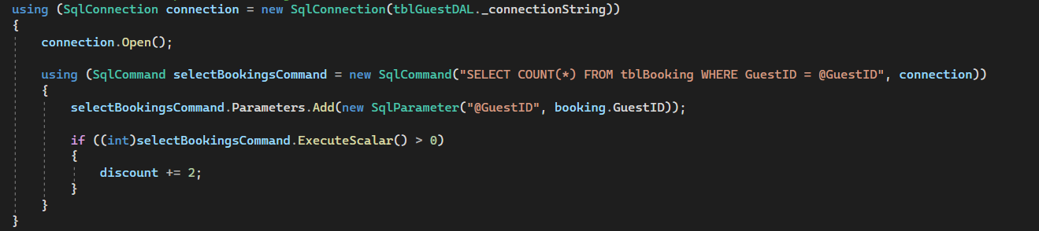Figure 6‑40 –Test 19.9 Original Code (Fail)

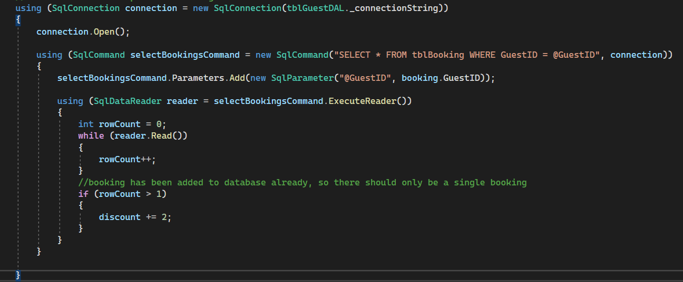Figure 6‑41 – Test 19.9 Revised Code (Pass)

*Guest ID*



Figure 6‑42 – Test 19.9 Passed

*Discount*

Note: Guest with an ID 7 has previous bookings and Guest with an ID 8 has not

# User Guide

USER GUIDE

Lakeside Escapes Booking System

Systems14Development

Table of Contents

Getting started 1

Introduction 1

System requirements 1

Installation instructions 1

User interface 2

Home screen 2

Navigation 2

Guest Records 4

Creating a guest record 4

Viewing a guest record 5

Editing a guest record 6

Bookings 7

Adding a booking 7

Viewing a booking 8

Edit or delete a booking 9

Pods 12

View pods 12

Add or edit a pod 12

Reporting 15

Appendix 17

Staff Training 17

Backing up data 17

Frequently asked questions 18

Troubleshooting 19

Contact Information 20

**Getting Started**

**Introduction**

Welcome to the Lakeside Escapes Booking System. This purpose of this system is to manage the pod bookings in Lakeside Escapes. This document will detail the management of the application and instructions to complete each task.

**System requirements**

Windows 10, 64-bit. ARM64 or x86, 1.8GHz or faster. 4GB RAM. At least 2Gb of free space.

**Installation instructions**

1. Download the folder LakesideEscapesBookingSystem.zip
2. Unzip this folder in file explorer, by right clicking and clicking the ‘Extract All’ option. The files should be extracted to a suitable locaton to avoid unintentional deletion.
3. To open the application, follow the file path to find the executable file /LakesideEscapesPodBooking/LakesideEscapesPodBooking/bin/Debug, in this folder there will be a file of type Application named ‘LakesideEscapesPodBooking’. Double click this file to start the application.
4. It would be advantageous to add a shortcut to this file on the desktop.

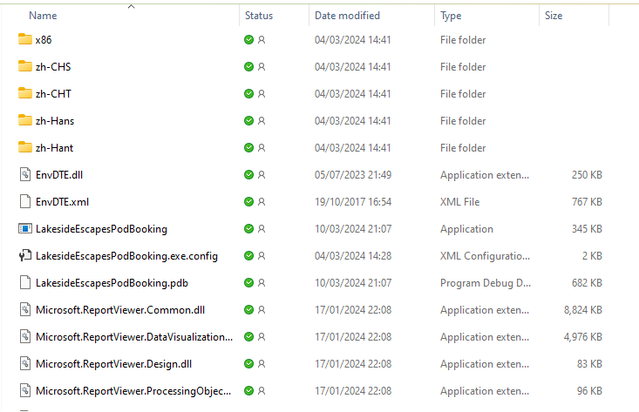

**User Interface**

**Home screen**

On opening the application, the user is presented with the home screen. The home screen has two main areas; the sidebar which is used for navigating around the application, and the main window which is used to display and edit information. Users can navigate back to the home screen at any time by clicking the **X** in the top left of the main window when in one of the information screens.

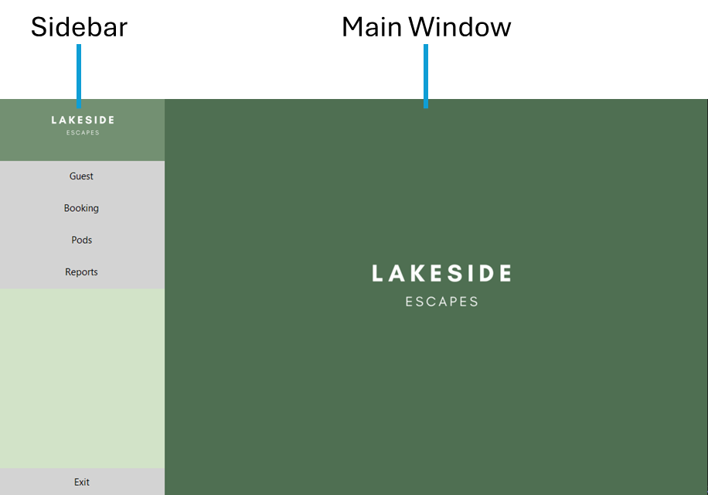

**Navigation**

Users navigate around the application using the buttons in the sidebar. The **Guest**, **Booking** and **Pods** buttons open sub-menus as shown below. The **Reports** button opens the form used to generate reports. The **Exit** button closes the application.

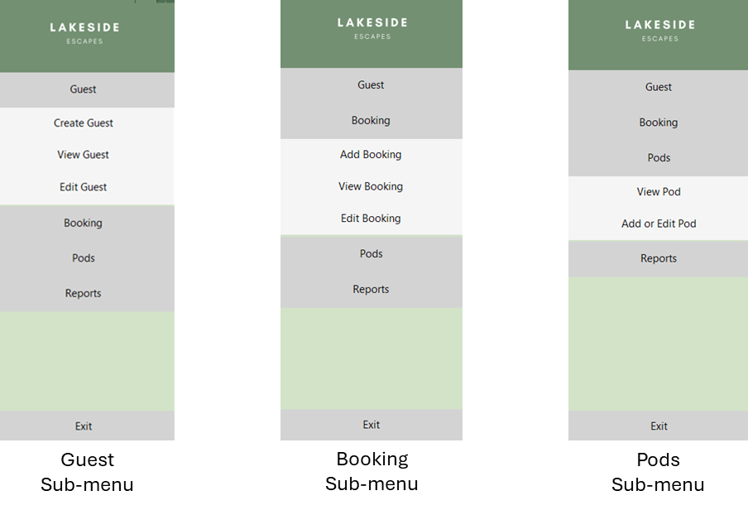

**Guest Records**

**Creating a guest record**

1. Navigate to the *Create Guest* form by selecting **Guest > Create Guest** in the *Sidebar*.

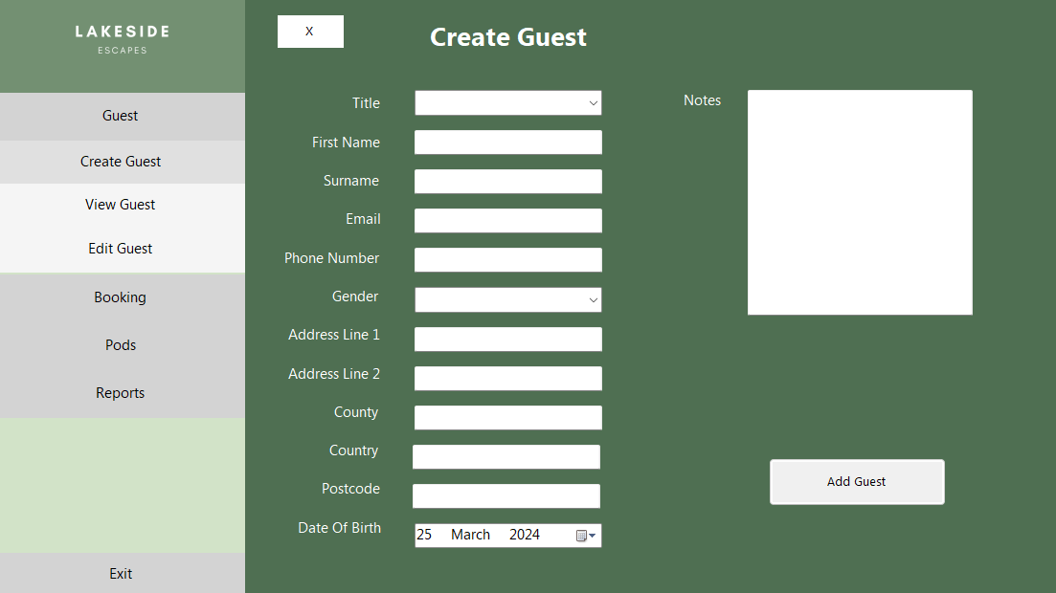

1. Complete the form with the appropriate information. Refer to the table below for data entry requirements.

| ***Field*** | ***Criteria*** | ***Required*** |
| --- | --- | --- |
| Title | Must be chosen from the drop-down list | ✔ |
| First Name | Must be under 20 characters and contain only letters | ✔ |
| Surname | Must be under 30 characters and contain only letters | ✔ |
| Email | Must be in the format ‘test@subject.com’ | ✔ |
| Phone Number | Must only contain numbers and be 10-12 digits in length | ✔ |
| Gender | Must be chosen from the drop-down list | ✔ |
| Address Line 1 | Must be under 40 characters | ✔ |
| Address Line 2 | Must be under 40 characters | ✔ |
| County | Must be under 25 characters and contain only letters | ✔ |
| Country | Must be under 30 characters and contain only letters | ✔ |
| Postcode | Must be 7 or 8 characters in length | ✔ |
| Date Of Birth | The guest must be 18 | ✔ |
| Notes | None |  |

1. Click the **Add Guest** button.
2. If the information entered is valid a confirmation window will open with the newly created Guest ID. Click the **OK** button to return to the home screen.
3. If any of the information entered is invalid, the label corresponding to the invalid information will turn red. The guest record will not be created until all the information is valid.

**Viewing a guest record**

1. Navigate to the *View Guest* form by selecting **Guest > View Guest** in the *Sidebar*.

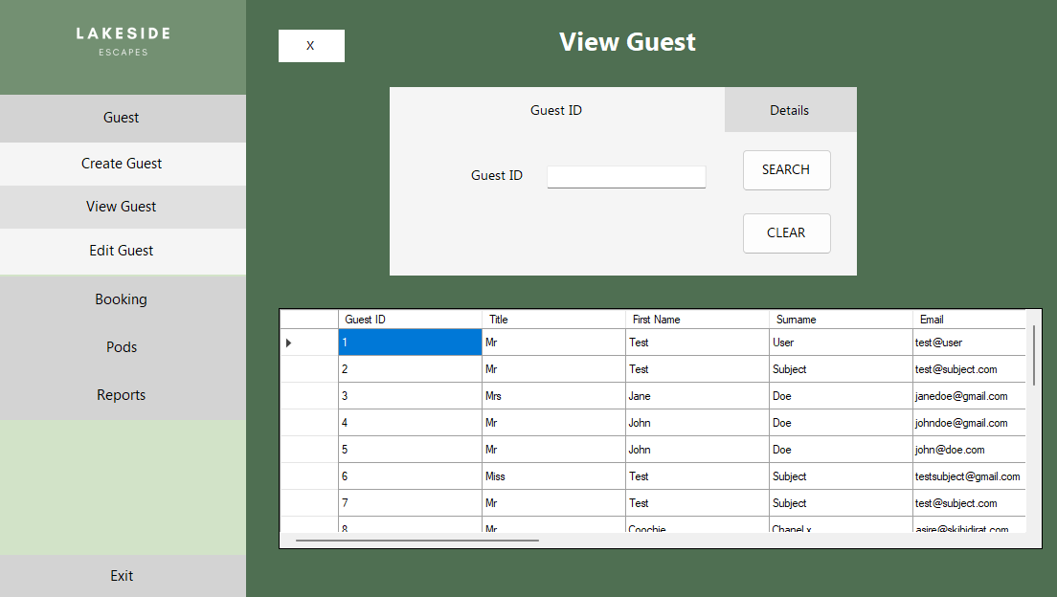

1. All guests in the database are shown in a data grid at the bottom of the *View Guest Window*.
2. It is possible to search for guests using either their Guest ID or their Details. Select the **Guest ID** tab or **Details** tab to open the relevant search window.
3. To search for a guest by their Guest ID:
   1. Input the guest ID and click the **Search** button.
   2. When a valid guest ID is entered, a single record will be displayed in the data grid.
   3. If the guest ID is invalid, an error will be displayed.
   4. Click the **Clear** button to clear the Guest ID textbox and any error messages, and to reset the data grid view to show all guests.
4. To search for a guest by their surname and postcode:
   1. Type the guest’s surname and postcode into the textboxes. The data grid view will update to show all guests with corresponding details.
   2. If no records are shown in the data grid view, there is no guests with the given details.
   3. Click the **Clear** button to clear the textboxes and any error messages, and to reset the data grid view to display all guests.

**Editing a guest record**

1. Navigate to the *Edit Guest* form by selecting **Guest > Edit Guest** in the *Sidebar*.

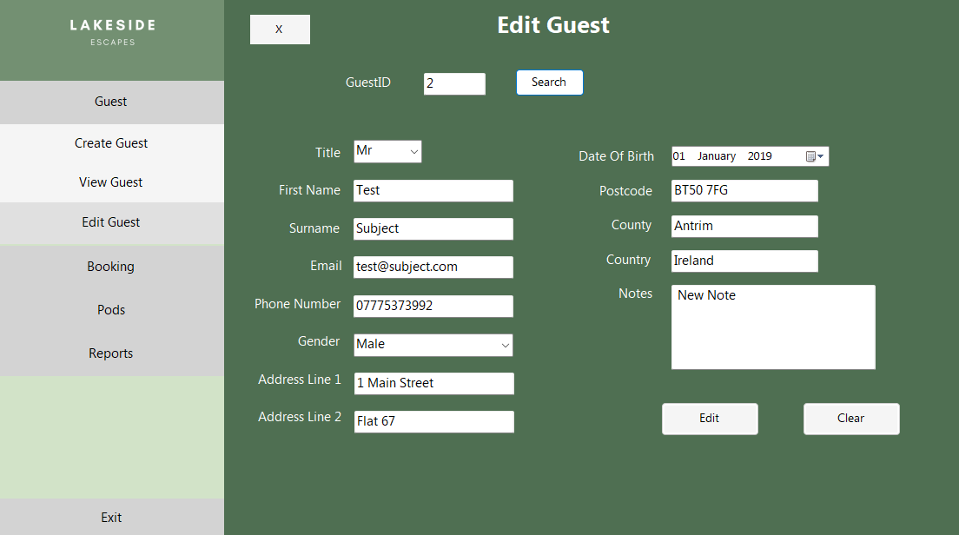

1. Enter the Guest ID of the guest you wish to edit and click the **Search** button. If you are unsure of the Guest ID, use the *View Guest* form to search by guest details.
2. If the guest ID is valid, the guest’s details will be presented in the form and available to edit.
3. If the guest ID is invalid, an error message will appear in red text.
4. After making the required changes, click the **Edit** button to update the guest record.
5. If all data is valid, a window will appear to confirm that the changes have been saved. The fields in the *Edit Guest* form will also be cleared and it will return to its initial state.
6. If invalid data has been entered (the data is validated using the same criteria required in the *Add Guest* form), the corresponding label text will turn red, and changes will not be saved.
7. Clicking the **Clear** button will reset the form back to its initial state and clear the Guest ID textbox.

**Bookings**

**Adding a booking**

1. Navigate to the *Add Booking* form by selecting **Booking > Add Booking** in the *Sidebar*.

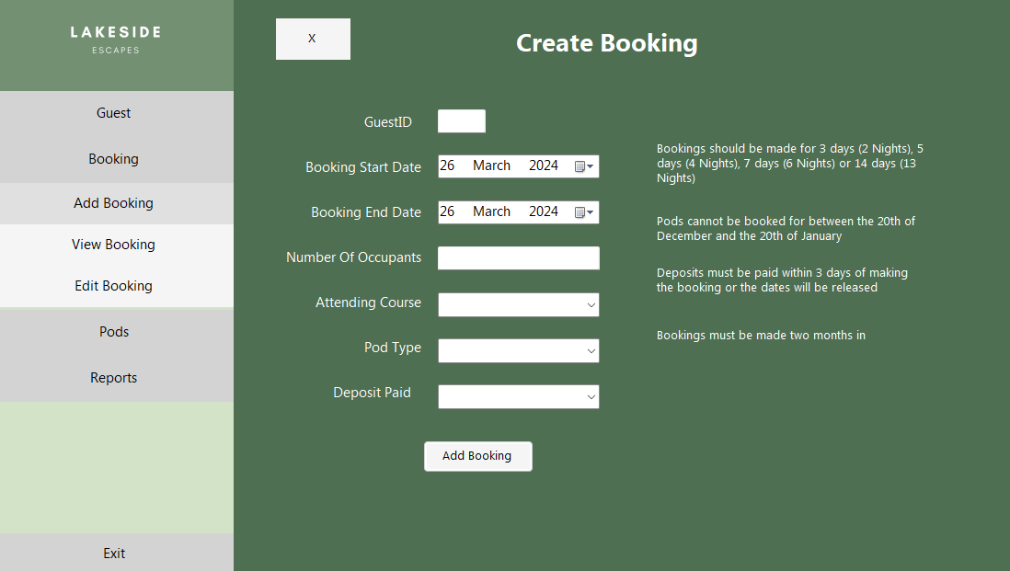

1. Complete the form with the appropriate information. Refer to the table below for data entry requirements.

| ***Field*** | ***Criteria*** | ***Required*** |
| --- | --- | --- |
| Guest ID | Must be a valid Guest ID that corresponds to a guest stored in the database. | ✔ |
| Booking Dates | Must be two months in advance.  Must have the correct duration (valid durations are detailed in the application).  Must not be between the 20th of December and 20th of January. | ✔ |
| Number of Occupants | Must be no more than 4 if the pod type is standard.  Must be no more than 6 if the pod type is luxury. | ✔ |
| Attending Course | If true, guest must be enrolled in a course of which the dates are within the booking dates.  Must be selected from the drop-down list. | ✔ |
| Pod Type | Must be selected from the drop-down list | ✔ |
| Deposit Paid | Must be selected from the drop-down list | ✔ |

1. Click the **Add Booking** button.
2. If the information entered is valid a confirmation window will open with the Booking ID and the Pod ID. Click the **OK** button to return to the home screen.

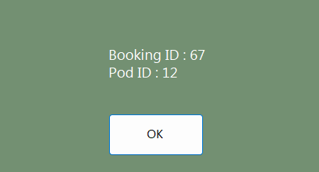

1. If any of the information entered is invalid, the label corresponding to the invalid information will turn red. The booking will not be made until all the information is valid.

**Viewing a booking**

1. Navigate to the *View Booking* form by selecting **Booking > View Booking** in the *Sidebar*.

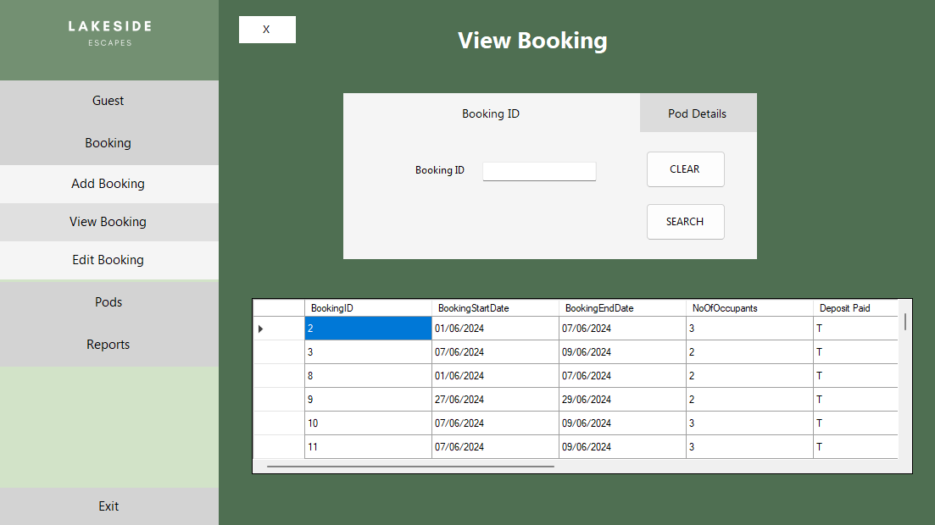

1. The form will open on the search by Booking ID tab and all bookings are shown in the data grid at the bottom of the *View Booking* window.
2. It is possible to search for bookings using either the Booking ID or the Pod ID. Select the Booking ID tab or the Pod ID tab to open the relevant search window.
3. To search for a booking by the Booking ID:
   1. Input the Booking ID and click the **Search** button.
   2. When a valid Booking ID is entered, a single record will be displayed in the data grid.
   3. If the Booking ID is invalid, an error will be displayed.
   4. Click the **Clear** button to clear the Booking ID textbox and any error messages, and to reset the data grid view to show all bookings.
4. To search for a booking by the Pod ID and date range:

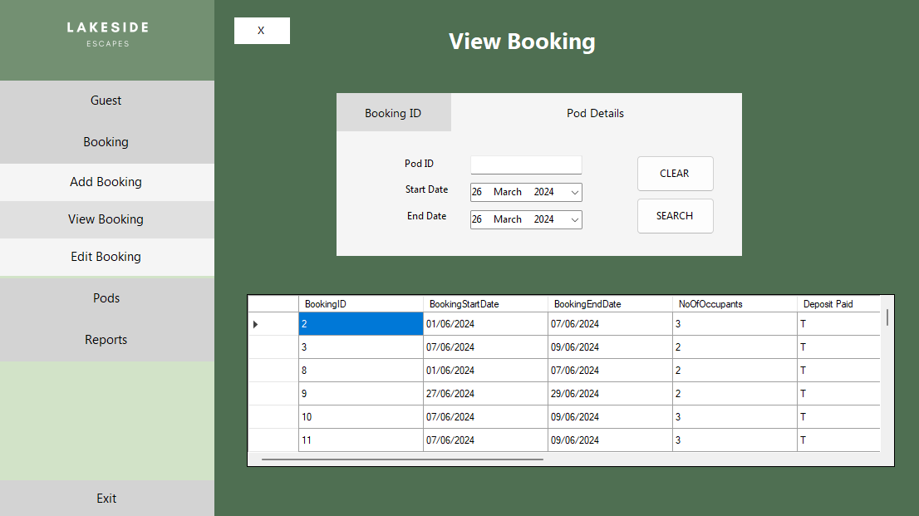

* 1. Input the Pod ID and date range and click the **Search** button.
  2. When a valid Pod ID is entered, all bookings within the date range will be shown in the data grid. If there are no bookings within the date range the data grid will be empty.
  3. If a Pod ID is entered that is numeric but does not exist in the database, the system will accept it but will not show any bookings in the data grid view. To view a list of pods in the database please navigate to the *View Pods* form.
  4. If the Pod ID entered is non-numeric, an error will be displayed.
  5. Click the **Clear** button to clear the Pod ID textbox and any error messages, and to reset the data grid view to show all bookings.

**Edit or delete a booking**

1. Navigate to the Edit Booking form by selecting **Booking** > **Edit Booking** in the Sidebar.
2. This form can be used to edit or delete a booking.
3. To edit a booking:

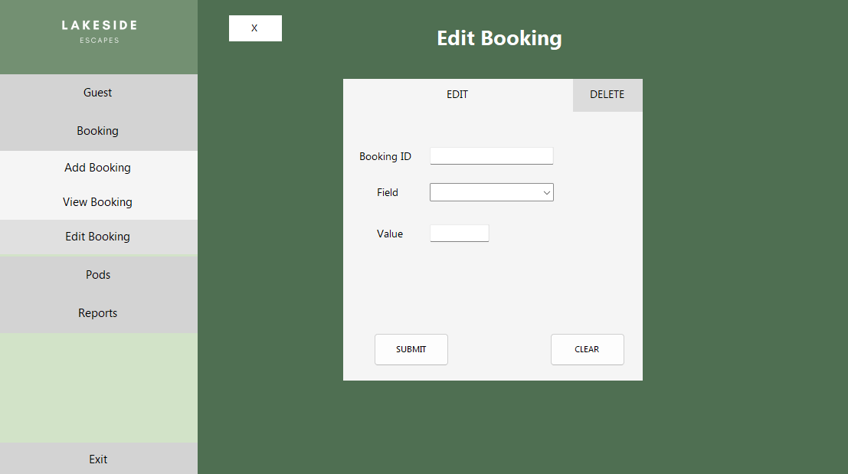

* 1. Click the **Edit** tab if it is not already selected.
  2. Enter the Booking ID, the field to be edited and the new value for the field.
  3. Click the **Submit** button.
  4. If the field value is valid, the booking will be updated.
  5. If the field value is invalid, an error message will appear in red text. The data must comply with the same criteria required when first creating a booking.
  6. Click the **Clear** button to clear all data and reset the form back to its initial state when opened.

1. To delete a booking:

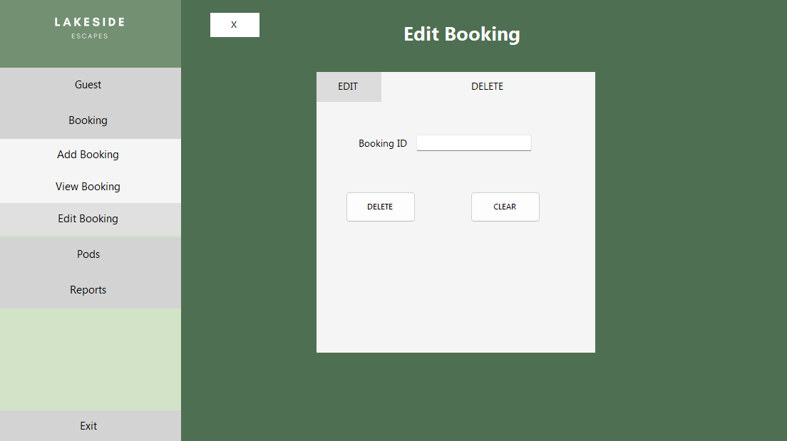

* 1. Click the **Delete** tab if it is not already selected
  2. Enter the Booking ID of the booking you wish to delete.
  3. Click the **Delete** button to complete the deletion.
  4. Click the **Clear** button to clear all data and reset the form back to its initial state when opened.

**Pods**

**View Pods**

1. Navigate to the *View Pod* form by selecting **Pods > View Pod** in the Sidebar.

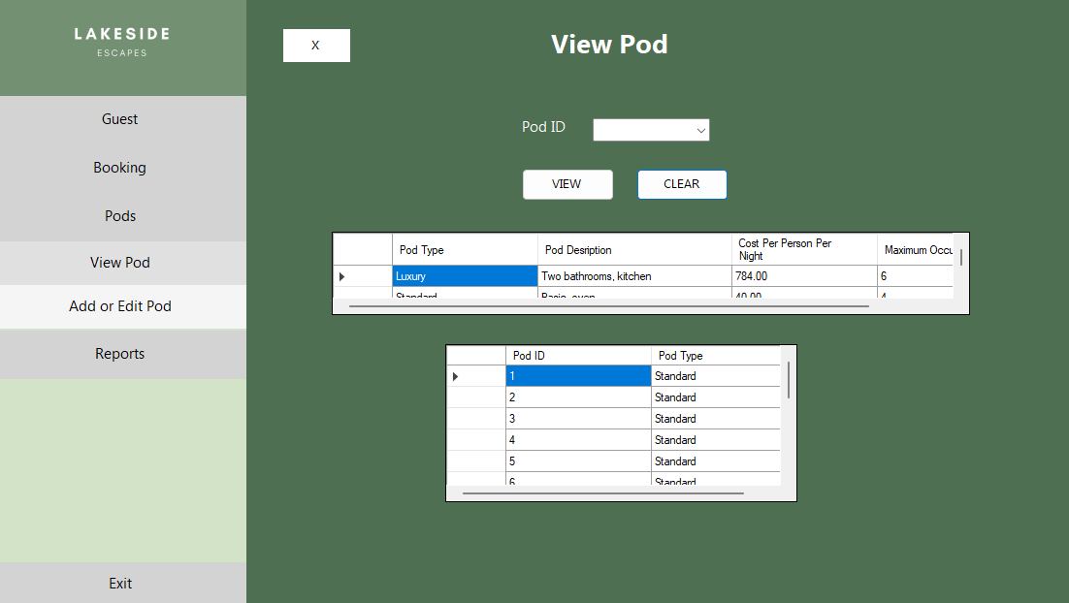

1. The *View Pod* form has a search box and two data grids below. The data grids list the pods available and provide details of the pod types.
2. To search for a pod:
   1. Select the Pod ID from the drop-down list and click the **View** button.
   2. If the Pod ID is valid, the two data grid views will be replaced with a single data grid view which will show the chosen pod ID, its type, and details of the type.
   3. If the Pod ID is invalid, an error will be displayed.
   4. Click the **Clear** button to clear the Pod ID, and to reset the data grid view back to its initial state.

**Add or edit a pod**

1. Navigate to the A*dd or Edit Pod* form by selecting **Pods > Add or Edit Pod** in the *Sidebar*.
2. This form allows the user to carry out all common updates to the pod records. New pods can be created, exiting pods can be edited or deleted, and the details held for each pod type can be amended. Each action is accessed through a specific subsection on the form.
3. Successful changes made in the subsections are confirmed with a message below the subsection.
4. Invalid changes are flagged with an error message below the subsection.
5. The **Clear** button will clear data and messages, and resit each subsection back to its initial state.

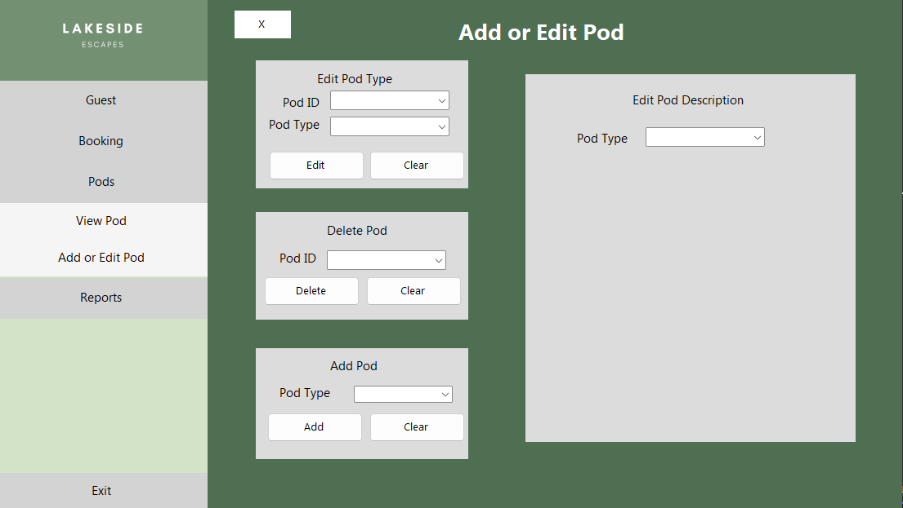

1. To edit pod type for an existing pod:
   1. Select the Pod ID from the drop-down list.
   2. Select the new pod type.
   3. Click the **Edit** button.
2. To delete an existing pod:
   1. Select the Pod ID from the drop-down list.
   2. Click the **Delete** button.
   3. A message box will appear asking for confirmation. The pod will be deleted when the user clicks the **OK** button

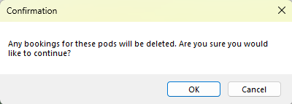

1. To add a new pod:
   1. Select the type required for the new pod from the drop-down list.
   2. Click the **Add** button.
2. To edit the description associated with a pod type:
   1. Select the pod type from the drop-down list. The description of that pod type will populate the subsection if it does not the input is not a valid pod type.
   2. Update the *Pod Description* and *Cost Per Person Per Night* fields as appropriate. The maximum occupancy cannot be changed.

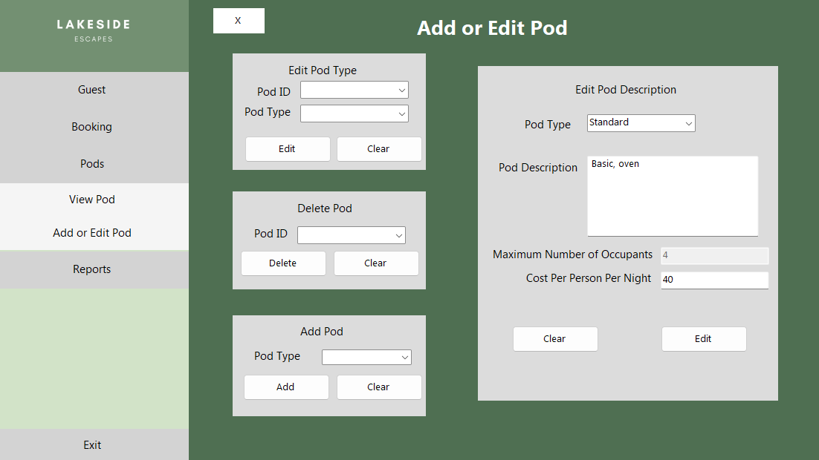

* 1. Once the details have been changed, click the **Edit** button to update the pod description in the database.
  2. If any invalid data has been input, for example, a non-numerical value in *Cost Per Person Per Night* field, an error message will be shown in red text.

**Reporting**

1. Navigate to the *Reports* form by selecting **Reports** in the *Sidebar*.

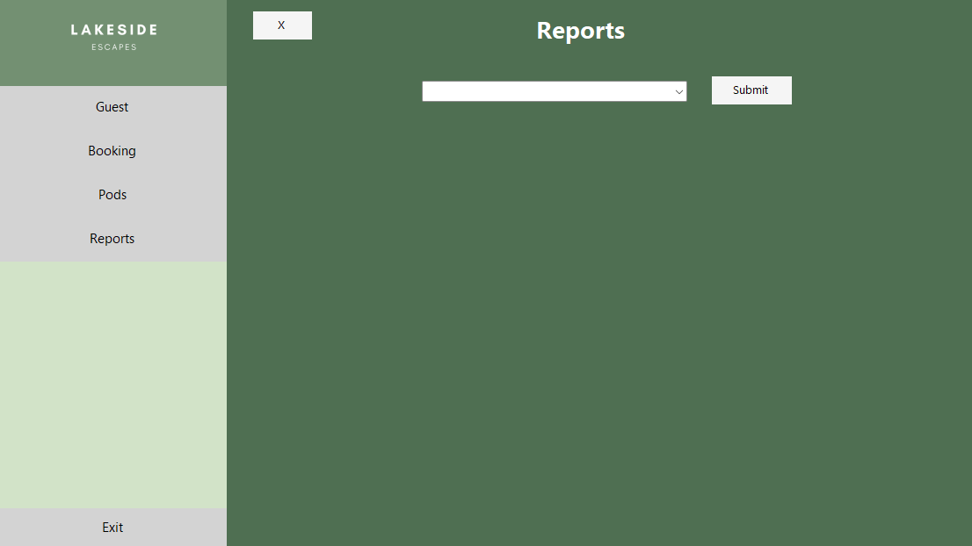

1. Four types of report are offered through the drop-down menu:
   1. Most Popular Pods
   2. Most Frequent Guests
   3. Rate of Bookings
   4. Course Guests
2. After selecting a report in the drop-down menu, click the **Submit** button.
3. If the input is valid, the report will be shown.
4. If the input is invalid, the form will not show a report.
5. The user can interact with each report through the menu toolbar.



|  |  |  |  |
| --- | --- | --- | --- |
|  | Refresh the report |  | Page setup for printing |
|  | Print the report |  | Export the report |
|  | Show the print layout |  | Change the zoom scale |

1. Exporting the report:
   1. The export button will allow reports to be exported to an Excel, Word or PDF document.
   2. The document type is selected in a drop-down menu within the export button.



* 1. After selecting the export file type, the user is presented with the a *Save As* window. The file name and location are defined here.

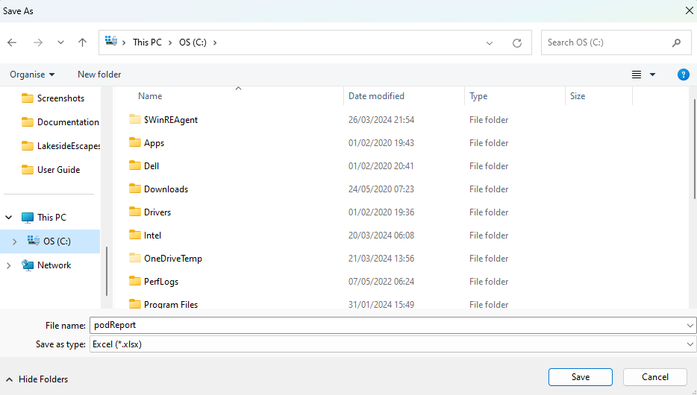

**Appendix**

**Staff Training**

A video walkthrough of the application can be found within the LakesideEscapesBookingSystem.zip folder. This will be a helpful resource to familiarize employees with the system.

**Backing up data**

These backups must be done regularly by Lakeside Escapes. By backing up the data in the database you eliminate the risk of major data loss by data corruption, hardware failure or accidental deletion. Major data loss has proven tremendously detrimental to businesses much larger than Lakeside Escapes and hence steps should be taken in preventing this outcome. If data loss occurred, the system could be redeployed in a short period of time given the database has been backed up correctly. We suggest that backups should be done after every working day.

The backups should be done using SQL Server Management Studio.

Please use this link as a guide:

[Create a Full Database Backup - SQL Server | Microsoft Learn](https://learn.microsoft.com/en-us/sql/relational-databases/backup-restore/create-a-full-database-backup-sql-server?view=sql-server-ver16)

**Frequently Asked Questions**

**How do you edit the cost per night of a pod type?**

Navigate to the ‘Add or Edit Pod’ form, select the required pod type from the drop-down list in the Edit Pod Description subsection, edit the textbox which corresponds to the cost and click the Edit button to update the cost per night of the pod.

**Can Guest ID be changed?**

No, guest ID is assigned by the system and is vital in identifying guests. There should not be a time when it is necessary to change this ID.

**Can Booking ID be changed?**

Similar to guest ID, booking ID is assigned by the system and is necessary to identify bookings. There should not be a time when it is necessary to change this ID.

**Can you edit the font size in the application?**

No, the user interface is not currently modifiable.

**How do I reschedule a booking?**

Navigate to the Edit Booking interface and edit the dates of the booking.

**Can the application become full screen?**

No, during development we felt full screen would be unnecessary and would leave too much blank space in the forms.

**How will I know when there are no available pods?**

The application will display the error message ‘There are no pods available for these dates’ when the user attempts to add a booking in which there are no available pods for the given type and date range.

**How do I know the restrictions in making a booking?**

There is text in the Add Booking interface which details the restrictions on the dates that can be booked, all other restrictions are detailed in this User Guide under Booking > Add a booking.

**Troubleshooting**

**First Steps**

* Are all the cables connected correct and secure?
* Is the computer connected to a power supply and is the power light on?
* Is the computer working as expected in other applications?

**Restarting the Computer**

* If the first steps have not resolved the issue it may help to restart the computer.
* First, save any work that is underway in other applications.
* Ensure there are no other users logged into the computer. If there are, they will need to save all work and log out.
* Restart the computer by navigating to **Windows Start > Power > Restart**

**User Interface**

* In the Add and Edit pod form, the pod ID drop-down lists will only be updated, when the form is closed. To edit a pod that has just been created, please close and open the form.

**Reporting**

* Any problems with reporting are likely to be due to their dependence on the NuGet packages downloaded, ensure all NuGet packages are the latest version if issues arise.

**Contact Information**

As the developers, it is our duty to perform maintenance of the system. If you choose to outsource system maintenance with another company, please provide them with the corresponding documentation in order to provide them with a comprehensive understanding of the solution. If any bugs or errors are brought to your attention, the system is not behaving as expected or you have any questions, please contact us using the following details. We aim to respond as soon as possible.

Email : [info@systems14development.com](mailto:info@systems14development.com)

Phone Number: 07777 123987

Website: systems14development.co.uk

# Evaluation

Evaluation is a critical aspect of the software development process. By reflecting on the development process, the developers can adopt a critical viewpoint on the work completed and identify any areas for improvement. The evaluative stage of the project promotes accountability and encourages the highest quality of work from individuals. It helps the development team understand the strengths and weaknesses of the project and any mishandling by the team during the development. Regardless of their agile or rigid nature, the majority of design methodologies emphasise the importance of evaluation.

This assessment will be a tool used to optimise the quality and development of subsequent projects to be undertaken

Evaluation of Range of Approaches

In the design phase of the development, the decision was made that the appropriate solution for this project was a Windows Desktop Application with a locally hosted SQL database, programmed in C# using the Windows Forms framework in Microsoft Visual Studio.

As previously stated, the language C# is well documented with extensive support online and the framework was familiar to the developer. This interpretation proved correct and was of significant value during the development. Despite the developer’s previous experience with Windows Forms, they had little experience in developing systems that utilise SQL databases. The support of the framework regarding the database components of the system was impressive and minimised any potential long-term issues that would have been time consuming and resource intensive to amend. The framework offered a graphical user interface for each database table along with the SQL that corresponded to it, allowing the developer to resolve issues with more ease than if a less comprehensive framework was used. Visual Studio offered an impressive interface which the developer confirmed was vital to the organisation of the class files and stored procedures. Any runtime errors during the implementation and testing regarding the database were clearly displayed to the developer which was ideal for determining the root of the bug and correction of the code.

The system is confined to a computer with a windows operating system, but this did not prove to be an issue. It was presumed in the initial consideration of possible solutions that the Lakeside Escapes computer utilised a windows operating system. This assumption was confirmed by Lakeside Escapes before the solution was established during the design phase. If it had been incorrect a re-evaluation of the solutions would have been necessary as would a discussion with the business on whether they should consider purchasing a Windows compatible computer.

The convenience of the local database was evident to the developer regarding the programming involved in the connection and the speed of reading and writing data. In retrospect, the responsibility of routinely backing up the data should not have been left with the business as despite the detailed user guide, it requires familiarity with SQL databases and an employee with this skillset is presumably not at the disposal of Lakeside Escapes. The regularity of the backups are not time and resource efficient for the business and despite the benefits previously outlined regarding the security of data and financial advantages of the solution, the developer subsequently concluded that the business may have been better suited to a cloud-based database solution. A cloud-based database service would perform backups without involvement from the business and the disadvantage of the financial obligation would be outweighed by the ‘hands-off’ approach the business could take regarding database management. The cloud would also be more resilient to data loss and would therefore reduce downtime regardless of backup status. Problems regarding the internet connectivity could be minimised by ensuring the business had sufficient bandwidth and a robust network infrastructure.

A browser-based application had been considered and rejected at the outset. Reflecting on this decision at the end of the project raised similar points as when it was initially considered. The convenience of a website interface would be beneficial to the company as it offered multi-user capabilities with no restrictions on the platform used to access except internet connectivity. However, a web-based solution requires knowledge of a range of programming languages and was not within the cost or time limitations of this project. This project was working within a short timeframe using Windows Forms, in which programming was not required in creating the graphical user interface. A web-based option requires extensive programming in client-side languages such as HTML, CSS, and JavaScript to create the graphical user interface alongside the programming to implement the functionality of the website. This further verified that a web-based option, despite the benefits was not feasible for this project.

On consideration of the overall project, the range of solutions evaluated could have been more exhaustive. The developer only considered three which put the development at risk of pursuing a solution which was not the best within the constraints of the project. Regardless, the key discussion topics were explored, each solution was considered to a comprehensive degree and all decisions were well justified. An appropriate solution was chosen which allowed all required functionality to be implemented successfully. Any topics discussed in this evaluation can be used as a reference for future projects and could be a helpful resource when determining a solution for future systems.

Evaluation of User Requirements

|  |  |  |  |
| --- | --- | --- | --- |
| *User Requirement* | *Description* | *Implemented* | *Location in Application* |
| **Functional Requirements** | | | |
| F-UR1 | Must be able to add a booking | ✓ | Add Booking Form |
| F-UR2 | Must be able to view a booking | ✓ | View Booking Form |
| F-UR3 | Must be able to add a guest | ✓ | Create Guest Form |
| F-UR4 | Must be able to view a guest | ✓ | View Guest Form |
| F-UR5 | Must be able to delete a booking | ✓ | Edit Booking Form |
| F-UR6 | Must be able to edit a guest | ✓ | Edit Guest Form |
| F-UR7 | Must be able to edit a booking | ✓ | Edit Booking Form |
| F-UR8 | Must not take bookings between the 20th of December and 20th of January | ✓ | Add Booking Form |
| F-UR9 | Must check if guest has booked 6 months before their stay and record a 3% discount if true | ✓ | Add Booking Form |
| F-UR10 | Must check if guest has stayed before and record a 2% discount if true | ✓ | Add Booking Form |
| F-UR11 | Must check if course dates are within pod booking dates if the guest is attending a course | ✓ | Add Booking Form |
| F-UR12 | Must not allow pods to be double booked | ✓ | Add Booking Form |
| F-UR13 | Must store the cost per person per night for each pod type | ✓ | Database |
| F-UR14 | Must be able to view a pod’s details | ✓ | View Pod Form |
| F-UR15 | Must be able to add a pod of type “Standard” or “Luxury” | ✓ | Edit Pod Form |
| F-UR16 | Must delete the booking if the deposit is not made within three days | ✓ | Application deletes the outdated bookings every time it is executed. |
| F-UR17 | Must not take bookings for dates closer than two months | ✓ | Add Booking Form |
| F-UR18 | Must be able to edit the description of a pod type | ✓ | Edit Pod Form |
| F-UR19 | Must be able to delete a pod | ✓ | Edit Pod Form |
| F-UR20 | Must be able to search for guest by their details | ✓ | View Guest Form |
| F-UR21 | Must provide a report to show the number of bookings made per month | ✓ | Reports Form |
| F-UR22 | Must provide a report to show the most popular pods | ✓ | Reports Form |
| F-UR23 | Must provide a report to show the most frequent guests | ✓ | Reports Form |
| F-UR24 | Must provide a report to show the guest details of each guest on each course | ✓ | Reports Form |
| **Non-Functional Requirements** | | | |
| NF-UR1 | Each employee should have an account with different privileges for different responsibilities within the business | ✕ | - |
| NF-UR2 | The user interface should be simple and visually appealing | ✓ | N/A |
| NF-UR3 | Should email customers with booking confirmation emails | ✕ | - |
| NF-UR4 | Should provide clear error messages when problems occur | ✓ | N/A |
| NF-UR5 | Should have a comprehensive user manual | ✓ | See Chapter 6 |
| NF-UR6 | Should be able to view course details | ✕ | - |

|  |  |  |
| --- | --- | --- |
| *User Requirement* | *Notes* | *Criticism / Future Improvements* |
| F-UR9 | This procedure occurs when a booking is initially made and is the discount is not recalculated when a booking is edited. This was at the discretion of the developer. Once the discount is calculated and updated in the database, the user is never displayed the discount applied. | Despite the discount being able to view in the ‘View Booking’ Form, by displaying it to the user with the Booking ID and Pod ID when the booking was initially made, it could have been an opportunity to increase the usability of the application. |
| F-UR10 |
| F-UR11 | The application displays a basic error message which remains static for all bookings in which the Attending Course field is ‘True’ and the guest is not enrolled in a course for which the dates are within the provided booking dates. | A more comprehensive error message which displayed the dates of the courses the guest was enrolled on could have proven helpful to the user due to the absence of any functionality to view course dates along with guests enrolled. |
| NF-UR1 | Despite the benefits, this was an ambitious requirement for the system and was outside of the scope of the project. | For future expansions on this system, it could be beneficial as it would allow managers to view reports on employee activity and offer a method to hide sensitive information to less senior employees. |
| NF-UR2 | Using the end user design feedback as a reference the user interface and navigation of the application received predominantly positive feedback. | The developer was content with the end result of the user interface. |
| NF-UR3 | The system did not implement this user requirement. It was not within the time frame or scope of the system. | The user’s email is stored in the database which offers an opportunity for expansion of the system in the future if booking confirmation emails became a priority. |
| NF-UR4 | Clear error messages were implemented throughout the solution. | Concise error messages are important for a satisfactory system. In the future the developer should consider classifying this user requirement as functional. |
| NF-UR6 | Implementing functionality involving courses was discussed throughout the project and was raised in the end user design feedback. A method to view course dates and guests enrolled would have proven useful to users but ultimately was not defined by Lakeside Escapes as an essential user requirement and was not within the scope of the project. | In the future, the developer could endeavour to discuss any potential requirements that could be implemented in the system and the implications on the cost, time, and scope of the project. |

Upon reflection, this project can be considered a success as all functional user requirements have been implemented to a high standard. Despite some of the non-functional user requirements being absent from the solution, the developer has justified this as many of them were not realistic or feasible within the given timeframe and budget. The user requirements remained static throughout the development of the project and proved suitable for the chosen design methodology which did not accommodate for changing or vague user requirements. The non-functional user requirements were last to be implemented as the developer added the functionality in order of priority. Due to the waterfall methodology and clearly defined requirements this project did not succumb to scope creep, this allowed the development to solely focus on the predefined requirements and implement them to an excellent standard.

Evaluation of Testing

The test plan was completed early in the development process, during the design phase, where it detailed an exhaustive set of tests to be completed. This preparation simplified the testing process and ensured the testing completed corresponded to the user requirements, as the plan was completed before the implementation of the solution. By completing these plans in a timely manner, it allowed for significant time to be spent in the testing phase of the development. This testing was instrumental in the success of the project. Testing identified a range of errors and shortcomings that were hindering the systems performance and were not evident to the developer during the implementation of the solution. These bugs were addressed in a timely manner and documented once they were recognised in testing. The documentation of failed tests, initial code, corrected code, and evidence of the tests passed can be used as a helpful reference for future projects with similar units of code.

The first set of testing completed was Data Entry Testing. This ensured all data passed to the database was of the correct type and in the correct format, which maintained a high standard of data consistency. The developer utilised a validation class in which most data validation occurred, this proved advantageous as it prevented the duplication of code and offered an organised procedure when data was input. The organisation was beneficial during this set of testing as the majority of data entry restrictions were validated in this class, which allowed the developer to isolate the location of the faulty code to a single method. This testing presented several issues which was to be expected with the number of tests in this set. However, these issues were all resolved and did not present any significant problems. To take a critical view on this set of tests, some errors found were obvious, such as incorrect operators in IF statements which should have been implemented correctly initially. The test plan detailed the test data and its type along with the correct output. If the actual output did not match the defined correct output when given the defined test data, then the test had failed.

The next set of testing was Link Testing, which relates to the application’s ability to move between different user interfaces. The majority of this functionality was implemented early in the implementation phase as it was required to navigate the application. The menu component of the application was vital, as many errors became obvious during the implementation and were amended before the testing phase. Despite this, link testing highlighted a minor issue regarding the user interface, a button failing to change colour once the corresponding form had been closed. The error was corrected, and this set of testing was concluded swiftly. The minimal issues presented during this set of testing was positive and the developer believed it was due to the menu driven interface as all forms opened and closed out of a single hub form.

Finally, the developer completed User Acceptance testing in which the application was tested against the predefined user requirements. This testing is of significant importance to the overall success of the project, as the user requirements, which define the necessary functionality of the system, are expected to be met. The testing performed correlated to the user requirements and demonstrated that the solution was almost complete. This testing highlighted some faults with the system which was not unforeseen as each user requirement encompasses several units of complex code and hence has the potential to be problematic. Problems occurred in the application of discounts and with verifying that course dates were within the booking dates if the guests were attending a course. The error in applying discounts was initially difficult to identify but was concluded to be a logical error in the ApplyDiscounts method which interacts with the database. The course dates proved difficult to implement initially and errors were not unexpected, this error was laborious to amend and required a complex understanding of both the stored procedure and the corresponding C# method. The developer concluded that the testing and correction of this component would have been simplified by added a substantial amount of test data in both the course guests table and the course details table. Checking the booking dates and guest ID to ensure they corresponded to a course the guest was enrolled in, and in which the dates were within the booking dates while also obeying the booking criteria was highly time consuming. After these corrections, the system passed all tests and was concluded to successfully implement all user requirements.

All testing completed was white box or alpha and did not employ the end user. It was carried out by the developer of the system which in hindsight was not the most advisable strategy. This testing was extensive and labour intensive and had the tests been divided between several people the workload on the individual would have been reduced along with the elapsed testing time. The most significant concern with this approach was the testing being completed to a poor standard if the developer were to exhibit unconscious bias or make assumptions about the functionality of a component of the solution. Another developer could offer a more critical outlook on the system and suggest refinements. Another key point would be the lack of user involvement. They offer a unique perspective as they have no understanding of the code behind the system. Involving the end user through beta testing would give them the opportunity to become familiar with the system which will be beneficial when the system is deployed. It could also be considered to be more useful testing as it mimics the use of the system once it has been deployed.

Despite the waterfall design methodology chosen for this system, after each component of the system had been developed, the developer felt obligated to perform basic tests on these small units of code. This meant that any errors could easily be located, and the developer could offer a fresher perspective as the unit had just been programmed. The developer also utilised breakpoints in testing which helped highlight any problems through viewing the data being passed between methods and the database.

In general, the testing completed correlated to the test plan which referenced the user requirements appropriately. A substantial number of tests were conducted with suitable test data and any problems were amended and documented. Despite the lack of outside involvement, the testing was completed to a high standard and the white box testing was of significant importance. White box testing allowed for rapid fixing of errors and the in-depth understanding of the necessary functionality proved beneficial. In future projects white-box testing should be accompanied by black box, alpha and beta as they will enhance the quality of testing. All elements of the test plan were completed once the implementation phase had concluded, as defined in the waterfall method.

As technology advantages, cyber-attacks are becoming more prevalent. In future projects the security of the system and the data stored should be considered, tested, and documented.

Testing was time consuming, and the developer researched possible ways to simplify and speed up the testing process. The outstanding option was artificial intelligence which minimises manual testing and can remove redundant tests in the given test plan. While AI would decrease the time spent on testing, the developer is still required to be present to analysis the results, handle any situations that call for human judgment and manage the testing process in general. AI tools can be expensive and to implement this technology, the project must have a substantial budget.

Evaluation of Design Methodology

Reflecting on the project, the waterfall model was the correct choice for the design methodology. The framework of this model was implemented throughout the development and the progression of phases is shown clearly in the documentation and the solution. As the user requirements had been defined clearly and did not change, it was simple to produce a plan for the development of the system. The documentation has promoted organisation throughout the development and will be a useful resource in the future if the system is ever redeveloped or expanded. The exhaustive planning in this model hugely simplified the implementation and testing phases as it provided a structure for each component of the system and defined the required functionality to a detailed standard; involving the inputs, processes and outputs expected within each user interface.

While the waterfall models inflexibility could make it unsuitable for certain projects, it was not an issue in this instance. There were instances in the implementation phase where small elements of the design had to be altered which was inconvenient but did not present a serious issue. There were also occasions where the development aligned with a more agile methodology. As discussed in the evaluation of testing, the developer tested units of code in parallel to their development. While this is a technique used in methodologies such as RAD and Scrum, it did not account for the majority of testing which instead occurred after the implementation as defined in the waterfall model. While scrum was unsuitable due to its team-based nature, the concepts of regular sprints to complete a set amount of work was appealing to the developer. The prioritised list of functionalities would prove helpful for a project under time pressure similar to this project. A composite methodology which utilises the extensive planning of waterfall, the user requirements ordered by importance and the testing and implementation phases completed in parallel could potentially offer a helpful framework for future projects.

The developer concluded that the chosen design methodology was invaluable during the development of the system and the documentation had been completed to a high standard. The characteristics of this model mean it would not be suitable for many projects of significant size or high customer involvement although it was ideal for the Lakeside Escapes project and should be considered as a methodology for future projects provided, they fit the criteria. These criteria include no risk of changing user requirements and smaller projects with shorter development lifecycles.

Evaluation of Project Management

Early in the development lifecycle, a range of project management tools were researched, and a decision was made on the most suitable option for this project. Both Gantt and PERT charts were considered, and it was concluded that a Gantt chart would be most appropriate given the timescale and size of the project. The Gantt chart was initially created using Draw.io although the developer found the usability of this resource poor and felt it did not produce a good quality chart. The developer remade the Gantt chart using Microsoft Excel, with which they were familiar. This meant the chart was more customizable and offered a better user experience for the developer. The creation of the chart took considerable time as each component of the development, its timescale and the order in which tasks were completed had to be considered. The developer did not account for this and hence was under time pressure very early in the development. PERT charts are widely considered to be more extensive than Gantt charts, which further verified the initial assumption that the Gantt chart would be the least labour intensive to create and should be used to maximise time spent on the design and implementation of the solution.

The developer produced the Gantt chart early in the lifecycle of the project, maximising its potential to assist in the development. Most of the tasks were completed within the given timeframe and the project followed the sequence of tasks defined in the chart. Understandably, the development did not mirror the chart completely as the Gantt chart is considered a rigid tool and offers little flexibility for tasks that extend beyond the time scale. A downside to this aspect was that when a task ran late, the developer would then have to complete the subsequent tasks in less time than assigned to get the development aligned with the chart again. This threatens the quality of these tasks and is not ideal. The pseudocode in the documentation took longer than expected which left little time to analysis the End-User Design Feedback before the developer was expected to start data entry testing. The UML diagrams also took significant time meaning the developer had an unrealistic daily workload during this duration to complete the task in time. The developer diary found in Appendix A can be used to inspect the alignment between the plan and the development.

The developer utilised GitHub as an additional tool throughout the development, it was used to store and track changes in both the solution and the documentation. This is standard practice among developers as it allows for collaboration and branching. As this was a single developer and the solution was confidential, the files were held in a private repository. Branching essentially copies the codebase and isolates the copied version which allows the developer to experiment with the code. If it is a successful branch, it can be merged to the main branch. GitHub is a cloud-based service, hence by pushing these files they are stored both locally and on the cloud which essentially eliminates the risk of lost files which would be catastrophic to the development. The version control component of GitHub means that if the developer needed to return to the latest functioning version of the solution, they could do a ‘Revert Commit’ and return the files to their state in that commit. Each commit is named and contains notes, these commits proved helpful in project management and the developer diary.

In conclusion, the rigid nature of the Gantt chart produced several disruptive issues throughout the development. Despite this fact, a PERT chart was not feasible within the given timeframe and would not have been suitable for this project. In the future, there should be significant consideration for the timeframe of each task, the inability to extend task durations means the initial assumption must be very accurate to maximise the benefits of the project management tool and warrant the resources and time required to create it. It is also important to provide realistic durations for each task and consider any dependencies between tasks which could disturb the defined task order. Finally, future projects should account for the time required to create the project management tool itself.

Evaluation of This Solution

As previously discussed, the solution met all functional user requirements and can be considered to be successful in that regard. This project implemented the Model-View-Controller framework. This modular approach appealed to the developer as it allowed the codebase to be easily maintained. The developer felt this approach aligned to the Windows Forms solution well as it was straightforward to assign the Model (Database), Views (Forms) and Controllers (Data Access Layer classes). It offered impressive scalability, so that when new functionality was introduced, new data access layer classes could be created, or existing ones expanded without disrupting functionalities that had previously been implemented.

The organisation of the code was of a high standard through the use of classes. The validation class was a large component of the solution and proved time consuming to create. A range of data had to be validated when a guest or booking was added or edited, which resulted in each of these validation methods being called from several different forms. The validation class significantly reduced the duplication of code in the solution which in turn decreased the time required to implement each element of functionality that utilised validation. While the developer was familiar with and understood the benefits of implementing inheritance within a system, this project did not present any opportunities to do so, and the lack of these principles did not hinder the system. During the implementation, all data required to implement the necessary functionalities was present in the database. This was helpful, as due to the nature of the waterfall model these fields were defined in the design phase and would have been difficult to change once that phase had been concluded. The database contains course data fields which is not utilised in the solution. These fields, while unnecessary for this system, were included to allow the implementation of course functionality in the future without the need to redesign the database structure. The use of stored procedures in communicating with the database with user input will act as a defence against SQL injection and ensure the security of the database while also reducing the duplication of code.

Elements of programming in the solution, while functional was not optimally effective. For example, the naming of some variables within the same class are similar and lack readability, which has the potential to be problematic if collaborating with other developers. In the Data Access Layer classes, the developer used both stored procedures and string variables containing SQL queries to execute commands on the database. These inconsistencies will be difficult to understand when looking back on the code. It should also be noted that more comprehensive commenting is required throughout the solution, the developer neglected to allocate sufficient time to the commenting of code and hence it will be difficult for other developers to understand the logic of the programming.

The user interface component of the solution was developed in the design phase and the storyboards created were comprehensive. This was extremely helpful during the creation of the forms, and the end UI was satisfactory. In hindsight, the error labels with red text blended into the green background and could have been missed by the user, especially if red-green colour blind. In the future, the labels should have a white backcolour with red forecolour or a different, more striking forecolour. There were also forms in the application which contained too much empty space, in future projects the developer should take the amount of content on each form into account in the design. Although it was not within the scope of this project, an application in which the font size of the text can be changed could prove helpful to users with visual impairments and offer a more accessible system. The menu-driven interface was concluded to be the correct decision for the application, it improved the usability of the application through the simplicity of the navigation. Throughout each form, the solution offered a user-friendly experience and how to complete tasks was obvious to the user, this will be beneficial during the deployment of the application as the business can utilise the system without extensive training of employees.

The developer considered that the edit booking functionality does not offer the same usability as the edit guest functionality. It could potentially be difficult for users to visualise the changes to the booking when they can only edit one field at a time. Whereas the edit guest form allows for many fields to be updated in each edit. In contrast, the developer was satisfied with the expansion on the view edit functionality which allowed the user to view all bookings for a specific pod within a date range, this will prove useful to the business. For example, if a pod had been damaged in February the user could view all guests who stayed in that pod in February to help identify who was responsible. It should be considered that many guests may not remember their guest ID when the user is editing guest details, while you can search for this ID using guest details in the ‘View Guest’ form, it should be noted that in future projects there should be a method to edit guest details without the Guest ID.

As discussed in the evaluation of chosen solution, a web-based solution would have been ideal but was unrealistic for this project. The large codebase involved in web development would be difficult to manage despite the Model-View-Controller framework and the developer did not possess the extensive knowledge required to develop this solution, while the languages could be learnt using online resources, this would extend the duration of the development to a length which did not correspond to the size of the project and businesses would not opt for this option.

The system created will be suitable for the booking of pods in Lakeside Escapes which will prove much more efficient than the current system.

Evaluation of Developers Performance

Firstly, it should be noted that this project took considerable time to complete and significant commitment to the project was necessary for its success. As the developer, I believe I spent sufficient time analysing the case study, which allowed me to define a suitable set of user requirements which were vital to the success of the project. I was unable to meet every milestone identified in the Gantt chart, although went on to complete all tasks before the project deadline. This again emphasised the importance of providing realistic durations for each milestone. Due to this, I found that the daily workload to be much greater towards to project deadline. Ideally, the workload would remain constant and maintainable throughout the development lifecycle. I found it helpful to create a to-do list at the beginning of each day which detailed the work that should be completed by the end of the day to remain on track. This list was typically completed but there were occasions where it was incomplete. In this case, the unfinished tasks would be added to the following days to-do list. These lists were produced on paper which in hindsight was ineffective as they were frequently lost. In future projects these lists should be produced digitally, ideally a service which allowed them to be accessed through an internet browser from anywhere. GitHub offers task lists in the ‘Issue’ functionality on Github.com, with this option each input task corresponds to a clickable checkbox. As I utilised GitHub throughout this project, it would of been highly efficient and an advisable strategy to localise this project management component to my repository.

My productivity regarding the project was to a good standard which was encouraged by the Gantt chart and the emphasis on meeting milestones. I believe I possessed the knowledge required to implement the functionality regarding both the C# code, SQL queries and database design. There were instances in which I referenced a range of online resources to provide guidance in implementing specific elements of the code and fixing bugs that had presented during testing. C# and SQL are both well-documented languages and these resources proved helpful throughout the development. I found the implementation simplified by the UML diagrams created in the design phase. The use case diagram was helpful in providing a more general overview of the system and helped me to divide the system into each individual functionality. The class diagram decreased the time spent in the implementation phase and significantly enhanced the efficiency in the creation of classes. It took considerable time to make, as all methods and variables had to be considered. Although, the duration was justified as it promoted organisation and good programming practices throughout the system.

The documentation of the development was comprehensive although the User Guide and Evaluation were completed under time pressure from the project deadline, which suggested that more time should be allocated to the components of the documentation that follow the implementation of the solution. The documentation only provides pseudocode for the more complex elements of the solution, a more extensive range could be helpful in following the process of each functionality. Unfortunately, this was not viable due to time constraints but should be considered in future projects.

The defined functional user requirements were completed although some of the non-functional requirements were not. While this was disappointing, I believe it was not feasible to implement these in the solution due to the time constraints of the project. By investing time in these components, I would risk diminishing the quality of the essential functionality and the overall standard of the project. I am satisfied with the detail of the documentation of the design; each component of the system was well planned, and all decisions were researched thoroughly and justified. This design was pivotal for the success of the implementation. The storyboards and property tables created mirrored the forms in the application and the testing executed aligned with the test plan. All testing was documented thoroughly and utilised the ‘V-Model’ to eliminate the risk of serious issues presenting themselves towards the end of the development lifecycle.

In future projects I would ensure to meet every milestone in order to allocate each task in the development sufficient time. These milestones are vital to time management and should be outlined at the beginning of every project. I would continue to create an extensive design of the system provided this aligns with the chosen design methodology and create a range of diagrams which proved helpful in this project, both in implementation and database design.

I would consider this project to be a success, a system has been developed which will offer a new, more efficient way for Lakeside Escapes to manage pod bookings which exceeds all functional user requirements. Reflecting on the problems identified with the current system regarding pod bookings, it is obvious to me that this system will alleviate these problems and the impressive usability and documented support will minimise any issues during the deployment of the system.

Appendix A – Developer Diary

| ***Date Completed*** | ***Action*** |
| --- | --- |
| 03/09/23 | Research of project management tools |
| 02/09/23 | Create Gantt chart |
| 04/09/23 | Review of the case study and problems documented with Lakeside Escapes current pod booking system |
| 18/09/23 | User requirements identified and documented |
| 25/09/23 | Assess and determine a design methodology |
| 28/09/23 | Assess and determine a solution |
| 07/10/23 | Create Entity Relationship Diagram |
| 20/10/23 | Normalisation of data |
| 24/10/23 | Complete data dictionaries |
| 28/11/23 | Create UML diagrams |
| 10/11/23 | Create storyboards and property tables |
| 15/11/24 | Complete pseudocode |
| 16/11/24 | Input-Process-Output documentation complete |
| 18/11/24 | End User Feedback Analysed |
| 23/11/24 | Application and database created |
| 28/11/23 | Graphical User Interface complete |
| 04/12/23 | Creation of Classes |
| 19/12/23 | Guest functionality implemented |
| 29/12/23 | Booking functionality implemented |
| 05/01/24 | Pod functionality implemented |
| 12/01/24 | Reporting functionality implemented |
| 17/01/24 | Create test plan |
| 12/02/24 | Data Entry Testing |
| 14/02/24 | Link Testing |
| 21/02/24 | User Acceptance Testing |
| 23/02/24 | Evaluation of Range of Approaches |
| 28/02/24 | Evaluation Of User Requirements |
| 05/03/24 | Evaluation of Testing |
| 06/03/24 | Evaluation of Design Methodology |
| 07/03/24 | Evaluation of Project Management |
| 14/03/24 | Evaluation of Solution |
| 18/03/24 | Evaluation of Individual Performance |
| 28/03/24 | User Guide |
| 05/04/24 | Code Repository |

Appendix B – Code Repository

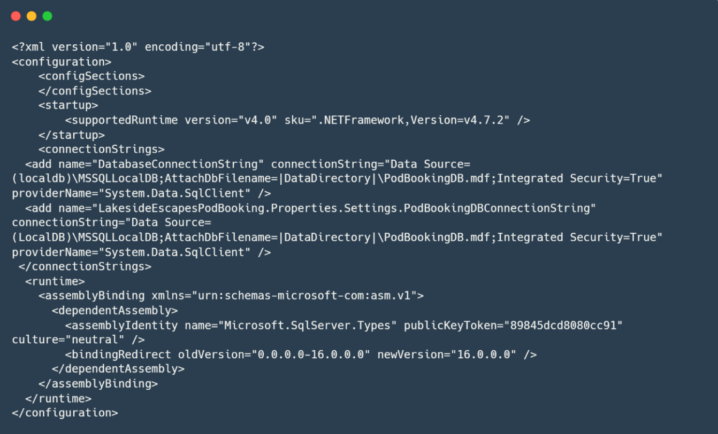B.1. App.config

B.2. Classes

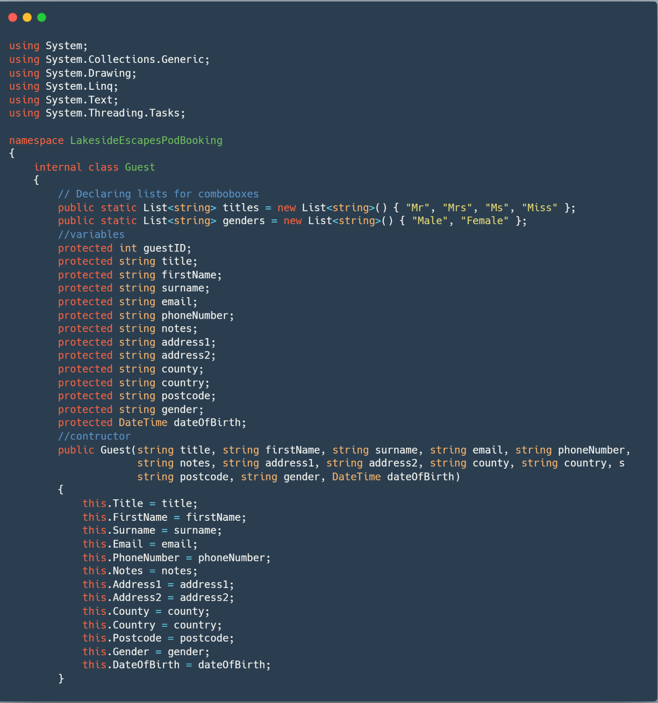B.2.1. Guest.cs

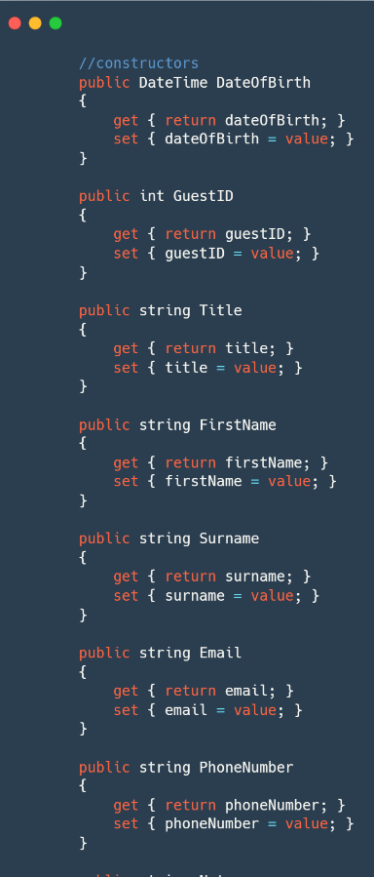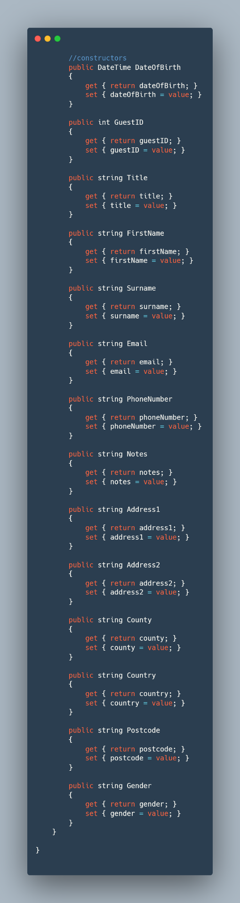

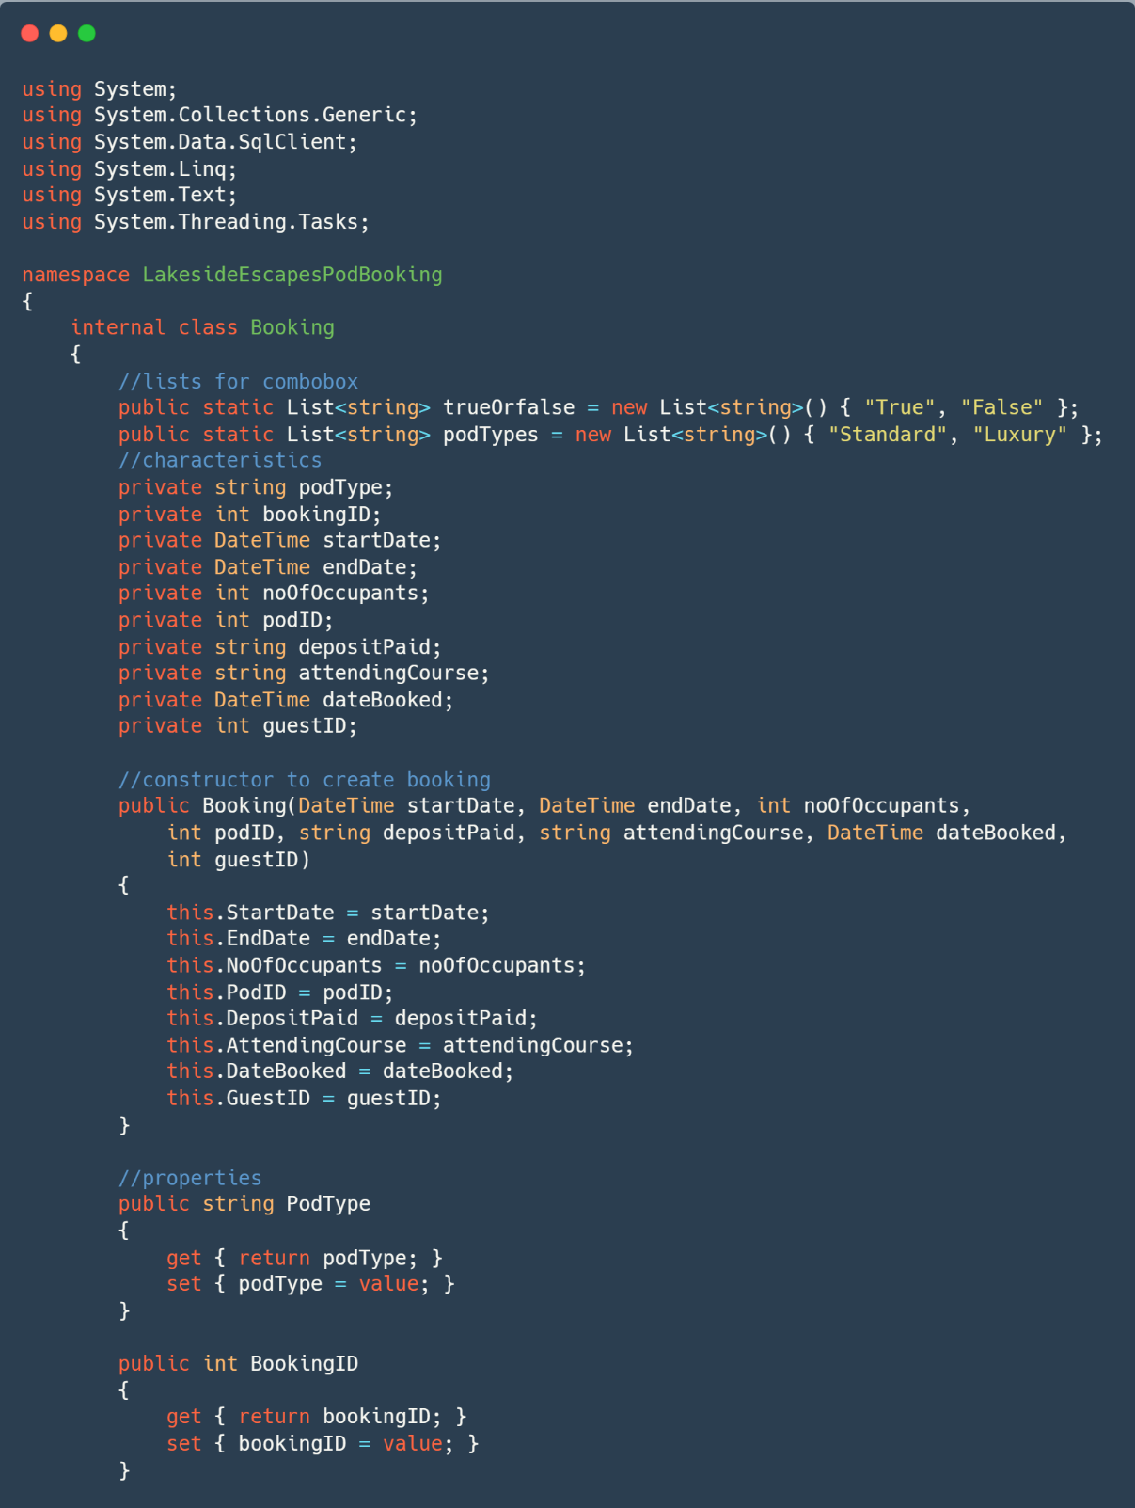B.2.2. Booking.cs

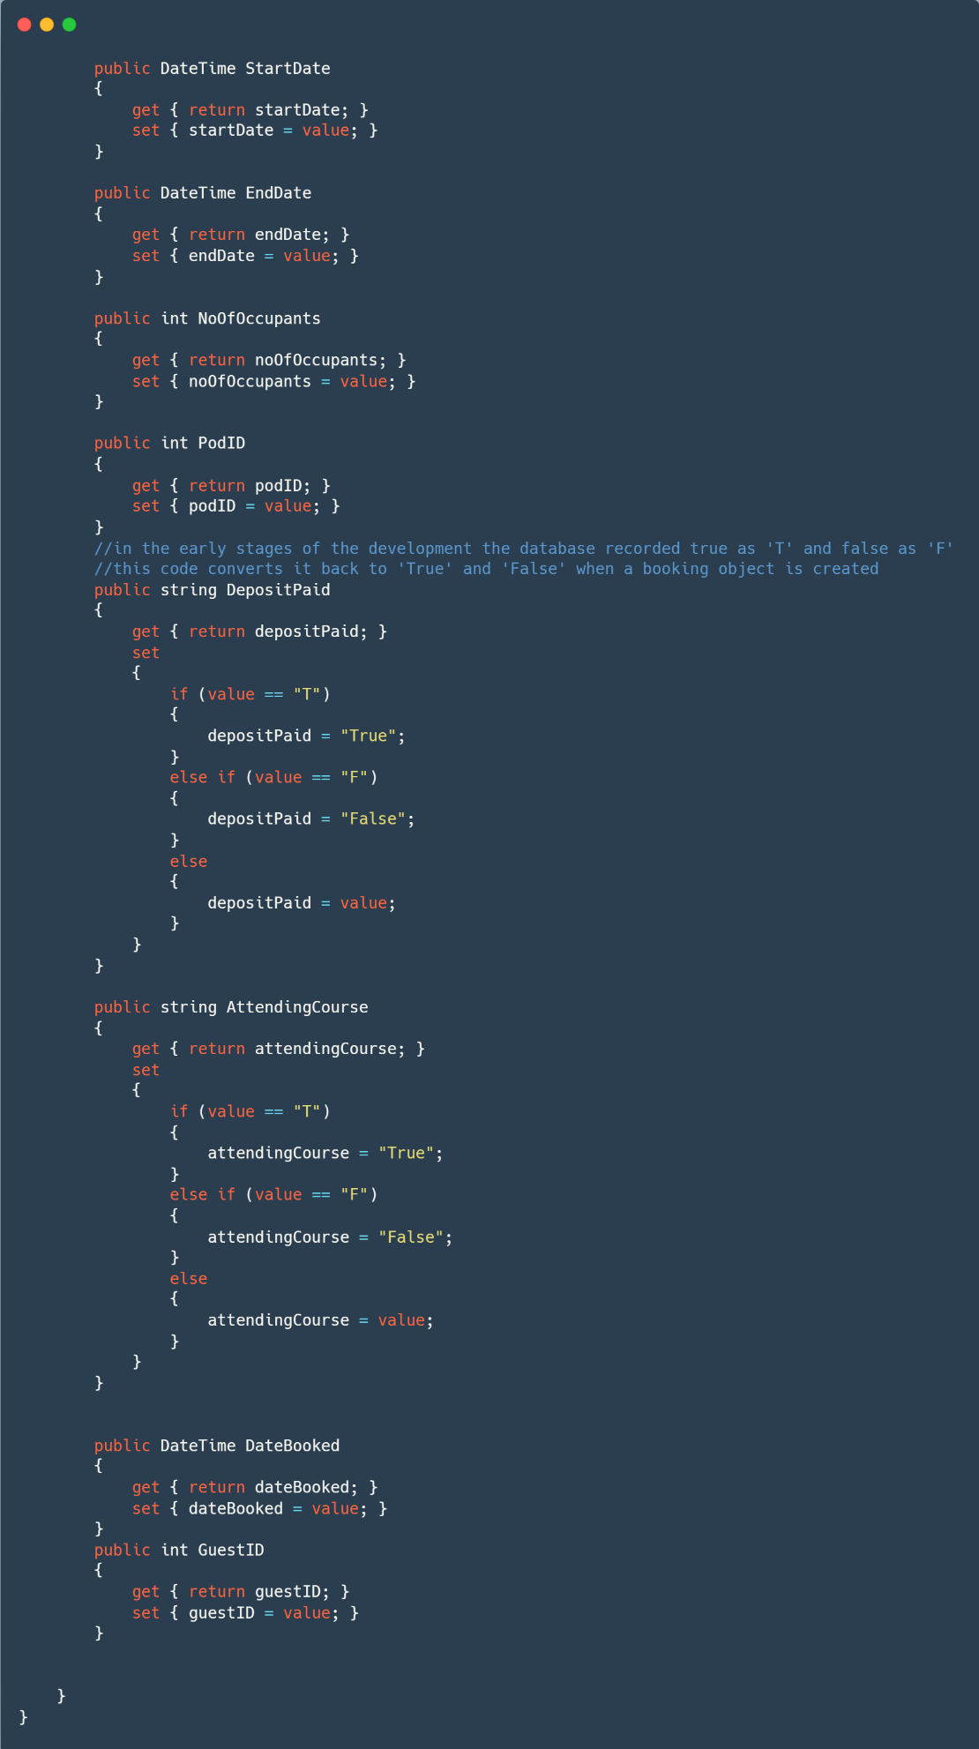

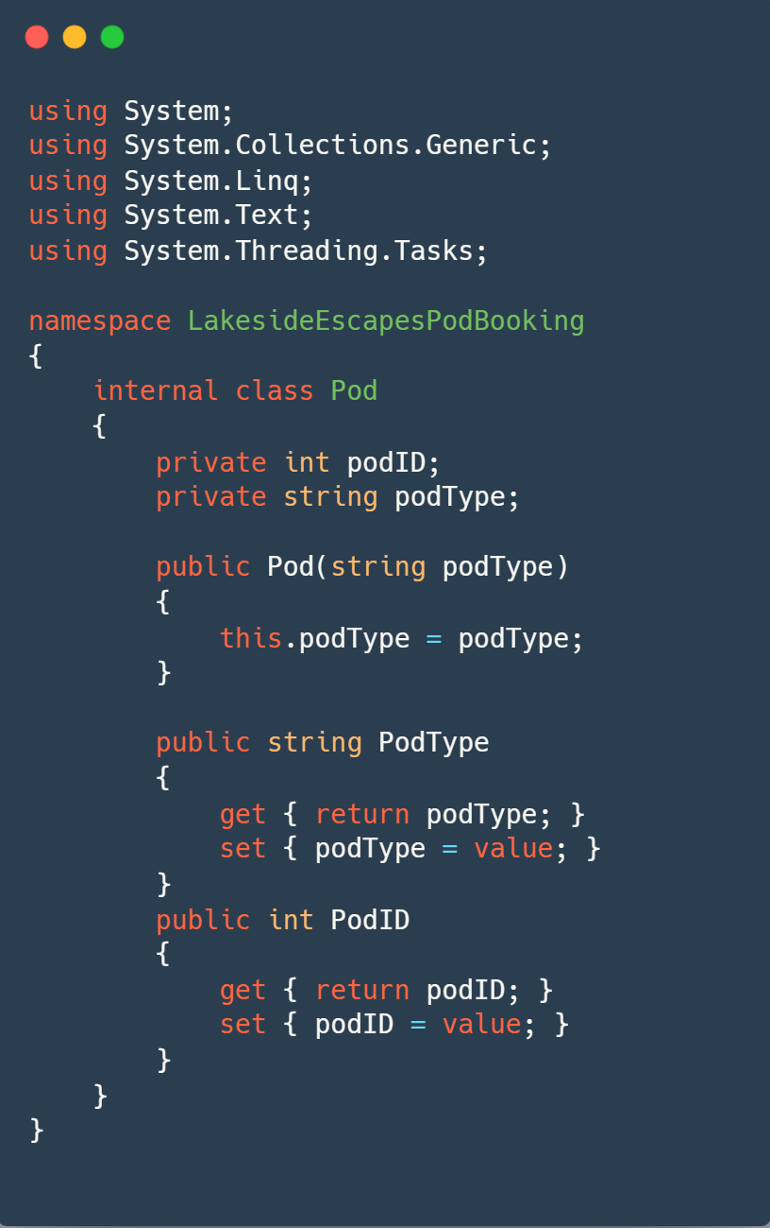B.2.3. Pod.cs

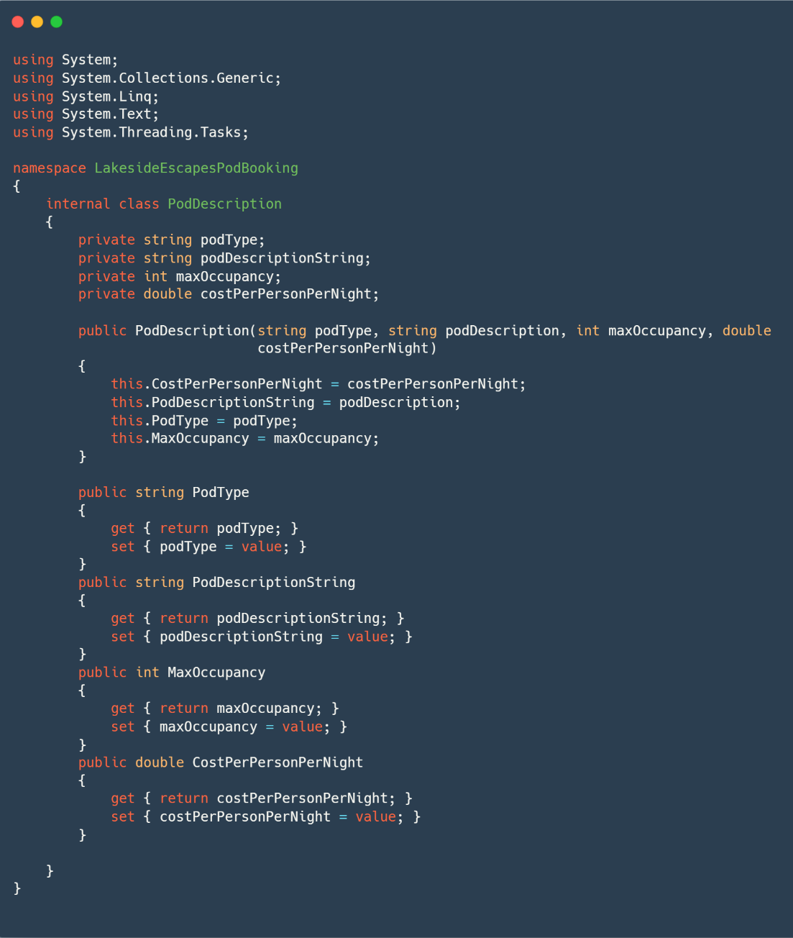B.2.4. PodDescription.cs

B.2.5. Validation.cs

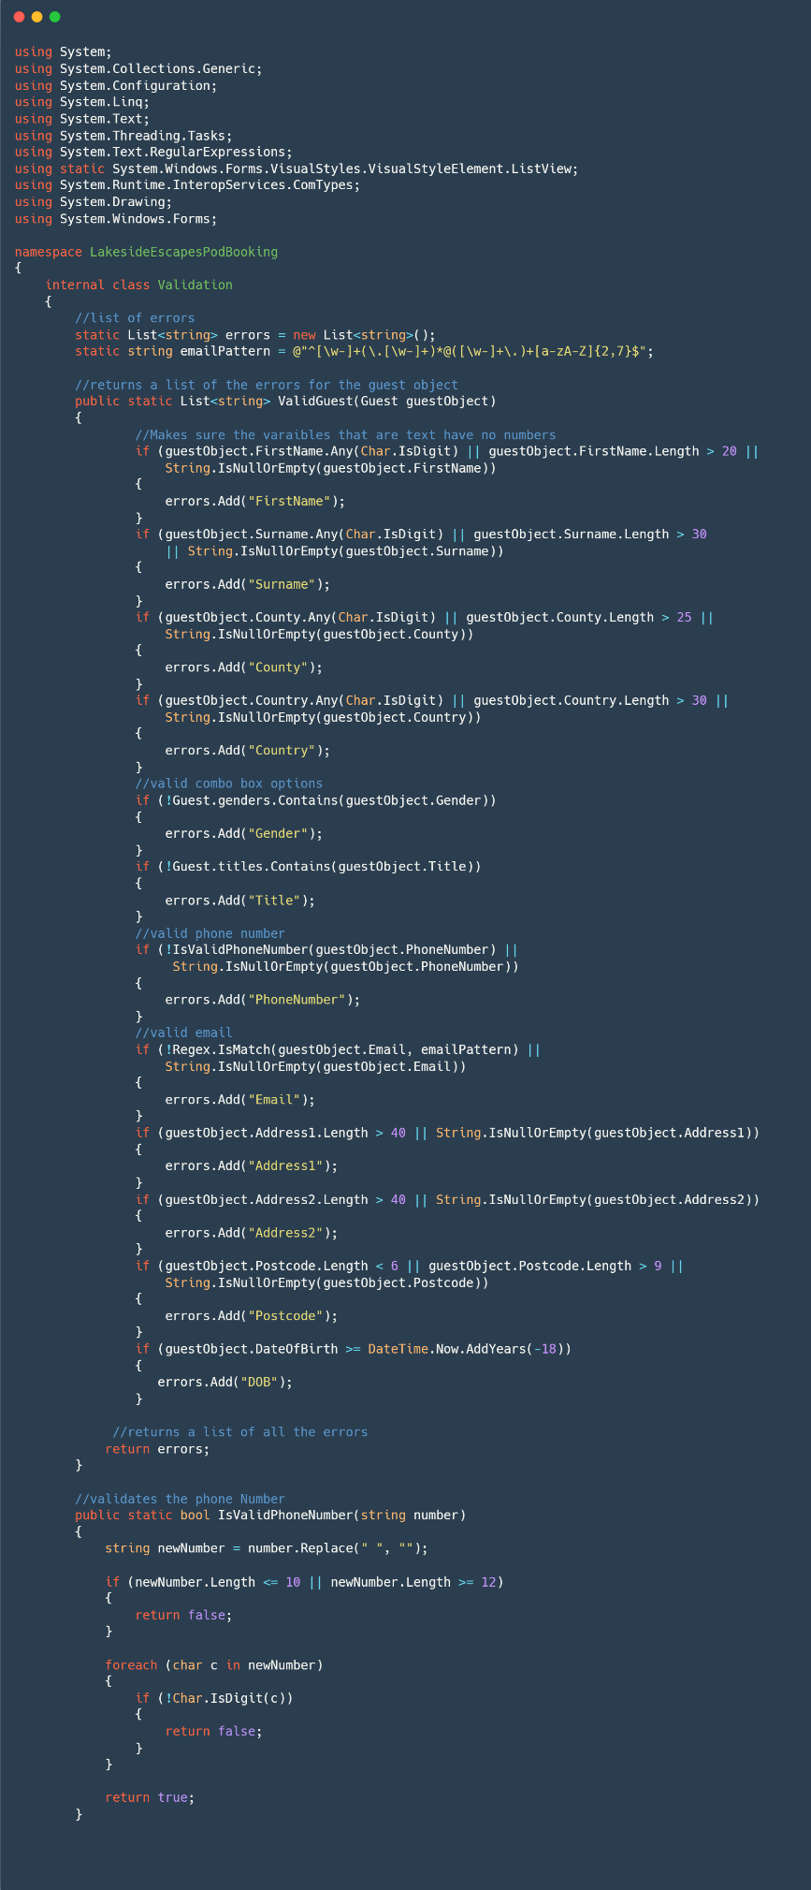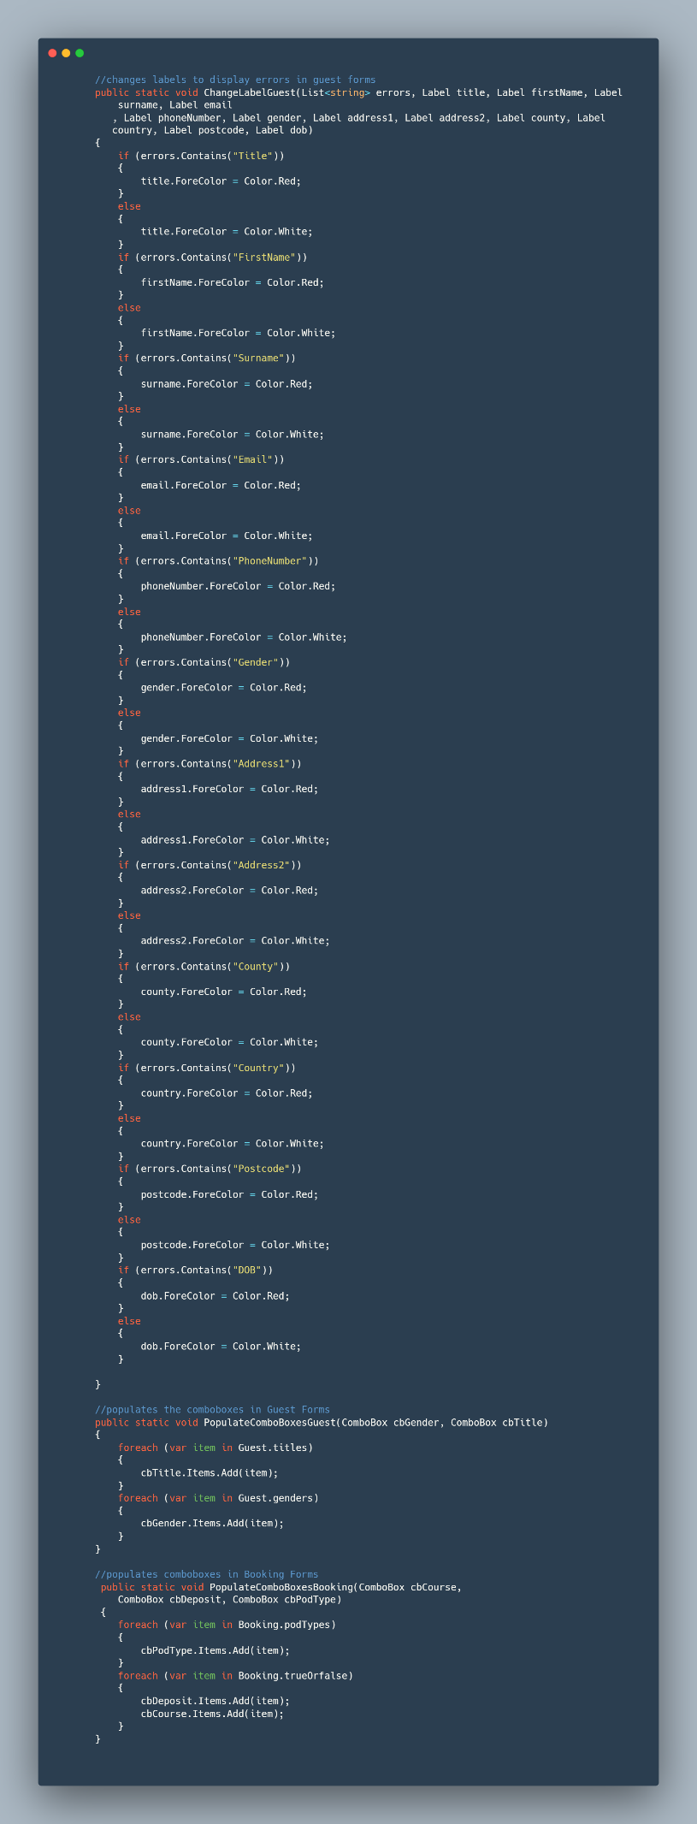

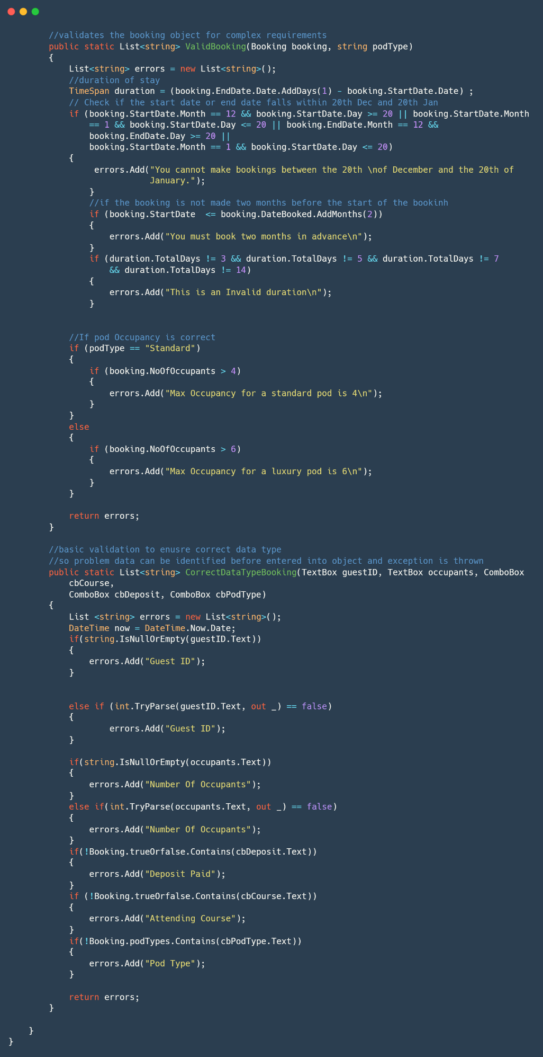

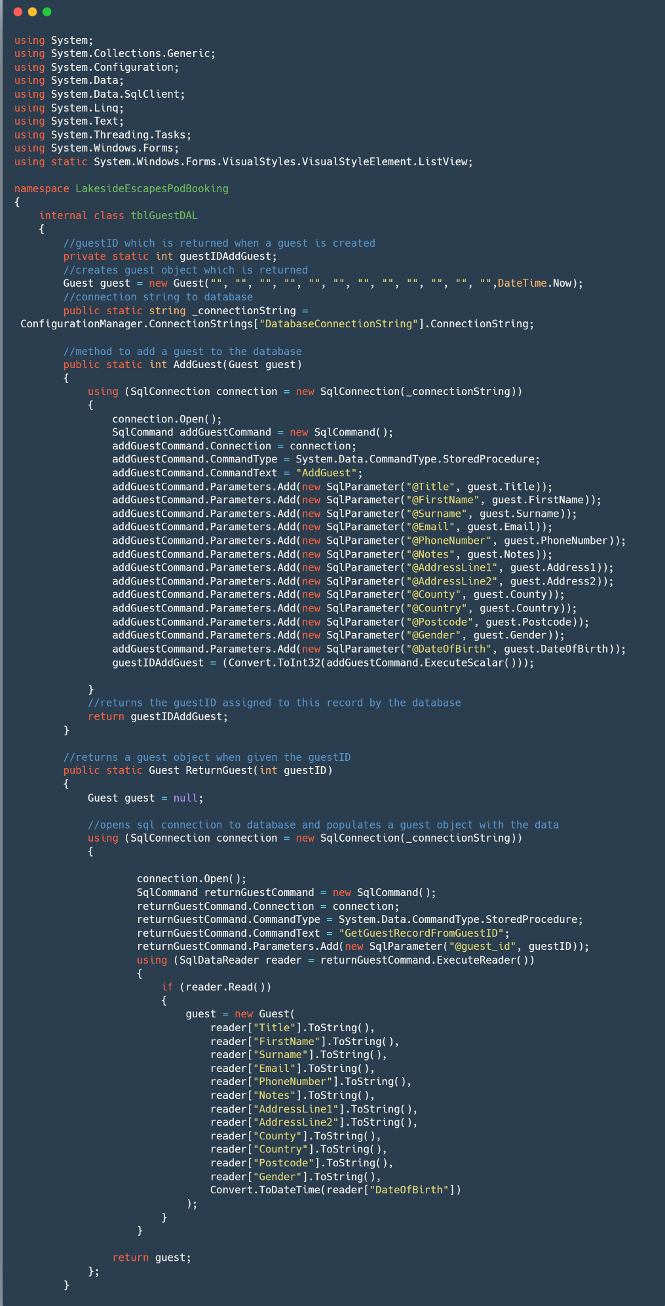B.2.6. tblGuestDAL.cs

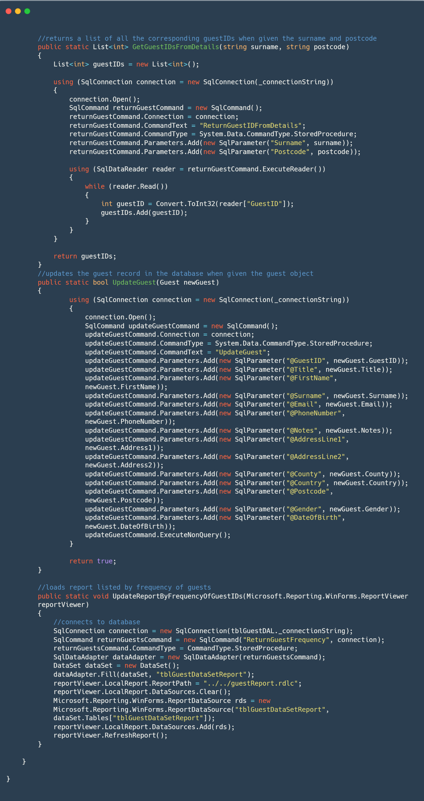

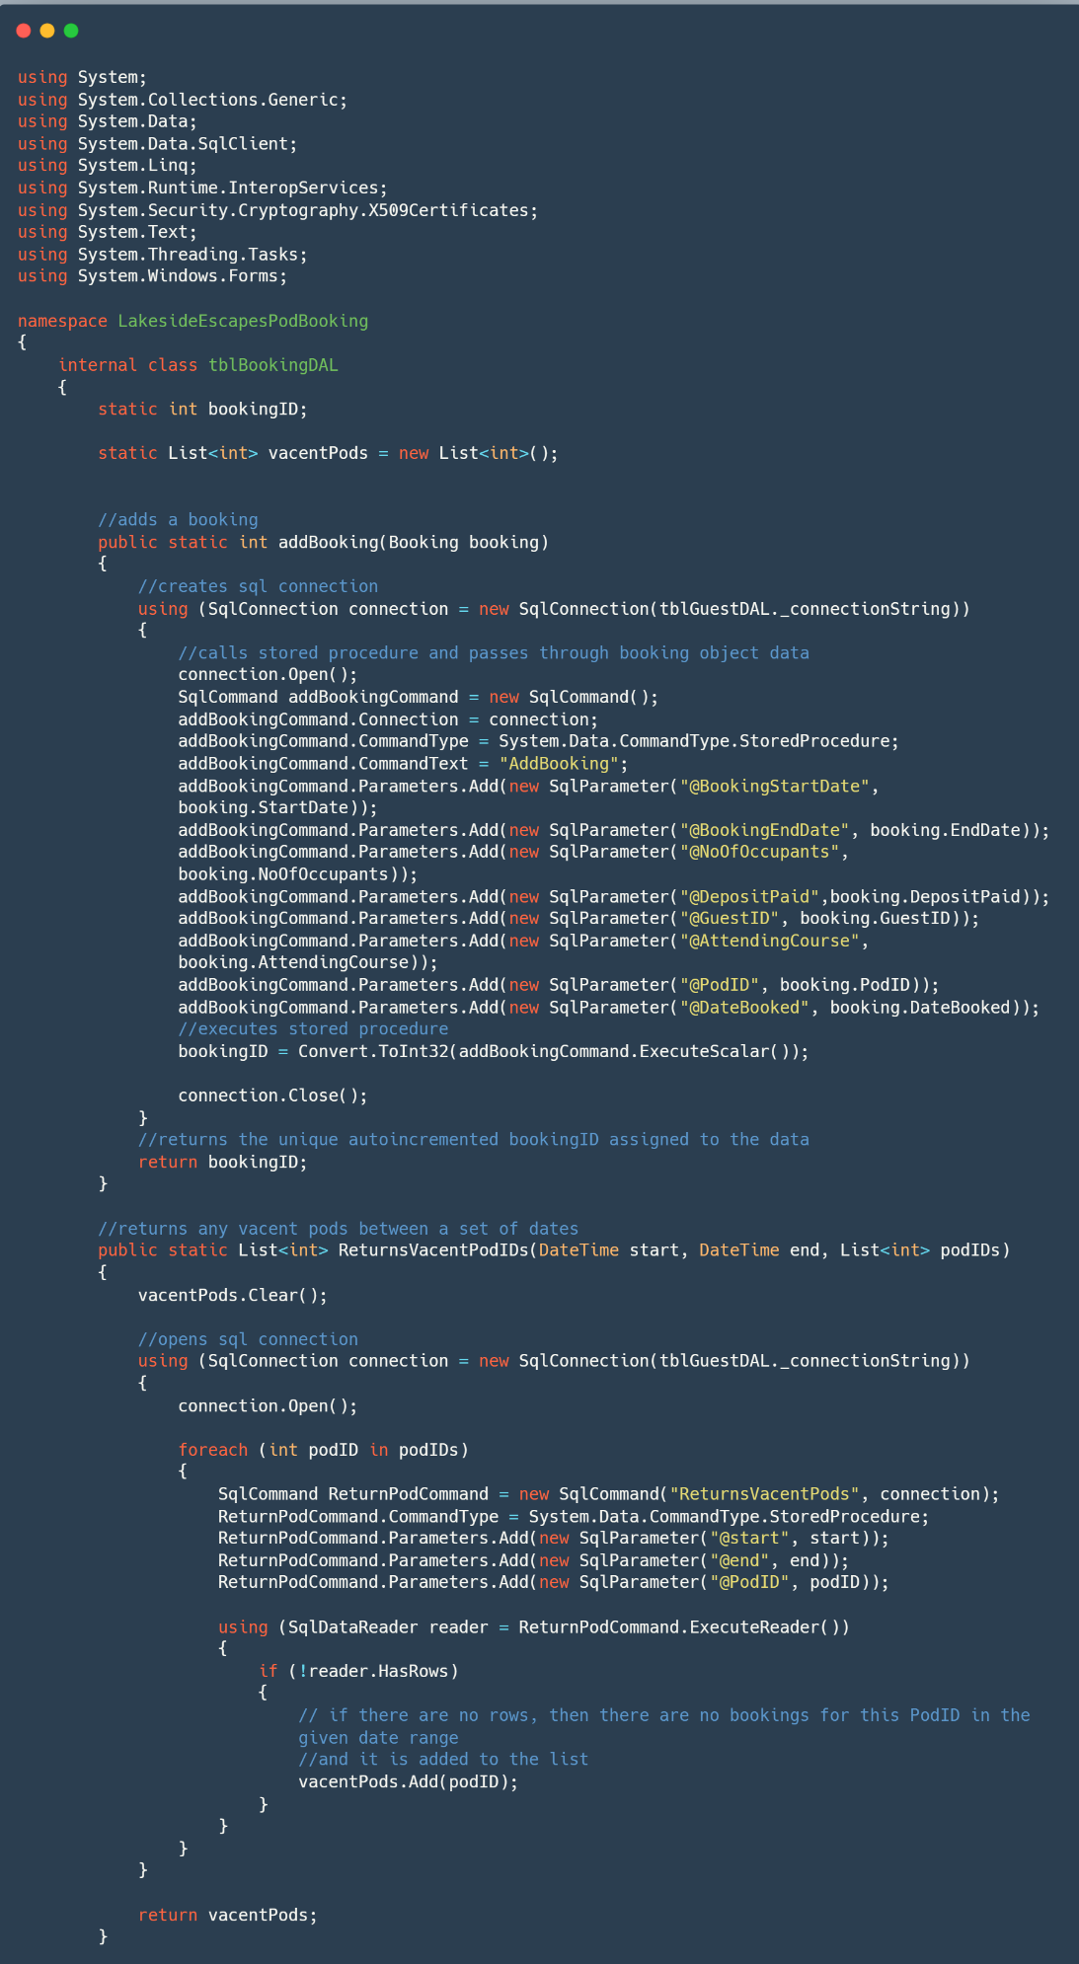B.2.7. tblBookingDAL.cs

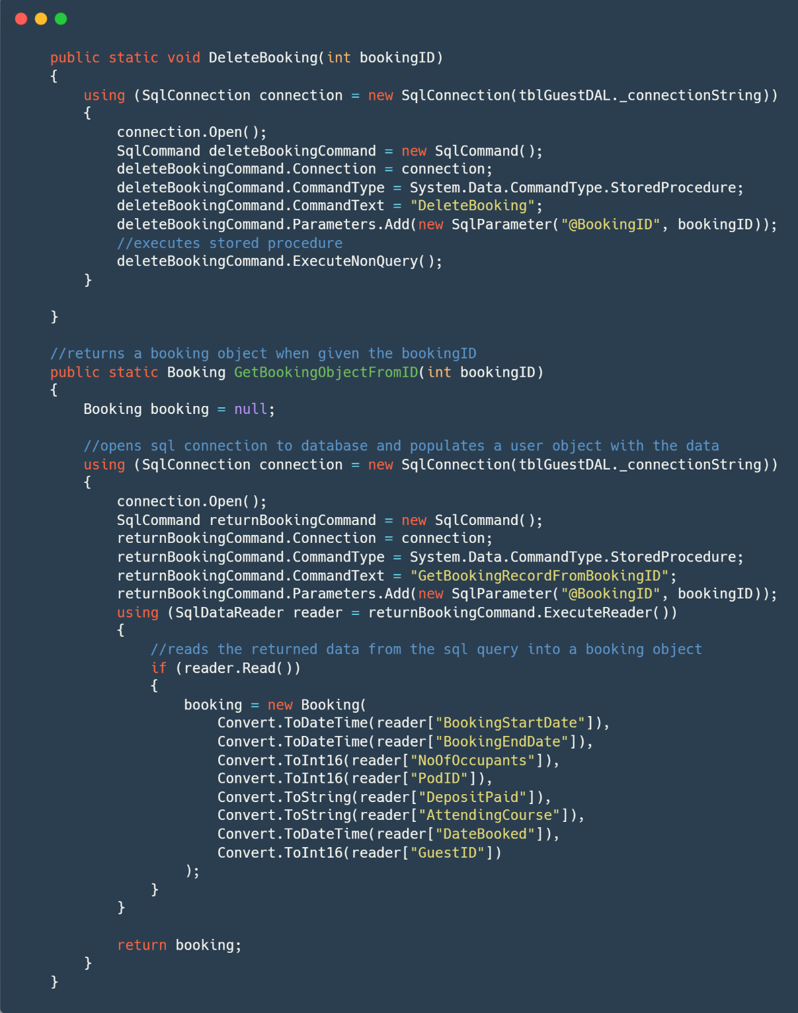

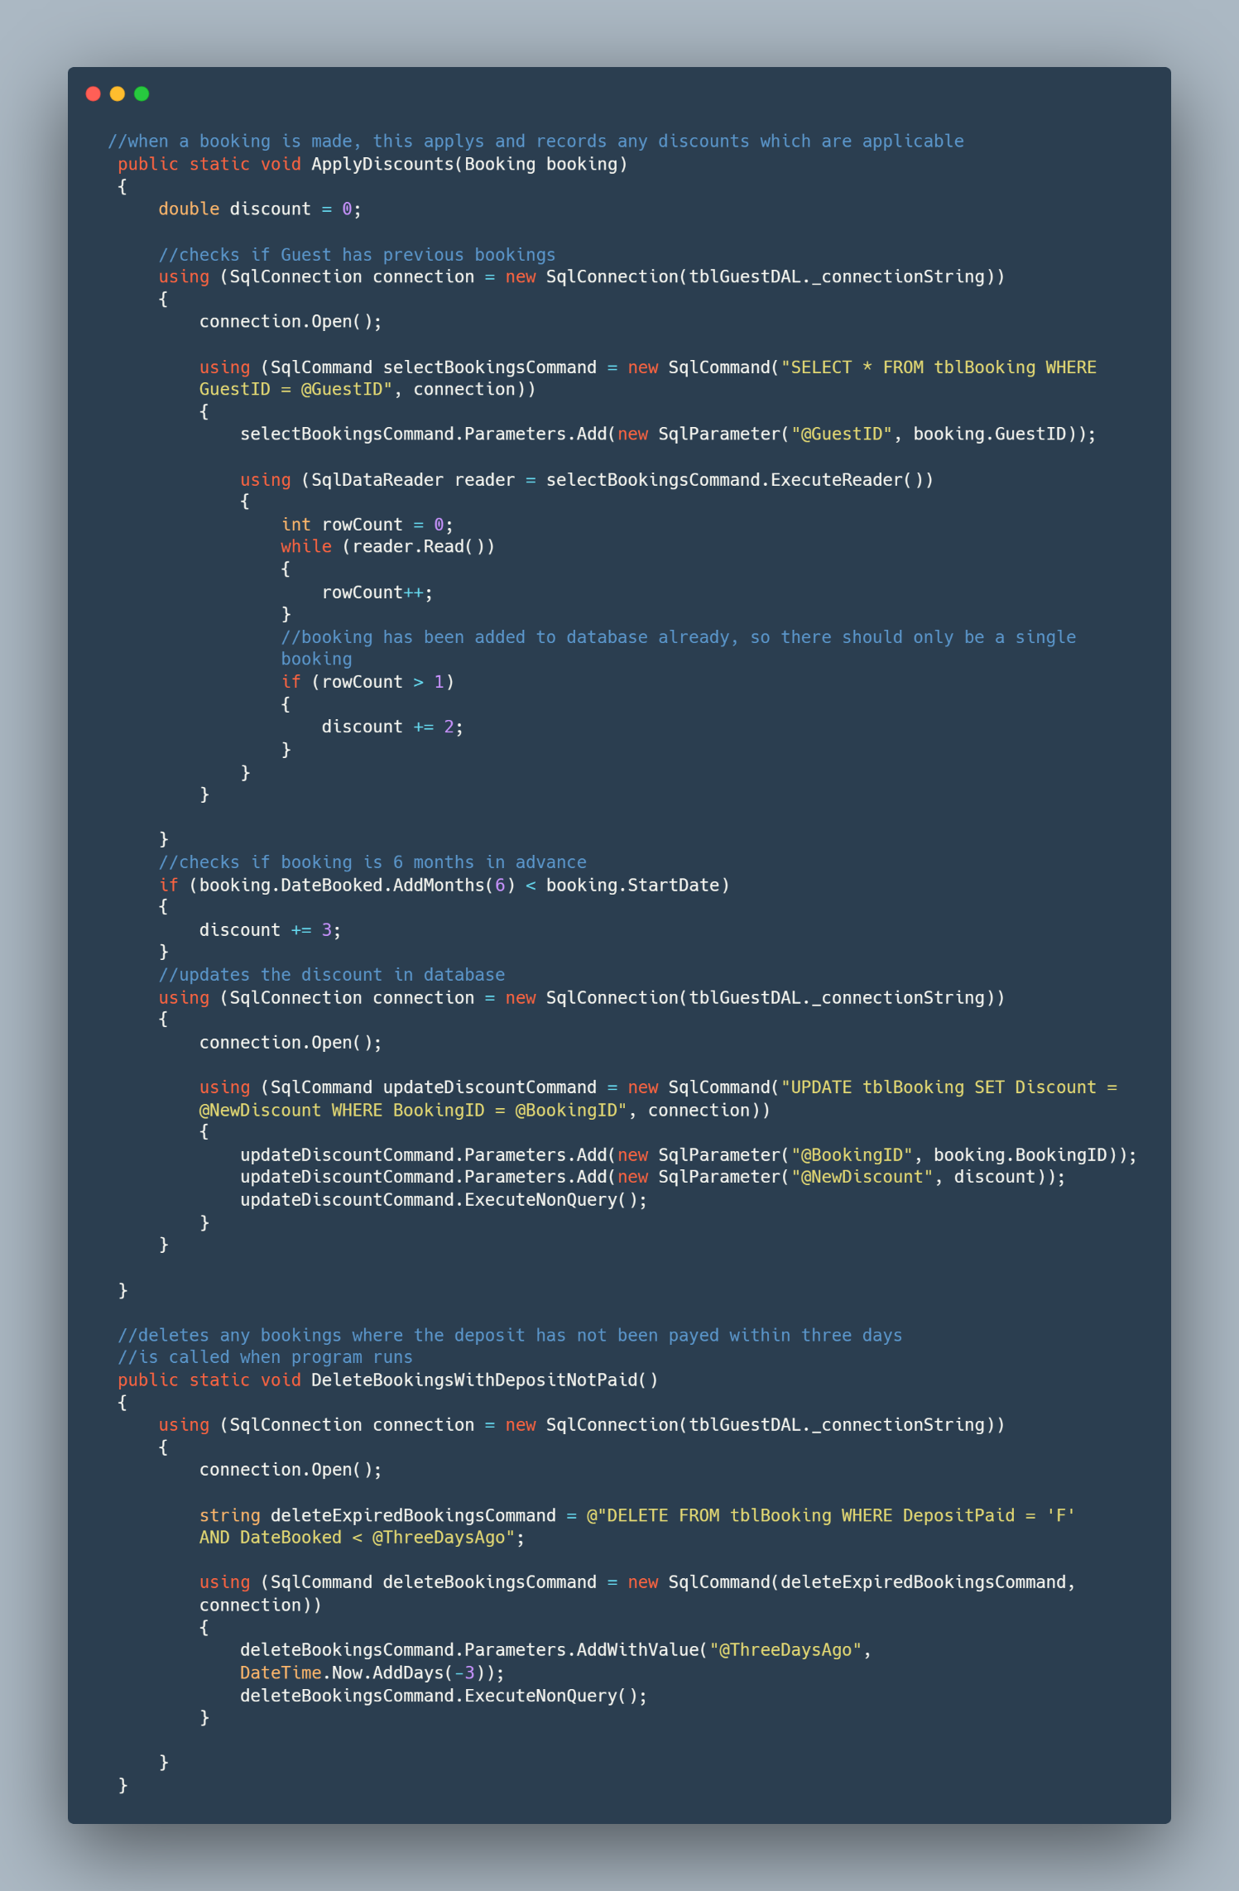

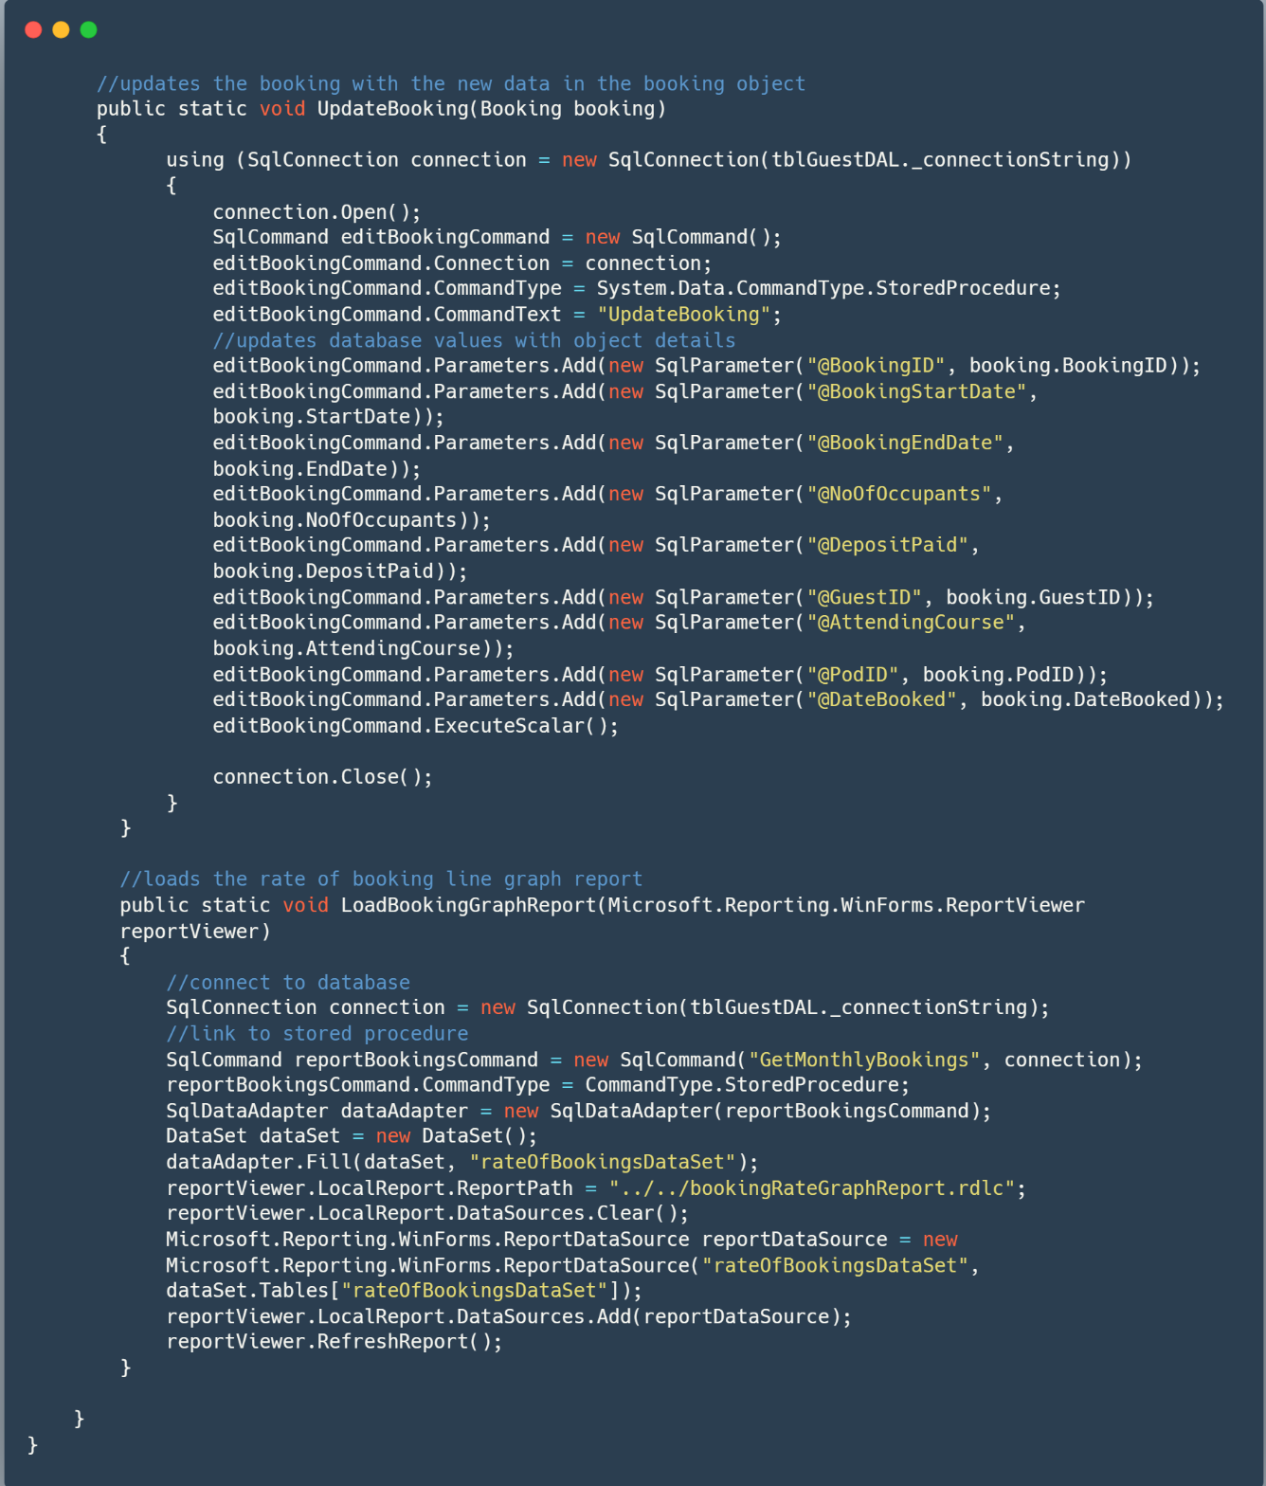

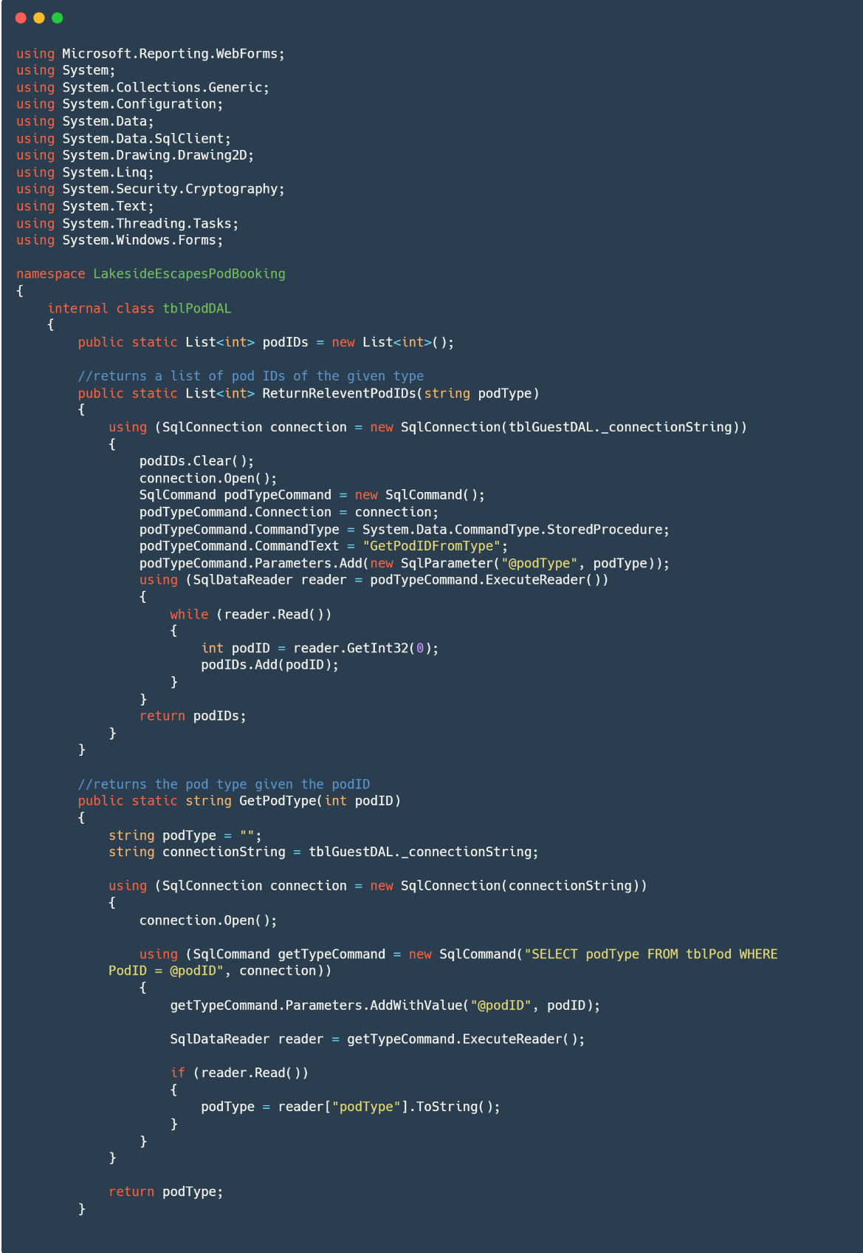B.2.8. tblPodDAL.cs

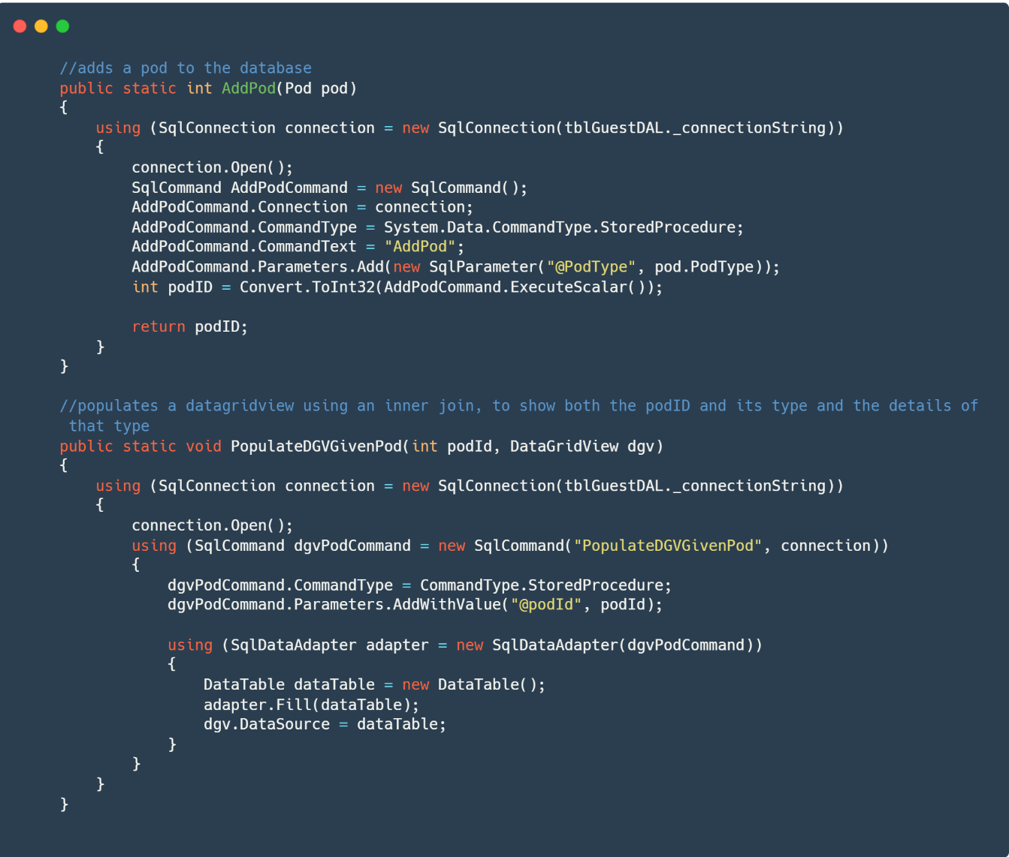

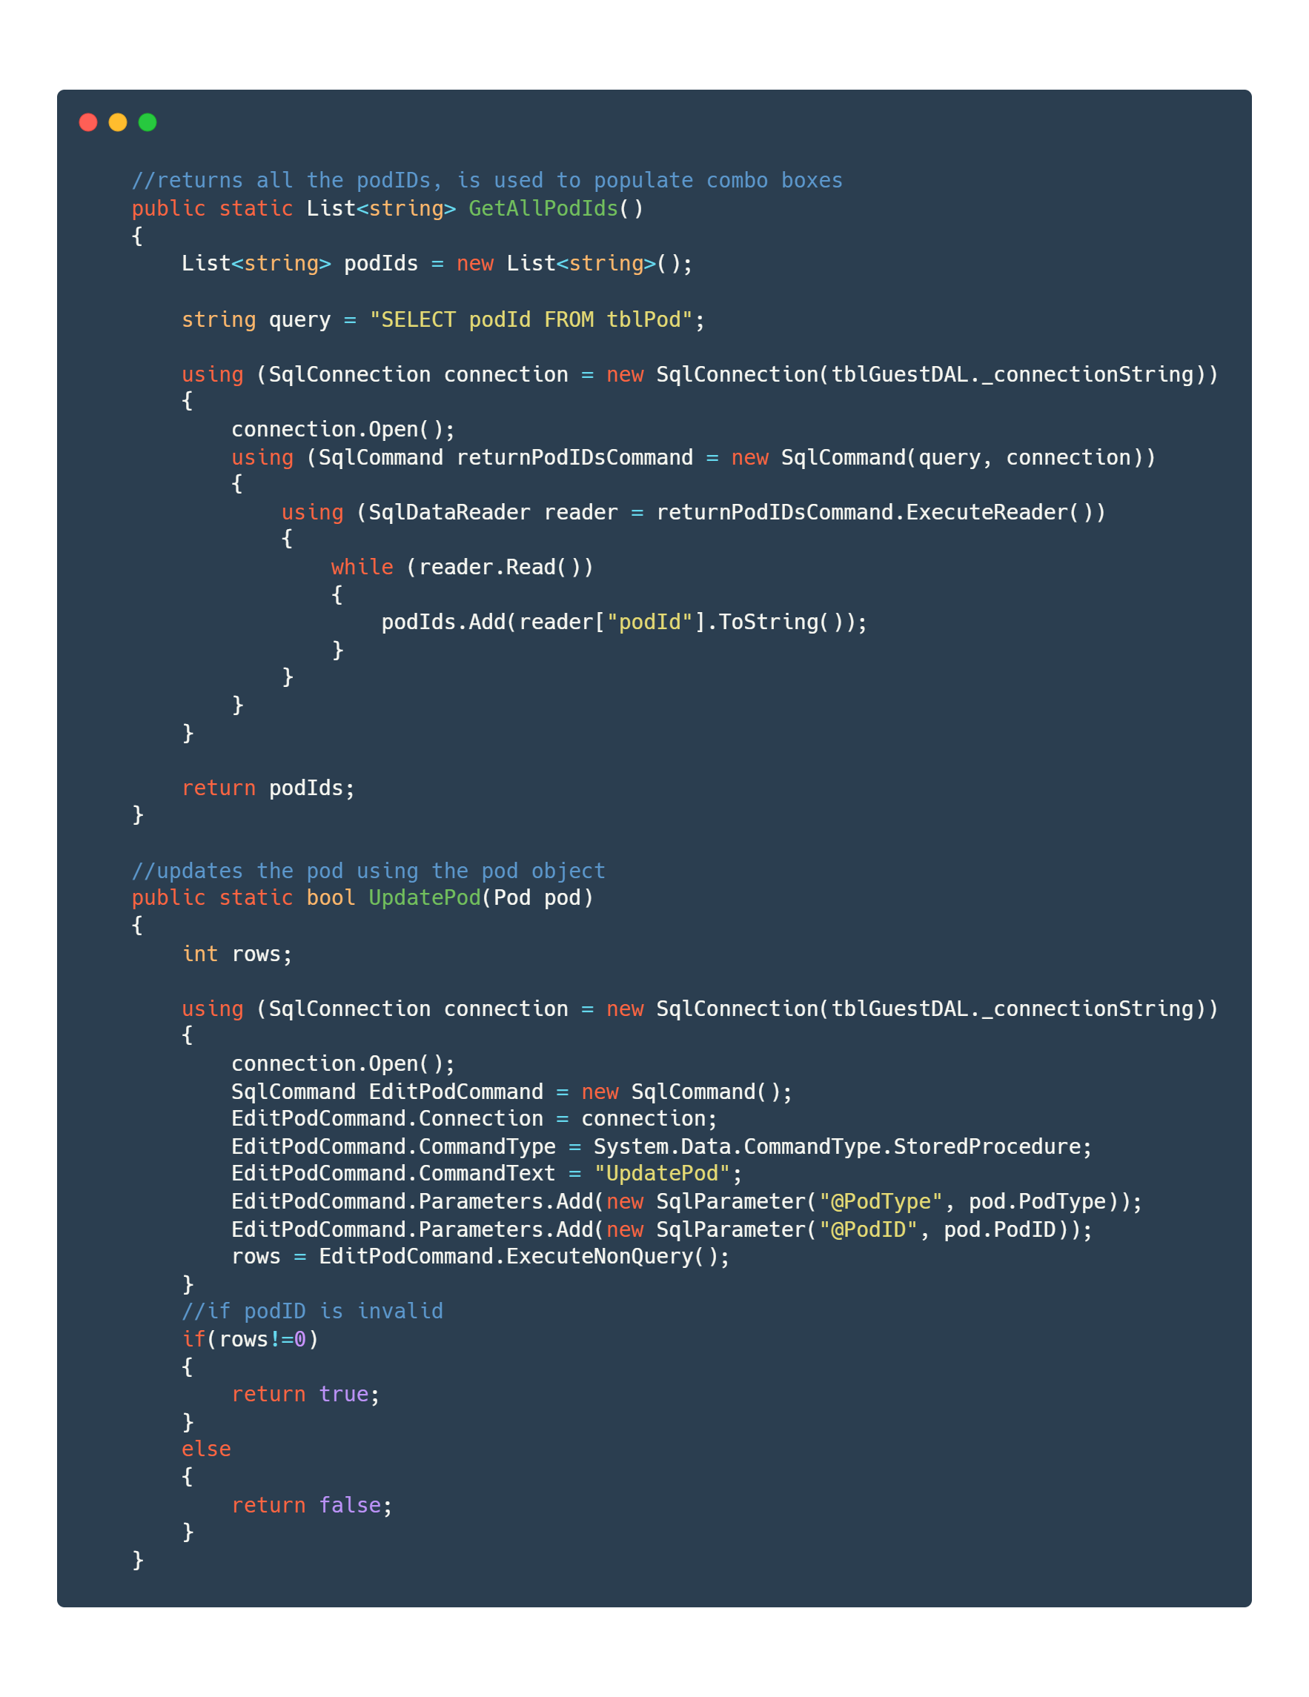

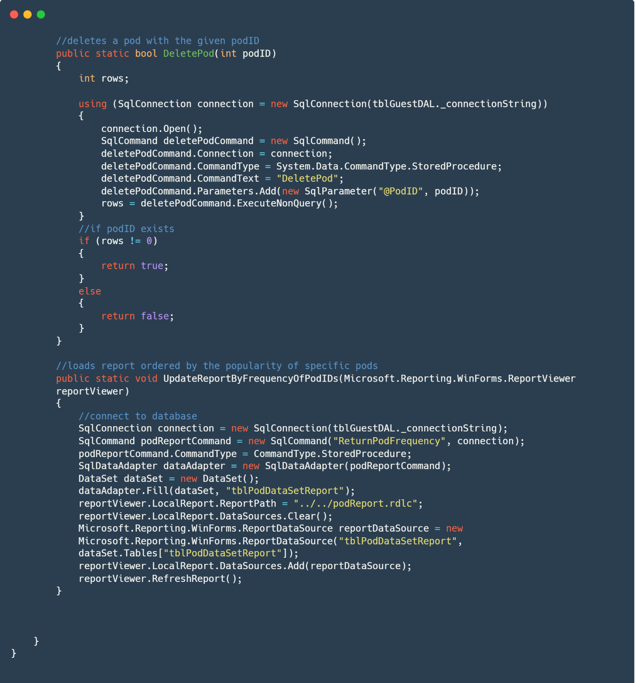

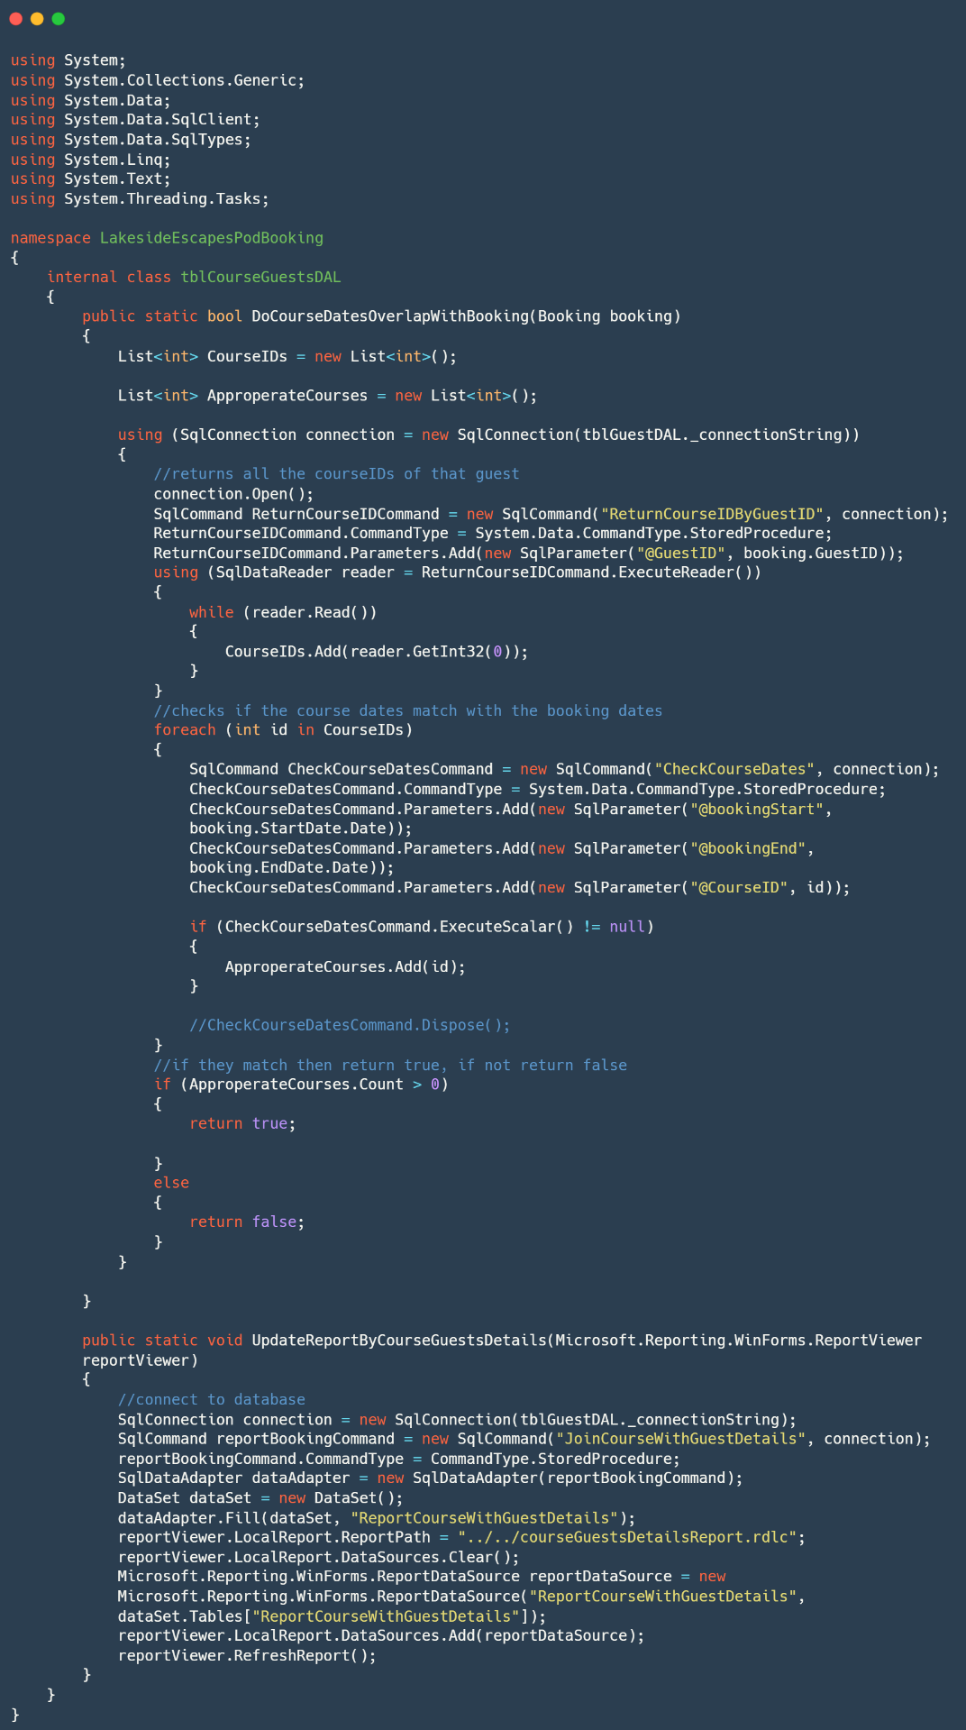B.2.9 tblCourseGuestsDAL.cs

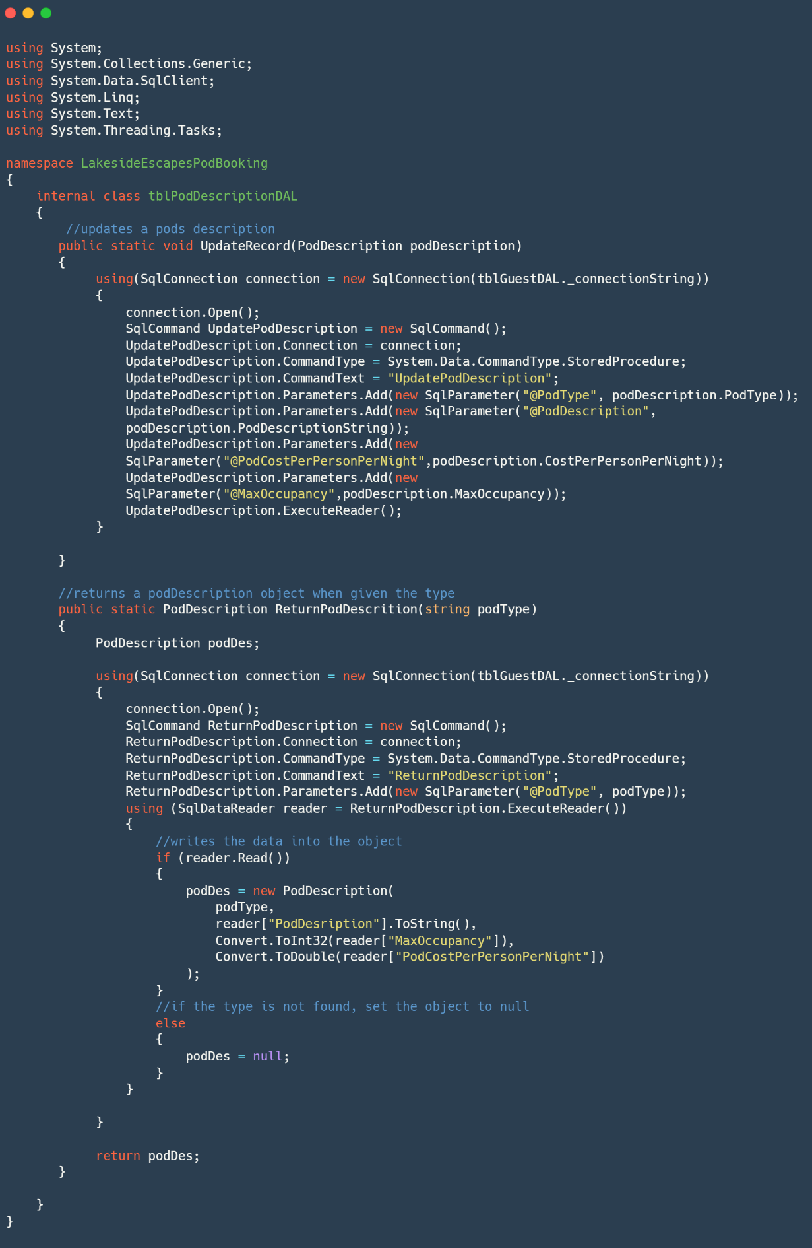B.2.10. tblPodDescriptionDAL.cs

B.3. Forms

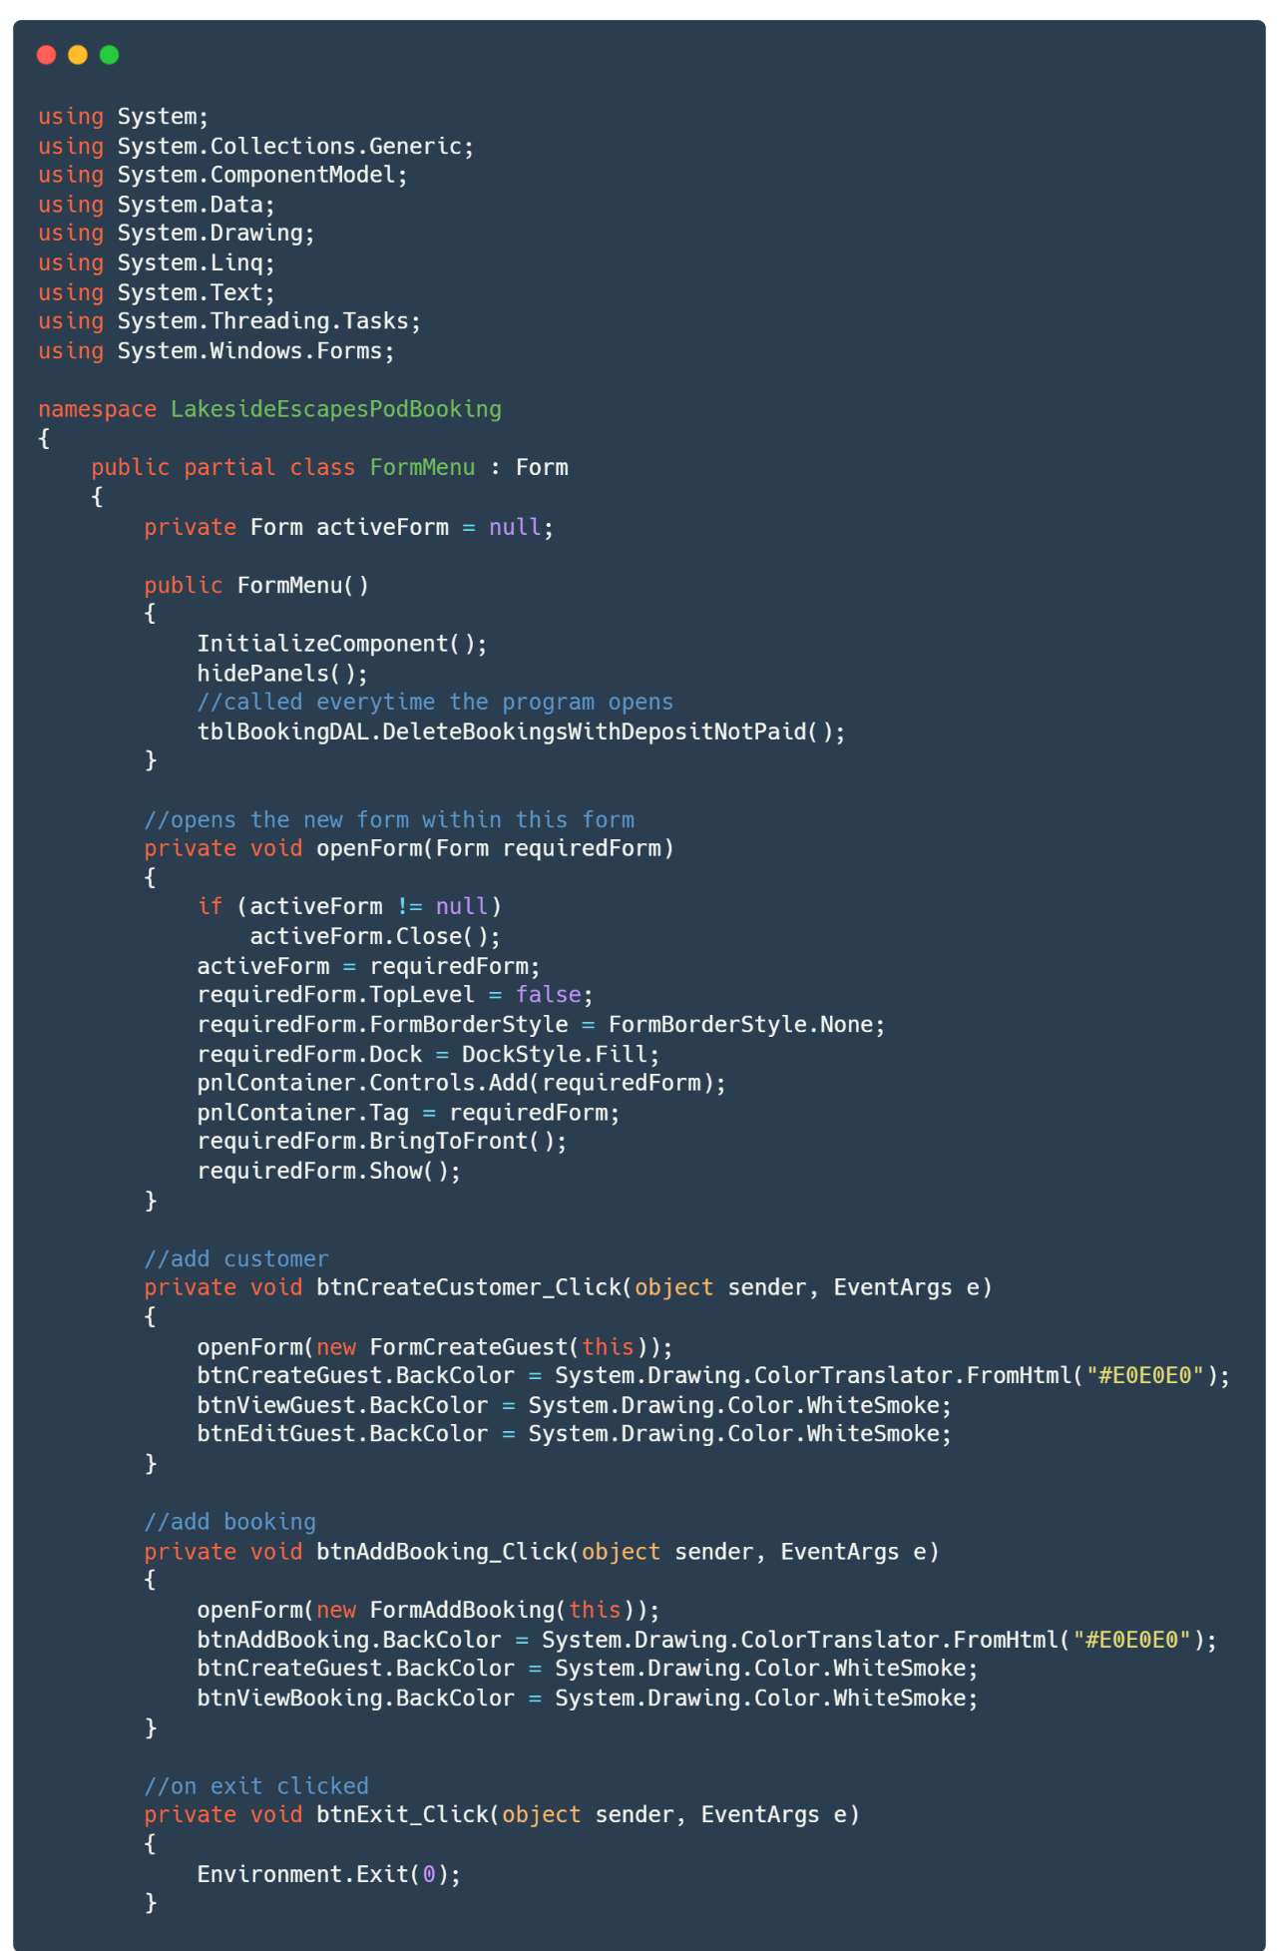B.3.1. FormMenu.cs

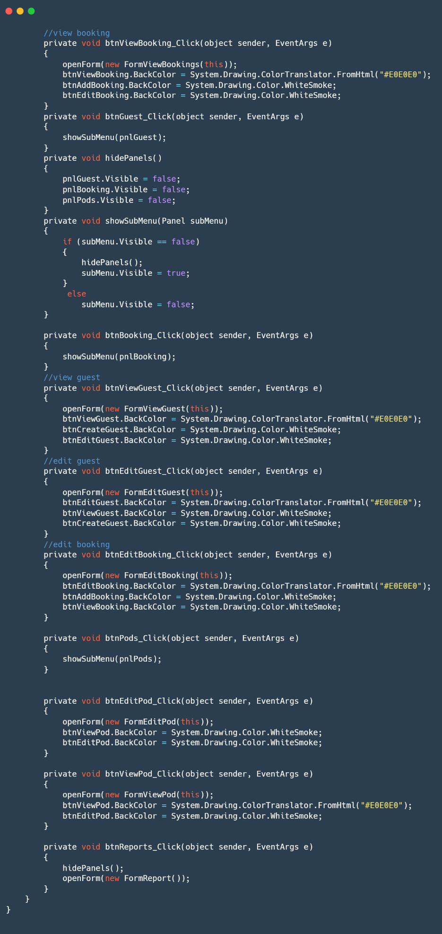

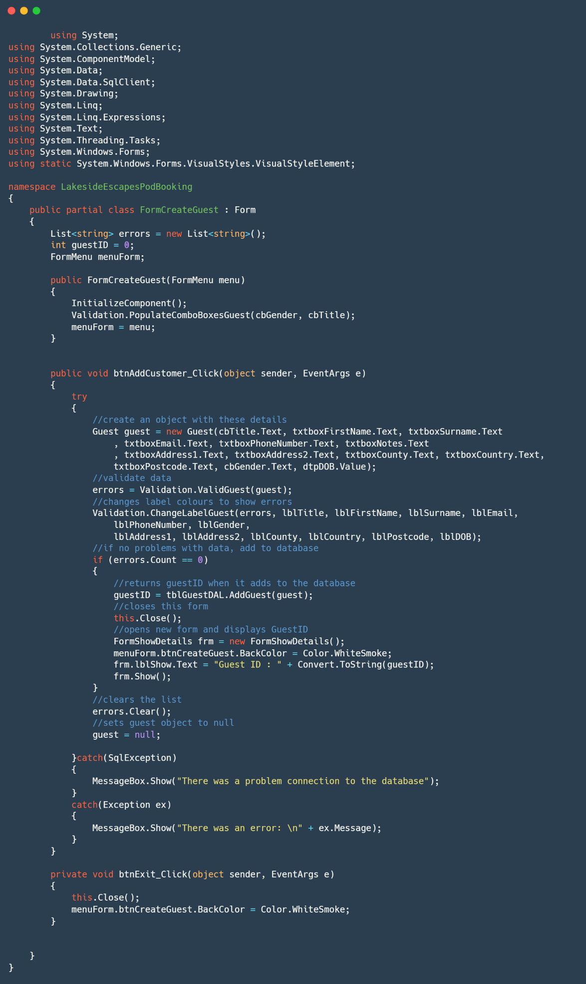B.3.2. FormCreateGuest.cs

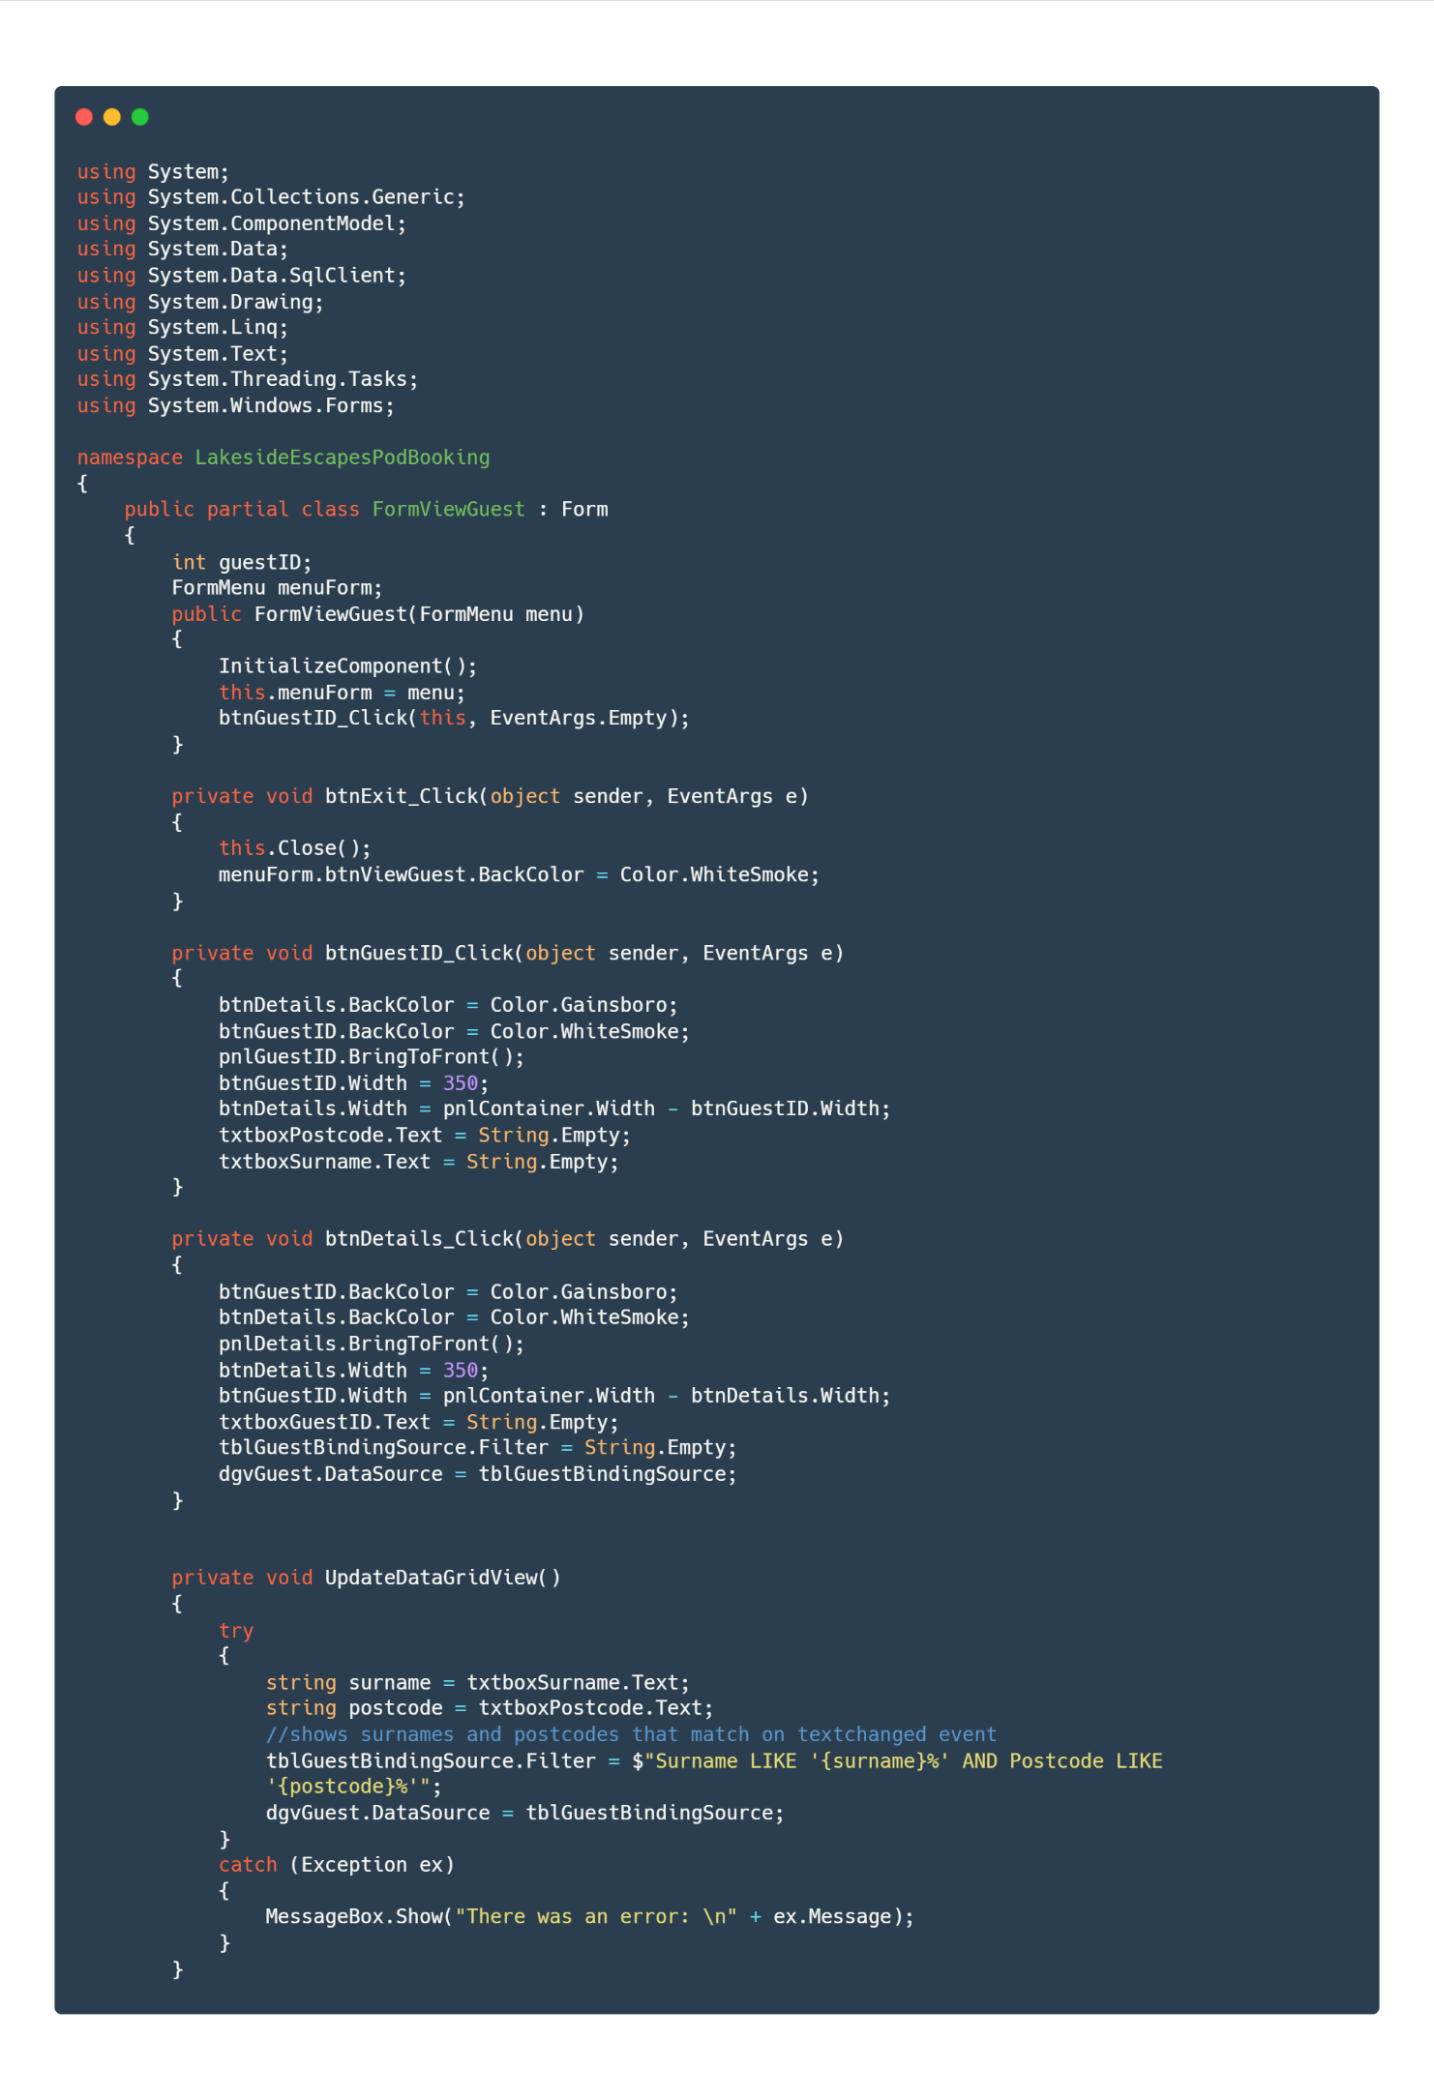B.3.3. FormViewGuest.cs

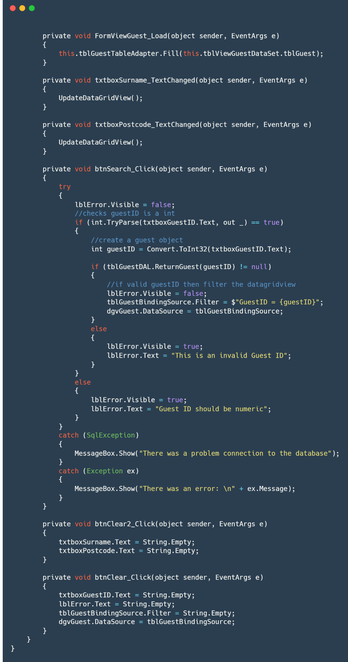

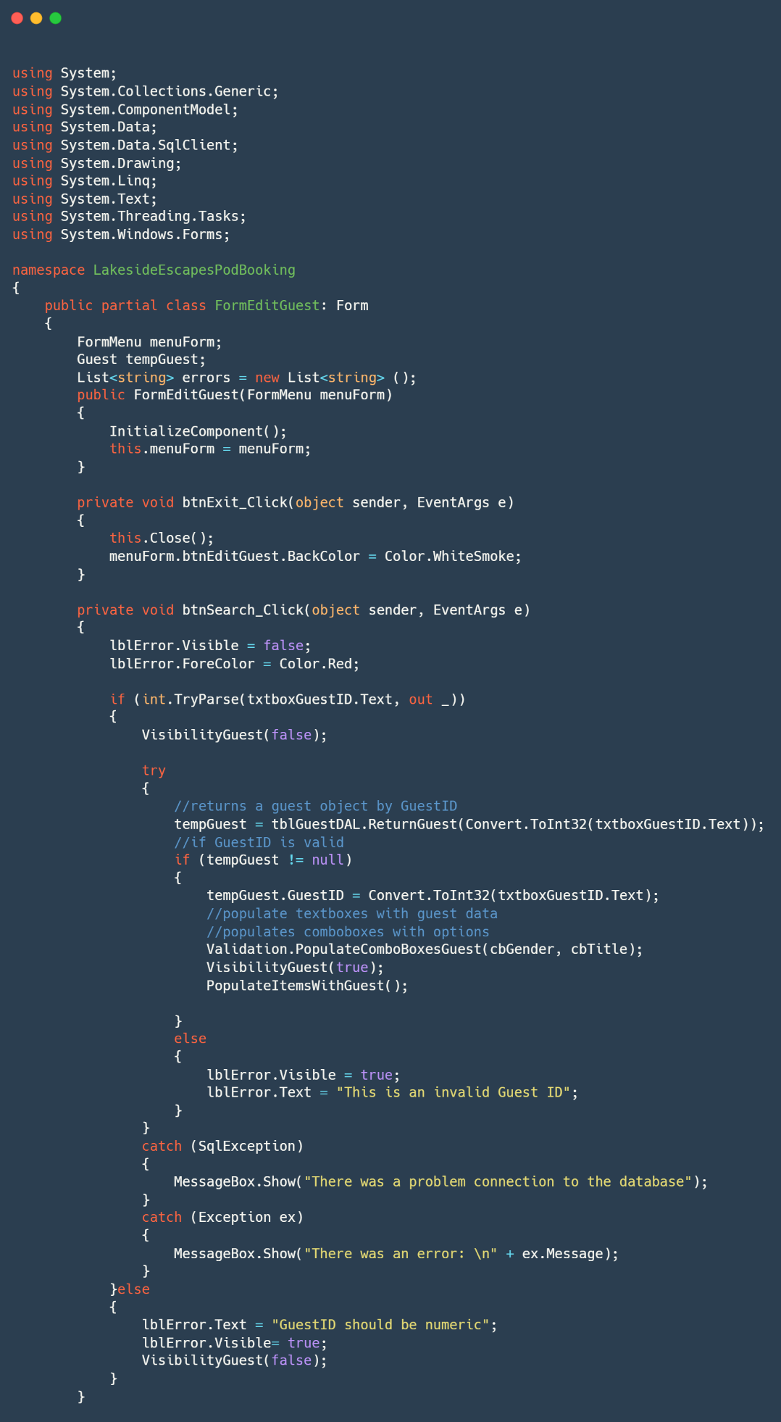B.3.4. FormEditGuest.cs

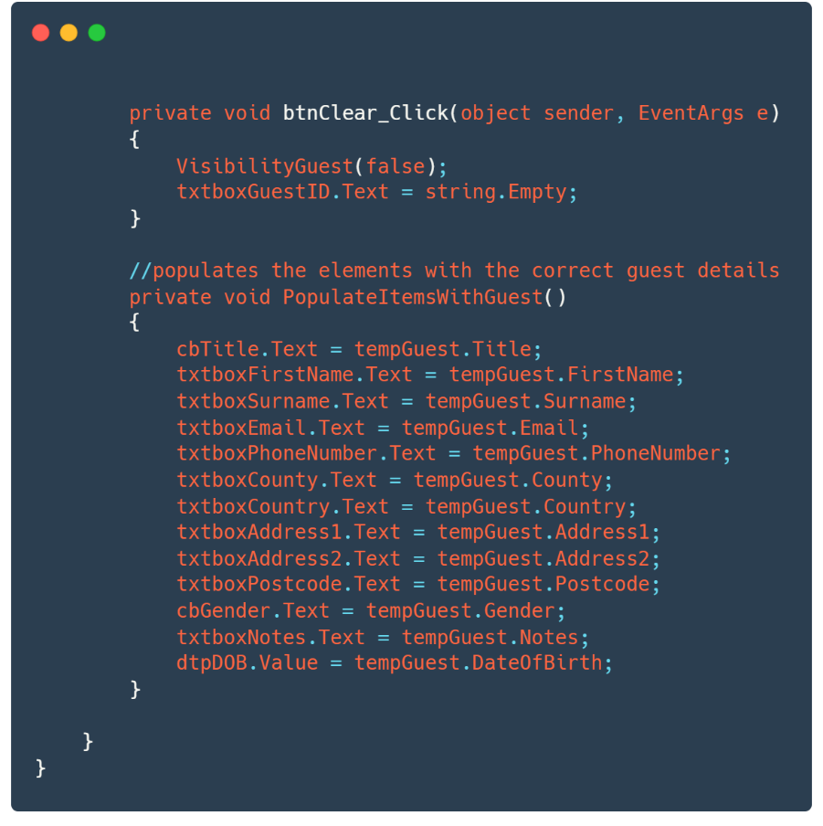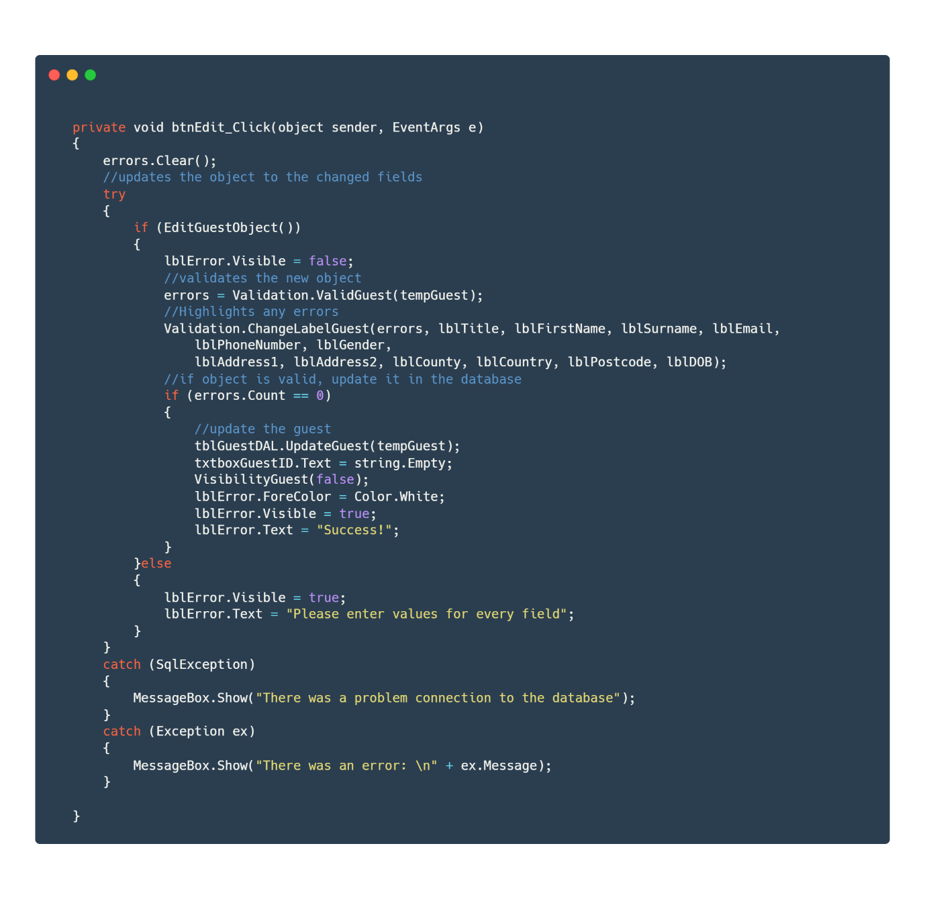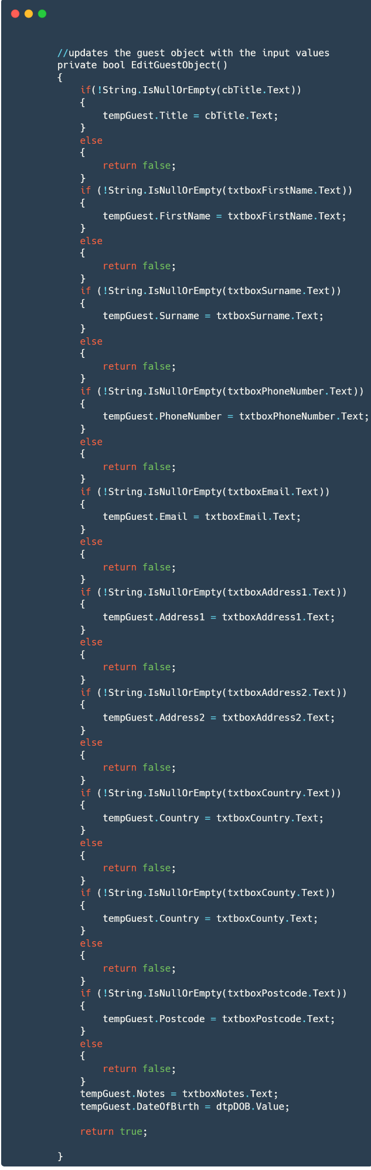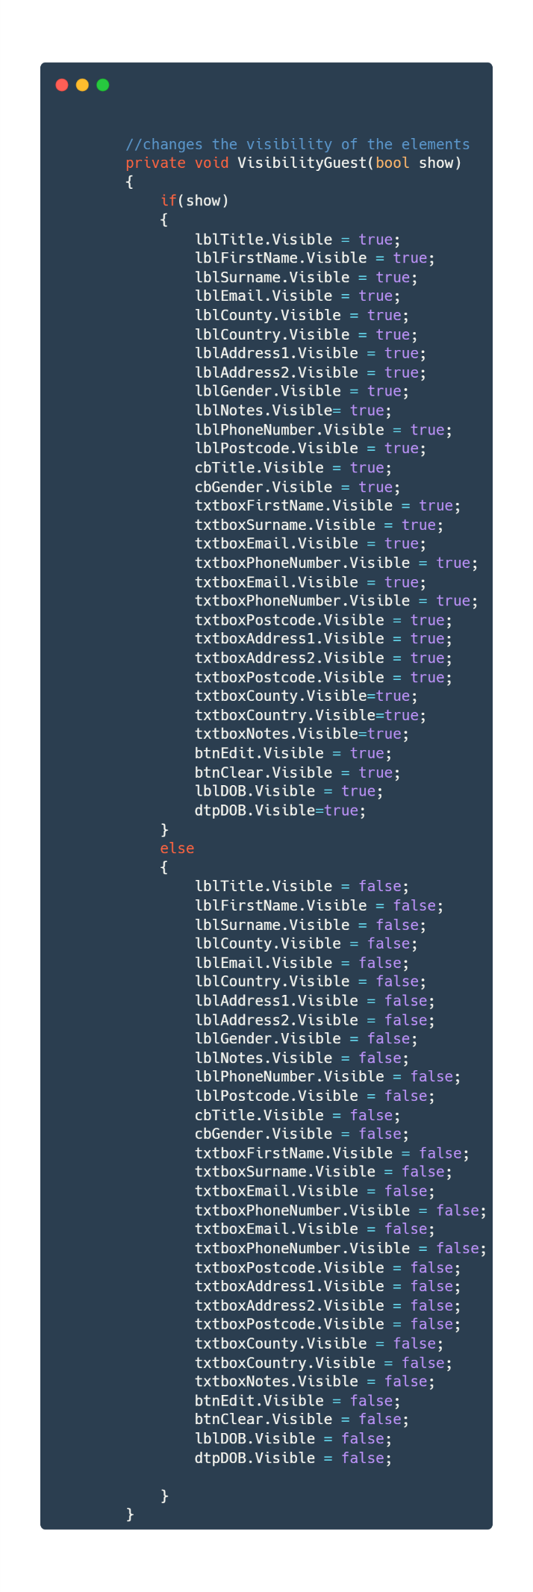

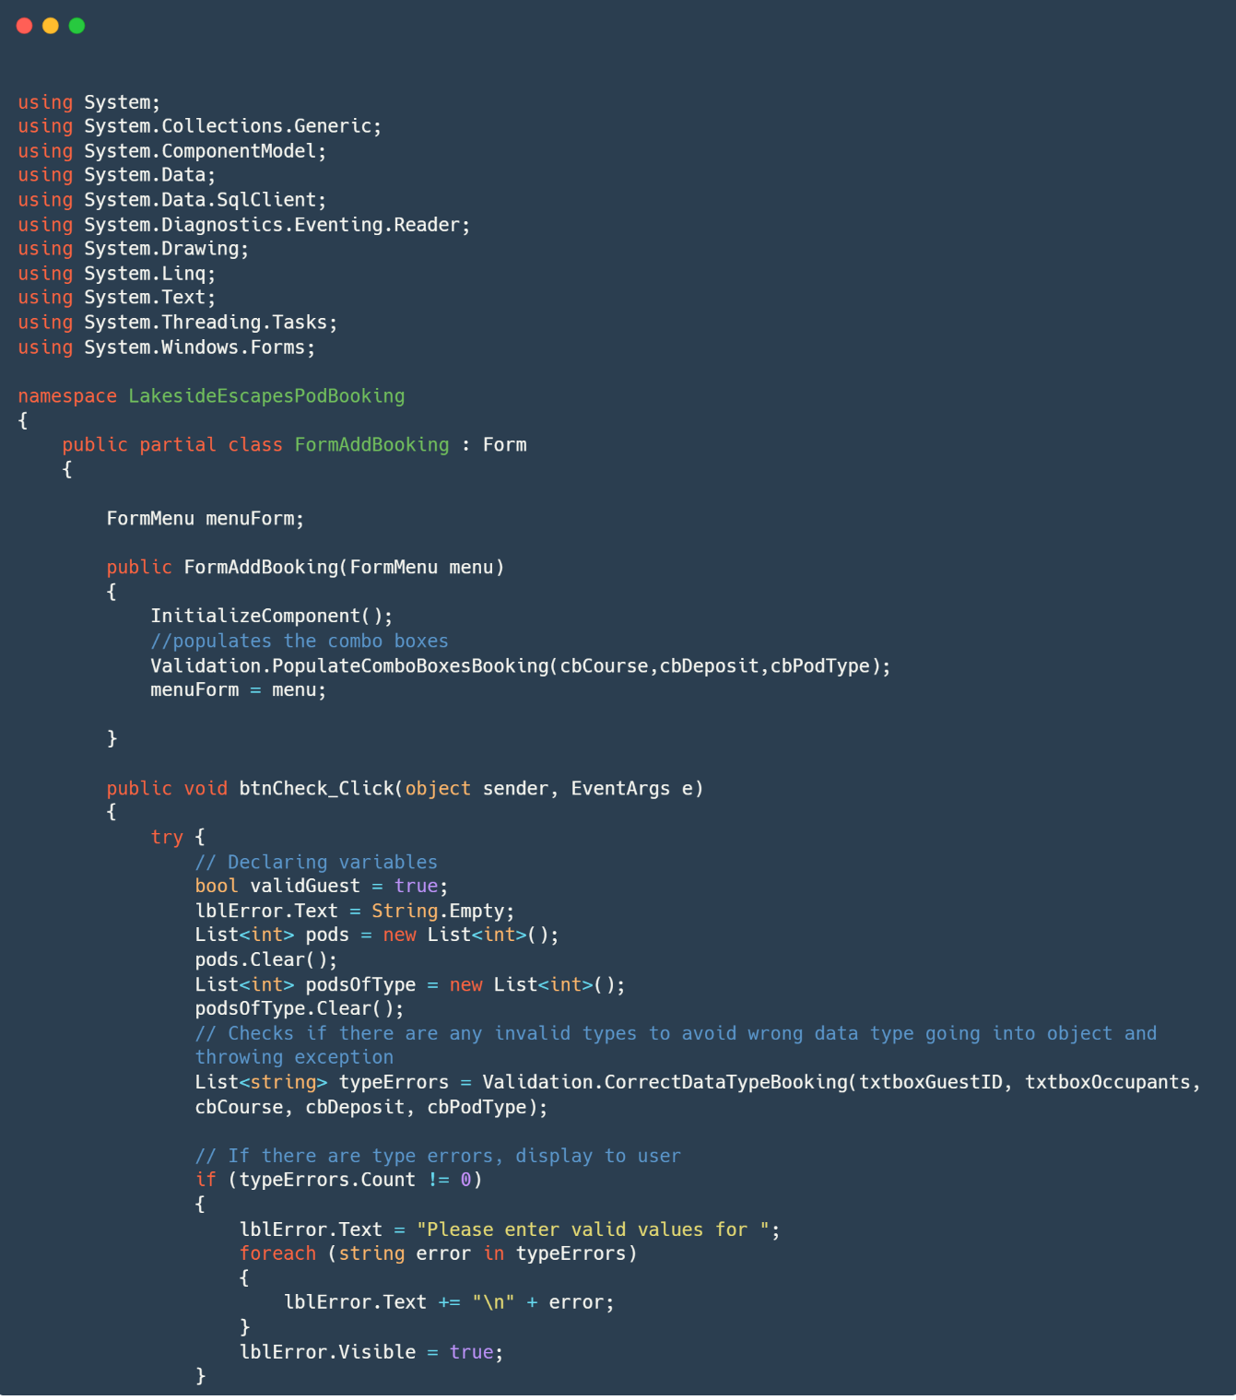B.3.5. FormAddBooking.cs

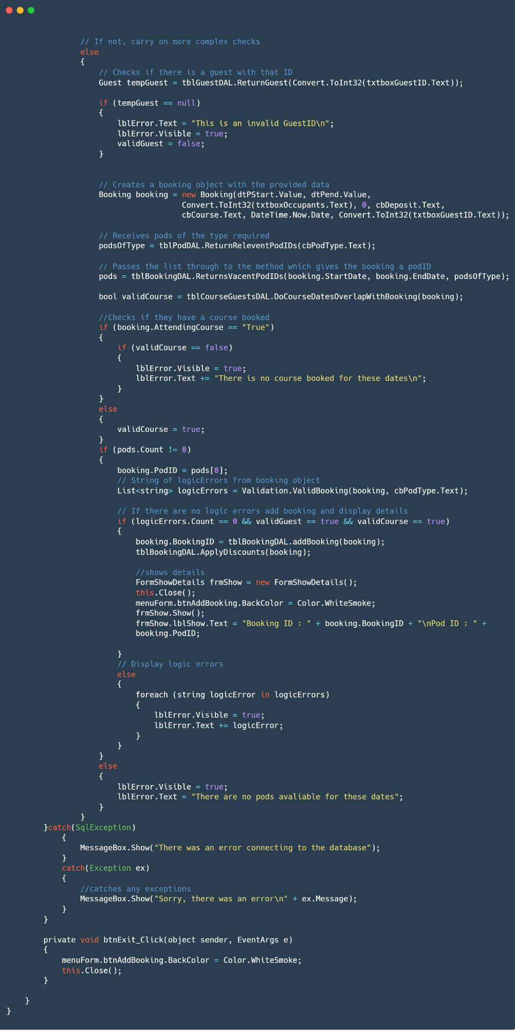

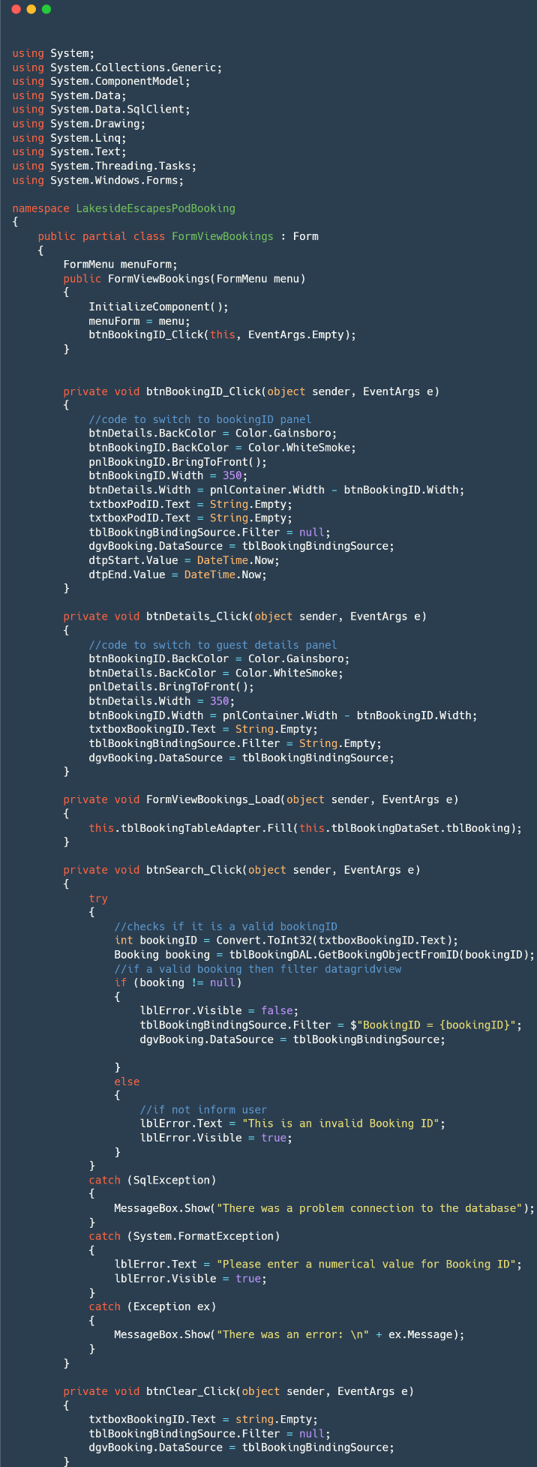B.3.6. FormViewBookings.cs

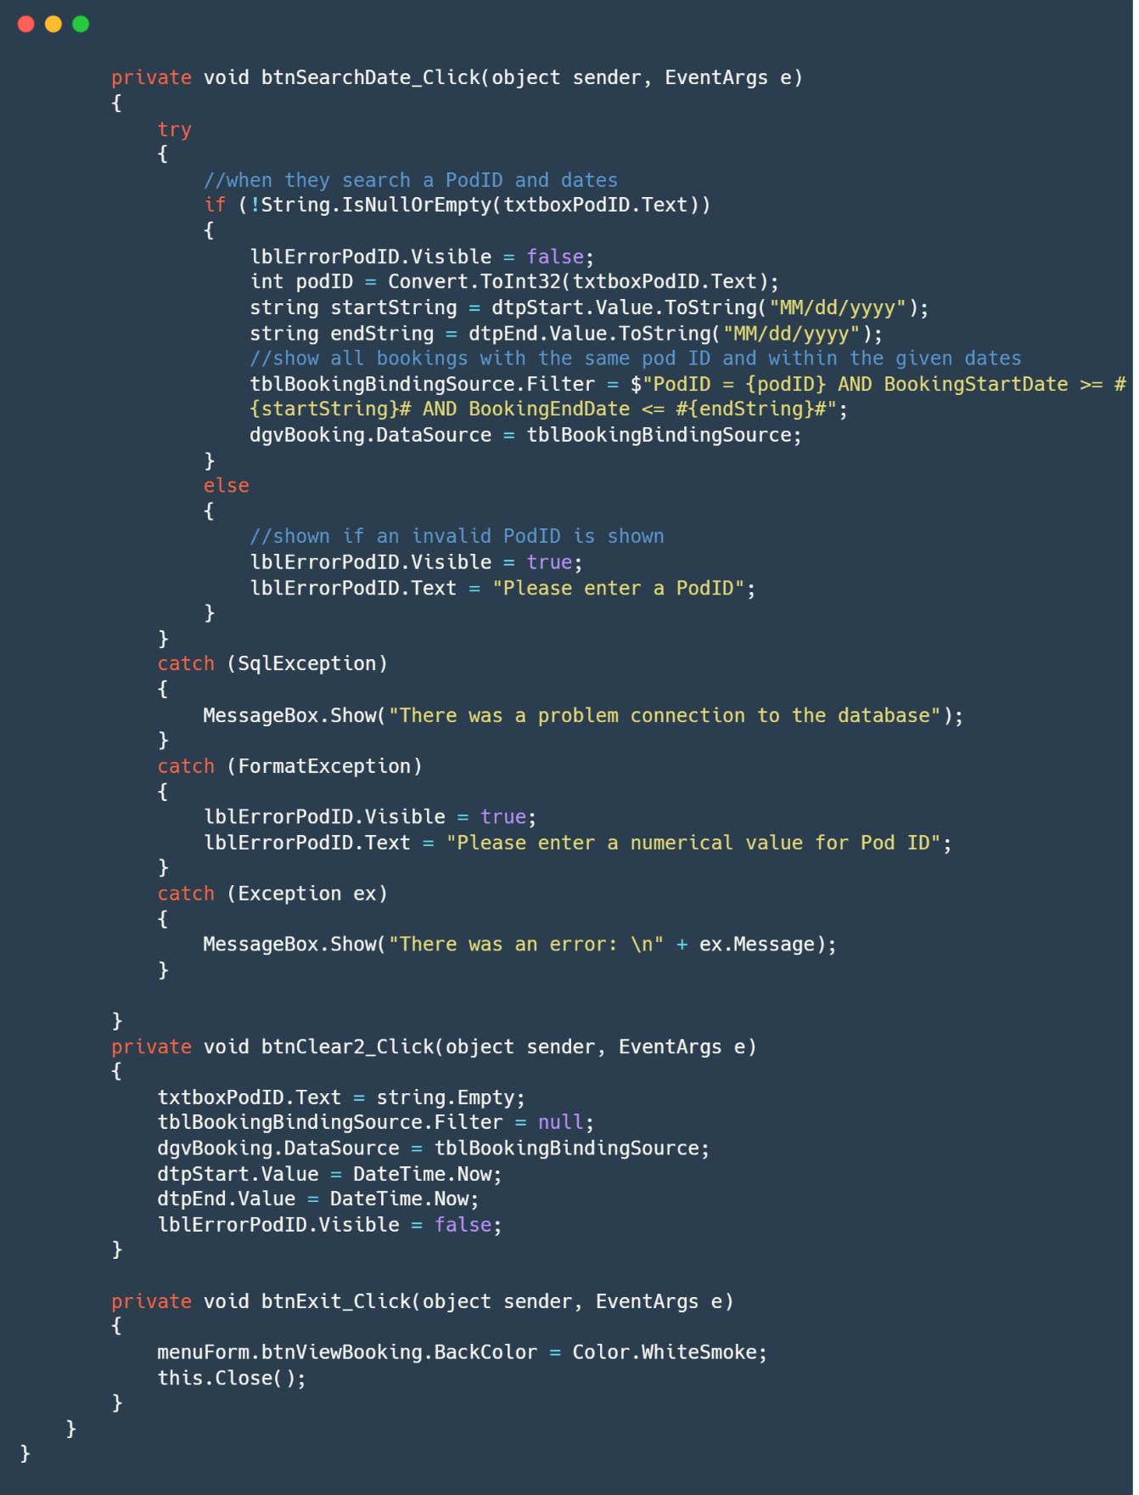

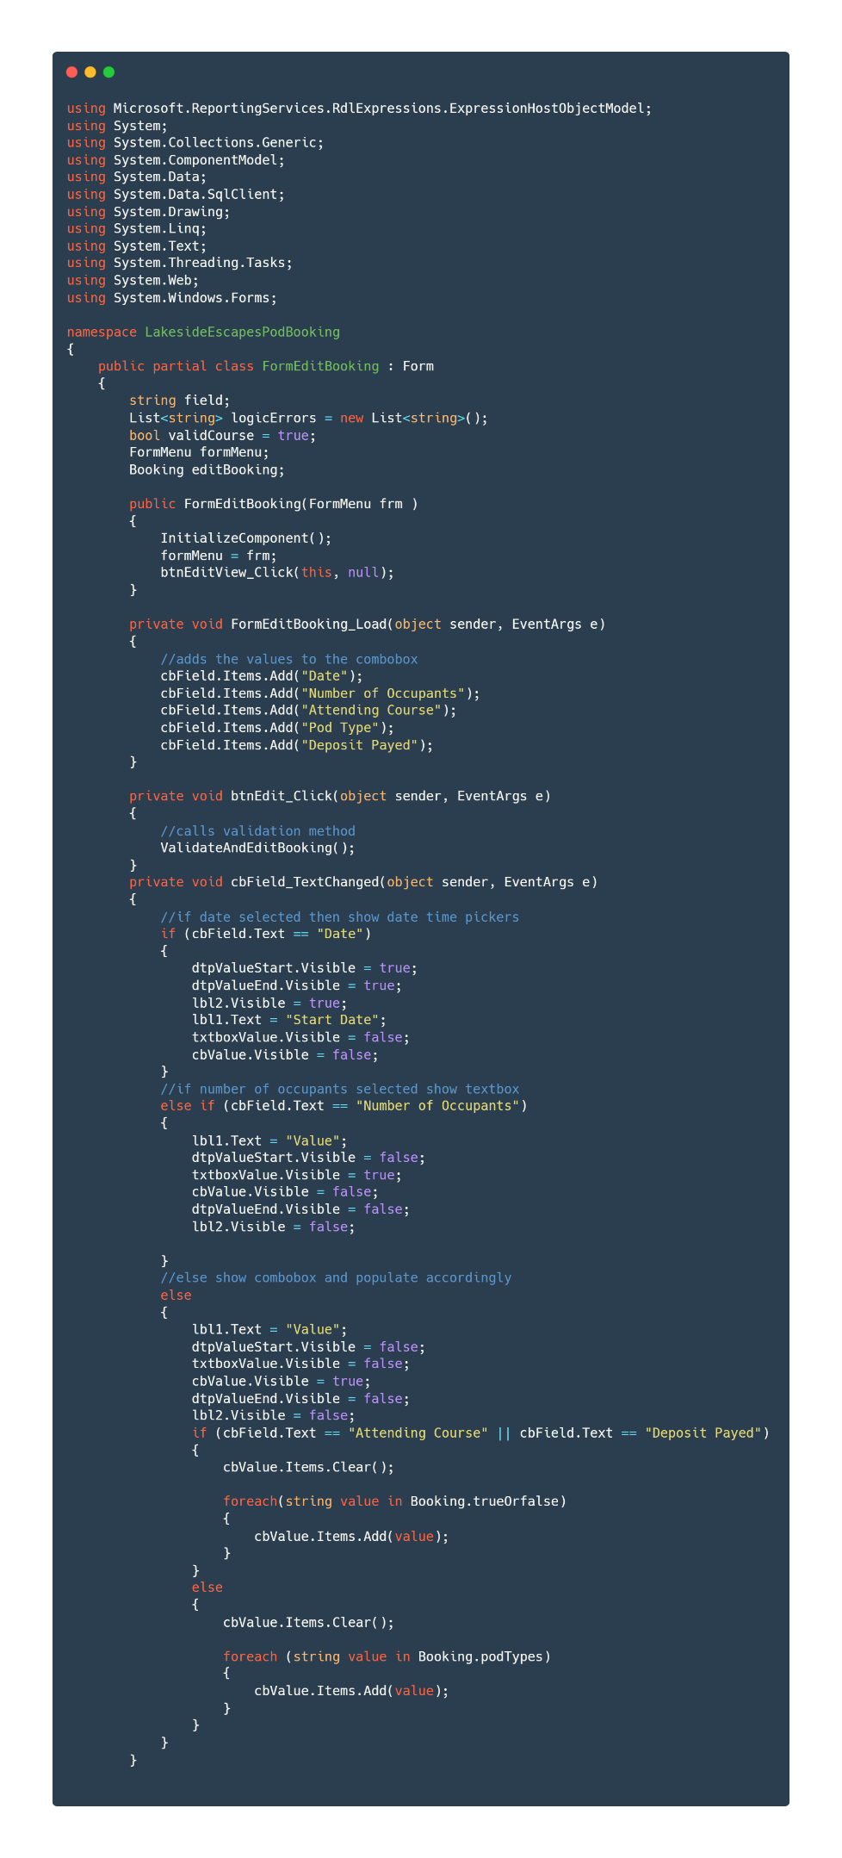B.3.7. FormEditBooking.cs

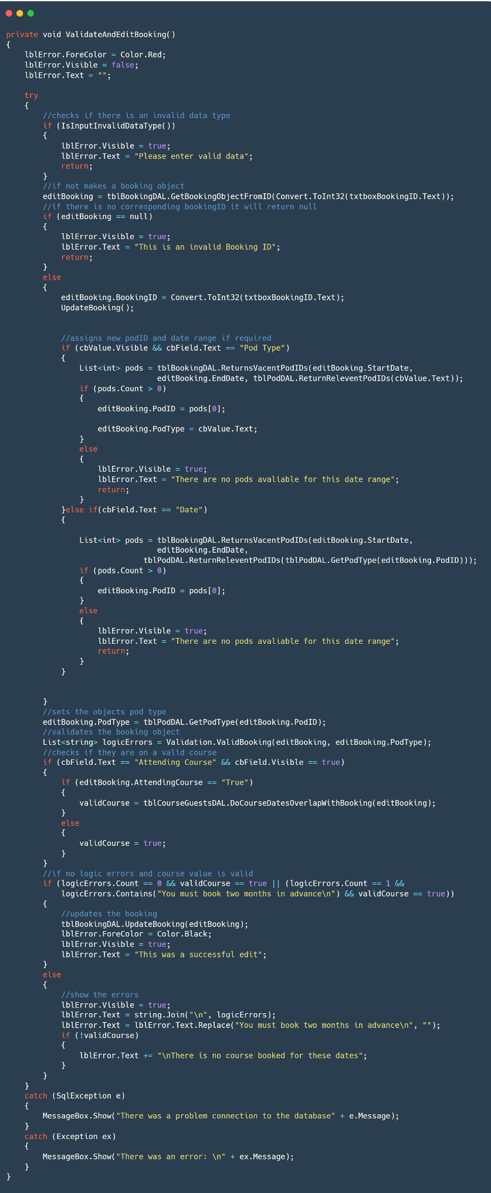

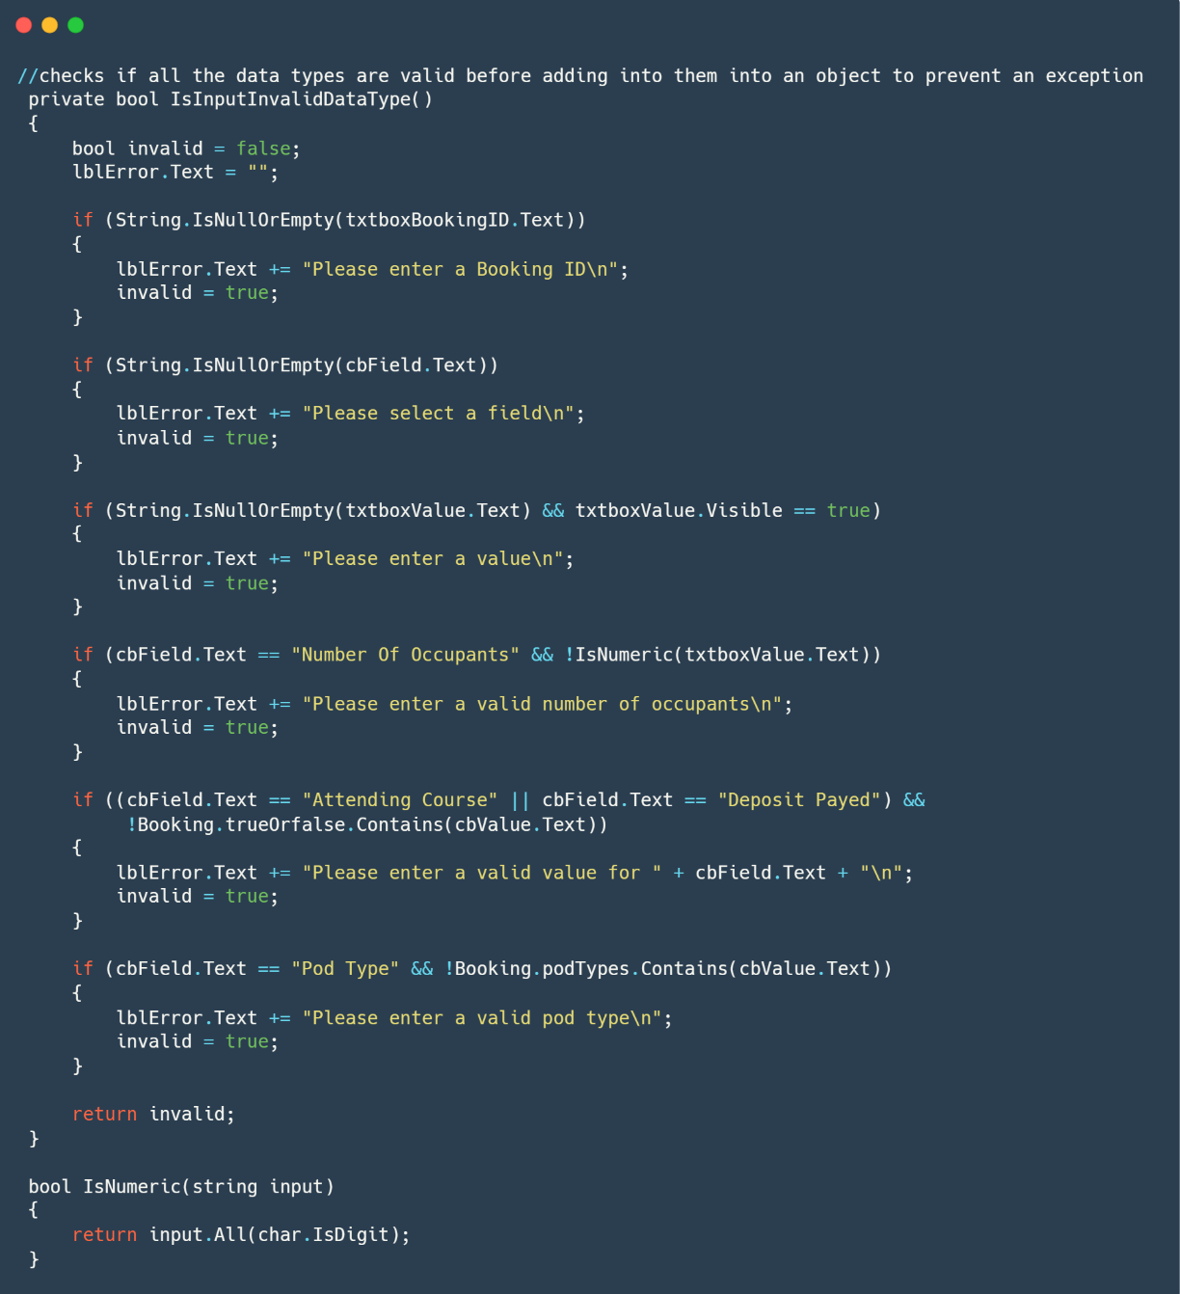

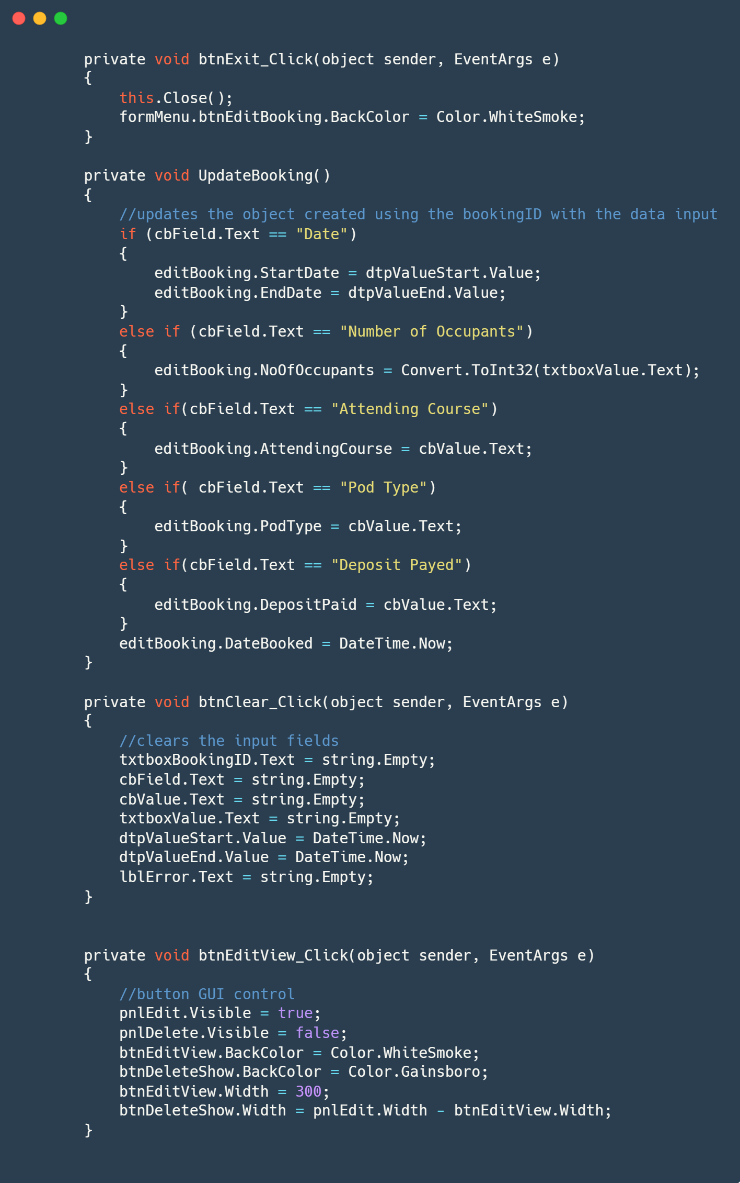

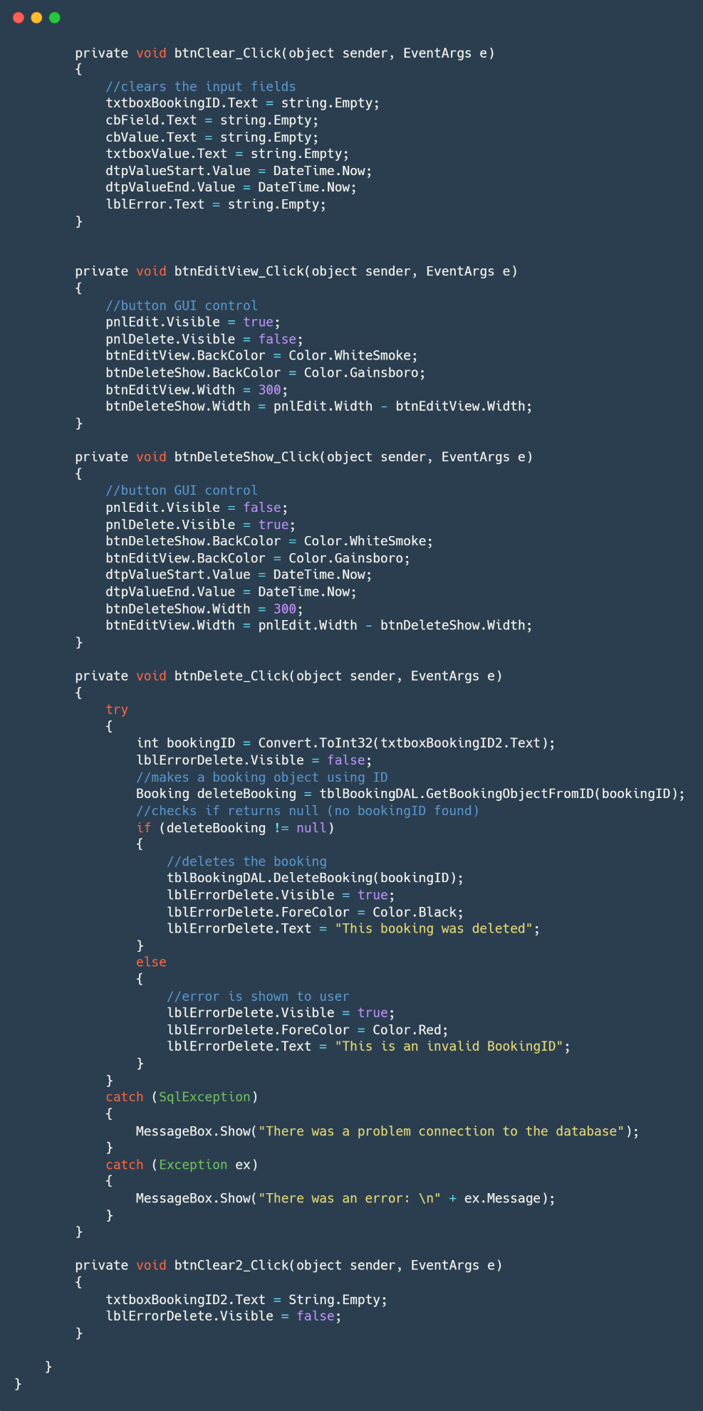

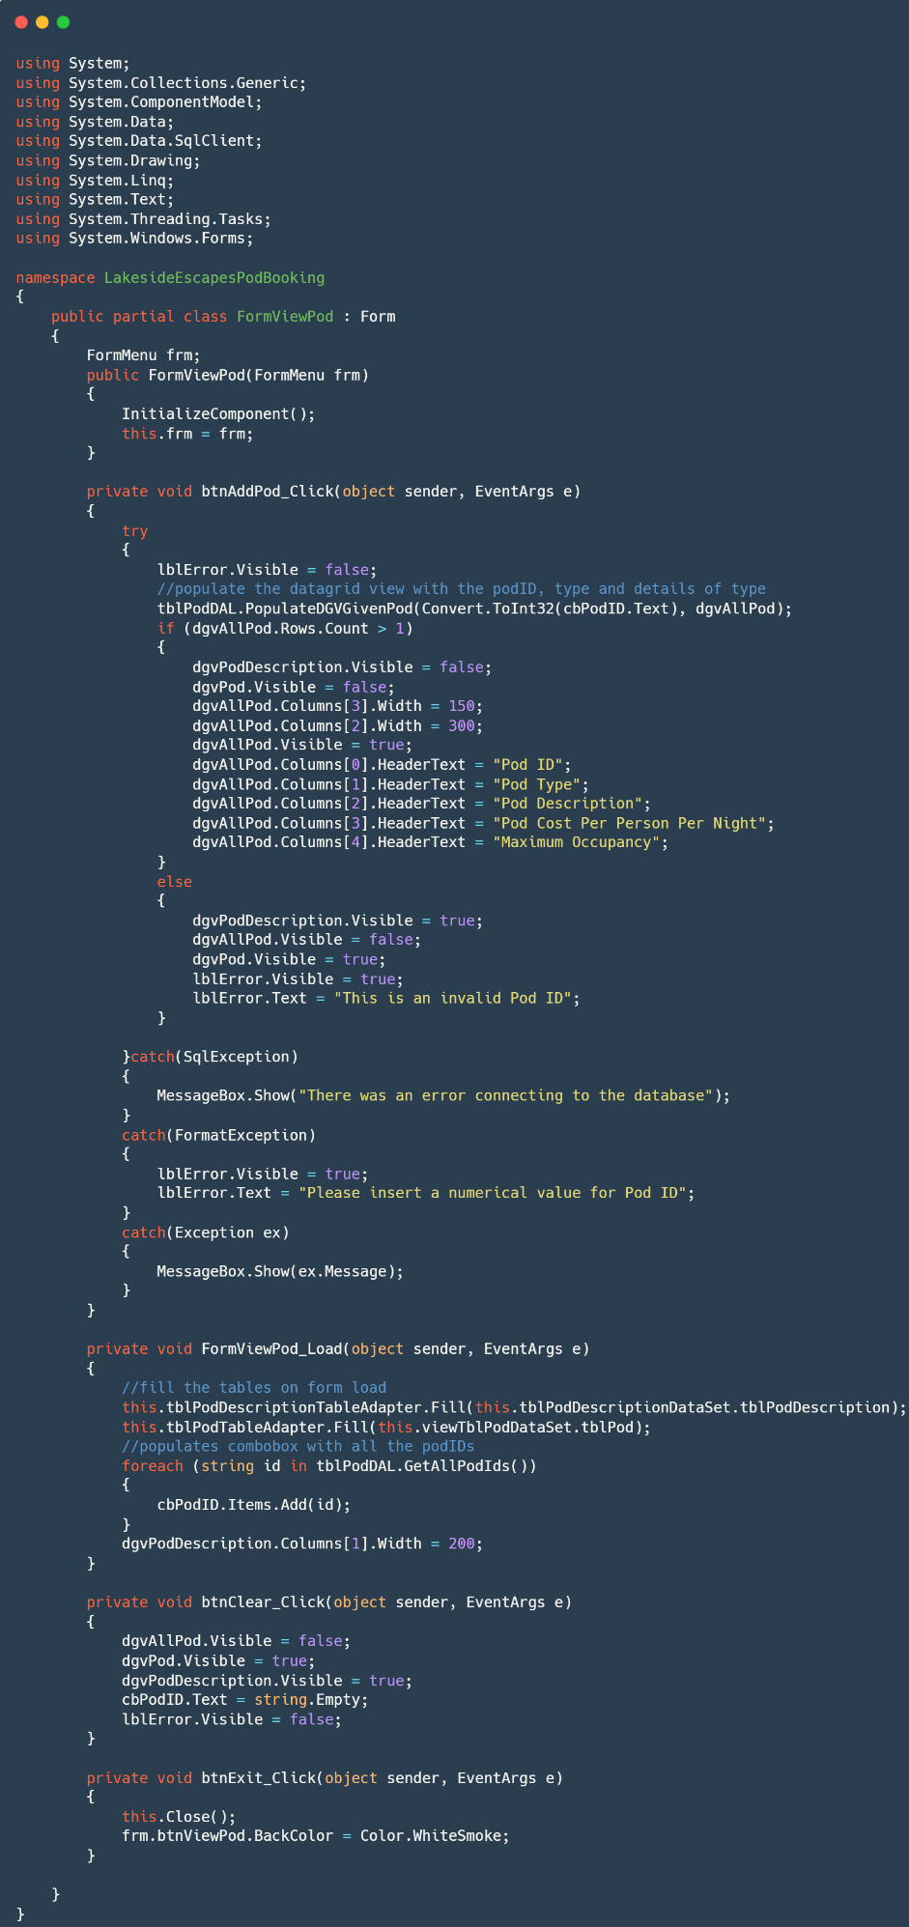B.3.8. FormViewPod.cs

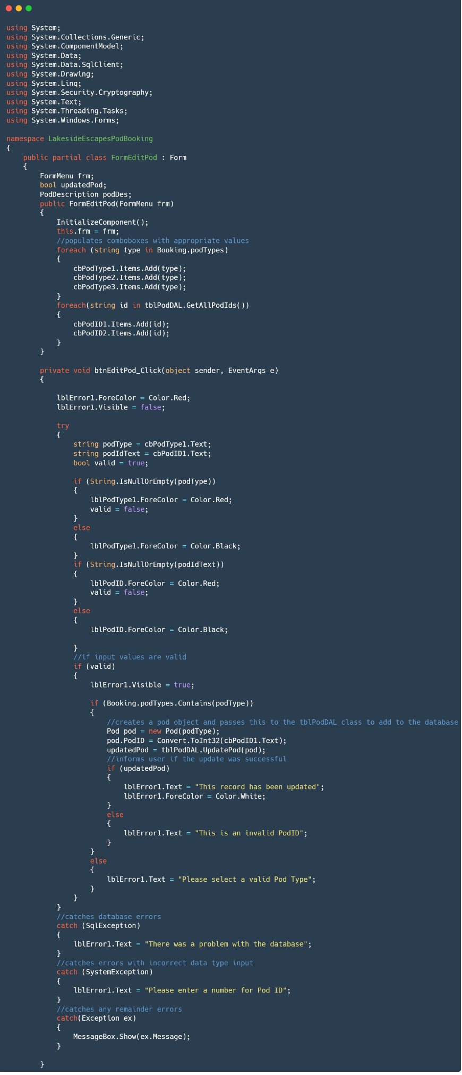B.3.9. FormEditPod.cs

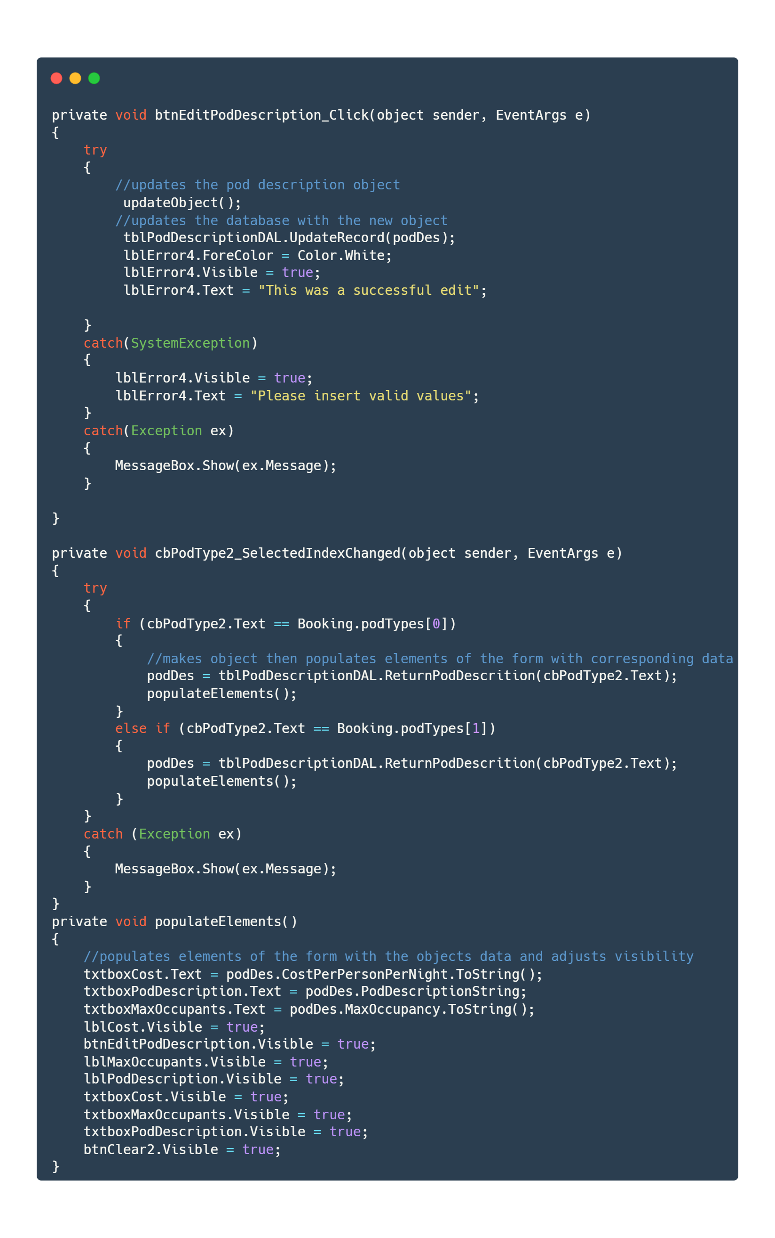

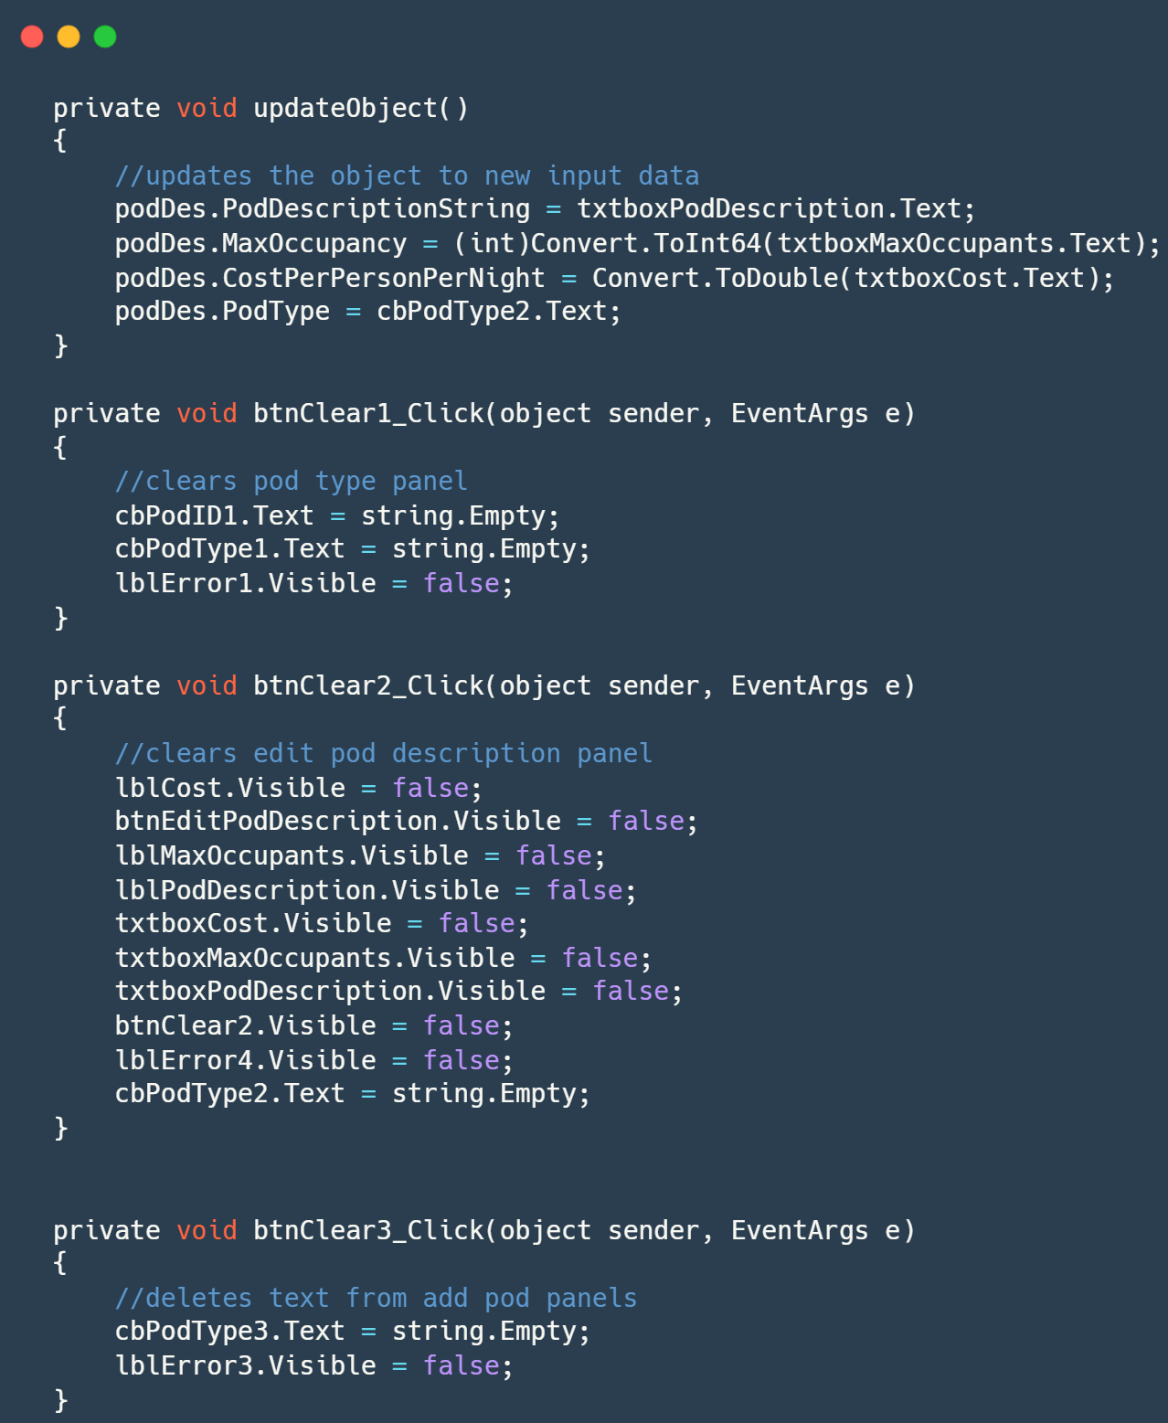

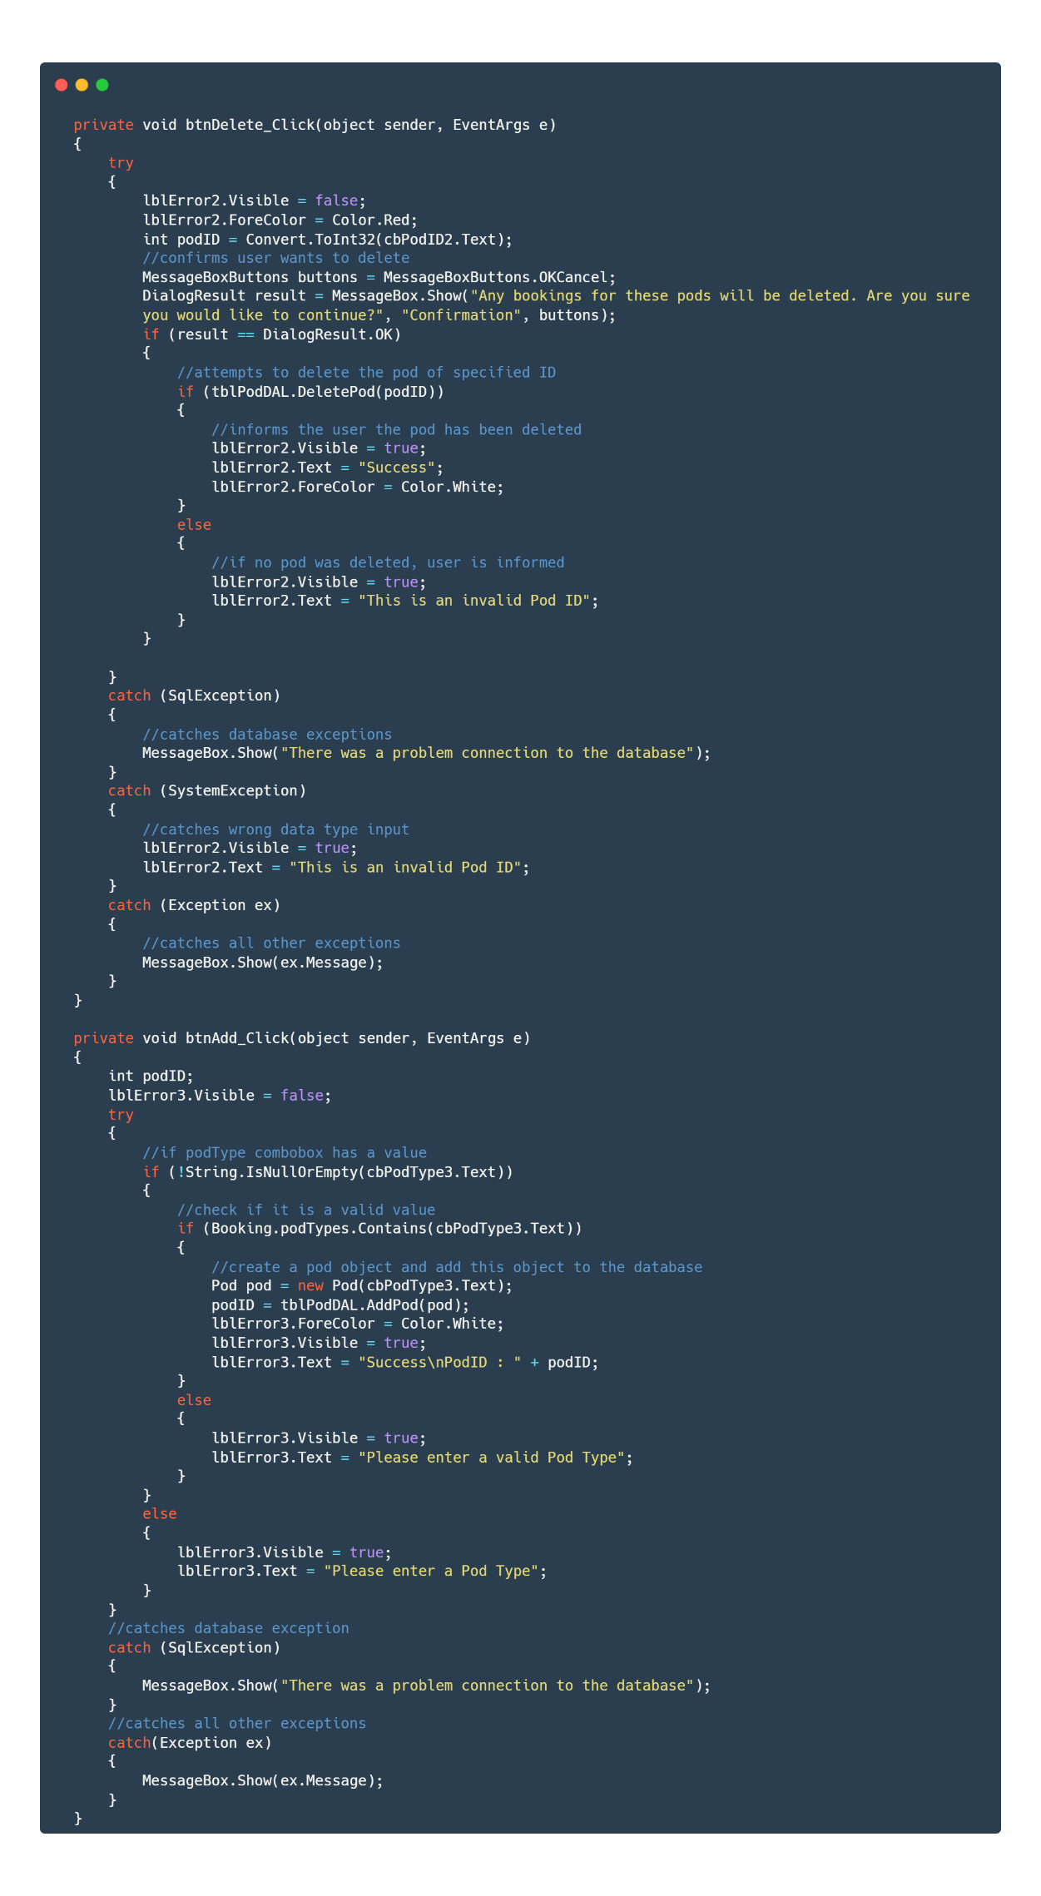

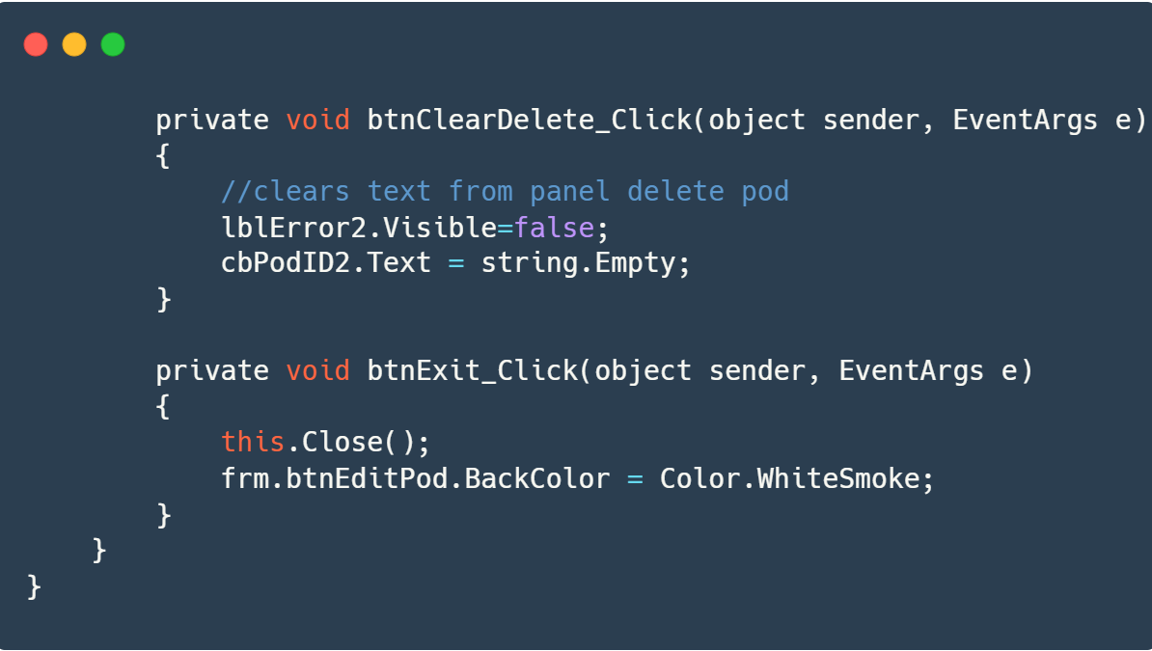

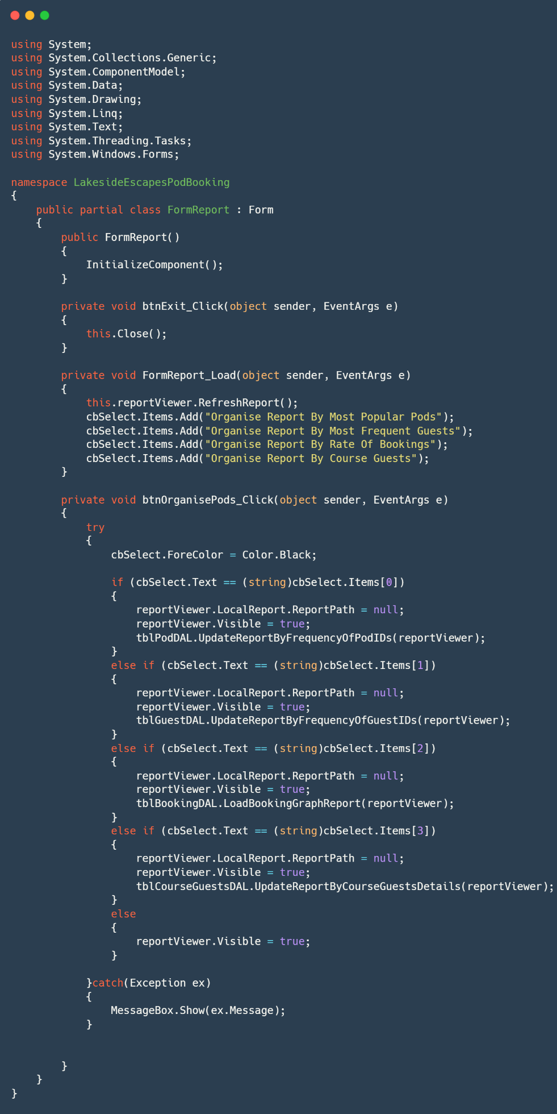B.3.10. FormReport.cs

B.4. SQL Stored Procedures

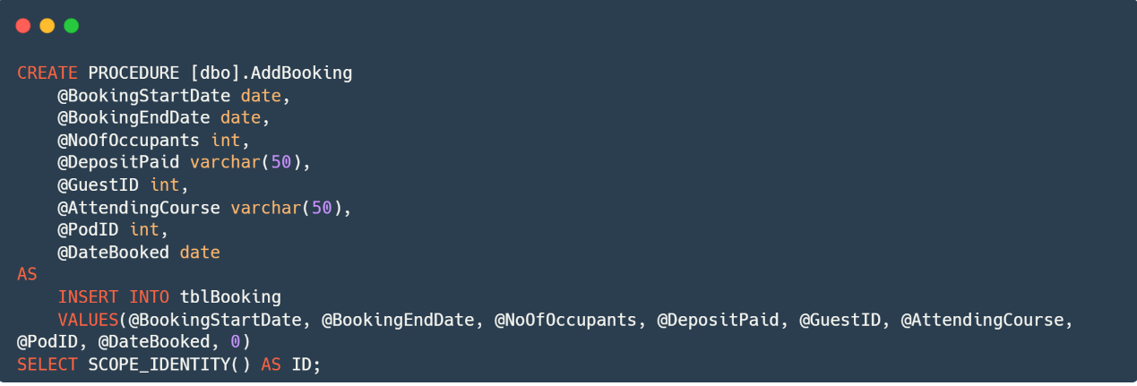B.4.1. AddBooking

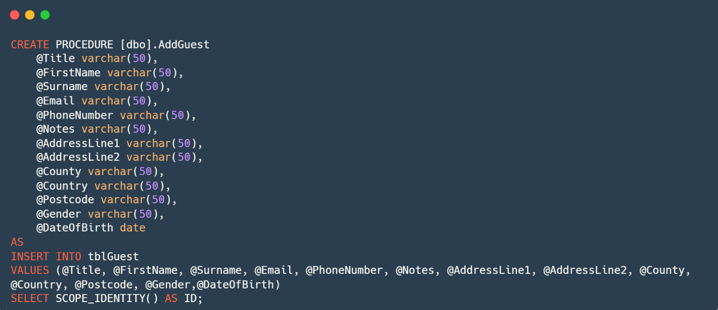B.4.2. AddGuest

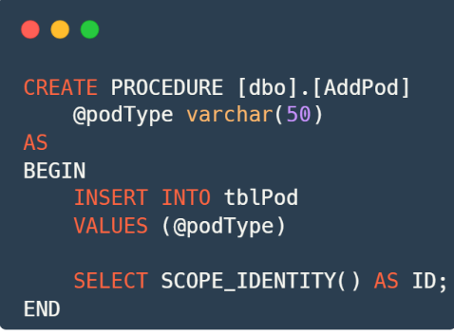B.4.3. AddPod

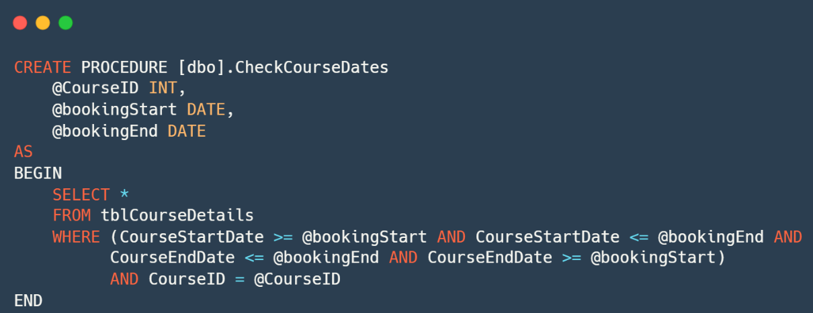B.4.4. CheckCourseDates

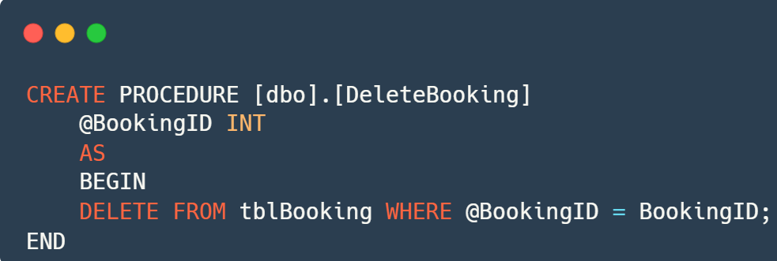B.4.5. DeleteBooking

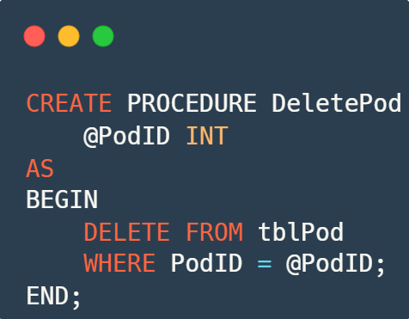B.4.6. DeletePod

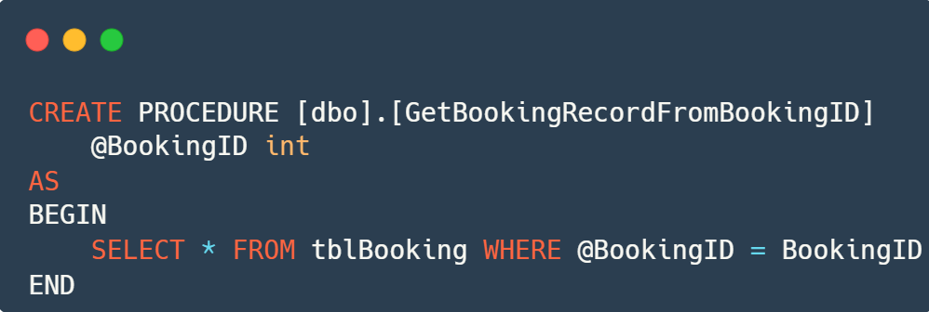B.4.7. GetBookingRecordFromBookingID

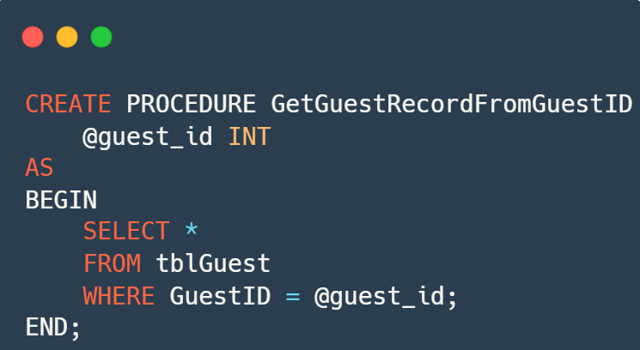B.4.8. GetGuestRecordFromGuestID

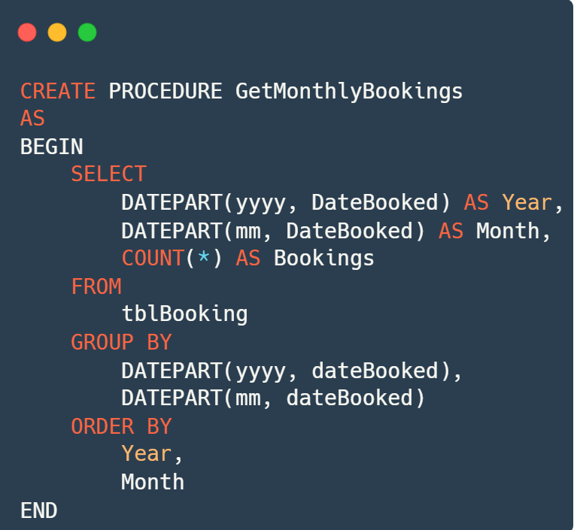B.4.9. GetMonthlyBookings

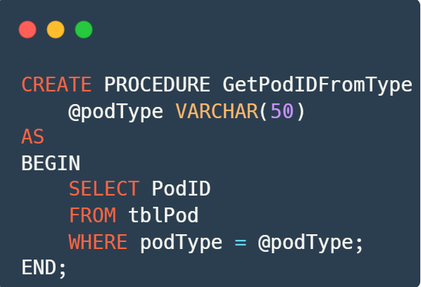B.4.10. GetPodIDFromType

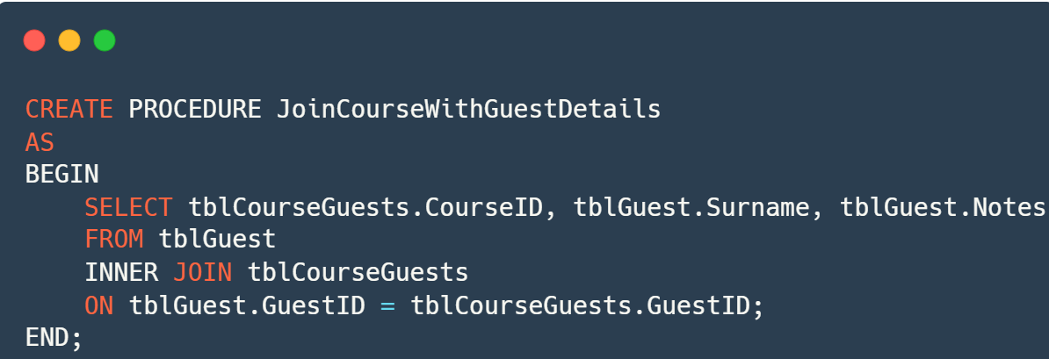B.4.11. JoinCourseWithGuestDetails

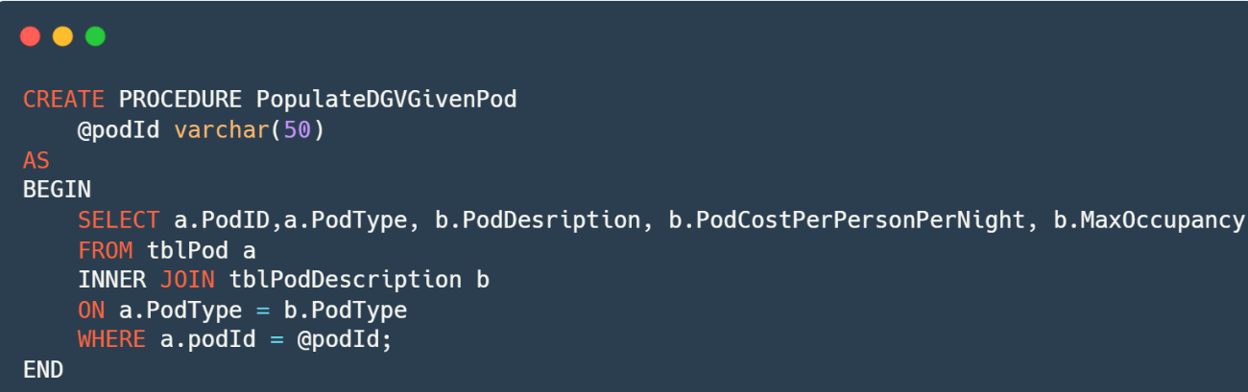B.4.12. PopulateDGVGivenPod

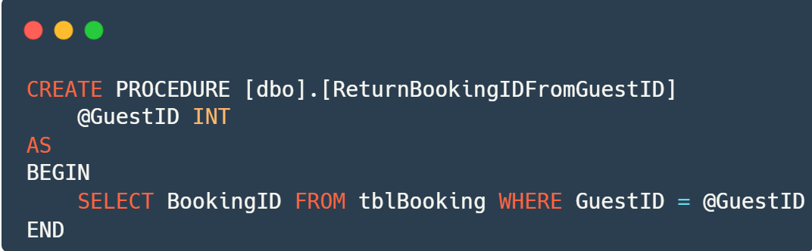B.4.13. ReturnBookingIDFromGuestID

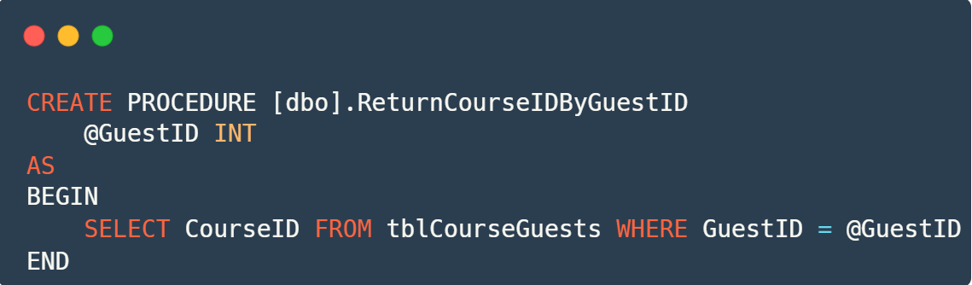B.4.14. ReturnCourseIDByGuestID

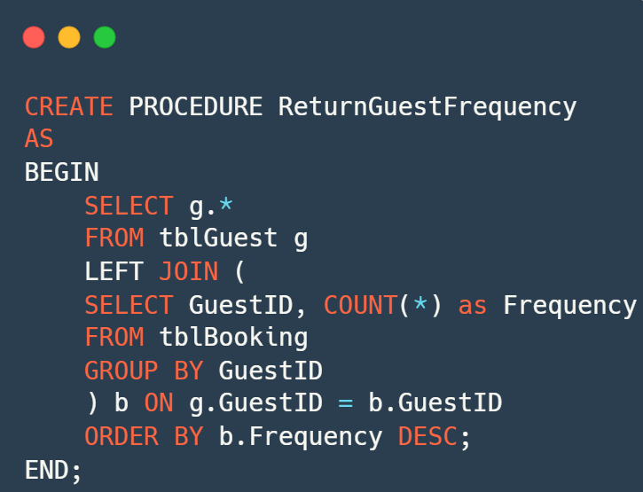B.4.15. ReturnGuestFrequency

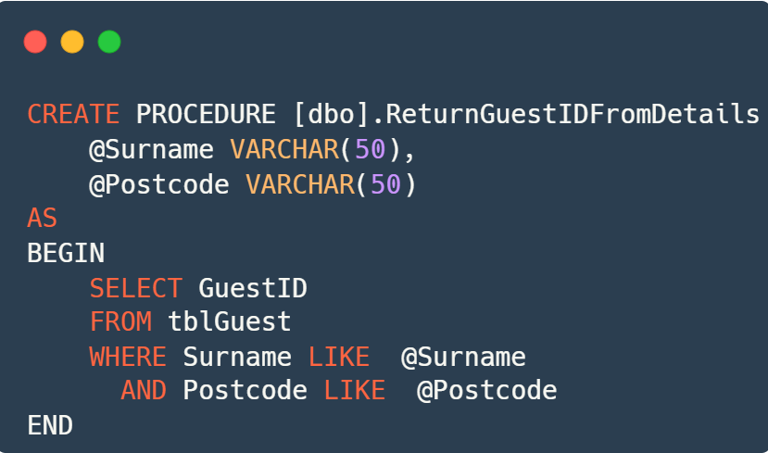B.4.16. ReturnGuestIDFromDetails

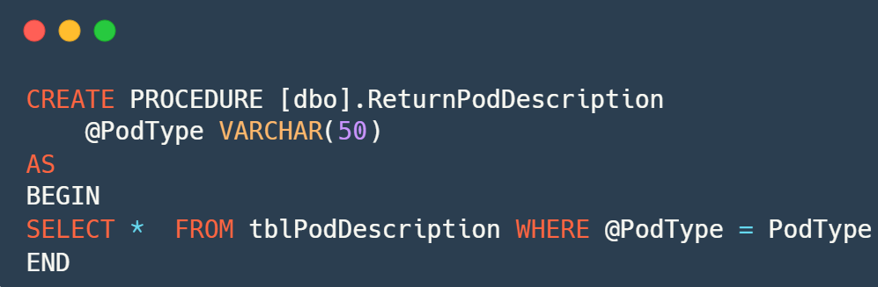B.4.17. ReturnPodDescription

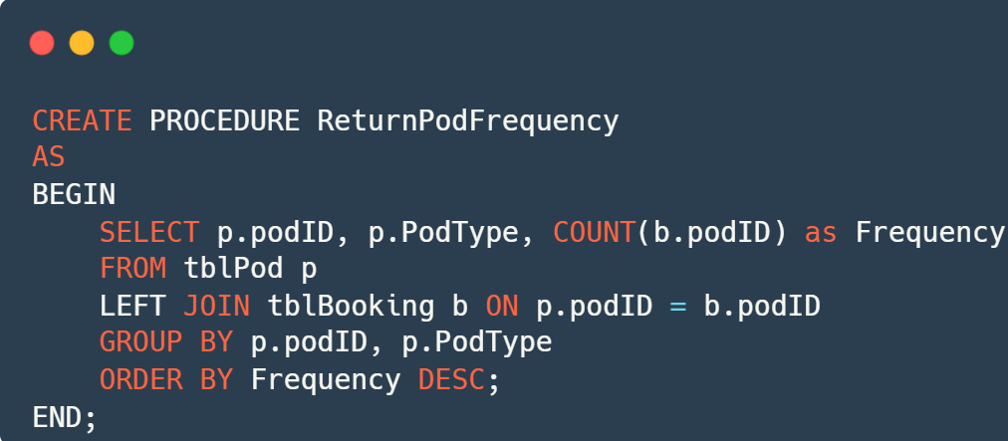B.4.18. ReturnPodFrequency

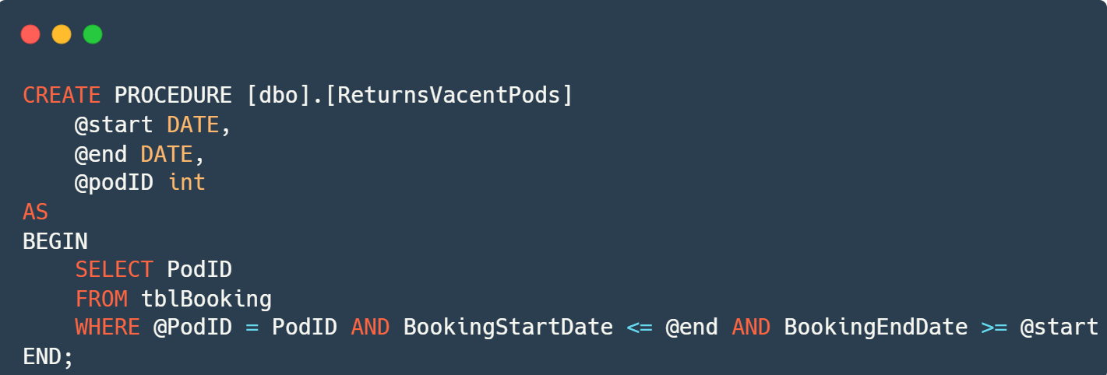B.4.19. ReturnVacentPods

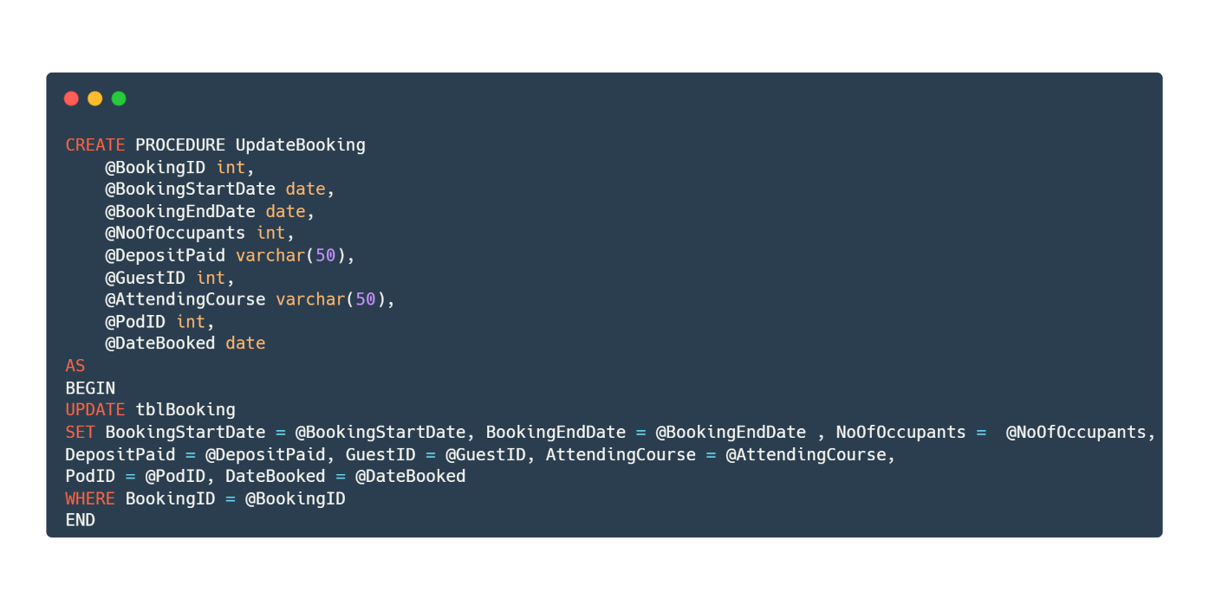B.4.20. UpdateBooking

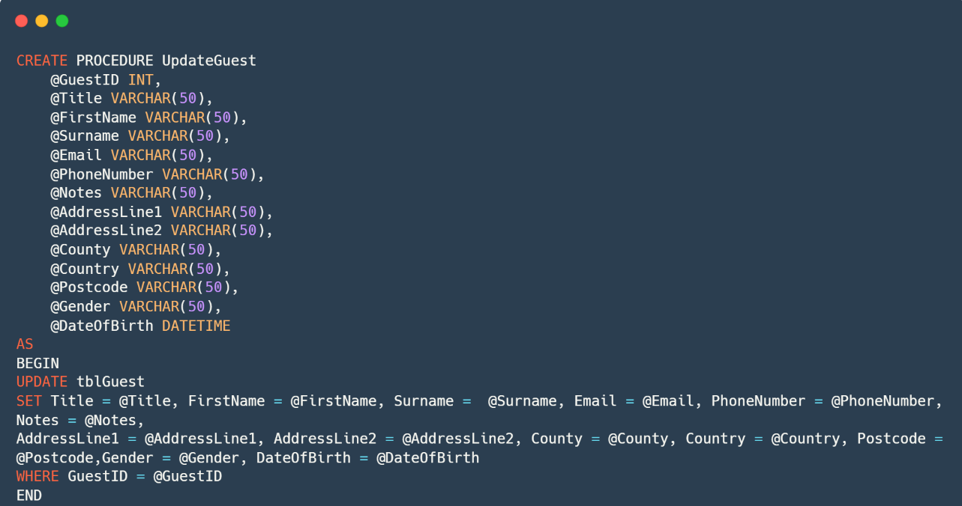B.4.21. UpdateGuest

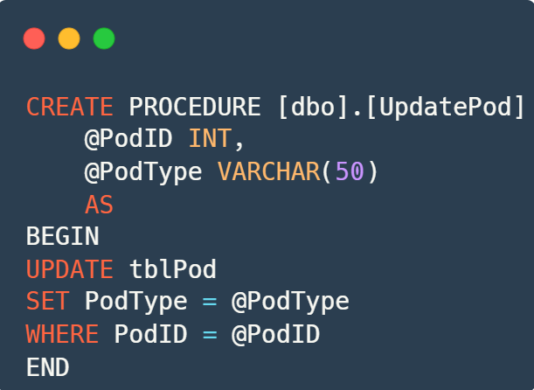B.4.22. UpdatePod

B.4.23. UpdatePodDescription

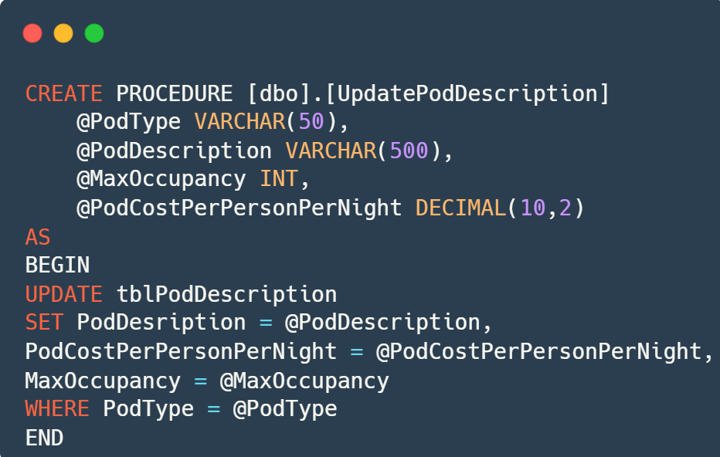

B.5 Database Tables

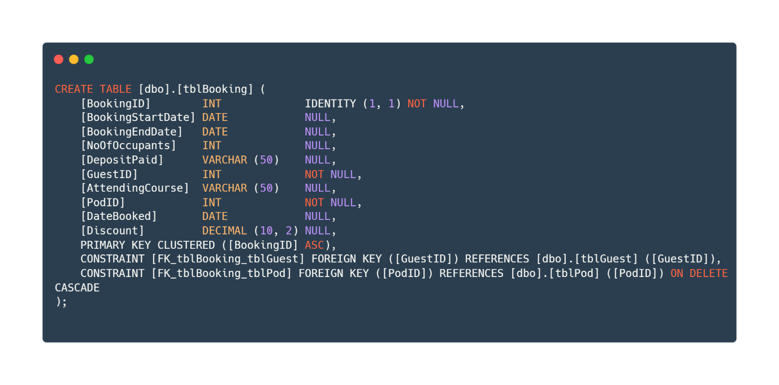B.5.1. tblBooking

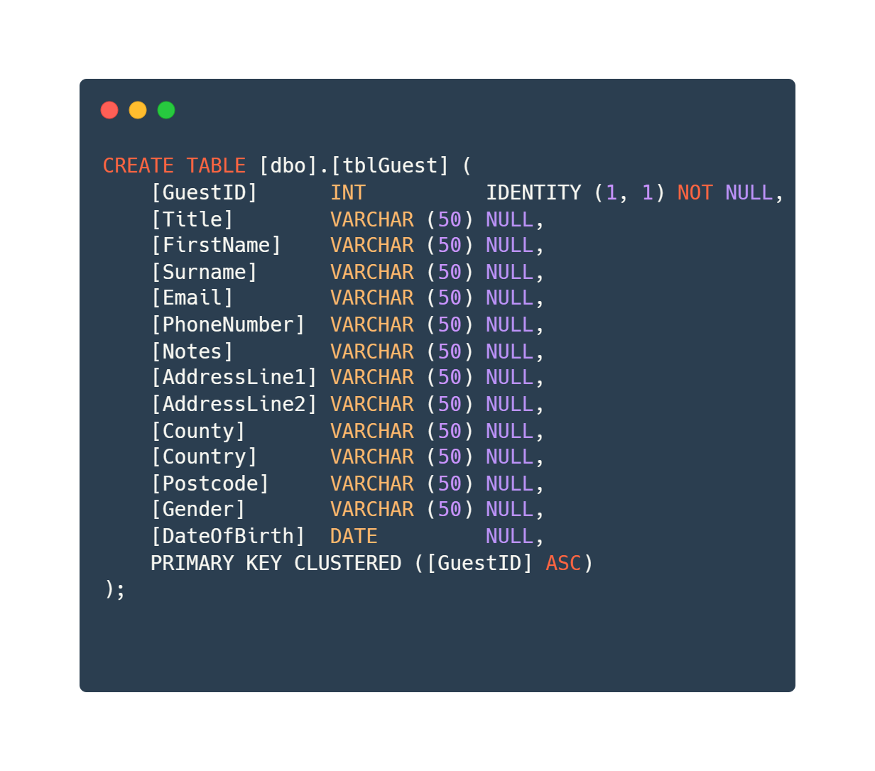B.5.2. tblGuest

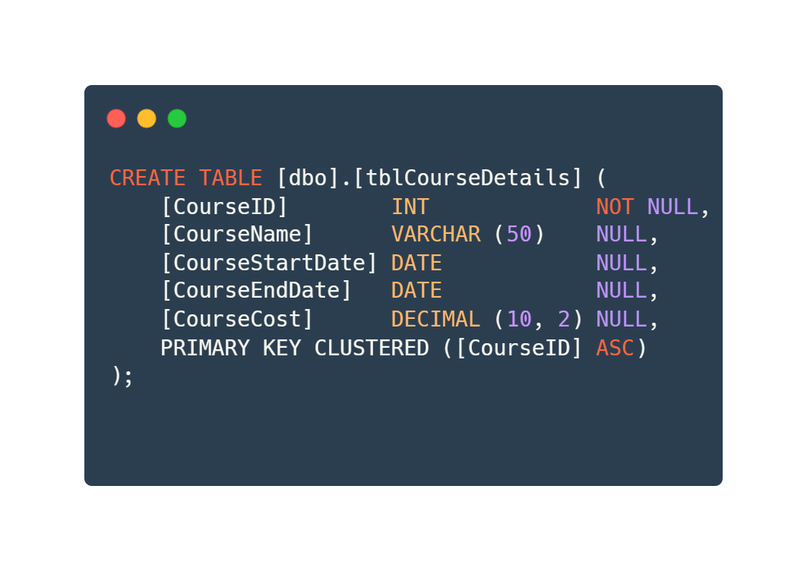B.5.3 tblCourseDetails

B.5.4. tblCourseGuests

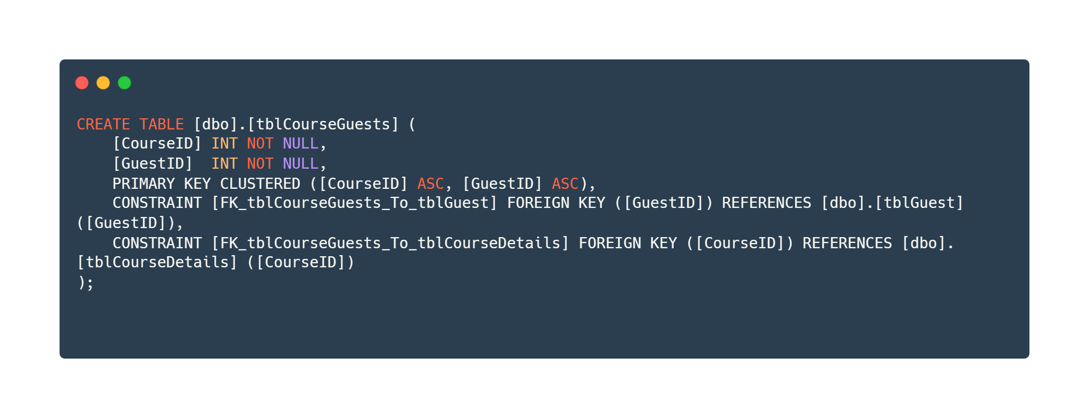

B.5.5. tblPod

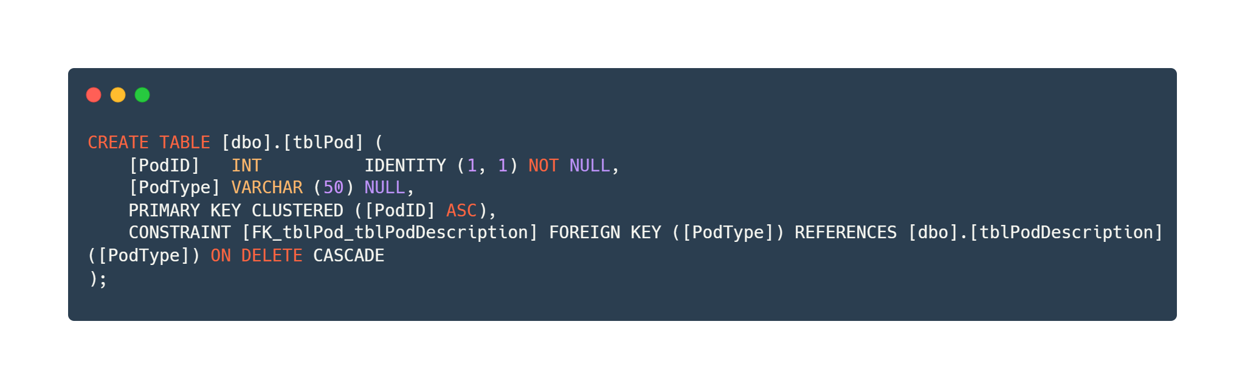

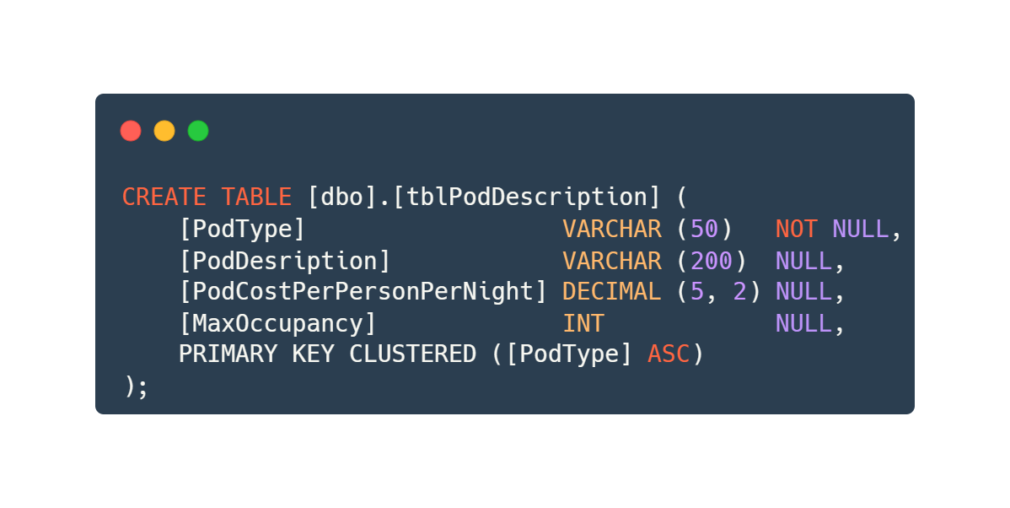B.5.6. tblPodDescription